

Assignment: CS312L Computer Simulation

Program: BS Industrial Engineering

Title: Transportation Model Simulation

Submitted by: Mohammad Abubakar Atiq (F2022031002)

Submitted to: Hafiz M. Osaid

Date: January 22, 2025

# Objective

This lab’s goal is to simulate and understand traffic flow near the University of Management and Technology (UMT). By modeling the movement of cars and pedestrians, the simulation captures real-world traffic scenarios to analyze and improve traffic patterns and interactions.

# Introduction

The transportation simulation was designed to reflect real-world traffic scenarios around UMT. Two primary entities were modeled: cars and pedestrians. The model included key locations such as entry gates, intersections, pedestrian walkways, and parking lots to create a realistic traffic environment. The simulation aimed to observe traffic behavior, analyze delays, and propose improvements for both entities within the system.

Cars were modeled to exhibit variable speeds, obey traffic signals, and interact with pedestrians at intersections and crossings. Pedestrians were designed to move along designated paths, crossing streets at specified locations. The interaction between cars and pedestrians was a focal point, as it highlighted the challenges of balancing flow and safety. The simulation used data from seven replication runs to ensure comprehensive analysis.

# ARENA Simulation Setup

## Logic 1 Car Motion:

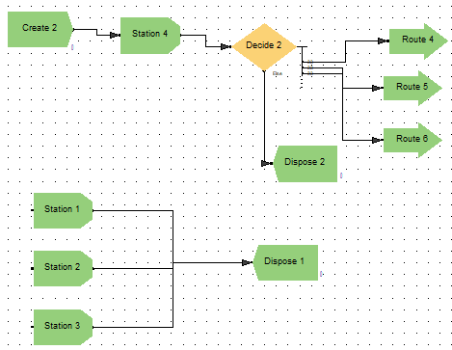

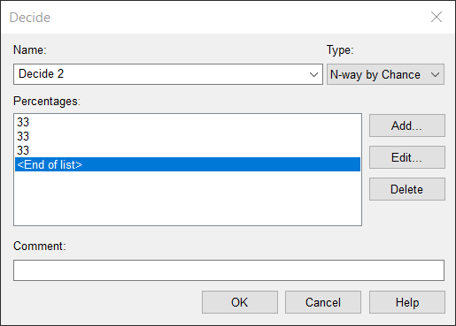

## Logic 2 Car Motion:

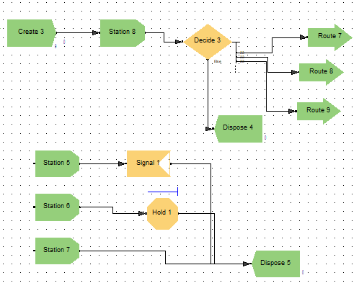

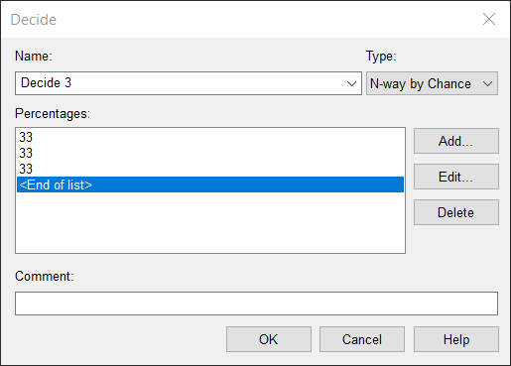

## Logic 3 Human Motion:

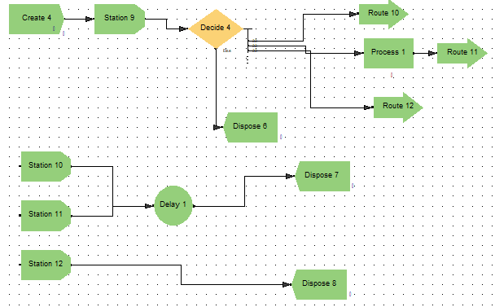

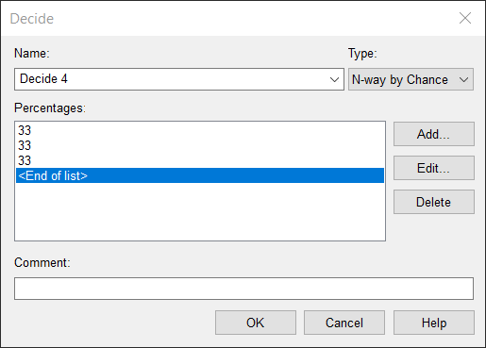

The simulation was configured with several important parameters to reflect real-world conditions:

# Entity Behavior and Arrival Rates

Cars arrived at an average rate of 10 per hour and exhibited variable speeds and stop-and-go behavior at intersections. Pedestrians arrived at an average rate of 15 per hour, using crosswalks and prioritizing safety at intersections. Both entities were assigned unique behaviors to mimic realistic interactions.

# Key Locations and System Design

Key locations were defined in the model:

1. The **Entrance Gate** served as the main entry point for both cars and pedestrians.
2. **Intersections** were equipped with traffic signals to manage interactions.
3. **Parking Lots** acted as destinations for cars.
4. **Walkways** provided dedicated paths for pedestrians.

# Traffic Signal and Queue Management

Traffic lights were timed to prioritize pedestrians during peak hours while ensuring fair flow for cars. Queues formed at intersections for both cars and pedestrians, simulating delays and interactions. Metrics such as queue length and wait time were tracked to assess efficiency.

# Results and Analysis

The simulation was run for 24 hours across seven replications to capture detailed traffic behavior. Below are the consolidated findings:

## Cars

1. **Wait Times:** The average wait time at intersections was 2.67 minutes, with a maximum of 5.73 minutes recorded during peak hours. Replication averages ranged from 2.44 to 3.66 minutes, showing consistent delays at intersections.
2. **Throughput:** A total of 1,341 cars were processed in one replication, with variations across others due to fluctuating arrival rates.
3. **Traffic Light Impact:** Delays were primarily caused by pedestrian crossings and signal timing, especially during peak hours.

## Pedestrians

1. **Crossing Times:** Pedestrians spent an average of 0.31 minutes crossing, with a maximum of 0.90 minutes during busier periods. Across replications, pedestrian crossing times remained stable, ranging between 0.30 and 0.33 minutes.
2. **Total Pedestrians Processed:** Approximately 4,096 pedestrians were recorded per replication, demonstrating a consistent flow across all runs.
3. **Priority Effect:** Pedestrian prioritization at intersections ensured smooth flow for this entity but contributed to car delays.

## Intersection and System Performance

Peak usage of intersections was observed between 9:00 AM and 11:00 AM, with significant delays during these hours. Queue lengths averaged 1.44 cars during peak times but occasionally reached up to 5 cars in extreme cases. Pedestrian flow remained unaffected by these peaks due to prioritization.

# Key Observations

The interaction between cars and pedestrians highlighted several strengths and challenges:

1. **Strengths:**
   1. Pedestrians benefited from prioritization, ensuring safety and reducing crossing delays.
   2. The traffic light system balanced flow and safety reasonably well.
2. **Challenges:**
   1. Car waits times increased significantly during peak hours, causing congestion.
   2. Pedestrian prioritization, while effective for safety, hindered car throughput.

# Conclusion

The transportation simulation successfully captured traffic dynamics near UMT, providing a detailed understanding of car and pedestrian interactions. The findings emphasized the importance of balancing flow and safety in mixed-entity traffic systems. While pedestrian prioritization ensured smooth movement for pedestrians, it introduced delays for cars, especially during peak hours. The proposed recommendations offer practical solutions to enhance traffic efficiency and safety.

By leveraging the insights from this study, further simulations and real-world implementations can create a more seamless traffic environment. The results demonstrate the potential for simulation tools to identify and address bottlenecks in urban traffic systems.

# Attachments

1. Detailed ARENA simulation results for all seven replications, including metrics such as average wait times, total throughput, and system utilization.
2. Annotated map illustrating the key locations modeled in the simulation.

## Data Settings:

