Name: Click or tap here to enter text. Photo: 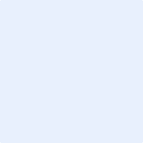

ID: Click or tap here to enter text.

Select Degree Program (Drop Down Option): N/A

Date of Submission: Click or tap to enter a date.

Current Job company & Position: Click or tap here to enter text.

If Enrolled in Higher Education: Choose an item.

Question 1:

How was your life as an undergraduate student? (drop down options), Choose an item.

Question 2:

Does UMT change your life? (drop down options), Choose an item.

Question 3:

What are your future plans?



Question 04:

Does your education is worth investing in UMT? Choose an item.

Question 05:

Do you recommend UMT to your social circle? Choose an item.

Please leave comment for future students: Click or tap here to enter text.