# Class Assignment 03

By Mohammad Abubakar Atiq, F2022031002, BS Industrial Engineering, Apparatus of Material Engineering Lab.

Subject: TECHNICAL REPORT WRITING AND PRESENTATION SKILLS

Instructor: Hira Syed

# User Manual of Metallurgical Microscope

Contents

Class Assignment 03 1

User Manual of Metallurgical Microscope 2

Components after assembly 4

Specifications of M.M (Metallurgical Microscope) 5

Materials Specimen Conditions 5

Procedure: 5

QR CODE ALL FILES 7

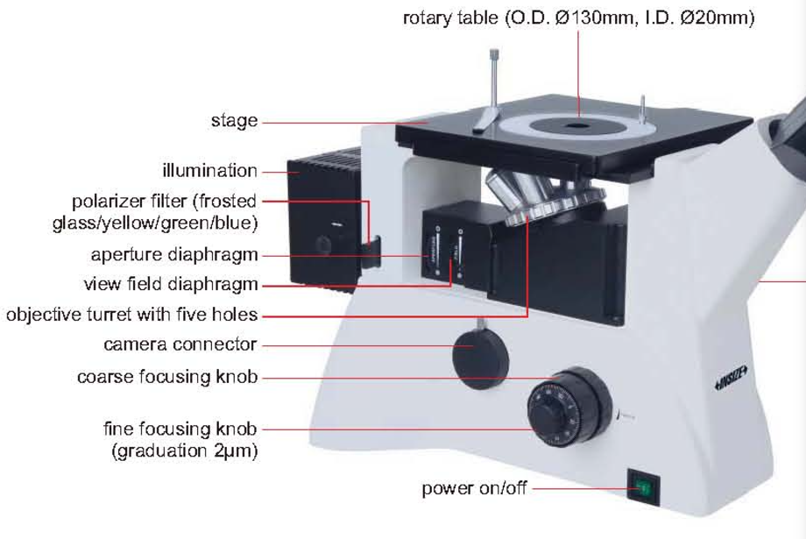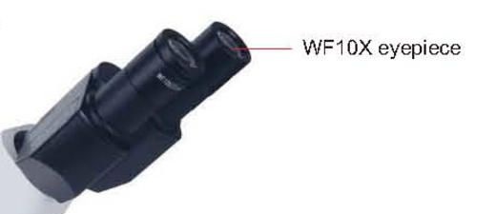

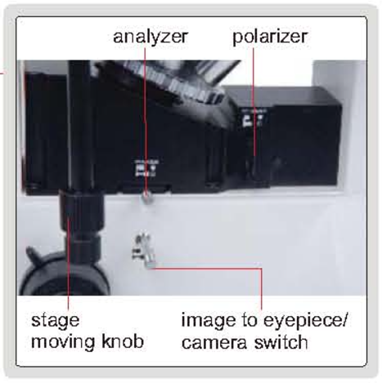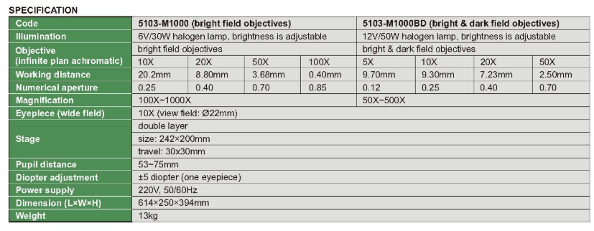

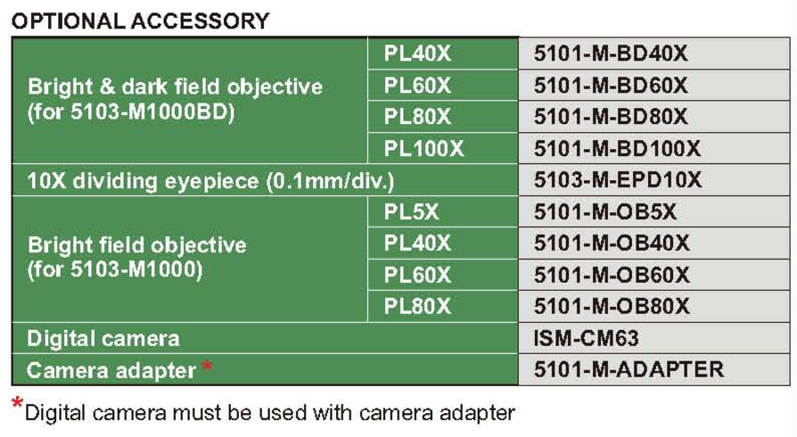

# Components after assembly

1. Stage
2. Rotary table
3. Illumination
4. Polarizer filter {frosted glass/yellow/green/blue}
5. Aperture diaphragm
6. View field diaphragm
7. Objective turret with five holes
8. Camera connector
9. Coarse focusing knob
10. Fine focusing knob
11. WF10X eyepiece

# Specifications of M.M (Metallurgical Microscope)

Company: Insize, [www.insize.com](http://www.insize.com)

CODE: ISM-M1000-P

Input: 220V, 50Hz

Serial No: 100414401

# Materials Specimen Conditions

Specimen after or before quenching, annealing and normalizing.

# Procedure:

1. Switch on the power supply
2. Make sure lamp is active.
3. Adjust the light coming from the lamp.

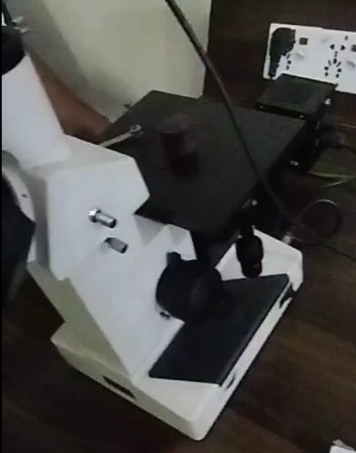

Lamp

From this probe

Power Switch

Specimen before or after treatment on plate.

1. Adjusts filters (blue, green, orange). Which color combination person operating wants to see on the specimen.
2. 

Probe which control x, y direction of plate.

Push button outwards to view on computer.

Parts: : Push button inwards to view on M.M

Push button inwards to view on M.M

Major and Minor Dia Probe to focus the light on the specimen.

1. 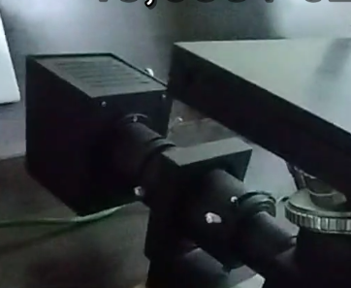

This probe crops the image generated based on the direction. Anti-clockwise (current position) for Max view. Vice versa.

Set of Lens, 10, 20, 40, and 100mm.

current setting: 40mm

1. 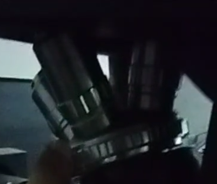

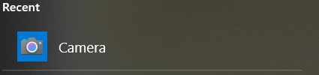

1. After connecting M.M, to your laptop make sure to select front camera options.
2. From control panel>hardware and device manager, “camera-x8” is available.
3. You are ready to do the analysis.

See following videos to get the more insight into digital microscope.

# QR CODE ALL FILES

0‑1:Google Drive

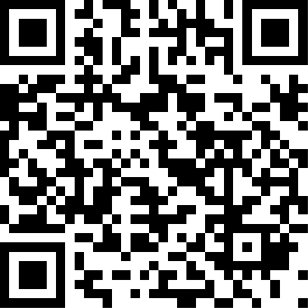

0‑2: Youtube Videos Playlist