# Lab 06 Perform straight drilling to calculate Material removal rate and machining time.

# Required:

1. Plot a relationship between RPMs and Feed Rate.
2. Plot a relationship between RPMs and Material Removal Rate.
3. Plot a relationship between RPMs and Machining time.
4. Plot a relationship between RPMs and Actual Machining time.
5. Plot a relationship between machining time and actual time.

# MATLAB CODE:

% Student: (Mohammad Abubakar Atiq - F2022031002)

% Given Data

L = [23.3, 25.15, 25.15, 25.15, 25.15, 25.15]; % Depth of hole in mm

D = [2, 16, 16, 16, 16, 16]; % Diameter of drill bit in mm

RPMs = [420, 660, 660, 660, 660, 660]; % RPMs for each drilling operation

feed_rate = [43, 43, 43, 43, 43, 43]; % Feed Rate in mm/min (constant for this data)

MRR = [135, 8646, 8646, 8646, 8646, 8646]; % Material Removal Rate in mm^3/min for each operation

machining_time = [0.561162791, 0.604186047, 0.604186047, 0.604186047, 0.604186047, 0.604186047]; % Machining Time in min for each operation

actual_machining_time = [1.37, 0.67, 0.68, 0.61, 0.72, 0.77]; % Actual Machining Time in min for each operation

% Plotting Relationships

% Plot: RPMs vs Feed Rate

figure; % Create a new figure window

plot(RPMs, feed_rate, '-x', 'LineWidth', 2); % Plot RPMs against Feed Rate with '-x' markers

xlabel('RPM (rev/min)'); % Label for x-axis

ylabel('Feed Rate (mm/min)'); % Label for y-axis

title('Lab 06: RPMs vs Feed Rate (Mohammad Abubakar Atiq - F2022031002)'); % Title of the plot

legend('Feed Rate vs RPMs'); % Legend to describe the plot

grid on; % Enable grid for better readability

% Plot: RPMs vs Material Removal Rate

figure; % Create a new figure window

plot(RPMs, MRR, '-x', 'LineWidth', 2); % Plot RPMs against Material Removal Rate with '-x' markers

xlabel('RPM (rev/min)'); % Label for x-axis

ylabel('Material Removal Rate (mm^3/min)'); % Label for y-axis

title('Lab 06: RPMs vs Material Removal Rate (Mohammad Abubakar Atiq - F2022031002)'); % Title of the plot

legend('Material Removal Rate vs RPMs'); % Legend to describe the plot

grid on; % Enable grid for better readability

% Plot: RPMs vs Machining Time

figure; % Create a new figure window

plot(RPMs, machining_time, '-x', 'LineWidth', 2); % Plot RPMs against Machining Time with '-x' markers

xlabel('RPM (rev/min)'); % Label for x-axis

ylabel('Machining Time (min)'); % Label for y-axis

title('Lab 06: RPMs vs Machining Time (Mohammad Abubakar Atiq - F2022031002)'); % Title of the plot

legend('Machining Time vs RPMs'); % Legend to describe the plot

grid on; % Enable grid for better readability

% Plot: RPMs vs Actual Machining Time

figure; % Create a new figure window

plot(RPMs, actual_machining_time, '-x', 'LineWidth', 2); % Plot RPMs against Actual Machining Time with '-x' markers

xlabel('RPM (rev/min)'); % Label for x-axis

ylabel('Actual Machining Time (min)'); % Label for y-axis

title('Lab 06: RPMs vs Actual Machining Time (Mohammad Abubakar Atiq - F2022031002)'); % Title of the plot

legend('Actual Machining Time vs RPMs'); % Legend to describe the plot

grid on; % Enable grid for better readability

% Plot: Machining Time vs Actual Machining Time

figure; % Create a new figure window

plot(machining_time, actual_machining_time,'-x', 'LineWidth', 2); % Plot Machining Time against Actual Machining Time with '-x' markers

xlabel('Machining Time (min)'); % Label for x-axis

ylabel('Actual Machining Time (min)'); % Label for y-axis

title('Lab 06: Machining Time vs Actual Machining Time (Mohammad Abubakar Atiq - F2022031002)'); % Title of the plot

legend('Actual Time vs Machining Time'); % Legend to describe the plot

grid on; % Enable grid for better readability

# Graphs

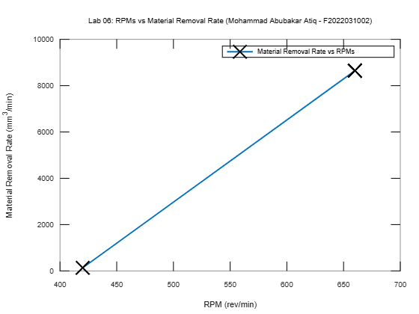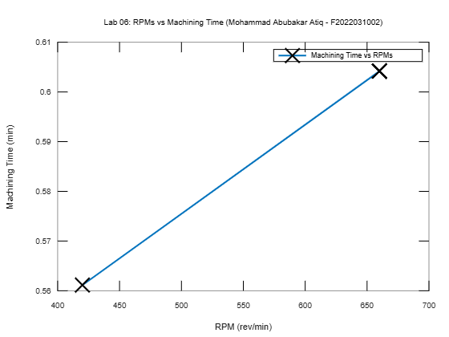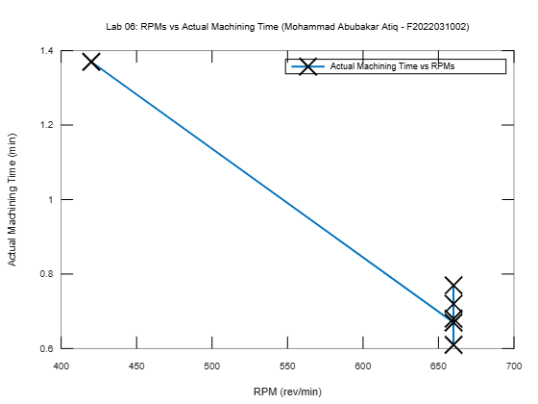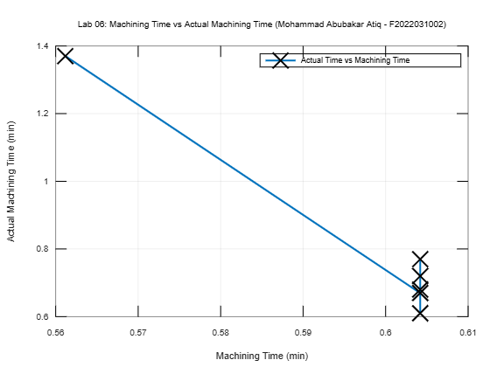

# Comments:

________________________________________________________________________________________________________________________________________________________________________________________________________________________________________________________________________________________________________________________________________________________________________________________________________________________________________________________________________________________________________________________________________________