Table of Contents

Lab 02 2

Plots 2

MATLAB Code 2

Graphs: 5

Comments 8

Lab 04 9

Plots 9

MATLAB Code 9

Graphs: 12

Comments: 15

Lab 07 16

Plots 16

MATLAB CODE: 16

Graphs: 19

Comments: 21

Lab 09 22

Plot 22

MATLAB CODE: 22

Graphs 25

Comments 28

# Lab 02

**Introduction to lathe Machine perform straight turning and calculate machining time.**

# Plots

1. Plot a relationship between RPMs and Cutting speed.
2. Plot a relationship between RPMs and Feed.
3. Plot a relationship between RPMs and Machining time.
4. Plot a relationship between RPMs and Actual time.
5. Plot a relationship between machining time and actual time.

# MATLAB Code

% Student: (Barira Qasim - F2022031016)

% Given Data

L = [52, 50, 49, 48, 45]; % Length of rod in mm

Di = [25.00, 43.10, 29.20, 36.90, 35.60]; % Initial Diameter in mm

Df = [24.00, 25.50, 23.20, 24.15, 25.50]; % Final Diameter in mm

N_t = 1; % Number of passes

RPM = 660; % RPM constant for all operations

% Depth of Cut Calculation

depth_of_cut = (Di - Df) / (2 * N_t); % Depth of cut in mm

% Cutting Speed Calculation

cutting_speed = pi .* Di * RPM; % Cutting speed Vi in mm/min

% Feed Rate Calculation

Fr = 60.03; % Feed rate in mm/min

feed_rate = Fr / RPM; % Feed in mm/rev

% Machining Time Calculation

Tm = (L ./ (feed_rate * RPM)) * N_t; % Machining Time in minutes

% Actual Times from Data

Ta_sec = [22.20, 124.80, 26.40, 49.20, 58.80]; % Actual times in seconds

Ta = Ta_sec / 60; % Convert to minutes

% Plotting Relationships

% 1. Plot: RPMs vs Cutting Speed

figure;

plot(RPM * ones(size(Di)), cutting_speed, '-o', 'LineWidth', 2);

xlabel('RPM (rev/min)');

ylabel('Cutting Speed (mm/min)');

title('Lab 02: RPMs vs Cutting Speed (Barira Qasim - F2022031016)');

legend('Cutting Speed vs RPMs');

grid on;

% 2. Plot: RPMs vs Feed Rate

figure;

plot(RPM * ones(size(Di)), feed_rate, '-s', 'LineWidth', 2);

xlabel('RPM (rev/min)');

ylabel('Feed Rate (mm/rev)');

title('Lab 02: RPMs vs Feed Rate (Barira Qasim - F2022031016)');

legend('Feed Rate vs RPMs');

grid on;

% 3. Plot: RPMs vs Machining Time

figure;

plot(RPM * ones(size(Di)), Tm, '-d', 'LineWidth', 2);

xlabel('RPM (rev/min)');

ylabel('Machining Time (min)');

title('Lab 02: RPMs vs Machining Time (Barira Qasim - F2022031016)');

legend('Machining Time vs RPMs');

grid on;

% 4. Plot: RPMs vs Actual Time

figure;

plot(RPM * ones(size(Di)), Ta, '-*', 'LineWidth', 2);

xlabel('RPM (rev/min)');

ylabel('Actual Time (min)');

title('Lab 02: RPMs vs Actual Time (Barira Qasim - F2022031016)');

legend('Actual Time vs RPMs');

grid on;

% 5. Plot: Machining Time vs Actual Time

figure;

plot(Tm, Ta, '-x', 'LineWidth', 2);

xlabel('Machining Time (min)');

ylabel('Actual Time (min)');

title('Lab 02: Machining Time vs Actual Time (Barira Qasim - F2022031016)');

legend('Actual Time vs Machining Time');

grid on;

# Graphs:

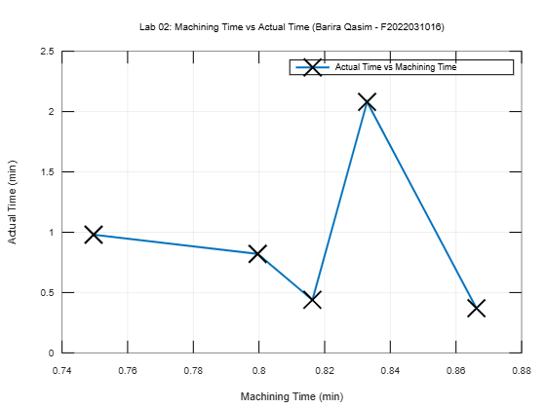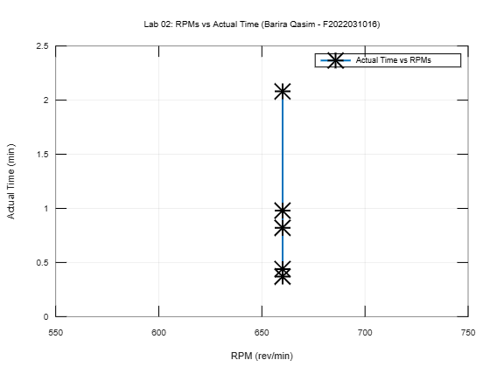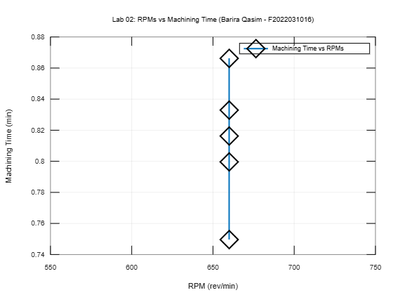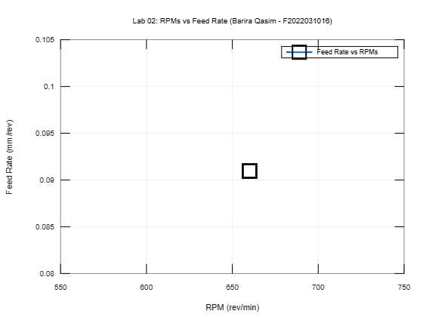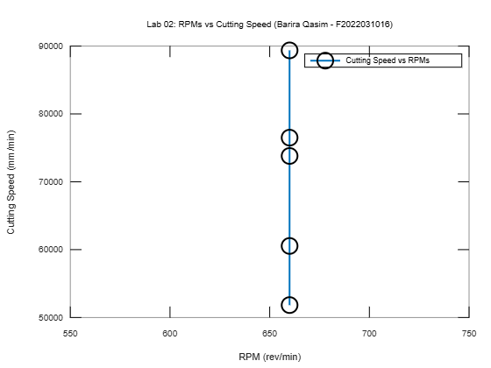

# Comments

______________________________________________________________________________________________________________________________________________________

# Lab 04

Perform facing operation on MS rod to calculate machining time and material removal rate (MRR).

# Plots

1. Plot a relationship between RPMs and cutting speed.
2. Plot a relationship between RPMs and feed.
3. Plot a relationship between RPMs and machining time.
4. Plot a relationship between RPMs and actual machining time.
5. Pot a relationship between machining time and actual machining time.
6. Plot a relationship between RPMs and material removal rate.

# MATLAB Code

% Lab 04: Facing Operation on MS Rod

% Student: (Barira Qasim - F2022031016)

% Given Data

RPM = [660, 660, 660, 660, 660, 660, 660, 660, 660]; % RPM constant for all

Cutting_Speed = [78376.45, 76303.00, 74229.55, 72156.10, ...

53080.35, 60544.77, 76510.35, 94549.37, ...

87706.98]; % Cutting speeds in mm/min

Feed = [0.018, 0.018, 0.018, 0.018, ...

0.018, 0.018, 0.018, 0.018, ...

0.018]; % Feed per revolution in mm/rev (constant for all)

Machining_Time = [1.10, 1.90, 1.50, 2.20, ...

2.28, 0.40, 0.81, 0.95, ...

0.89]; % Machining time in minutes

Actual_Time = [66.00/60, 114.00/60, 90.00/60, ...

132.00/60, 136.80/60, ...

24/60, 48.60/60, ...

57/60, 53.40/60]; % Actual time in minutes (converted from seconds)

Depth_of_Cut = [1, 1, 1, 1, ...

1, 2, 1, ...

1, 1]; % Depth of cut in mm (constant for all)

% Plotting Relationships

% Plot: RPMs vs Cutting Speed

figure;

plot(RPM, Cutting_Speed', '-o', 'LineWidth',2);

xlabel('RPM (rev/min)');

ylabel('Cutting Speed (mm/min)');

title('Lab04: RPM vs Cutting Speed (Barira Qasim - F2022031016)');

legend('Cutting Speed vs RPM');

grid on;

% Plot: RPMs vs Feed

figure;

plot(RPM, Feed', '-s', 'LineWidth',2);

xlabel('RPM (rev/min)');

ylabel('Feed (mm/rev)');

title('Lab04: RPM vs Feed (Barira Qasim - F2022031016)');

legend('Feed vs RPM');

grid on;

% Plot: RPMs vs Machining Time

figure;

plot(RPM, Machining_Time', '-d', 'LineWidth',2);

xlabel('RPM (rev/min)');

ylabel('Machining Time (minutes)');

title('Lab04: RPM vs Machining Time (Barira Qasim - F2022031016)');

legend('Machining Time vs RPM');

grid on;

% Plot: RPMs vs Actual Time

figure;

plot(RPM, Actual_Time', '-x', 'LineWidth',2);

xlabel('RPM (rev/min)');

ylabel('Actual Time (minutes)');

title('Lab04: RPM vs Actual Time (Barira Qasim - F2022031016)');

legend('Actual Time vs RPM');

grid on;

% Plot: Machining Time vs Actual Time

figure;

plot(Machining_Time', Actual_Time', '-*', 'LineWidth',2);

xlabel('Machining Time (minutes)');

ylabel('Actual Time (minutes)');

title('Lab04: Machining Time vs Actual Time (Barira Qasim - F2022031016)');

legend('Actual Time vs Machining Time');

grid on;

% Calculate Material Removal Rate (MRR)

MRR = pi .* Depth_of_Cut .* Feed .* Cutting_Speed; % MRR in mm^3/min

% Plot: RPMs vs Material Removal Rate

figure;

plot(RPM', MRR', '-^', 'LineWidth',2);

xlabel('RPM (rev/min)');

ylabel('Material Removal Rate (mm^3/min)');

title('Lab04: RPM vs Material Removal Rate (Barira Qasim - F2022031016)');

legend('Material Removal Rate vs RPM');

grid on;

# Graphs:

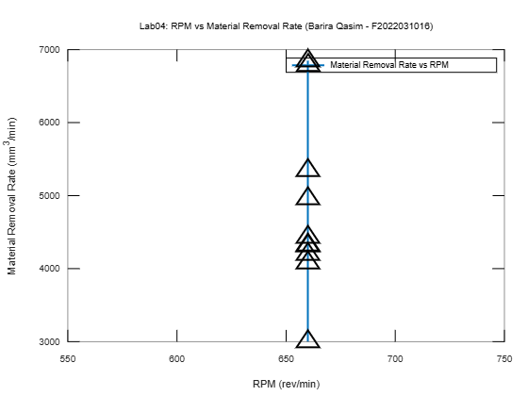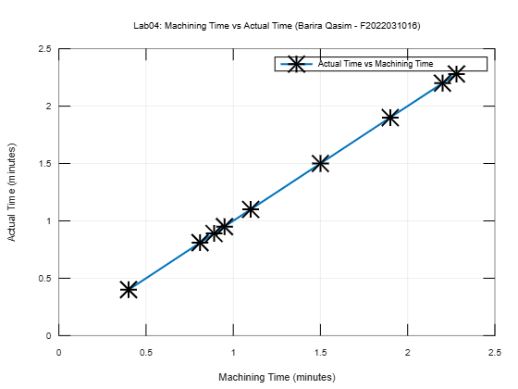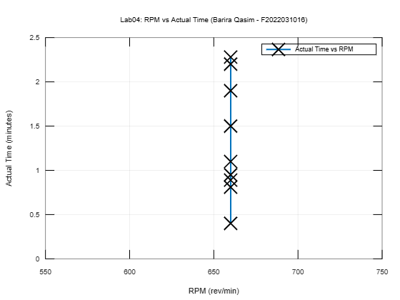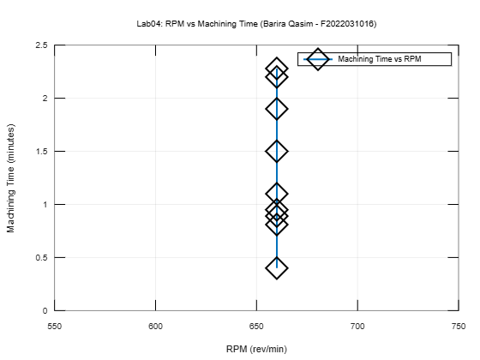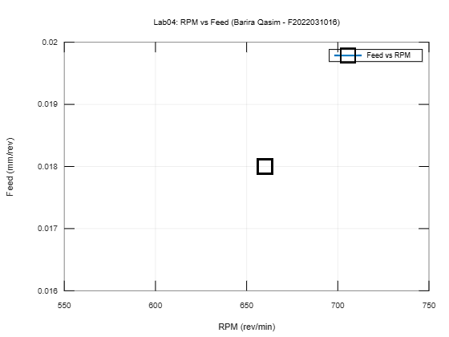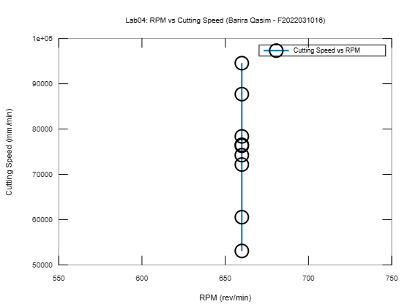

# Comments:

____________________________________________________________________________________________________________________________________________________________________________________________________________________________________________________________________________________________________________________________________________________________________

# Lab 07

**Perform facing operation on shape machine to calculate machining time.**

# Plots

1. Plot a relationship between feed and cutting speed.
2. Plot a relationship between cutting speed and theoretical machining time.
3. Plot a relationship between cutting speed and actual machining time.
4. Plot a relationship between actual and theoretical machining time.

# MATLAB CODE:

% Lab 07: Facing Operation on Shaper Machine

% Student: (Barira Qasim - F2022031016)

% Given Data

Length_of_Workpiece = [86, 123.45, 123.25, 123.35, 123.15, 123.05]; % mm

Width_of_Workpiece = [30, 26.4, 25.7, 26.25, 26.2, 26.1]; % mm

Clearance_Length = [142, 179.45, 179.25, 179.35, 179.15, 179.05]; % mm

No_of_Stroke_per_min = [60, 60, 60, 60, 60, 60]; % strokes/min

Feed = [0.3, 0.3, 0.3, 0.3, 0.3, 0.3]; % mm/stroke

Cutting_Speed = [14200, 17945, 17925, 17935, 17915, 17905]; % mm/min

Thickness_initial = [21.3, 20.0, 19.3, 18.25, 18.2, 18.1]; % mm

Depth_of_Cut = [0.5, 0.5, 0.5, 0.5, 0.5, 0.5]; % mm (set)

Thickness_final = [20.8;19.5;18.8;17.75;17.7;17.6]; % mm

Number_of_Passes = ones(size(Length_of_Workpiece)); % Number of passes set to 1

% Theoretical Machining Time Calculation (in minutes)

Theoretical_Machining_Time = Length_of_Workpiece ./ (Feed .* No_of_Stroke_per_min);

% Actual Machining Time (provided in seconds)

Actual_Machining_Time_sec = [140;160;155;175;171;174]; % seconds

Actual_Machining_Time = Actual_Machining_Time_sec / 60; % Convert to minutes

% Percentage Difference Calculation

Percentage_Difference = ((Actual_Machining_Time - Theoretical_Machining_Time) ./ Theoretical_Machining_Time) * 100;

% Plotting Relationships

% Plot: Feed vs Cutting Speed

figure;

plot(Feed', Cutting_Speed', '-o', 'LineWidth',2);

xlabel('Feed (mm/stroke)');

ylabel('Cutting Speed (mm/min)');

title('Lab07: Feed vs Cutting Speed (Barira Qasim - F2022031016)');

legend('Cutting Speed vs Feed');

grid on;

% Plot: Cutting Speed vs Theoretical Machining Time

figure;

plot(Cutting_Speed', Theoretical_Machining_Time', '-s', 'LineWidth',2);

xlabel('Cutting Speed (mm/min)');

ylabel('Theoretical Machining Time (min)');

title('Lab07: Cutting Speed vs Theoretical Machining Time (Barira Qasim - F2022031016)');

legend('Theoretical Machining Time vs Cutting Speed');

grid on;

% Plot: Cutting Speed vs Actual Machining Time

figure;

plot(Cutting_Speed', Actual_Machining_Time', '-d', 'LineWidth',2);

xlabel('Cutting Speed (mm/min)');

ylabel('Actual Machining Time (min)');

title('Lab07: Cutting Speed vs Actual Machining Time (Barira Qasim - F2022031016)');

legend('Actual Machining Time vs Cutting Speed');

grid on;

% Plot: Actual vs Theoretical Machining Time

figure;

plot(Theoretical_Machining_Time', Actual_Machining_Time', '-x', 'LineWidth',2);

xlabel('Theoretical Machining Time (min)');

ylabel('Actual Machining Time (min)');

title('Lab07: Actual vs Theoretical Machining Time (Barira Qasim - F2022031016)');

legend('Actual Time vs Theoretical Time');

grid on;

# Graphs:

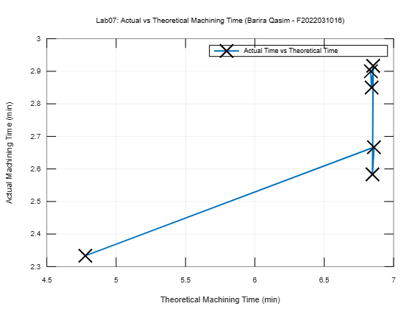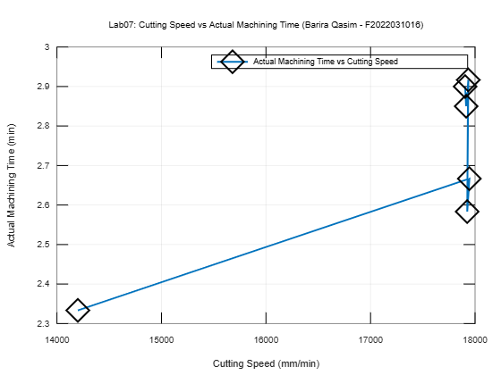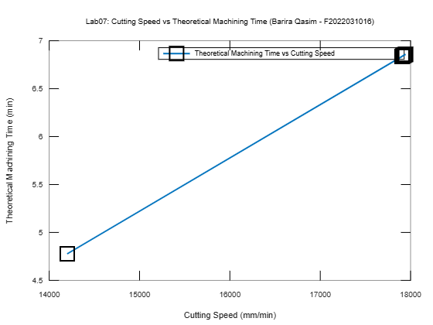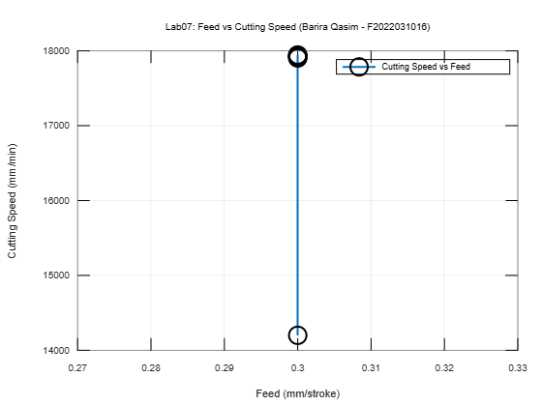

# Comments:

______________________________________________________________________________________________________________________________________________________________________________________________________________________________________________________________________________________________________________________________________________________________________________________________________________________________________________________________________________________________________________________________________________________

# Lab 09

**Introduction to milling machine and perform face milling to calculate machining time.**

# Plot

1. Plot a relationship between RPM and cutting speed.
2. Plot a relationship between RPM and feed rate.
3. Plot a relationship between cutting speed and feed rate.
4. Plot a relationship between actual and theoretical machining time.
5. Plot a relationship between theoretical machining time and feed rate.
6. Plot a relationship between actual machining time and feed rate.

# MATLAB CODE:

% Lab 09: Introduction to Milling Machine

% Student: (Barira Qasim - F2022031016)

% Given Data

L = 95; % Length of workpiece in mm

w = 50; % Width of workpiece in mm

D = 8; % Diameter of tool in mm

n_t = 4; % Number of teeth

LC = 4; % Approach and Overtravel length in mm

feed_per_tooth = 8; % Feed per tooth in mm/rev

RPM = [450, 450, 450]; % RPM values for each case

% Calculating Cutting Speed and Feed Rate

cutting_speed = pi * D * RPM; % Cutting Speed Vc in mm/min

feed_rate = feed_per_tooth * n_t .* RPM; % Feed rate fr in mm/min

% Theoretical Machining Time Calculation

T_theoretical = (L + LC) ./ feed_rate; % Theoretical Machining Time in min

% Actual Machining Times (converted from seconds to minutes)

T_actual_sec = [39, 22, 29]; % Actual machining times in seconds

T_actual = T_actual_sec / 60; % Convert to minutes

% Plotting Relationships

% 1. Plot: RPM vs Cutting Speed

figure;

plot(RPM, cutting_speed, '-o', 'LineWidth', 2);

xlabel('RPM (rev/min)');

ylabel('Cutting Speed (mm/min)');

title('Lab 09: RPM vs Cutting Speed (Barira Qasim - F2022031016)');

legend('Cutting Speed vs RPM');

grid on;

% 2. Plot: RPM vs Feed Rate

figure;

plot(RPM, feed_rate, '-s', 'LineWidth', 2);

xlabel('RPM (rev/min)');

ylabel('Feed Rate (mm/min)');

title('Lab 09: RPM vs Feed Rate (Barira Qasim - F2022031016)');

legend('Feed Rate vs RPM');

grid on;

% 3. Plot: Cutting Speed vs Feed Rate

figure;

plot(cutting_speed, feed_rate, '-d', 'LineWidth', 2);

xlabel('Cutting Speed (mm/min)');

ylabel('Feed Rate (mm/min)');

title('Lab 09: Cutting Speed vs Feed Rate (Barira Qasim - F2022031016)');

legend('Feed Rate vs Cutting Speed');

grid on;

% 4. Plot: Actual vs Theoretical Machining Time

figure;

plot(T_theoretical, T_actual, '-*', 'LineWidth', 2);

xlabel('Theoretical Machining Time (min)');

ylabel('Actual Machining Time (min)');

title('Lab 09: Actual vs Theoretical Machining Time (Barira Qasim - F2022031016)');

legend('Actual Time vs Theoretical Time');

grid on;

% 5. Plot: Theoretical Machining Time vs Feed Rate

figure;

plot(feed_rate, T_theoretical, '-^', 'LineWidth', 2);

xlabel('Feed Rate (mm/min)');

ylabel('Theoretical Machining Time (min)');

title('Lab 09: Feed Rate vs Theoretical Machining Time (Barira Qasim - F2022031016)');

legend('Theoretical Time vs Feed Rate');

grid on;

% 6. Plot: Actual Machining Time vs Feed Rate

figure;

plot(feed_rate, T_actual, '-x', 'LineWidth', 2);

xlabel('Feed Rate (mm/min)');

ylabel('Actual Machining Time (min)');

title('Lab 09: Feed Rate vs Actual Machining Time (Barira Qasim - F2022031016)');

legend('Actual Time vs Feed Rate');

grid on;

# Graphs

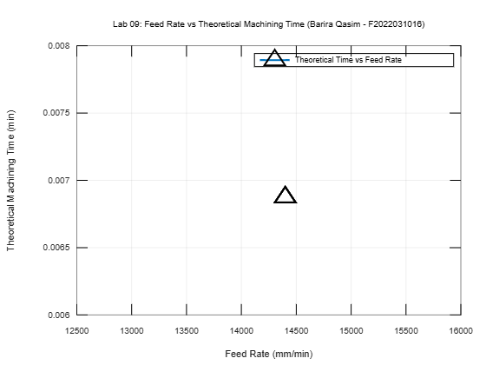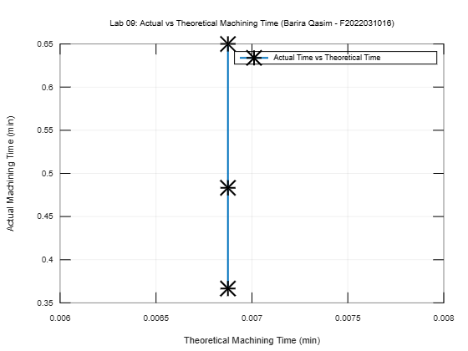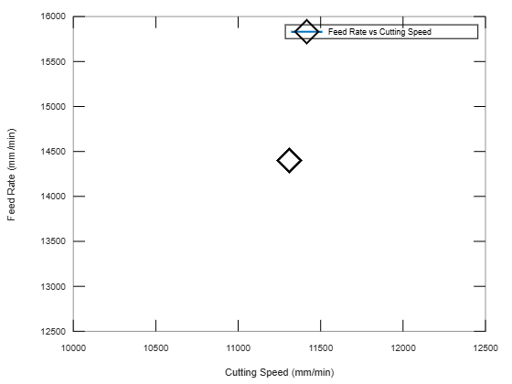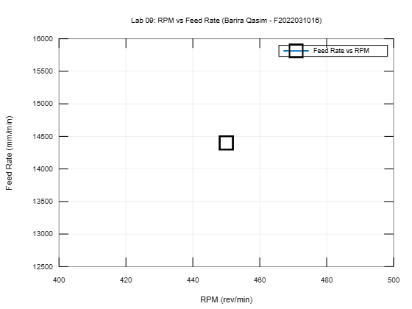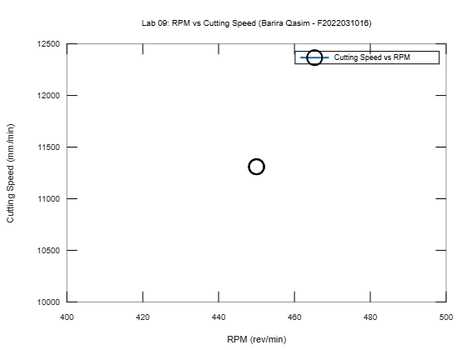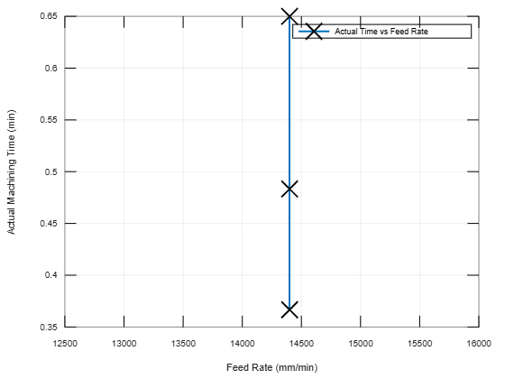

# Comments

___________________________________________________________________________________________________________________________________________________________________________________________________________________________________________________________________________