Open Ended Lab

IE322 L

# Machine Processes Lab



**Resource Person: Muhammad Ammar Arshad**

**Student Name: Mohammad Abubakar Atiq (F2022031002), Barira Qasim (F2022031016), Hannan Ahmed Siddiqui (F2022031008), Sarim Ullah (F2022031008)**

**Section: A - BSIE**

**Semester: Fall 2024**

#### Department of Mechanical Engineering

## School of Engineering

University of Management and Technology Lahore

# Simple Turning and Wire Cut on Cylinder Aluminum Shaft

## Objective:

In this OEL, we did turning Operation and wire cut to make the shaft keyhole and keyway. Which are shown below:

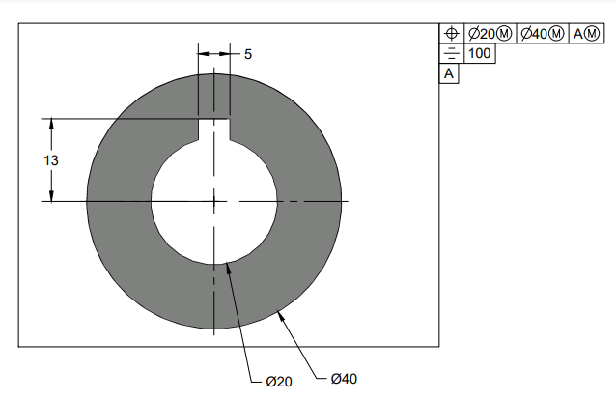

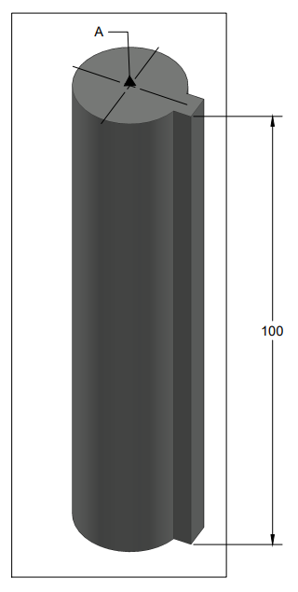

# Initial and final conditions:

Before machining:

1. Workpiece material: aluminum
2. Diameter: 50mm
3. Length: 256mm

After machining:

1. Workpiece shape: two separate pieces produced from the 256mm length
2. Outer keyhole diameter: 40mm
3. Inner keyway diameter: 19mm

NOTE:

1. Outer keyhole: turned on the lathe machine.
2. Inner keyway: produced using CNC wire cut technology
3. Tolerance is

## Cutting parameters

1. Cutting tool types:
   1. Uncoated: depth of cut = 1.5-5.0 mm; feed = 0.45mm/rev; cutting speed = 490 m/min.

## Machines used

1. Lathe machine
2. CNC Wire Cut machine
   1. Model: DK7745
   2. Cutting speed: standard = 110-120 mm/min; maximum = 160-180mm/min

# Results and observations:

Turning Operations:

Material removal rate (MRR) & Machining time ():

# After turning operations

Workpiece was divided into two equal pieces of length .

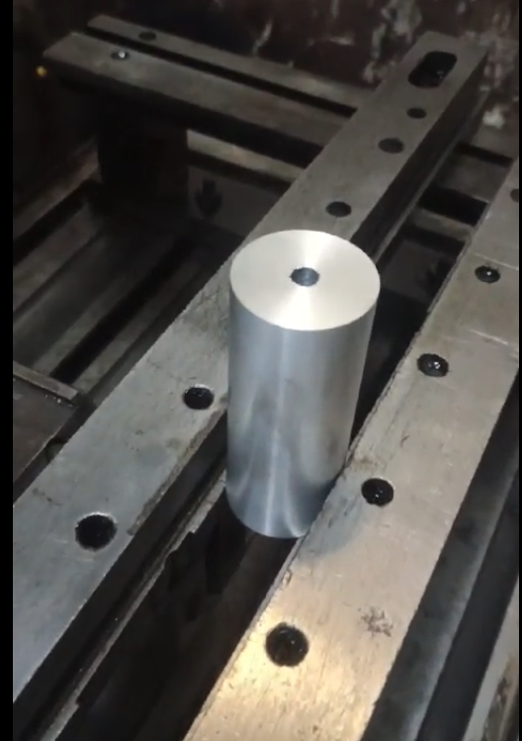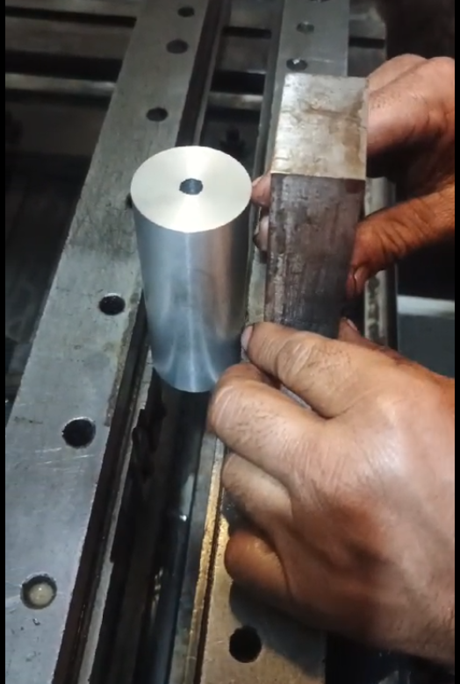

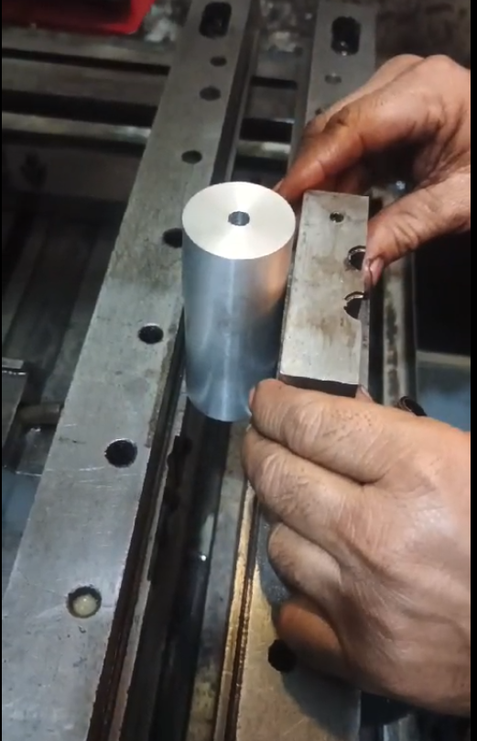

Figure ‑: Adjusted for center reference

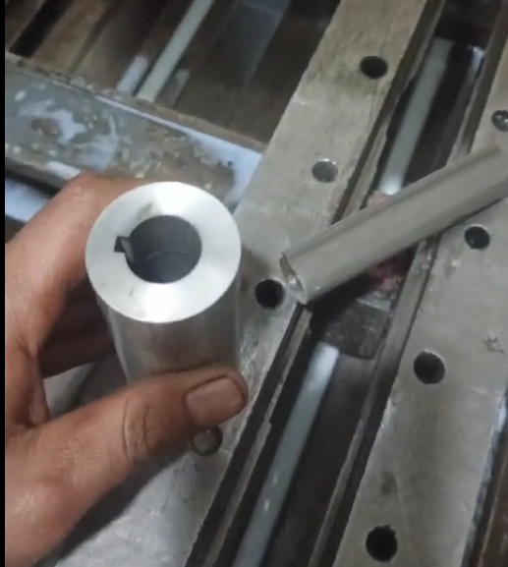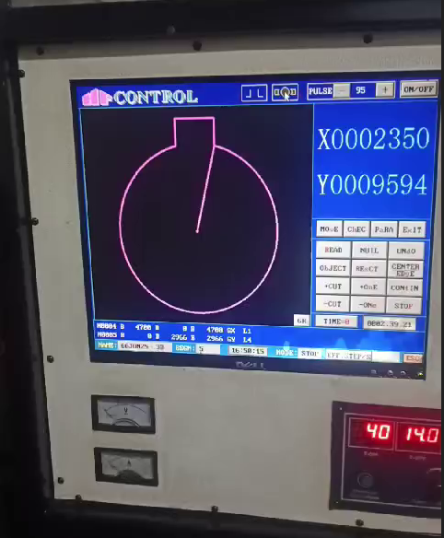These two pieces are made on HF Control CNC wire cutting machine. Each piece length was set . As you can see in pictures mentioned above, keyhole and keyways are generated after turning.

Reference:

Company profile for CNC wire cutting services: Dynamic Tooling Services: Lahore office: 33/S, Quaid-e-Azam Industrial Estate, Kot Lakhpat, Lahore. [info@dts.com.pk](mailto:info@dts.com.pk) , +92-42-35213737, Admin & Accounts DTS: +923214480052