Introduction to UML

Introduction:
The software needs the architectural design to represent the design of software. It is done through the construction of a model. The model abstracts the essential details of the underlying problem from its usually complicated real world. Several modeling tools are wrapped under the heading of the UML, which stands for Unified Modeling Language. The purpose of this lab is to present important highlights of the UML.

Tool Used in the Lab:
Software Design and Architecture lab is one of the most important labs for a software engineer. Developing a complete software application requires from each of you a good level of know-how of various tools.
In this lab we will learn to use Star UML.

Lab Objectives:
- Study the benefits of visual modeling.
- Understanding UML
- Installing StarUML
- Understanding Flow Chart Diagram
Visual Modeling
Visual modeling is the use of semantically rich, graphical and textual design notations to capture software designs. A notation, such as UML, allows the level of abstraction to be raised, while maintaining rigorous syntax and semantics. In this way, it improves communication in the team as the design is formed and reviewed, allowing the reader to reason about the design, and it provides an unambiguous basis for implementation.
A model is a simplified view of a system. It shows the essentials of the system from a particular perspective and hides the nonessential details. Visual models help you:
- Increase understanding of complex systems
- Explore and compare design alternatives at a low cost
- Form a foundation for implementation
- Capture requirements precisely
- Communicate decisions unambiguously

Using Flow chart for problem solving:
Flow charts are a useful tool as they make a process easy to understand at a glance. Using just a few words and some simple symbols, they show clearly what happens at each stage and how this affects other decisions and actions. This tool's simplicity makes communicating and documenting a process quick and clear, so that the process will more likely be understood and applied correctly and consistently.
Flow Chart Diagram:
A flowchart is a picture of the separate steps of a process in sequential order. It was originated from computer science as a tool for representing algorithms and programming logic but had extended to use in all other kinds of processes.
Flowchart main components:
- Flow: Lines represent the flow of the sequence and direction of a process.
- Terminator: The terminator symbol represents the starting or ending point of the system.
- Process: A box indicates some particular operation.
- Decision: A diamond represents a decision or branching point. Lines coming out from the diamond indicates different possible situations, leading to different sub-processes.
- Document: This represents a printout, such as a document or a report.
- Data or Input/Output: It represents information entering or leaving the system. An input might be an order from a customer. Output can be a product to be delivered.
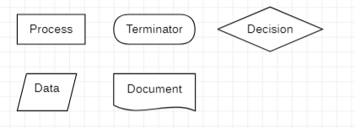

What is UML?
UML is a standard language for specifying, visualizing, constructing, and documenting for large software systems, as well as for business modeling and other non-software systems.
UML uses graphical notations to express design of software projects and its requirements.
Components of the UML:
The UML consists of a number of graphical elements that combine to form diagrams. UML is a language; it has rules for combining these elements. The purpose of the diagrams is to present multiple views of a system; this set of multiple views is called a model. A UML model tells what a system is supposed to do.

UML Diagrams:
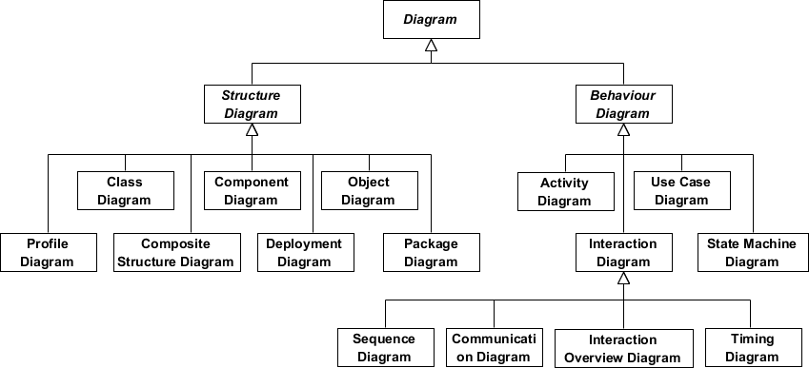

- Structure diagrams show the static structure of the system and its parts on different abstraction and implementation levels and how they are related to each other. The elements in a structure diagram represent the meaningful concepts of a system, and may include abstract, real world and implementation concepts.

- Behavior diagrams show the dynamic behavior of the objects in a system, which can be described as a series of changes to the system over time.

What is StarUML
StarUML™ is a software modeling platform that supports UML (Unified Modeling Language).

Downloading StarUML: Download StarUML from the website https://staruml.io/.
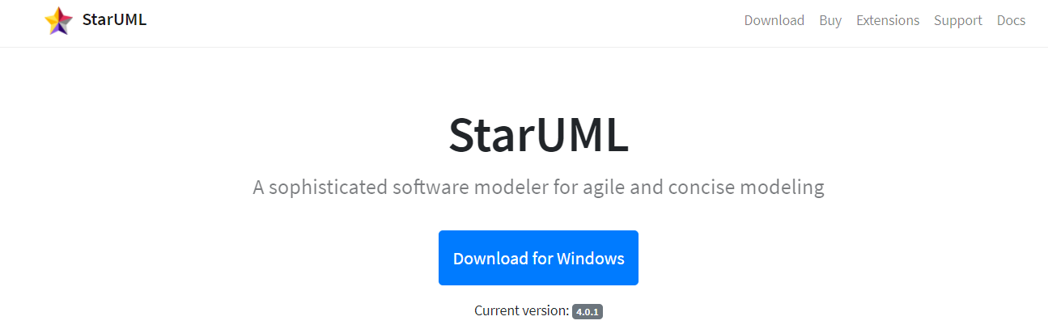

Installing StarUML: Run the setup to install StarUML
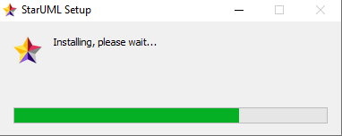

StarUML Interface:

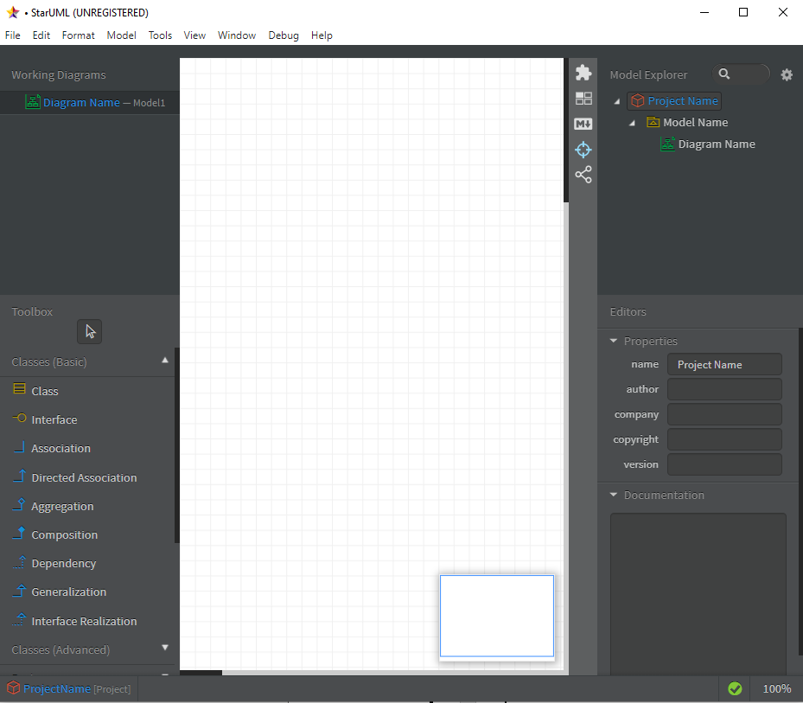

Star UML: Adding Flow Chart diagram:

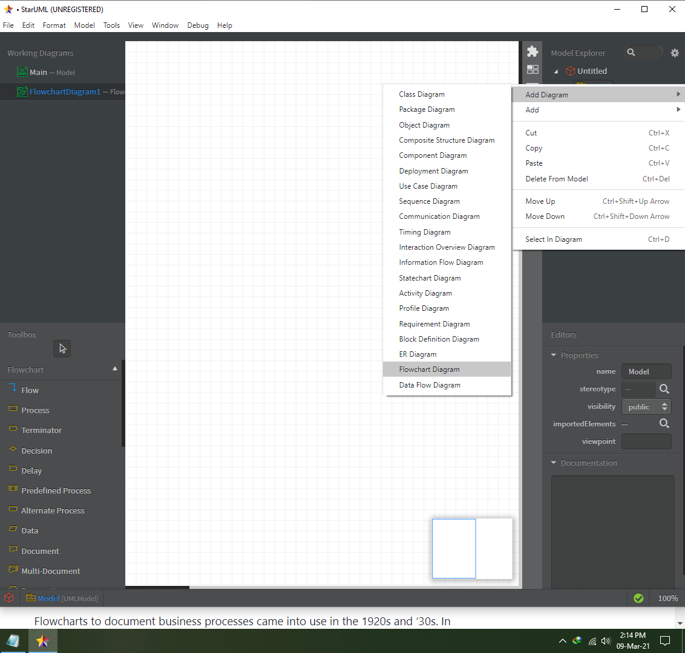

Exercises
- Install StarUML.
- Form groups of 4 students.
- Brainstorm and list 2 suitable project titles.
- Choose one of the projects from your list.
- Try to write (a hypothetical) project definition for it.
- Present it to the instructor.

Flowchart Exercise 1:

Prepare a program flowchart showing the process of cash withdrawal from ATM. Assume that transactions other than cash withdrawals are not allowed.

Flowchart Exercise 2:

Take three integers as an input from the user. And print the largest, second largest, and smallest number. Devise a solution using flow chart.

Flowchart Exercise 3:

Take an integer from the user and check if it’s a even no or not. Draw a solution using flow chart.

