Abu Bakar 0371
AWP Assignment
Github repo: https://github.com/AbubakarTechy/awp-assignment-3
(Please must check github repo and my github portfolio, i daily commits)
Task 1 — Project Setup
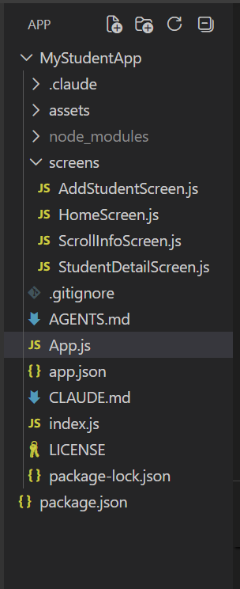

Project running:


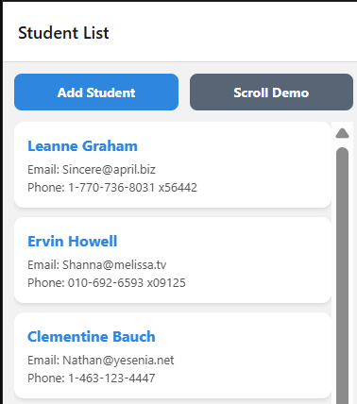

Task 2 — HomeScreen
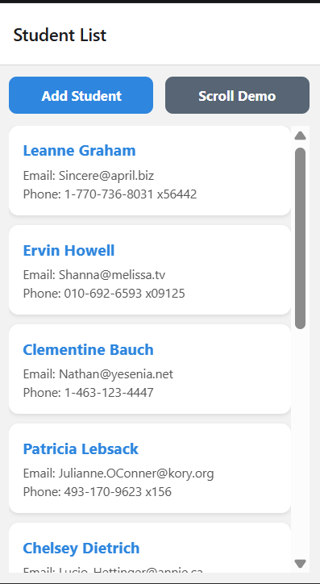

Task 3 — AddStudentScreen
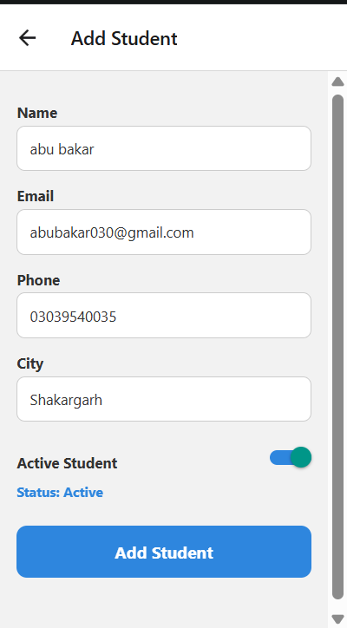

Task 4 — StudentDetailScreen
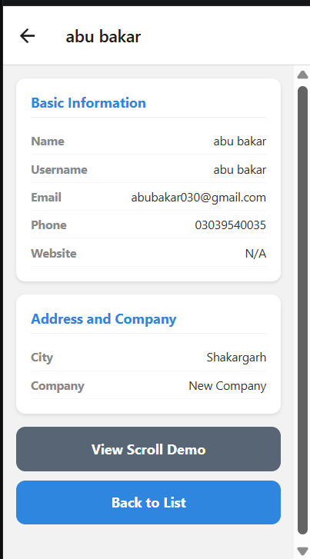

Task 5 — ScrollInfoScreen
