**Login Script**

Below are the instructions to the Devcloud login script. The picture below shows what the current script appears as. When you type the command “login”, the following output is shown. It separates the available nodes into 130-136, and 137-139, as well as stating what the nodes have.

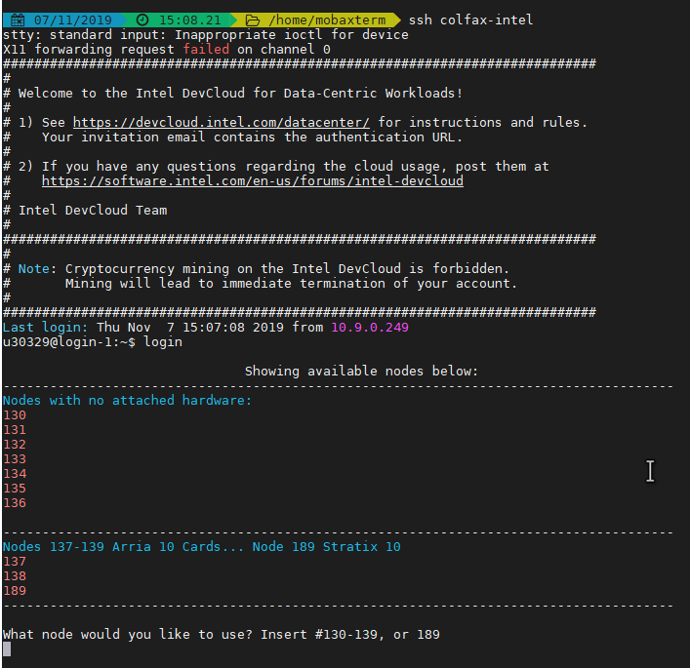

Figure : Login Script Running

The script is located inside the .bashrc, and looks as follows:

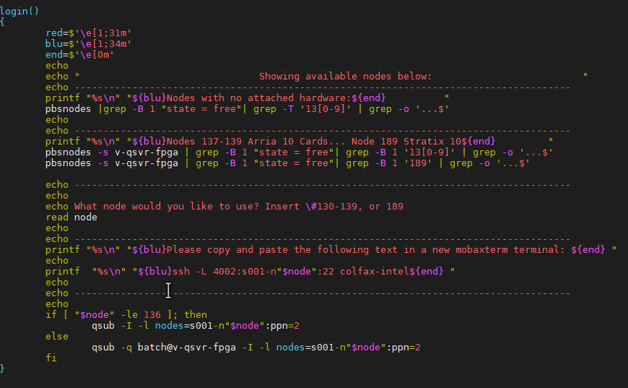

Figure : Login Script inside .bashrc

Below is the script, which you can copy and paste into the .bashrc.

Before pasting though, you must run the command “:set paste” and then paste. If not it will auto-indent and change the formatting of the script.

login()

{

red=$'\e[1;31m'

blu=$'\e[1;34m'

end=$'\e[0m'

echo

echo " Showing available nodes below: "

echo --------------------------------------------------------------------------------------

printf "%s\n" "${blu}Nodes with no attached hardware:${end} "

pbsnodes |grep -B 1 "state = free"| grep -T '13[0-9]' | grep -o '...$'

echo

echo --------------------------------------------------------------------------------------

printf "%s\n" "${blu}Nodes 137-139 Arria 10 Cards... Node 189 Stratix 10${end} "

pbsnodes -s v-qsvr-fpga | grep -B 1 "state = free"| grep -B 1 '13[0-9]' | grep -o '...$'

pbsnodes -s v-qsvr-fpga | grep -B 1 "state = free"| grep -B 1 '189' | grep -o '...$'

echo --------------------------------------------------------------------------------------

echo

echo What node would you like to use? Insert \#130-139, or 189

read node

echo

echo --------------------------------------------------------------------------------------

printf "%s\n" "${blu}Please copy and paste the following text in a new mobaxterm terminal: ${end} "

echo

printf "%s\n" "${blu}ssh -L 4002:s001-n"$node":22 colfax-intel${end} "

echo

echo --------------------------------------------------------------------------------------

echo

if [ "$node" -le 136 ]; then

qsub -I -l nodes=s001-n"$node":ppn=2

else

qsub -q batch@v-qsvr-fpga -I -l nodes=s001-n"$node":ppn=2

fi

}

Once you select a node, it will also output the command required to set up the x2go window. Just copy and paste into a new mobaxterm terminal.

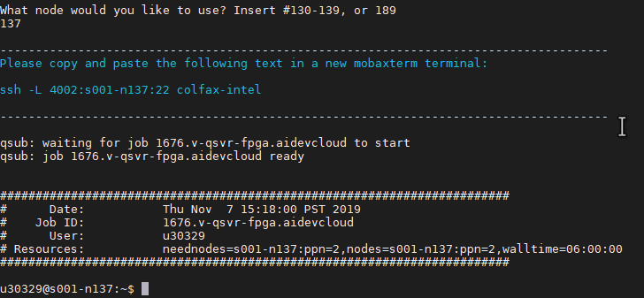

Figure : x2go Command