**EXERCISES – 01**

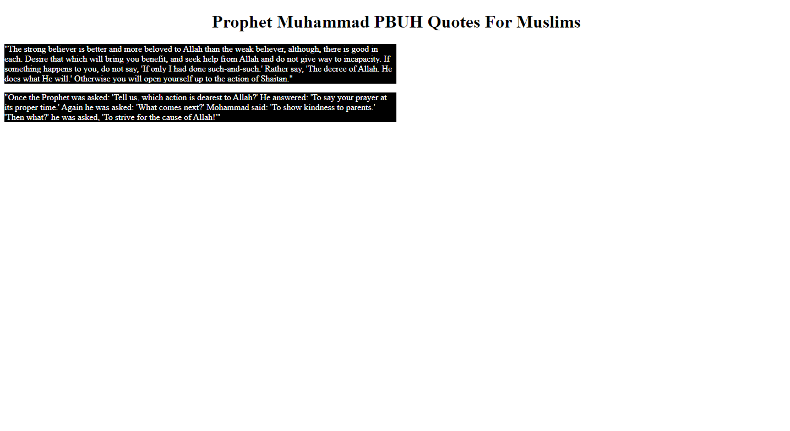div elements, class attributes, style elements for css, background-color, color, height, width for div container.

**EXERCISES – 02**

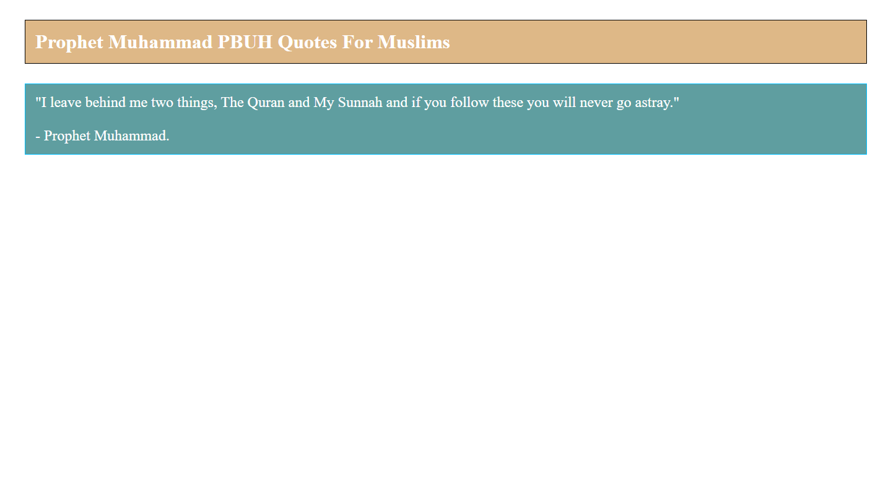p elements, style elements, margin, padding, color, background-color.

**EXERCISES – 03**

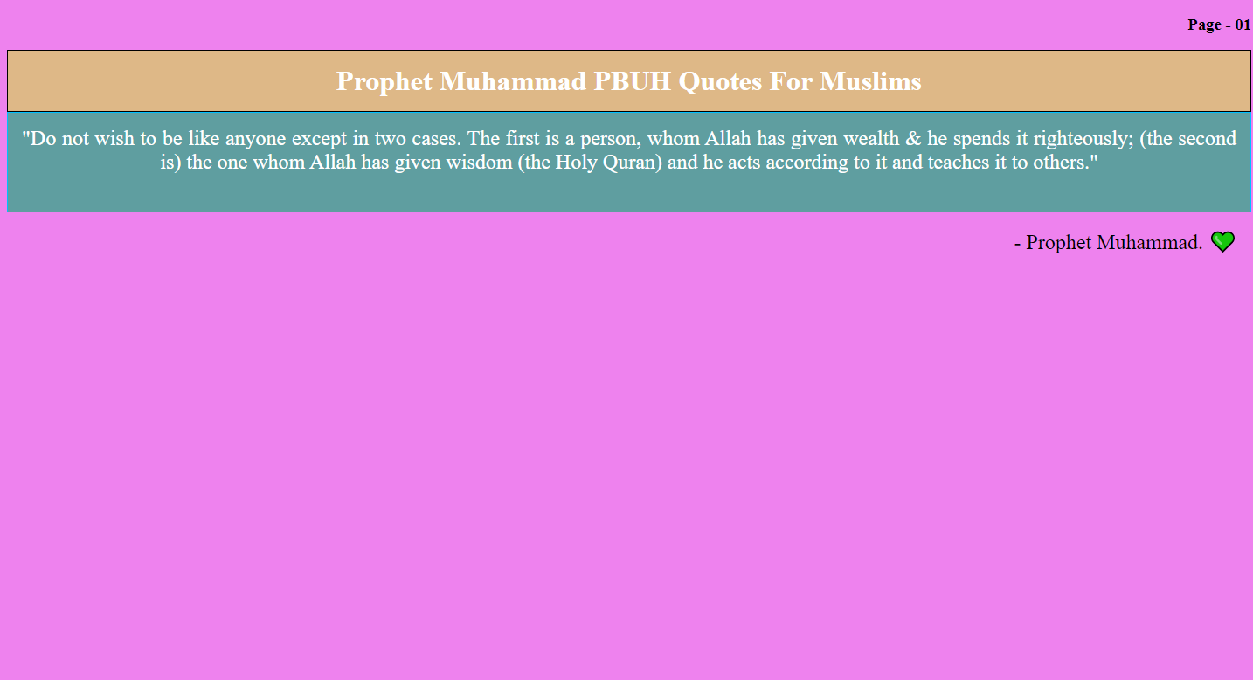margrin value auto, p elements, padding, direction property, text-align.

**EXERCISE – 04**

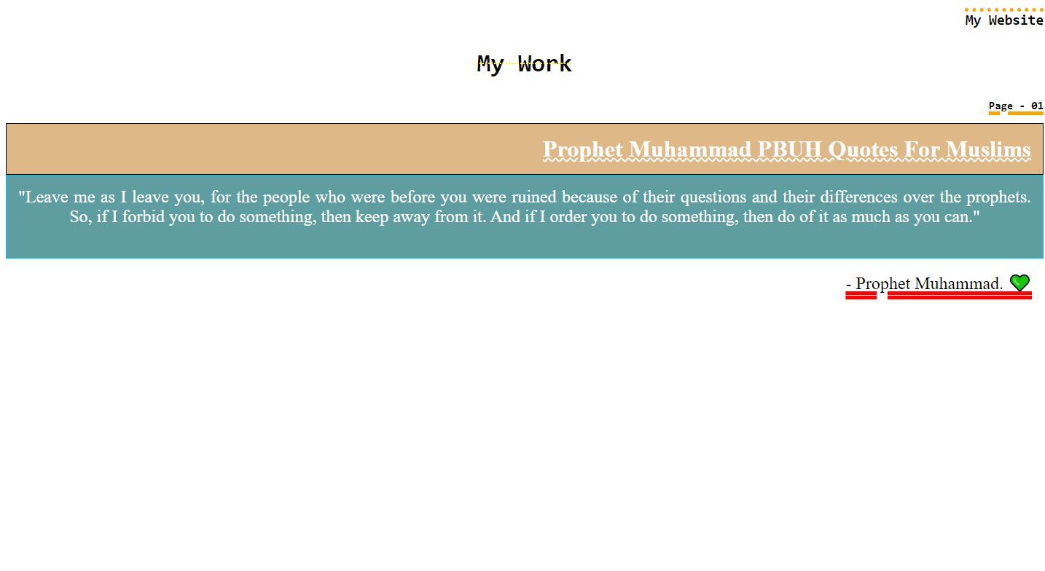text-decoration-line, text-decoration-thickness, text-decoration-color, text-decoration-style, font-family.