

Faculty of Business Department of Business and Economics

Engineering Project Management BUSA2302

Diabetes Smart Health App

Prepared by:

|  |  |
| --- | --- |
| Name | Student ID |
| Nafe Abubaker | 1200047 |
| Mohammad Ayyad | 1200940 |

Professor: Tareq Ashour Section: 2

Date: July ,4, 2024

# Executive Summary

We are thrilled to propose the development of the Diabetes Smart Health Mobile App, an innovative and comprehensive digital tool designed to significantly enhance the management of diabetes. Leveraging advanced technology and deep industry knowledge, our team of experts in UI/UX design, software development, and health informatics is committed to delivering a mobile application that not only meets but exceeds the needs of individuals managing diabetes.

The Diabetes Smart Health App is envisioned as a pivotal tool in diabetes care, offering dynamic features such as real-time glucose monitoring, automated dietary suggestions, medication reminders, and interactive health education modules. Our aim is to empower users by facilitating seamless access to their health information, thus enabling them to make informed decisions about their lifestyle and medical treatment.

This app sets itself apart by integrating personalized health management tools with user-friendly design elements, ensuring that the app is accessible to users of all ages and technical skills. With robust security measures and adherence to privacy laws, the app will safeguard sensitive health data while providing a reliable and efficient user experience across multiple platforms.

# Table of Contents:

* 1. Executive Summary 2
  2. Table of Contents 3
  3. List of Figures 3
  4. List of Tables 3
  5. Defining the Project 1
     1. Project Scope 1
        1. Project Objective 1
        2. Deliverables 2
        3. Milestones 2
        4. Technical Requirements 2
        5. Limits and Exclusions 3
     2. Project Priorities 4
     3. Work Breakdown Structure 5
     4. Coding the WBS for the Information System 7
  6. Estimating Project Times and Costs 7
  7. Project Plan 8
  8. Project Budget 9
  9. Risk Management Plan 9
     1. Risk Identification: 9
     2. Risk Assessment 10
     3. Minimize or Eliminate Risks 10
     4. Contingency Plans 11
     5. Risk Monitoring: 11

1. List of Figures

Figure 5-1: Work break-down structure 6

1. List of Tables

Table 5-1: MIlestones 2

# Defining the Project

# Project Scope

# Project Objective

The objective of the Diabetes Smart Health App project is to develop a comprehensive and user-friendly mobile application that serves as a reliable source of health information for the public and provides essential infection prevention and control resources for healthcare workers in Mauritius and Rodrigues specified in diabetes. The project aims to achieve the following goals:

* + - 1. Disseminate health information: The app will provide the public with easy access to accurate and up-to-date health information related to diabetes and other health concerns. It will deliver information through various formats, such as text, photos, videos, and audios, ensuring that users can obtain knowledge in a way that suits their preferences and literacy levels.
      2. Enhance infection prevention and control: The app will serve as a valuable tool for healthcare workers by providing them with access to standardized operating procedures, guidelines, checklists, and other resources related to infection prevention and control. This will assist healthcare professionals in implementing best practices and protocols to safeguard their patients and themselves.
      3. Reach a wide user base: The project aims to reach a significant number of healthcare workers and public users, with an estimated target user base of 25,000 individuals. By developing a mobile app, the project seeks to leverage the widespread use of smartphones and ensure that a large portion of the population can benefit from the app's features and functionalities.
      4. Promote public health and safety: The app will contribute to the overall public health and safety efforts by equipping individuals with the knowledge and resources necessary to protect themselves and prevent the spread of this disease. By empowering both the public and healthcare workers, the project aims to create a safer and healthier environment for the community.
      5. Support global COVID-19 response: The development of the Smart Health Mobile App aligns with the global efforts to combat the COVID-19 pandemic. By providing reliable information and resources, the project aims to strengthen the response to the pandemic in Mauritius and Rodrigues, ultimately contributing to the global fight against the spread of the virus.

Overall, the project objective is to create a Smart Health Mobile App that serves as a valuable resource for health information and infection prevention and control, fostering public health awareness, and supporting healthcare workers in their vital roles.

# Deliverables

The deliverables of the project include:

* Developed and tested Smart Health Mobile App.
* Back-end infrastructure hosted at the Government Online Centre (GOC).
* Secure user authentication and access control system.
* Integration with the MauPass authentication service.
* Data analysis functionality for test results.
* User documentation and training materials.

# Milestones

*Table* *5-1: MIlestones*

|  |  |
| --- | --- |
| **Milestone** | **Deadline** |
| Project Kickoff | September 1, 2022 |
| Requirements Gathering | September 5, 2022 |
| Design and Prototype Development | September 15, 2022 |
| Backend Development and Database Setup | October 1, 2022 |
| Frontend Development and Mobile App Interface | November 1, 2022 |
| Integration and Testing | November 20, 2022 |
| User Acceptance Testing (UAT) and Feedback | December 5, 2022 |
| Deployment and Launch | December 20, 2022 |
| Project Closure | December 30, 2022 |

# Technical Requirements

* + - 1. Platform Compatibility: The Smart Health Mobile App should be compatible with both iOS and Android platforms, supporting the latest versions of operating systems and devices.
      2. Responsive Design: The app should have a responsive design that adapts to different screen sizes and orientations, providing an optimal user experience on smartphones and tablets.
      3. User Authentication and Security: The app should implement secure user authentication mechanisms, such as login with username and password, biometric authentication (e.g., fingerprint or facial recognition), or two-factor authentication. User data should be securely stored and transmitted using encryption protocols.
      4. Database and Data Management: The app should integrate with a robust and scalable database system to store and manage user data, health information, and multimedia content. The database should support efficient data retrieval and ensure data integrity and security.
      5. Push Notifications: The app should have the capability to send push notifications to users for important updates, reminders, and alerts related to health information, new features, or critical notifications.
      6. Location Services: If required, the app should integrate location services to provide location-based features, such as finding nearby healthcare facilities, tracking user's location for emergency purposes, or providing relevant local health information.
      7. Multimedia Integration: The app should support the integration and playback of multimedia content, including videos, images, infographics, and audio recordings. It should have the capability to optimize and stream media files efficiently.
      8. Analytics and Reporting: The app should incorporate analytics and reporting functionality to gather user insights, app usage metrics, and feedback. It should have the capability to generate reports and visualize data for monitoring and improving the app's performance.
      9. Performance and Scalability: The app should be optimized for performance, ensuring fast response times, smooth navigation, and efficient use of system resources. It should be designed with scalability in mind to accommodate increasing user load and data growth.

These technical requirements will guide the development process, ensuring that the Smart Health Mobile App meets the necessary standards for functionality, security, usability, and performance.

# Limits and Exclusions

* + - 1. Hardware Limitations: The project does not include the provision of any hardware devices or equipment. The development and implementation of the Smart Health Mobile App will solely focus on the software application and its associated functionalities.
      2. Third-Party Integration Limitations: While the app may integrate with external APIs or services as specified in the technical requirements, the project does not cover the development or maintenance of these external systems. Any limitations

or constraints imposed by third-party providers or services will be considered outside the scope of this project.

* + - 1. Regulatory Compliance: The project assumes compliance with existing regulations and standards related to mobile app development and health information privacy and security. However, any changes in regulatory requirements during the course of the project may require additional efforts or modifications, which will be addressed separately.
      2. Network Connectivity: The project assumes the availability of network connectivity for users to access the app's features and functionality. The project does not cover any disruptions or limitations in network connectivity that may impact the app's performance or functionality.
      3. Localization: The initial release of the app will be developed in a specific language. Localization efforts to support additional languages or cultural adaptations may be considered as future enhancements or separate projects.
      4. User Training and Support: While the project may include documentation or user guides to assist users in using the app, comprehensive training or ongoing support for end-users will be excluded from the project scope. Any user training or support requirements will be addressed separately.
      5. Data Entry and Accuracy: The project assumes that users will enter accurate and reliable data into the app. The project does not cover data validation or verification processes, and any inaccuracies or errors in user-entered data will not be the responsibility of the development team.

These limits and exclusions help define the boundaries of the project, clarifying what is included and what is beyond the scope. They ensure that the project team and stakeholders have a clear understanding of the project's boundaries and responsibilities.

# Project Priorities

The project priorities for the Smart Health Mobile App are aligned with the project objectives and focus on delivering a high-quality, user-friendly, and impactful solution. The following priorities will guide the project implementation:

1. User-Centric Approach: The primary priority is to develop a mobile app that meets the needs and expectations of the target users, which include the general public and healthcare workers in Mauritius and Rodrigues. User experience (UX) design principles and user feedback will be incorporated throughout the development process to ensure the app is intuitive, accessible, and provides a seamless user journey.
2. Timely Delivery: Meeting project deadlines is crucial to ensure the app's availability when it is most needed. The project team will prioritize efficient project management, effective coordination, and adherence to the defined milestones and timelines. Regular

progress monitoring and communication will be implemented to identify and address any potential delays or issues promptly.

1. Functional and Technical Excellence: The Smart Health Mobile App should meet the defined technical requirements and functional specifications. The development team will focus on implementing robust security measures, integrating essential features such as user authentication, data management, push notifications, and multimedia integration. The app's performance, scalability, and responsiveness across different platforms and devices will be given high priority.
2. Stakeholder Engagement and Collaboration: The project team will prioritize stakeholder engagement and collaboration to ensure their active participation and buy-in. Regular communication channels will be established to keep stakeholders informed about the project progress, gather feedback, and address any concerns or requirements. Stakeholders, including healthcare professionals, government representatives, and the general public, will be actively involved in user acceptance testing (UAT) and providing input on the app's functionality and content.
3. Quality Assurance and Testing: The development process will emphasize rigorous quality assurance and testing to identify and rectify any defects or issues. Comprehensive testing methodologies, including functional testing, usability testing, security testing, and performance testing, will be employed to ensure the app's reliability, security, and optimal performance. Feedback from users and stakeholders during UAT will be utilized to further refine and enhance the app.
4. Sustainability and Future Enhancements: While the initial project scope focuses on the development and deployment of the Smart Health Mobile App, the project team will consider sustainability and future enhancements. The app's architecture and infrastructure will be designed with scalability in mind to accommodate potential future updates, additional features, and language localization. Documentation and knowledge transfer will be prioritized to facilitate ongoing maintenance and support by the operations team.

By prioritizing these key areas, the project team aims to deliver a Smart Health Mobile App that effectively addresses the project objectives, meets stakeholder expectations, and contributes to public health awareness and infection prevention and control efforts in Mauritius and Rodrigues.

# Work Breakdown Structure

The Work Breakdown Structure (WBS) provides a hierarchical representation of the project deliverables and the activities required to complete the Smart Health Mobile App project. It breaks down the project into manageable work packages, allowing for better estimation of resources, duration, and cost. The WBS for the health app proposal is as follows:

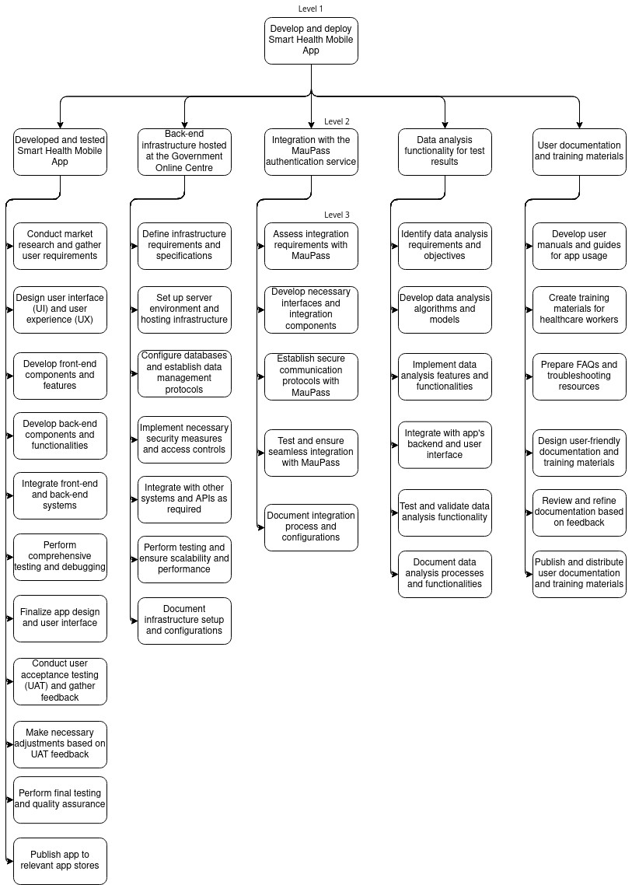

*Figure* *5-1: Work break-down structure*

# Coding the WBS for the Information System

# Estimating Project Times and Costs

Starting from September 1, 2022, and wrapping up on December 30, 2022, the project is carefully planned to span a total of 121 days, including both the start and end dates.

Here's a breakdown of the project timeline:

|  |  |  |  |
| --- | --- | --- | --- |
| **Description** | **Low estimate Days** | **Average estimate** | **High estimate** |
| Conduct market research and gather user requirements | 3 | 4 | 5 |
| Design user interface and user  experience | 4 | 5 | 6 |
| Develop front-end components and features | 4 | 5 | 6 |
| Develop back-end components  and functionalities | 4 | 5 | 6 |
| Integrate front-end and back- end systems | 8 | 9 | 10 |
| Perform comprehensive test-  ing and debugging | 2 | 3 | 4 |
| Finalize app design and user interface | 1 | 2 | 3 |
| Conduct user acceptance test-  ing and gather feedback | 2 | 3 | 4 |
| Make necessary adjustments based on UAT feedback | 2 | 3 | 4 |
| Perform final testing and QA | 2 | 3 | 4 |
| Define infrastructure require- ments and specifications | 2 | 3 | 4 |
| Set up server environment hosing infrastructure | 1 | 1.5 | 2 |
| Configure databases and estab- lish data management proto-  cols | 2 | 3 | 4 |
| Implement necessary security measures and access control | 6 | 7 | 8 |
| Integrate with other systems  and APIs as required | 6 | 7 | 8 |
| Perform testing and ensure scalability and performance | 2 | 3 | 4 |
| Document infrastructure setup  and configurations | 3 | 4 | 5 |
| Assess integration require- ments with MauPass | 3 | 4 | 5 |
| Establish secure communica-  tion protocols with MauPass | 1 | 2 | 3 |

|  |  |  |  |
| --- | --- | --- | --- |
| Test and ensure seamless inte- gration with MauPass | 2 | 3 | 4 |
| Identify data analysis require- ments and objectives | 1 | 1.5 | 2 |
| Develop data analysis algo- rithms and models | 5 | 6 | 7 |
| Implement data analysis fea- tures and functionalities | 2 | 3 | 4 |
| Integrate with app’s back-end and user interface | 2 | 3 | 4 |
| Test and validate data analysis functionality | 2 | 3 | 4 |
| Document data analysis pro- cesses and functionalities | 2 | 3 | 4 |
| Develop use manuals and guides for app usage | 3 | 4 | 5 |
| Create training materials for healthcare workers | 1 | 1.5 | 2 |
| Prepare FAQs and trou- bleshooting resource | 2 | 3 | 4 |
| Design user-friendly docu- mentation and training materi-  als | 2 | 3 | 4 |
| Publish and distribute user  documentation and training materials | 6 | 7 | 8 |

The estimated costs for the project, taking into account the resources needed: Project Initiation Phase: $25,600

Design Phase: $76,800 Development Phase: $107,840

Testing and Quality Assurance Phase: $19,200 Documentation and Training Phase: $9,120 Deployment and Launch Phase: $9,600 Project Closure Phase: $28,800

Adding up these costs, the total project budget is $276,960. These estimates consider the effort, resources, and expertise required at each stage to ensure the successful completion of the project within the given timeline.

# Project Plan

* + Project Initiation Phase (September 1, 2022 - September 14, 2022): Conduct market research and gather user requirements. Define infrastructure requirements and specifications. Assess integration requirements with MauPass. Identify data analysis requirements and objectives.
  + Design Phase (September 15, 2022 - September 30, 2022): Design user interface (UI) and user experience (UX). Develop user manuals and guides for app usage. Create training materials for healthcare workers.
  + Development Phase (October 1, 2022 - November 1, 2022): Develop front-end components and features. Develop back-end components and functionalities. Configure databases and establish data management protocols. Integrate front-end and back-end systems.
  + Testing and Quality Assurance Phase (November 2, 2022 - November 20, 2022): Perform comprehensive testing and debugging. Test and validate data analysis functionality. Ensure scalability and performance.
  + Documentation and Training Phase (November 21, 2022 - December 5, 2022): Design user-friendly documentation and training materials. Prepare FAQs and troubleshooting resources. Document integration processes and configurations. Document data analysis processes and functionalities.
  + Deployment and Launch Phase (December 6, 2022 - December 20, 2022): Set up server environment and hosting infrastructure. Establish secure communication protocols with MauPass. Integrate with the app's backend and user interface.
  + Project Closure Phase (December 21, 2022 - December 30, 2022): Complete project documentation, conduct project review and lessons learned session, hand over deliverables to the operations or maintenance team, and officially close the project.

# Project Budget

The budget includes a contingency of 10% and is calculated as follows: Contingency amount: Contingency Amount: 0.1 * $276,960 = $27,696 Budget: $276,960 + $27,696 = $304,656

Therefore, the budget for the project would be $304,656.

# Risk Management Plan

# Risk Identification:

Risk 1: Technical Complexity Description: The project involves complex technical requirements, including integration with external systems and data analysis functionalities, which may lead to implementation challenges and delays. Risk Owner: Project Manager

Risk 2: Resource Constraints Description: Limited availability of skilled resources and subject matter experts may impact the project's progress and quality of deliverables. Risk Owner: Project Manager

Risk 3: Security Breach Description: Unauthorized access to user data or system vulnerabilities could lead to a security breach, compromising user privacy and damaging the reputation of the project. Risk Owner: Security Officer

Risk 4: Scope Creep Description: Stakeholders may request additional features or changes beyond the project's defined scope, leading to scope creep and potential delays in project completion. Risk Owner: Project Manager

# Risk Assessment:

Risk 1: Technical Complexity

* + 1. Impact: High - The occurrence of technical complexities may result in delays, rework, and potential compromise in the quality of the final product.
    2. Likelihood: Medium - Complexities may arise due to integration challenges or unforeseen technical issues, but with proper planning and expertise, they can be managed effectively.

Risk 2: Resource Constraints

1. Impact: Medium - Limited availability of skilled resources may lead to delays in task completion and potential compromise in the quality of deliverables.
2. Likelihood: High - Skilled resources may be scarce, especially considering the specific technical requirements and expertise needed for the project.

Risk 3: Security Breach

1. Impact: High - A security breach can lead to significant reputational damage, loss of user trust, and potential legal implications.
2. Likelihood: Low - Security measures will be in place to mitigate the risk, but the possibility of a breach still exists, although it is relatively low.

Risk 4: Scope Creep

1. Impact: Medium - Scope creep can cause delays, increased costs, and potential conflicts with project objectives.
2. Likelihood: Medium - Stakeholders' evolving needs and requirements can introduce scope creep, but proper change management processes can help mitigate the risk.

# Minimize or Eliminate Risks:

Risk 1: Technical Complexity

* Allocate sufficient time for detailed technical planning and risk assessment.
* Engage subject matter experts and conduct thorough feasibility studies.
* Implement agile development practices to address emerging challenges promptly.

Risk 2: Resource Constraints

* Conduct resource capacity planning and identify skill gaps early.
* Explore options for resource augmentation through partnerships or outsourcing.
* Provide adequate training and knowledge sharing opportunities for existing resources. Risk 3: Security Breach
* Implement robust security measures, including encryption, secure authentication, and regular security audits.
* Stay updated with the latest security best practices and incorporate them into the development process.
* Conduct vulnerability assessments and penetration testing to identify and address potential vulnerabilities.

Risk 4: Scope Creep

* Establish a clear and well-documented project scope from the beginning.
* Implement a formal change management process to evaluate and approve scope changes.
* Regularly communicate and engage with stakeholders to manage expectations and ensure alignment with project objectives.

# Contingency Plans:

Risk 1: Technical Complexity

* Allocate additional time and resources in the project schedule to account for potential delays.
* Have a backup plan or alternative approaches in case specific technical challenges cannot be resolved within the original scope.

Risk 2: Resource Constraints

* Identify potential resource augmentation options in advance, such as freelancers or external consultants, to address any resource shortages.
* Develop a cross-training plan to ensure knowledge sharing and minimize the impact of resource constraints.

Risk 3: Security Breach

* Maintain regular backups of user data to mitigate the impact of a security breach.

# Risk Monitoring:

Regular risk assessments will be conducted throughout the project life-cycle. Open communication and reporting of potential risks by project team members and stakeholders will be encouraged. Project progress and external factors that may introduce new risks will be Continuously monitored. Risk management will be incorporated as an ongoing process, addressing new risks promptly.