DOCDROP
Implementing a Simple Digital Signature on Word Files

Project Report

International Islamic University Islamabad
Department of Computer Science

Course:
Information Security
Submitted to:
Dr. Zahid Mahmood
Submitted by:
Abubakkar Khan: 4992 FOC/BSCS/F23 B
Areeb Khan: 4994 FOC/BSCS/F23 B
Date:
May 14, 2026

Table of Contents
Executive Summary 3
1. Problem Statement 3
1.1 Background 3
1.2 The Gap 3
1.3 The Solution 3
2. Objectives 4
3. Literature Review & Theoretical Foundation 4
3.1 CIA Triad — Integrity & Authenticity Focus 4
3.2 Asymmetric Cryptography & Public Key Infrastructure 4
3.3 RSA-2048 Key Generation 4
3.4 SHA-256 Message Digest 4
3.5 Non-Repudiation & Zero-Trust Verification 5
4. System Design 6
4.1 Architecture Overview 6
4.2 Archetecture Diagram 6
4.3 Class Diagram 7
4.4 Sequence Diagram 8
5. Implementation Details 9
5.1 Key Generation Engine 9
5.2 Signature Generation Workflow 9
5.3 Real-Time Verification (Zero-Trust) 9
5.4 Payload Extraction from .docx 9
5.5 Frontend Design Decisions 9

Executive Summary
DocDrop is a full-stack educational web application demonstrating the complete lifecycle of digital signatures applied to Microsoft Word (.docx) files. Built on RSA-2048 asymmetric key pairs, SHA-256 message hashing, and PKCS1v1.5 signature generation, the system lets users cryptographically sign documents and verify their authenticity in real time.
The project's defining architectural choice is Zero-Trust Verification: rather than comparing against a cached hash, every verification re-reads the physical file from disk and recomputes the hash independently. Any modification to the document — even a single character — triggers an immediate Tampered alert. The system demonstrates applied understanding of the CIA Triad (Integrity and Authenticity), Public Key Infrastructure, and Pakistan's PECA 2016 legal framework.

1. Problem Statement

1.1 Background
Organizations routinely share Word documents across insecure channels for review, approval, and legal authorization. Without a cryptographic mechanism, these documents are exposed to critical risks:
- Unauthorized post-approval tampering — altering clauses or figures after a document is signed
- Identity fraud — falsely attributing a document to an authority
- Man-in-the-Middle (MitM) substitution attacks during transmission
- Inability to prove document provenance in legal or regulatory disputes
- Non-compliance with PECA 2016 and the Electronic Transactions Ordinance 2002 (Pakistan)

1.2 The Gap
Existing solutions are inadequate for the .docx workflow:
- Enterprise tools (Adobe Sign, DocuSign) are PDF-centric and require paid subscriptions
- Blackbox implementations hide underlying cryptographic operations, making them unauditable
- Server-side trust models store document hashes in the database — a single point of failure if the database is compromised
- No accessible open-source tool handles native .docx signing with a transparent, educational cryptographic pipeline

1.3 The Solution
DocDrop provides a transparent, file-based digital signature system that: automatically generates RSA-2048 identity keys per user; extracts text payloads directly from .docx binaries; produces SHA-256 fingerprints; signs them with PKCS1v1.5; and performs Zero-Trust real-time verification against the physical file — not a cached value.

2. Objectives

# | Objective | Achieved By
O1 | Generate a unique cryptographic identity per user | RSA-2048 key pair generated at registration
O2 | Bind a user cryptographically to a document version | SHA-256 hash of extracted payload signed with private key
O3 | Detect unauthorized post-signature modifications | Zero-Trust re-hash on every verification request
O4 | Support the standard .docx binary format | python-docx extracts paragraph text from OOXML
O5 | Provide an auditable signature history | SQLAlchemy ORM records signer, timestamp, hash per doc
O6 | Deliver an accessible UI for non-technical users | React 19 dashboard with color-coded status badges
O7 | Demonstrate educational transparency of crypto ops | API responses expose algorithm, hash, and padding scheme

3. Literature Review & Theoretical Foundation

3.1 CIA Triad — Integrity & Authenticity Focus
The CIA Triad (Confidentiality, Integrity, Availability) is the foundational framework of information security. DocDrop targets the Integrity dimension — guaranteeing that document content has not been altered between signing and verification — and Authenticity, ensuring the document was produced by the claimed entity. Every cryptographic operation in the system serves one or both of these properties.

3.2 Asymmetric Cryptography & Public Key Infrastructure
Asymmetric cryptography uses mathematically linked key pairs: a private key held exclusively by the owner to sign documents, and a public key distributed freely for verification. DocDrop implements a simple PKI by publishing each user's public key in the database at registration, making it available to any verifier without exposing the private key.

3.3 RSA-2048 Key Generation
RSA-2048 uses a 2048-bit modulus — the current NIST-recommended minimum for general-purpose digital signatures (NIST SP 800-57). Security rests on the computational hardness of integer factorization. The public exponent 65537 (2^16 + 1) is the universal standard: large enough to resist small-exponent attacks, small enough for efficient modular exponentiation.

3.4 SHA-256 Message Digest
SHA-256 converts document content into a fixed-length digest. Any modification to the document produces a different digest, enabling tamper detection during verification.

3.5 Non-Repudiation & Zero-Trust Verification
Non-repudiation prevents a party from denying an action after the fact. Since only the signer's private key can produce a signature verifiable by their public key, signers cannot credibly disavow a document. DocDrop extends this with Zero-Trust Verification: rather than comparing against a stored hash (which a compromised database could manipulate), every verification re-reads the physical .docx file from disk and recomputes the SHA-256 hash independently, providing tamper evidence grounded in the file itself — not the database.
Legally, Pakistan's PECA 2016 Section 36 recognizes electronic signatures produced by asymmetric cryptography as legally equivalent to handwritten signatures. The Electronic Transactions Ordinance 2002 (Section 7) further requires that signed electronic records identify the signatory and detect subsequent changes — properties directly satisfied by DocDrop's design.

4. System Design

4.1 Architecture Overview
DocDrop adopts a four-layer architecture with clean separation between cryptographic logic and the user interface:

Layer | Responsibility & Technology
Presentation | React 19 (Vite) SPA — file upload, status display, signature history, color-coded badges
Business Logic | Flask RESTful API — routes, session management, file handling, response formatting
Cryptographic Engine | backend/crypto.py — RSA key generation, SHA-256 hashing, PKCS1v1.5 sign/verify
Data Layer | SQLAlchemy ORM over SQLite — users (public key), signature records (Base64 sig, timestamp)
Table 4.1 — System Architecture Layers

4.2 Archetecture Diagram

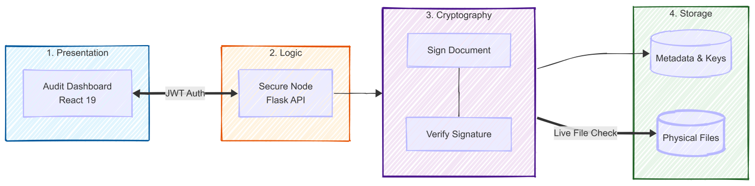
Figure 4.1 — Archetecture Diagram

4.3 Class Diagram

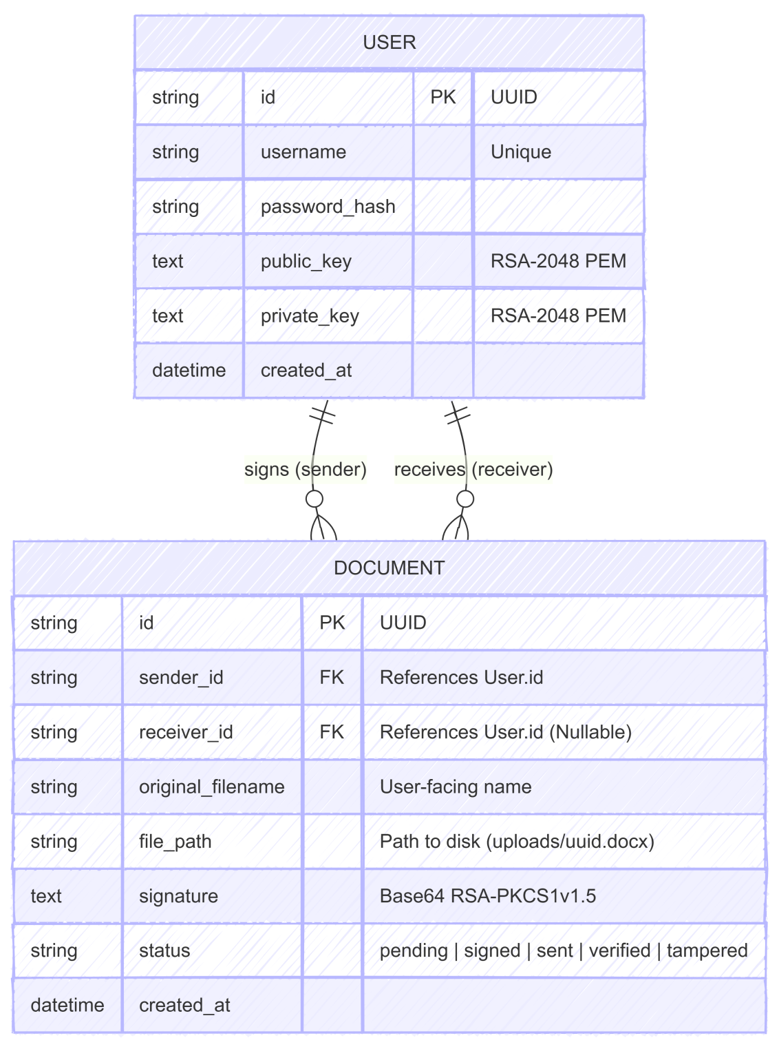
Figure 4.2 — Class diagram

4.4 Sequence Diagram

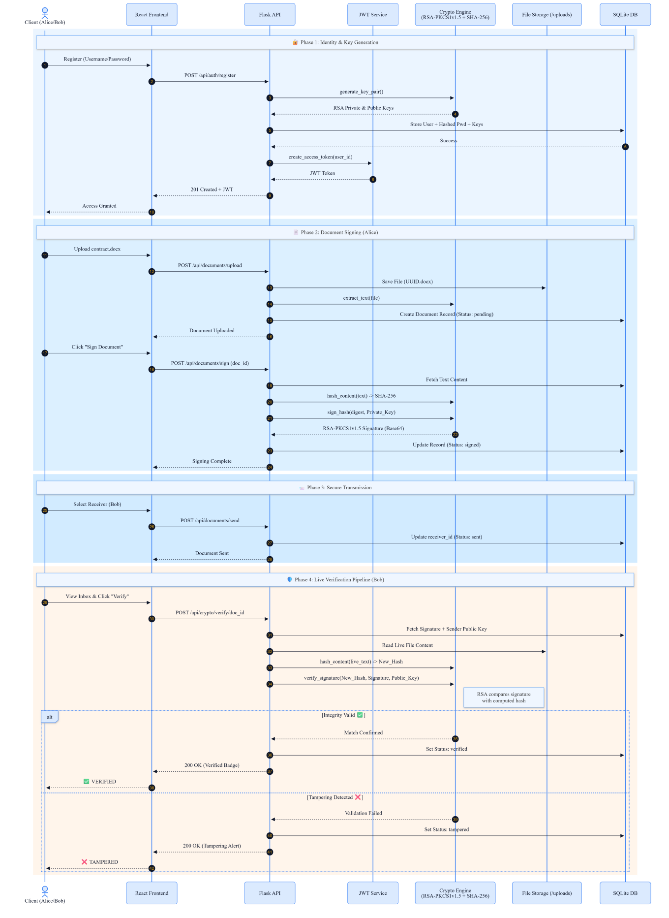
Figure 4.3 — Sequence diagram

5. Implementation Details

5.1 Key Generation Engine
At user registration, the system generates an RSA-2048 key pair using Python's cryptography library hazmat primitives. The public exponent is set to 65537 (the universal Fermat prime). The public key is stored in the database in PKCS#8 PEM format and shared with all verifiers; the private key is retained by the user's session. In a production environment, private keys must be stored in a Hardware Security Module (HSM) and never transmitted.

5.2 Signature Generation Workflow
Signing follows a four-step protocol:
- Live Payload Extraction — python-docx reads the .docx binary (OOXML ZIP), traverses all paragraph nodes, and returns concatenated plain text
- Deterministic Hashing — SHA-256 is applied to the UTF-8 encoded payload, producing a 64-character hex digest
- Authorization — the digest is signed with the user's RSA-2048 private key using PKCS1v1.5 padding
- Encapsulation — the raw signature bytes are Base64-encoded and stored in SQLite alongside the document name and timestamp

5.3 Real-Time Verification (Zero-Trust)
On every verification request the system performs a fresh, independent audit:
- The physical .docx file is re-read from disk — no cached content is used
- python-docx re-extracts the text payload identically to the signing step
- SHA-256 is recomputed from the live payload
- The stored Base64 signature is decoded and submitted to RSA public key verification
- A signature mismatch raises an InvalidSignature exception → status set to Tampered
- A successful match returns Verified with the live hash for audit transparency

5.4 Payload Extraction from .docx
Microsoft Word .docx files are ZIP archives following the Office Open XML (OOXML) standard. DocDrop uses python-docx to traverse the paragraph tree and extract plain text in document order. Only the main body text is included in the hash payload; headers, footers, embedded images, and table styling metadata are excluded to ensure a consistent, reproducible payload across different rendering environments.

5.5 Frontend Design Decisions

Decision | Rationale
React 19 + Vite | Fast HMR during development; smaller bundle via ESM tree-shaking
React Context API | Lightweight auth/session state without Redux overhead for single-domain app
Framer Motion | Smooth status transitions (Pending → Signed → Verified/Tampered)
Rough.js Sketched UI | Notebook aesthetic symbolizes transition from paper to digital signatures
REST-only API | Stateless backend; simplifies automated testing of cryptographic endpoints
Color-coded status badges | Green = Verified, Red = Tampered, Yellow = Pending — immediate visual feedback
Table 5.1 — Frontend Design
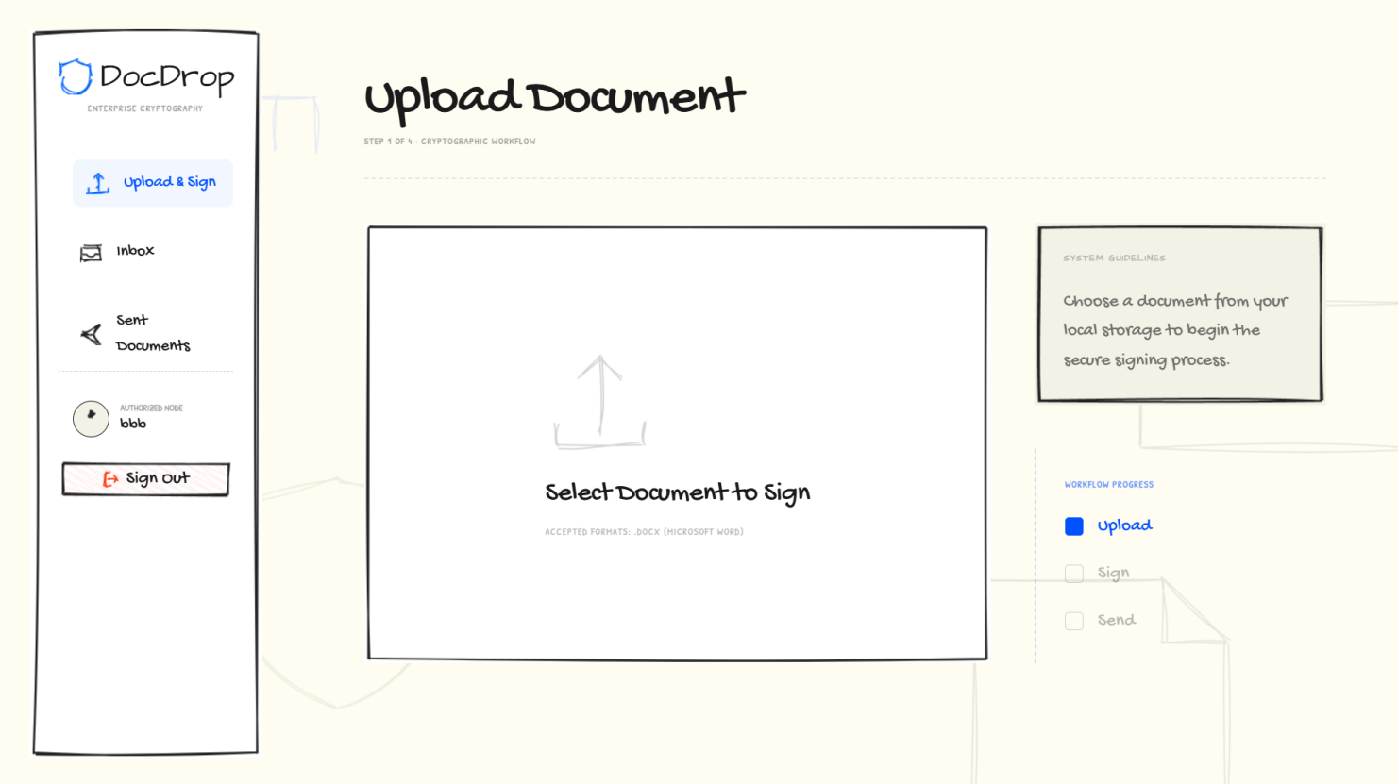

7. References

1. Rivest, R. L., Shamir, A., & Adleman, L. (1978). A method for obtaining digital signatures and public-key cryptosystems. Communications of the ACM, 21(2), 120–126.
2. National Institute of Standards and Technology. (2013). FIPS PUB 180-4: Secure Hash Standard. U.S. Department of Commerce.
3. Internet Engineering Task Force. (2016). RFC 8017: PKCS #1 — RSA Cryptography Specifications Version 2.2. IETF.
4. Government of Pakistan. (2016). Prevention of Electronic Crimes Act, 2016 (PECA). National Assembly of Pakistan.
5. Python Cryptography Library: https://cryptography.io/en/latest/
6. python-docx Documentation: https://python-docx.readthedocs.io/
7. DocDrop GitHub Repository: https://github.com/Abubakkar-Khan/DocDrop

