1. **Install Terraform on your PC**

#Steps To Install Terraform on Windows 10 or 8 or 7

1) Download Terraform

https://www.terraform.io/downloads.html

2) Unzip the terraform package

Extract the downloaded zip file, after extracting the zip file you can see terraform.exe file.

Extracted path can be Example "C:\Users\devops\Downloads\terraform_0.12.23_windows_amd64"

3) Configure environment variables for terraform

This PC(MyComputer)—>properties —>advanced system settings–>environment variables—>system variables—>path–edit–>new

paste the path "C:\Users\devops\Downloads\terraform_0.12.23_windows_amd64"

Click on Ok.

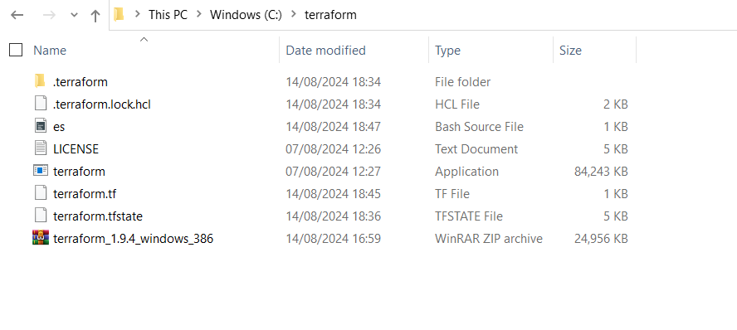

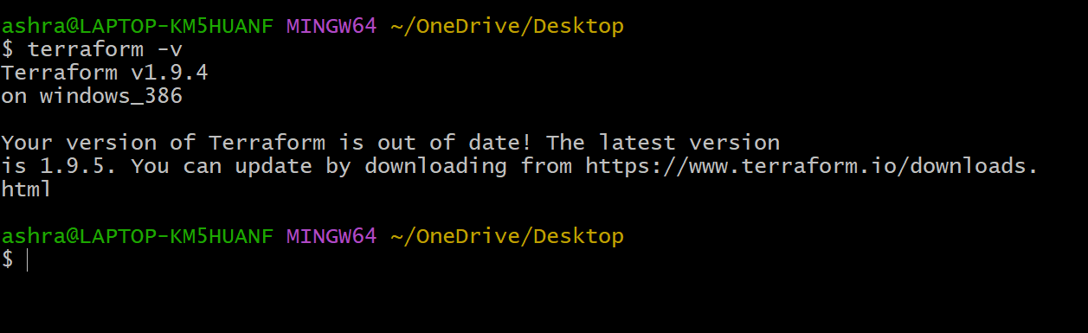

**2) Execute all the templates shown in video.**

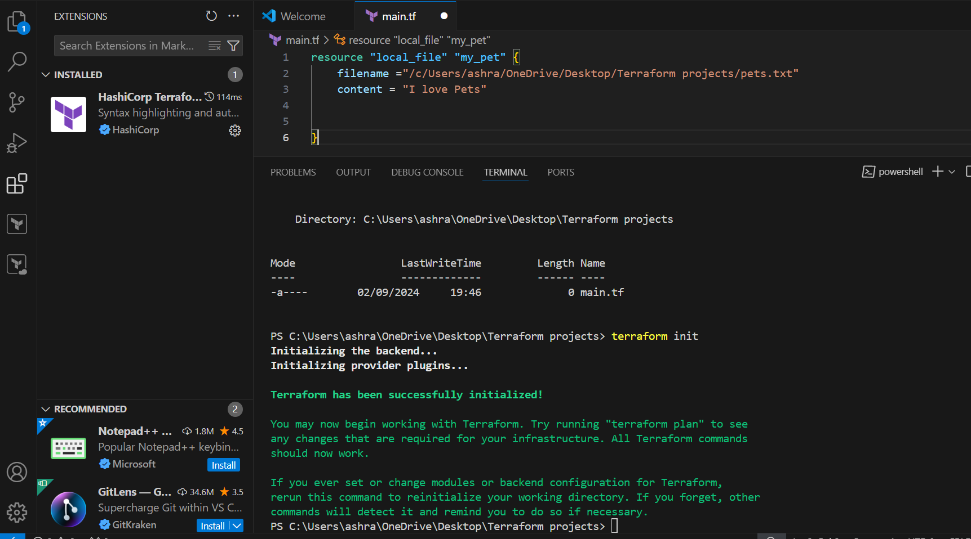

**4) Integrate a sample Terraform template in jenkins.**



