
Application of Information & Communication Technology Lab

Final Project Report


Department of Computer Science,
UET Lahore.

Group Members

Abdullah Akbar …………………….. 2025-CS-212
Mutaba Imtiaz ……………………… 2025-CS-192
Mazz Hassan ………………………… 2025-CS-202
Ali Khalid ……………………………… 2025-CS-220
Muhammad Sarim ……………….. 2025-CS-191

Project Title
School Admission Portal
Course Instructor
Miss Ramsha Khalid
Table of Contents
- Executive Summary ..................................................... 3
- Introduction .................................................................. 3
- Problem Statement ....................................................... 3
- Objectives of the Project .............................................. 4
- Scope of the Project ...................................................... 4
- Tools and Technologies Used ....................................... 4
- Site Structure and Navigation ..................................... 5
- Design Choices .............................................................. 5
- Assets Used .................................................................... 6
- How to Run or Publish the Website ................. 6
- Results and Output ............................................ 6
- Limitations of the System ................................. 11
- Future Enhancements ....................................... 11
- Reflection ........................................................... 12
- Conclusion ......................................................... 12
- References .......................................................... 15
- Website Live URL ............................................. 15

Summary:
The rapid advancement of information and communication technology has transformed traditional educational systems by introducing digital solutions for administrative and academic processes. This project presents the design and implementation of a School Admission Portal, developed as part of the AICT Lab course. The portal provides an online platform for schools to present institutional information, manage admission-related details, and facilitate communication with parents and students. The system is developed using HTML5 and CSS3, focusing on usability, responsiveness, and visual consistency. This project demonstrates how modern web technologies can improve accessibility, efficiency, and transparency in school admission processes.

Introduction:
Applications of Information and Communication Technology (AICT) plays a crucial role in modern educational institutions by improving data management, accessibility, and communication. Traditional school admission systems rely heavily on manual paperwork, physical visits, and repetitive administrative tasks, which are time-consuming and prone to errors.
The School Admission Portal aims to address these challenges by offering a centralized digital platform where parents and students can access school information, understand admission requirements, and contact the institution online. This project highlights the practical application of ICT concepts learned during the AICT Lab course.

Problem Statement:
Many schools still rely on manual admission procedures, which result in several challenges:
- Inefficient handling of admission inquiries
- Lack of centralized information
- Time-consuming paperwork
- Limited accessibility for parents
- Poor online presence of educational institutions
There is a need for a digital system that provides clear, structured, and easily accessible information regarding school admissions.

Objectives of the Project:
The main objectives of this project are:
- To design a professional and responsive school website
- To provide complete information about the school and admissions
- To enable online admission inquiries
- To improve communication between parents and school administration
- To apply AICT concepts practically using web technologies
Scope of the Project:
The scope of this project includes:
- A multi-page static website
- Information presentation for school and admissions
- Responsive layout for different screen sizes
- Clean and user-friendly interface
The project does not include backend functionality such as databases or authentication systems.

Tools and Technologies Used:
The following tools and technologies were used in the development of this project:
- HTML5 – Structure and content of the website
- CSS3 – Styling, layout, animations, and responsiveness
- Google Fonts – Typography enhancement
- Web Browser – Testing and deployment
- Visual Studio Code – Code editor
- Unsplash – For Stock Images
Site Structure and Navigation:
The project follows a structured design approach:
- A shared navigation bar and footer for consistency
- Use of CSS variables for theme management
- Responsive grid and flexbox layouts
- Background images and animations for visual appeal
- Clean separation of sections for readability
Each page is developed using semantic HTML elements to ensure accessibility and maintainability.

Design Choices:
The design of the School Admission Portal focuses on professionalism, clarity, and accessibility. The following design decisions were made during development:
- Fonts: Google Fonts such as Poppins and Inter were used to ensure modern and readable typography.
- Color Scheme: A blue and sky-blue color palette was selected to represent trust, calmness, and an academic environment.
- Layout: Grid and flexbox layouts were implemented to maintain consistency and responsiveness across different screen sizes.
- Hero Sections: Prominent hero sections with background images were used to create strong visual impact and guide user attention.
- Responsiveness: The website adapts smoothly to desktops, tablets, and mobile devices.
These design choices enhance the overall user experience and align with modern educational website standards.

Assets Used:
The following assets were used in the development of the School Admission Portal:
- Images: School-related images used in the gallery and hero sections. These images were either self-created or obtained from free stock image sources.
- Fonts: Google Fonts (Poppins and Inter) were used for typography.
- Icons and Symbols: Unicode symbols and basic icons were used where required.
- Data Figures: Statistical figures such as academic levels and institutional features are consistently used across the website, Excel analysis, and presentation slides.

How to Run or Publish the Website:
The School Admission Portal is a static website and does not require any special software to run. The following steps can be followed to view or publish the website:
- Download or copy the project folder containing all HTML, CSS, and image files.
- Open the index.html file using any modern web browser such as Google Chrome or Microsoft Edge.
- Ensure that all files remain in their respective folders for proper styling and image display.
- For online publishing, the website can be hosted using platforms such as GitHub Pages or any basic web hosting service.

Results and Output:
The developed School Admission Portal successfully achieves the following:
- Provides a professional online presence for a school
- Allows parents to explore admission-related information easily
- Enhances user experience through responsive design
- Demonstrates effective use of AICT concepts

Figure 1: Home Page



Figure 2: About Page

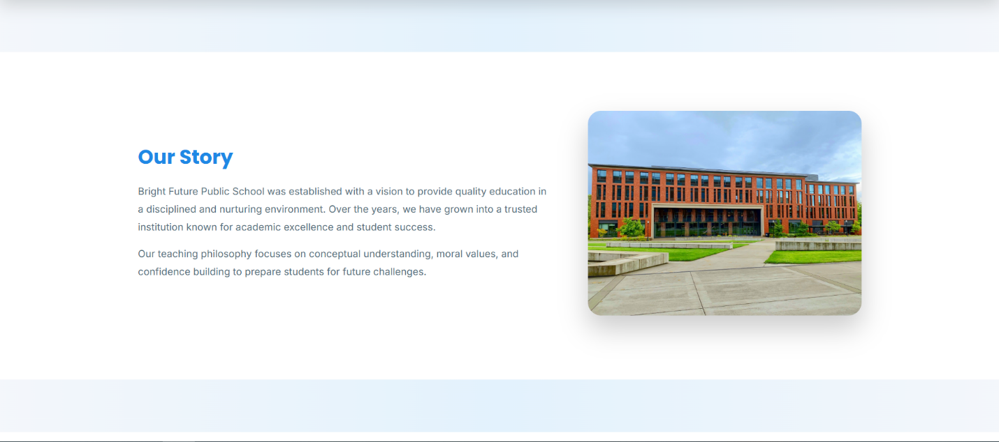
Figure 3: Admission Page

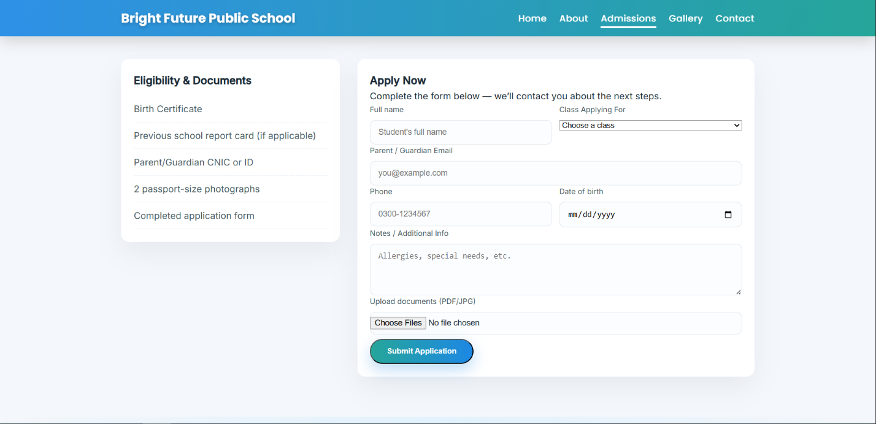

Figure 4: Gallery Page

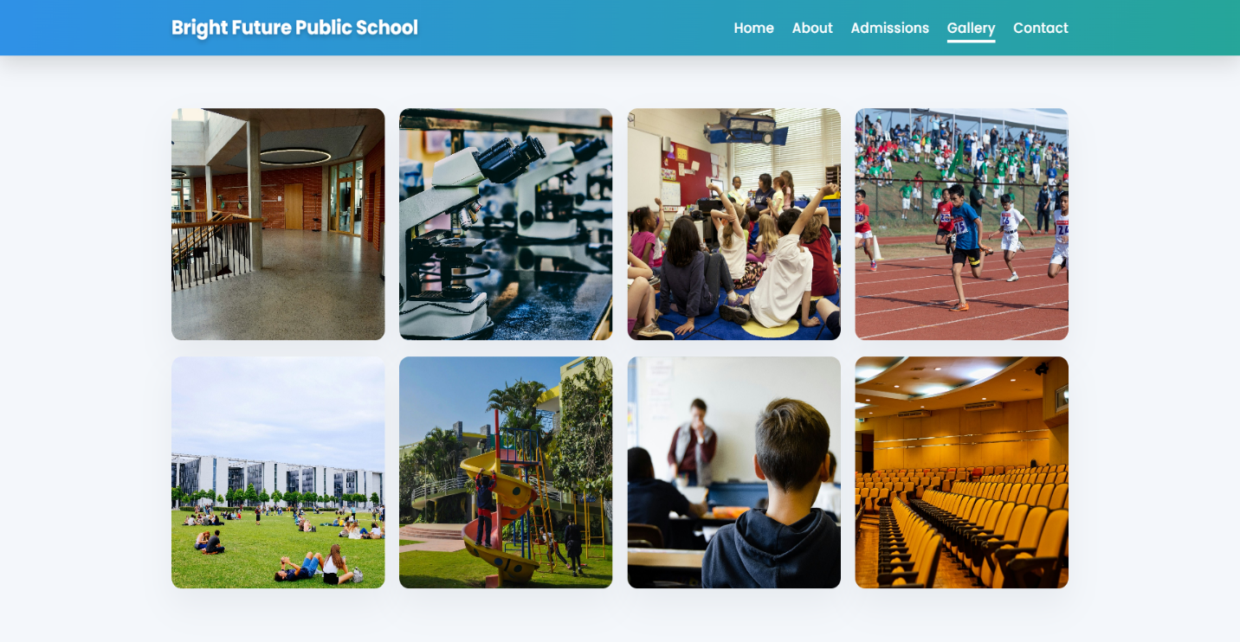

Figure 5: Contact Page

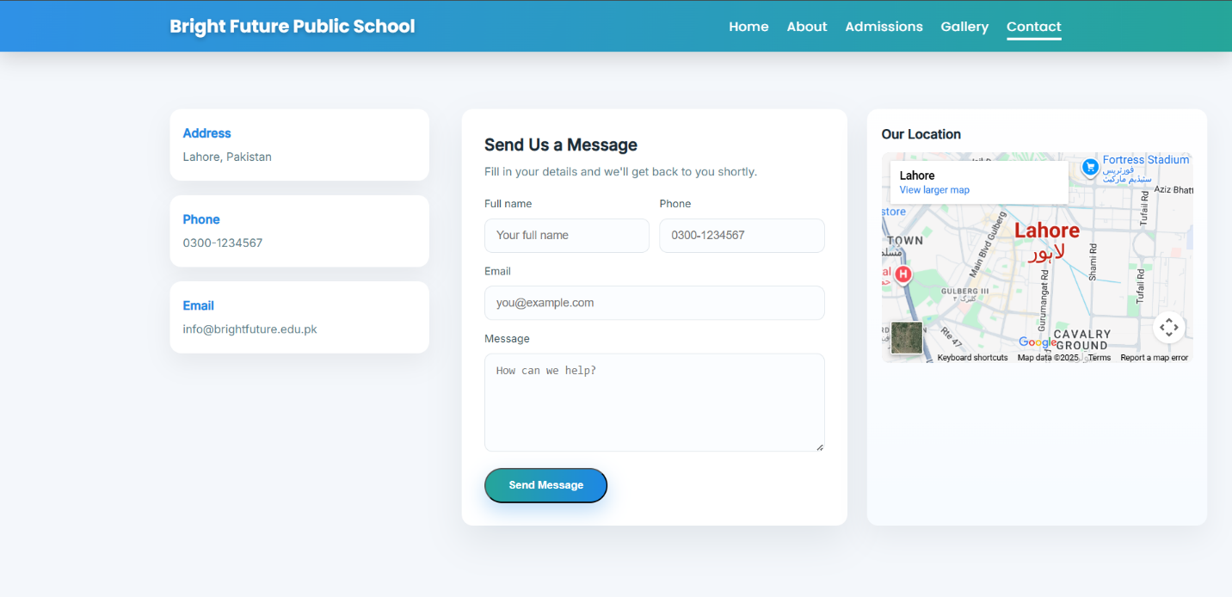

---------------------

Excel Data:
The project data was further analyzed using Microsoft Excel. Raw admission data, fee structure, timetable allocation, and website usage statistics were processed using Excel formulas such as SUM, AVERAGE, and IF. A dashboard was created to visually summarize the results using charts.

Figure 1: Raw Admission Data Used for Analysis
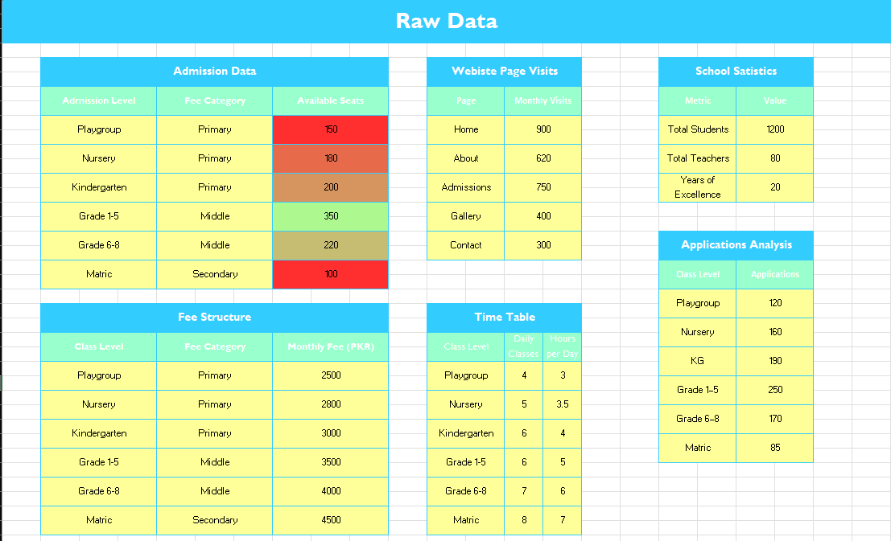
Figure 2: Excel Calculations Using SUM, AVERAGE, and IF Functions
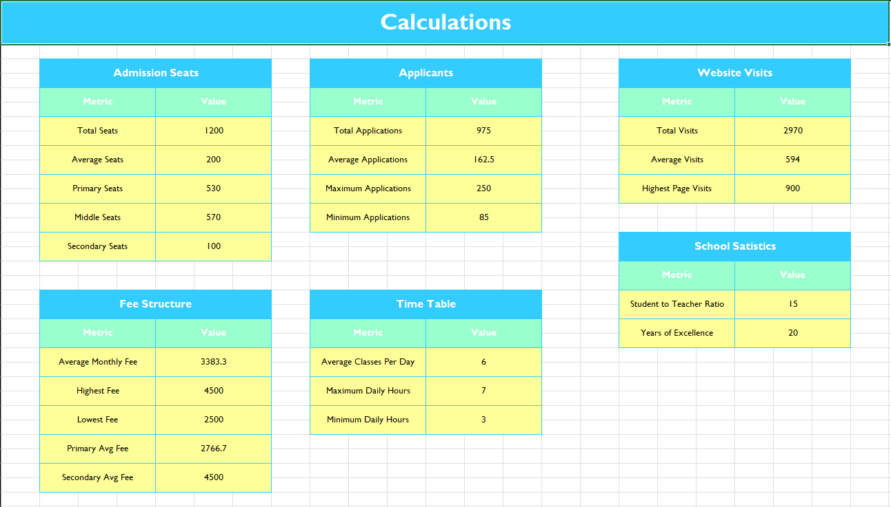

Figure 3: Excel Dashboard Showing Admission and Website Usage Analysis
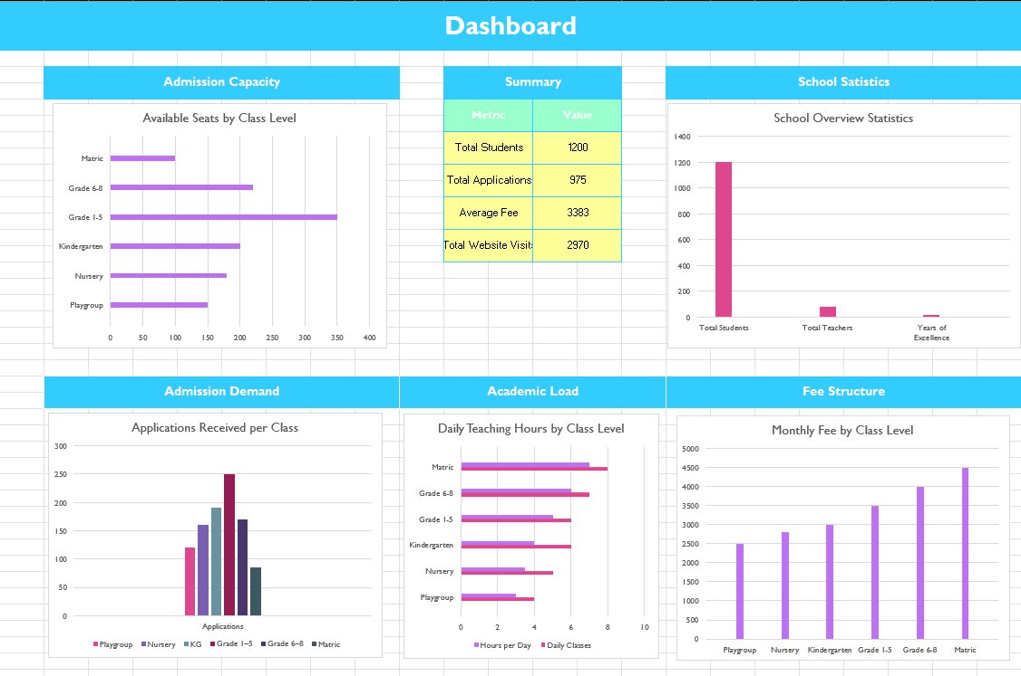

Limitations of the System:
Despite fulfilling its objectives, the system has certain limitations:
- No backend or database integration
- No online admission processing
- No admin dashboard
- Static content only
Future Enhancements:
The project can be extended further with the following features:
- Backend integration using PHP or Node.js
- Database connectivity for admission records
- Online fee payment system
- Admin panel for content management
- Student and parent login system

Reflection:
This project provided valuable practical experience in applying AICT concepts to a real-world scenario. Through the development of the School Admission Portal, skills in HTML structure, CSS styling, responsive design, and layout management were significantly improved. Challenges such as maintaining design consistency and organizing multiple pages were successfully addressed. If additional time and resources were available, the project could be enhanced further by adding backend functionality, database integration, and an administrative dashboard. Overall, this project strengthened understanding of web development and the role of ICT in educational systems.

Conclusion:
The School Admission Portal project demonstrates the practical implementation of AICT concepts in developing a real-world web-based solution. The project successfully provides a digital platform for school admission information while maintaining usability and visual consistency. Through this project, practical skills in web development, UI design, and system planning were enhanced. The project serves as a strong foundation for future enhancements involving dynamic web technologies.

Note: The figures, lists, and statistics presented in this document are consistently reused in the Excel analysis and presentation slides submitted as part of the AICT project.

LinkedIn Project Showcase:
As part of the AICT Lab project requirements, the project was shared on LinkedIn to demonstrate professional presentation, teamwork, and public project documentation. The post included a project video, GitHub Pages link, acknowledgements, and learning outcomes.
Figure 1: LinkedIn post showcasing the AICT Lab project and GitHub Pages link.
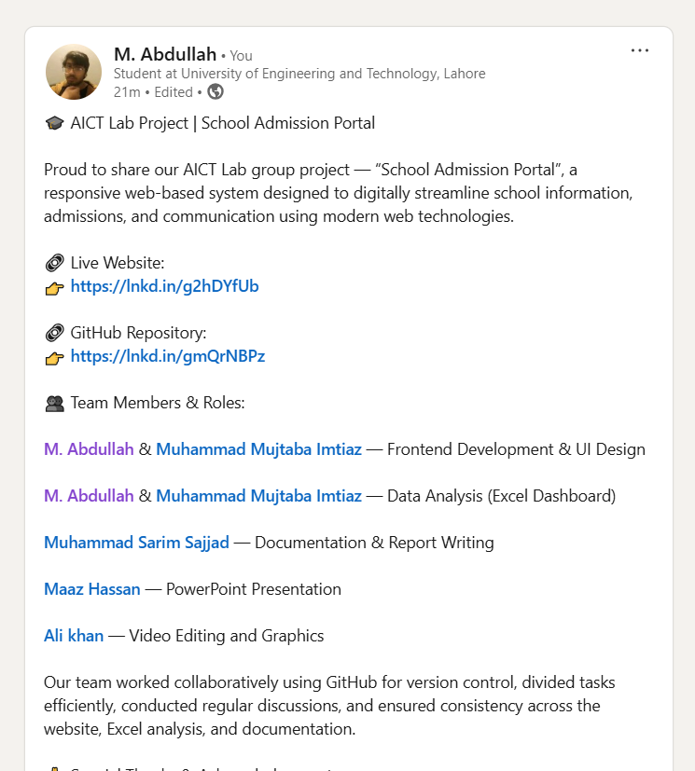
Figure 2:

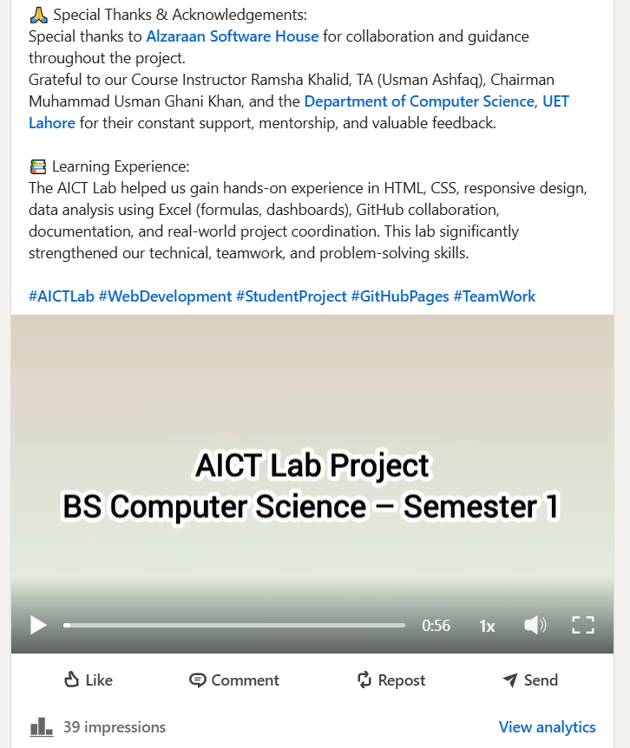

References:
- W3Schools – HTML and CSS Documentation - https://www.w3schools.com/html/
- MDN Web Docs – Web Development Resources - https://developer.mozilla.org/en-US/docs/Web/CSS
- Course Lecture Notes (AICT Lab)
- Unslpash – For Stock Images - https://unsplash.com/

Website Live Url:
https://abudora-0.github.io/School-Admission-Portal/

