The Association of SNAP on COVID-19 Cases: Evidence from Nebraska

Nadia Abuelezam, ScD;

From the Connell School of Nursing, Boston College (Abuelezam)

# Introduction

# Methods

## Overview

## Data Sources

We drew from two public data sources. First, we use the Household Pulse Survey to estimate state-level rates of food security, and vaccination rate by month. Second, we use the COVID Data Tracker from the Centers for Disease Control and Prevention to collect state-level information on COVID-19 prevalence.

# Results

# Discussion

# X

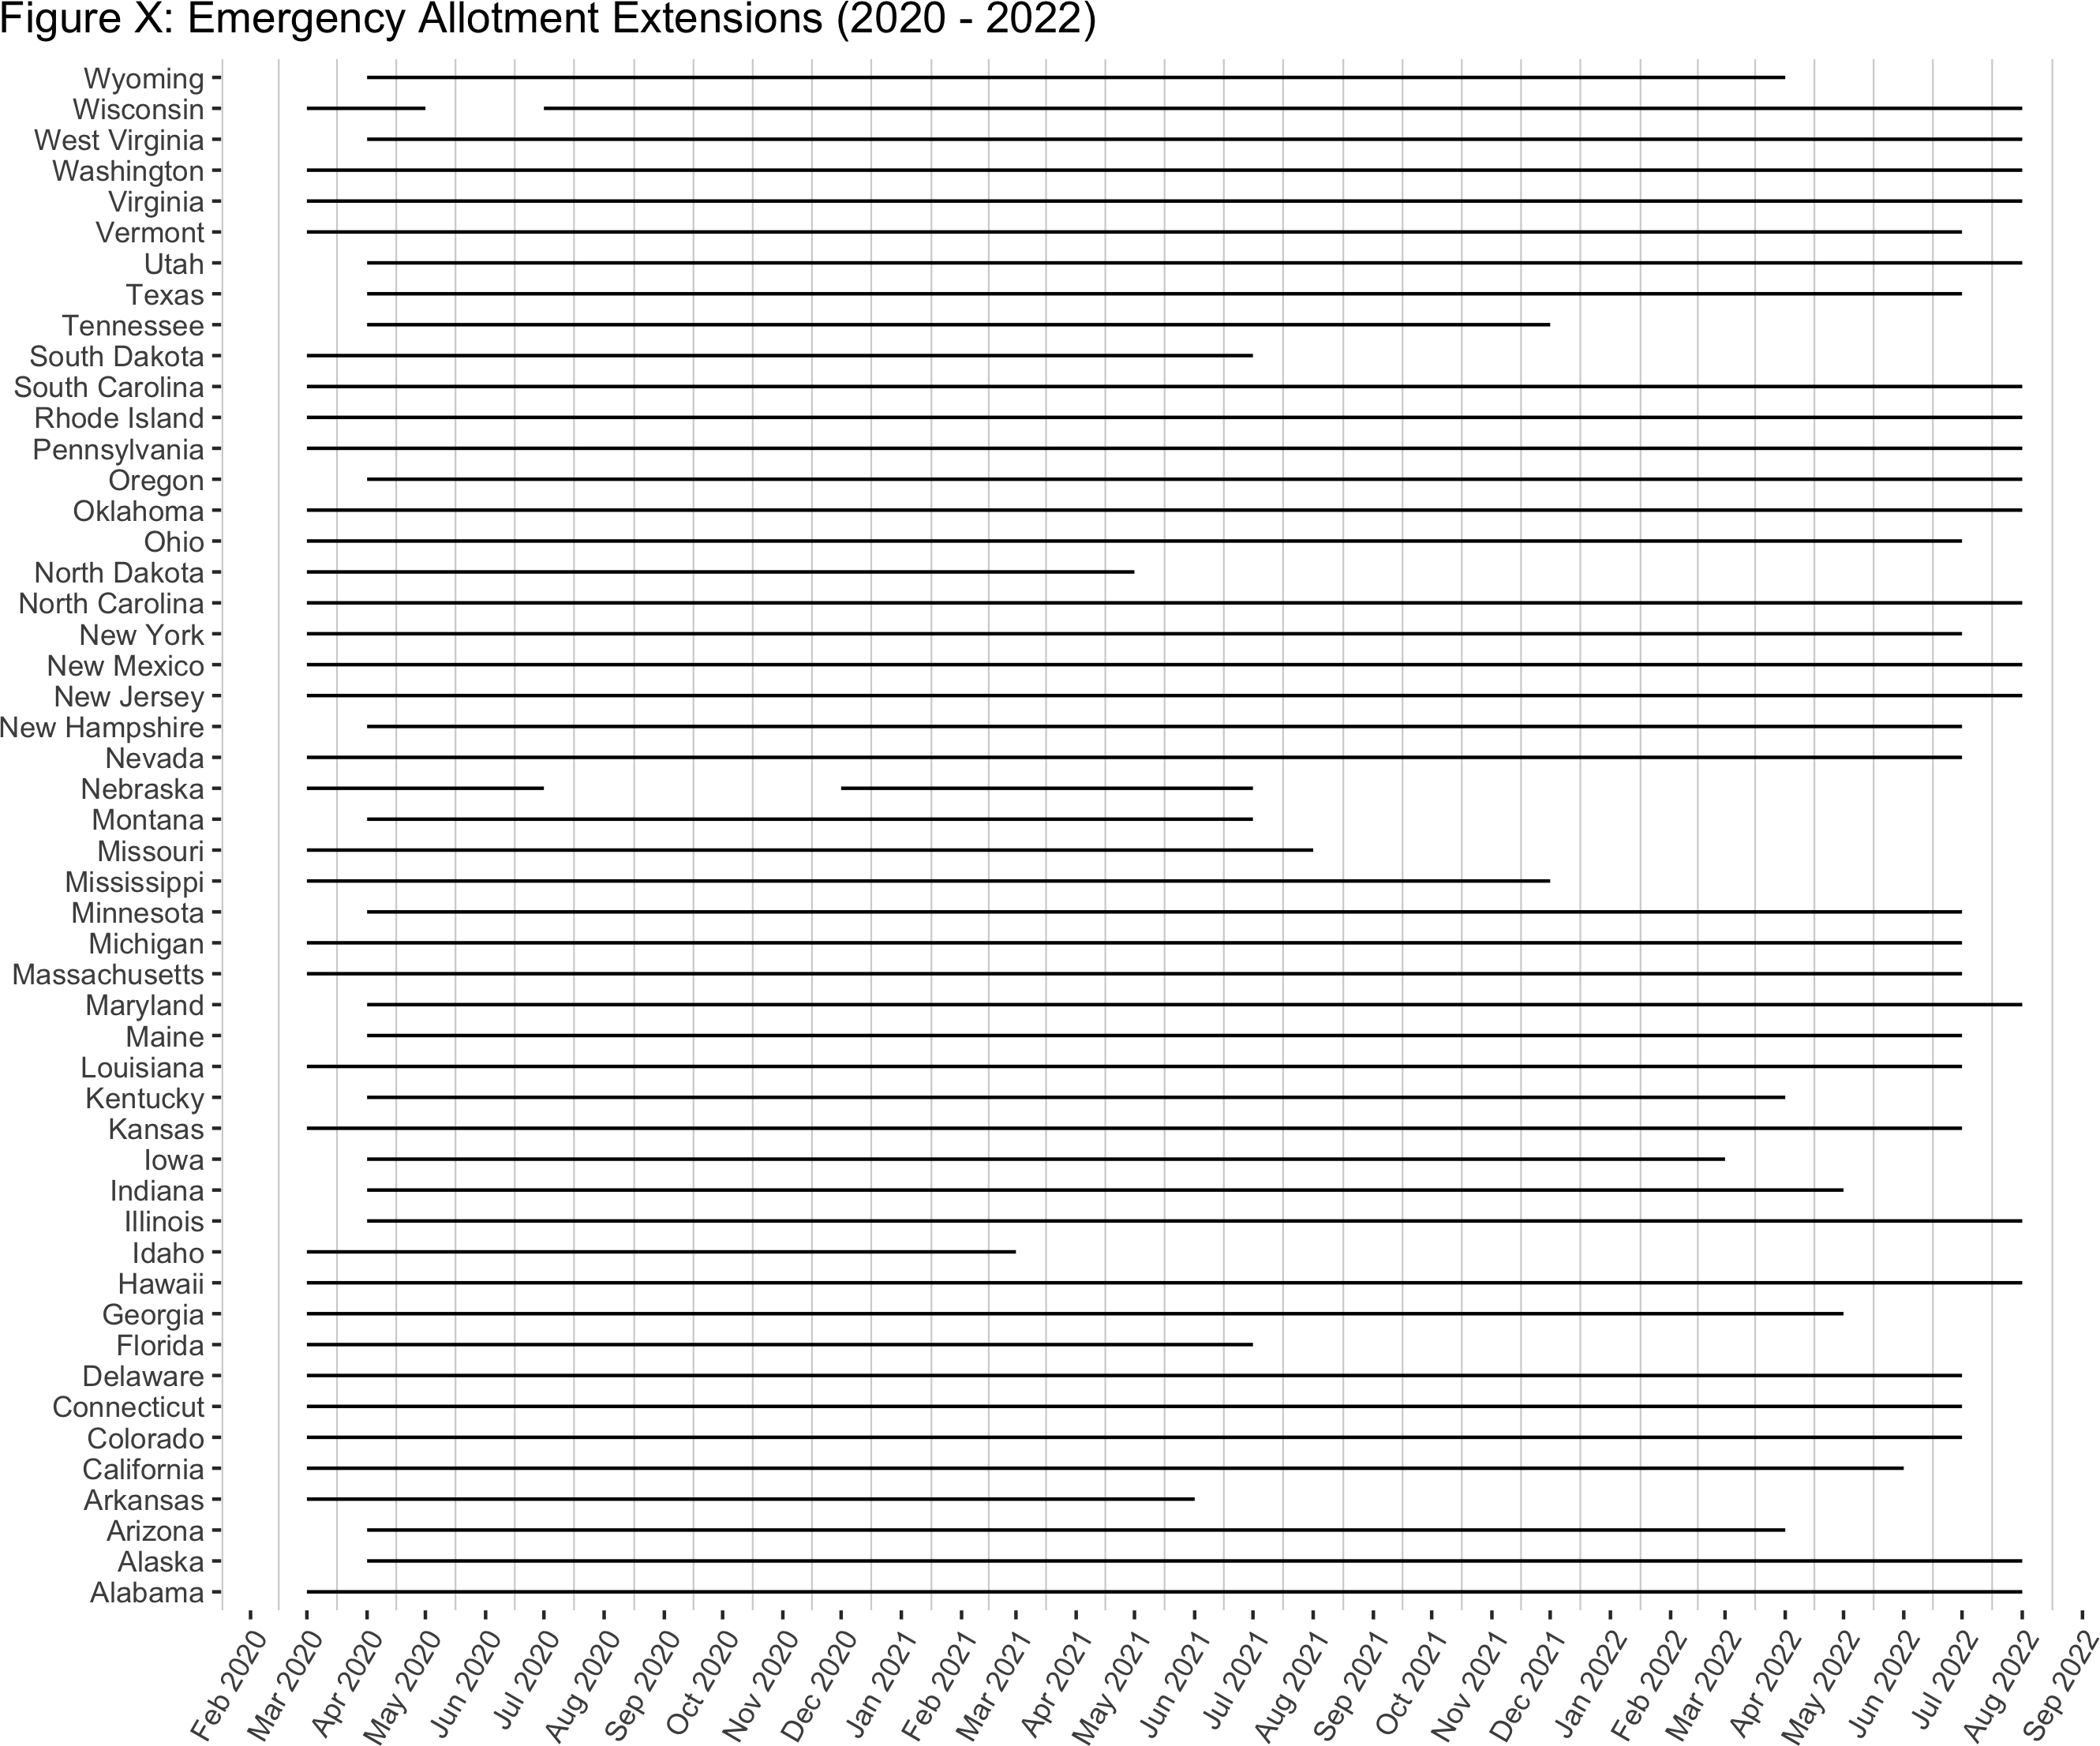

this is a caption

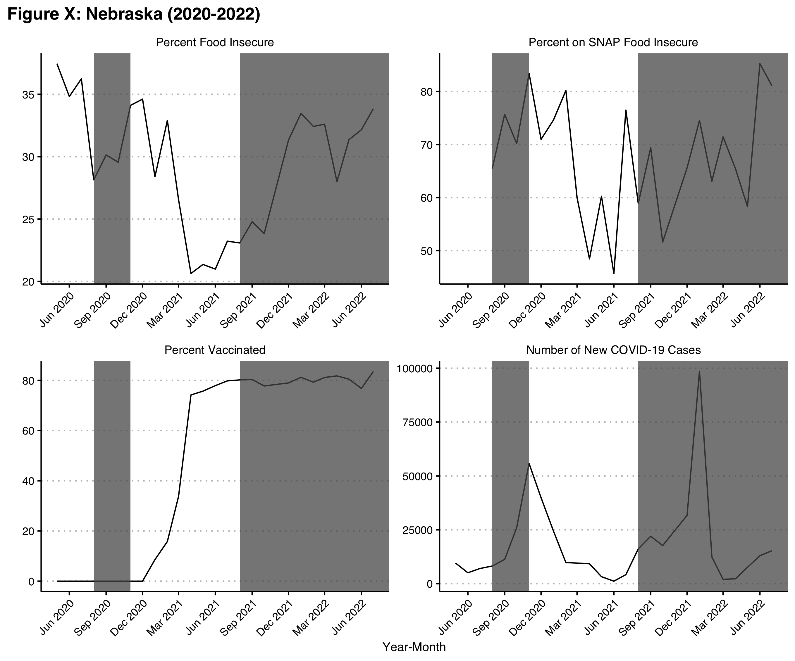

Shaded regions represent when Emergency allotments were inactive for Nebraska.

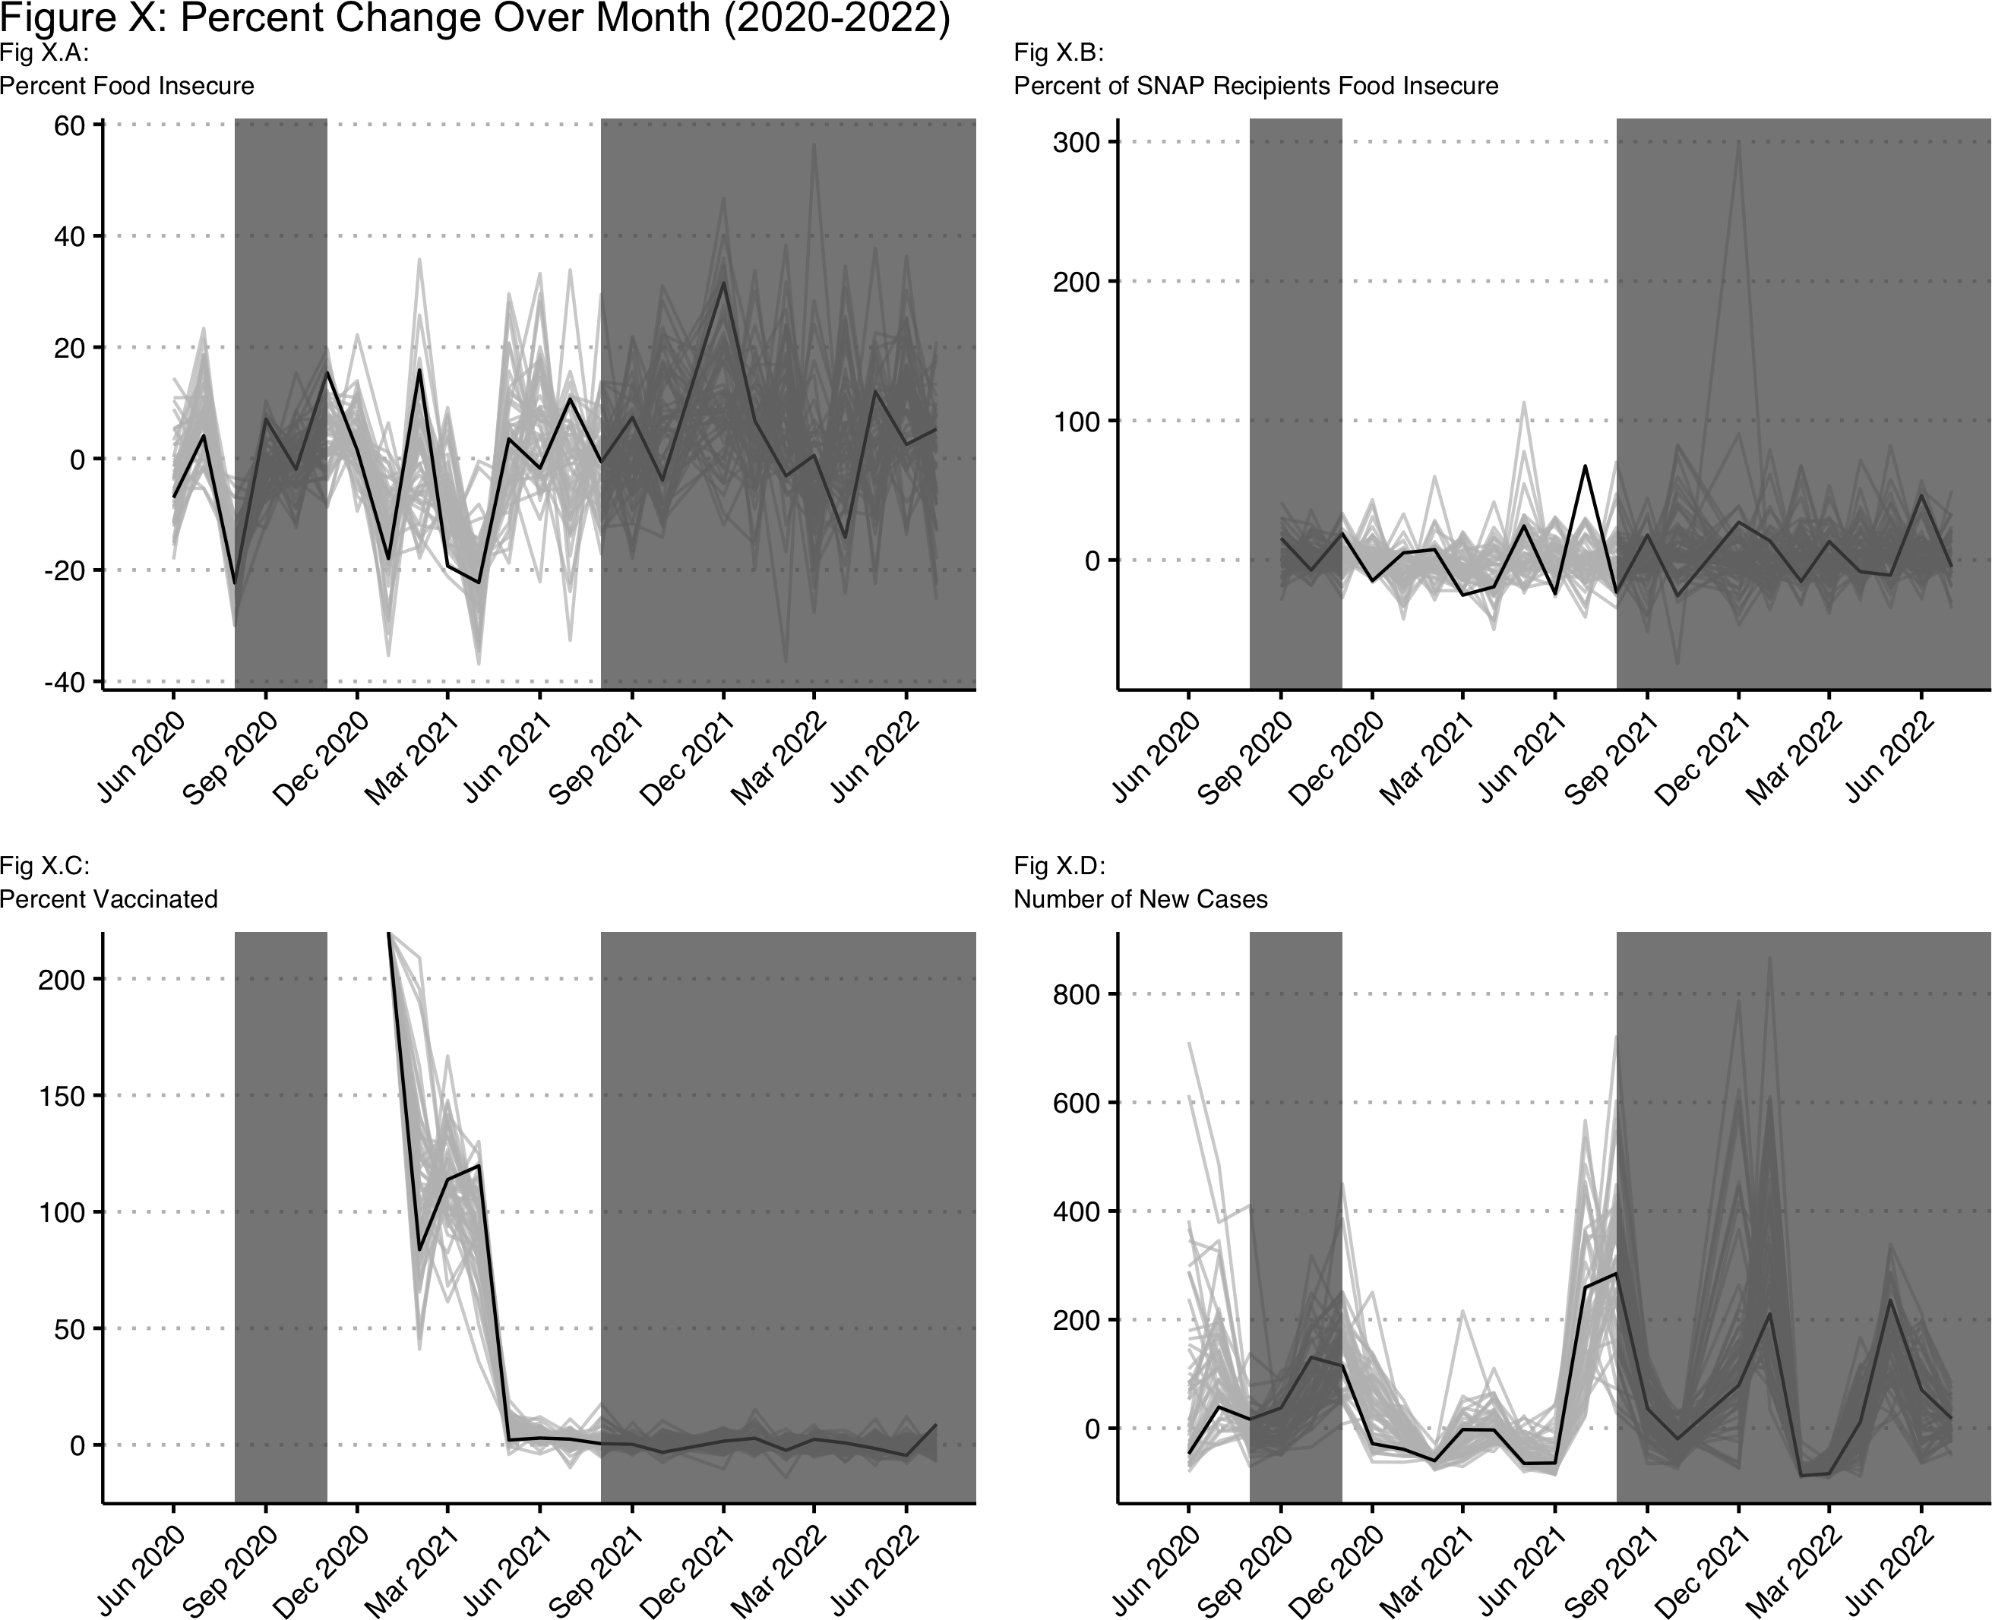

Black line is Nebraska. Shaded regions represent when Emergency allotments were inactive for Nebraska.