The Association between Food Insecurity and COVID-19 Cases: Evidence from Nebraska SNAP Policy

Matthew Lavallee, BA; Nadia Abuelezam, ScD;

From the Connell School of Nursing, Boston College (Lavallee, Abuelezam)

# Introduction

The COVID-19 pandemic1

# Methods

## Overview

## Data Sources

We drew from two public data sources. First, we use the Household Pulse Survey to estimate state-level rates of food security, and vaccination rate by month. Second, we use the COVID Data Tracker from the Centers for Disease Control and Prevention to collect state-level information on COVID-19 prevalence.

# Results

# Discussion

# X

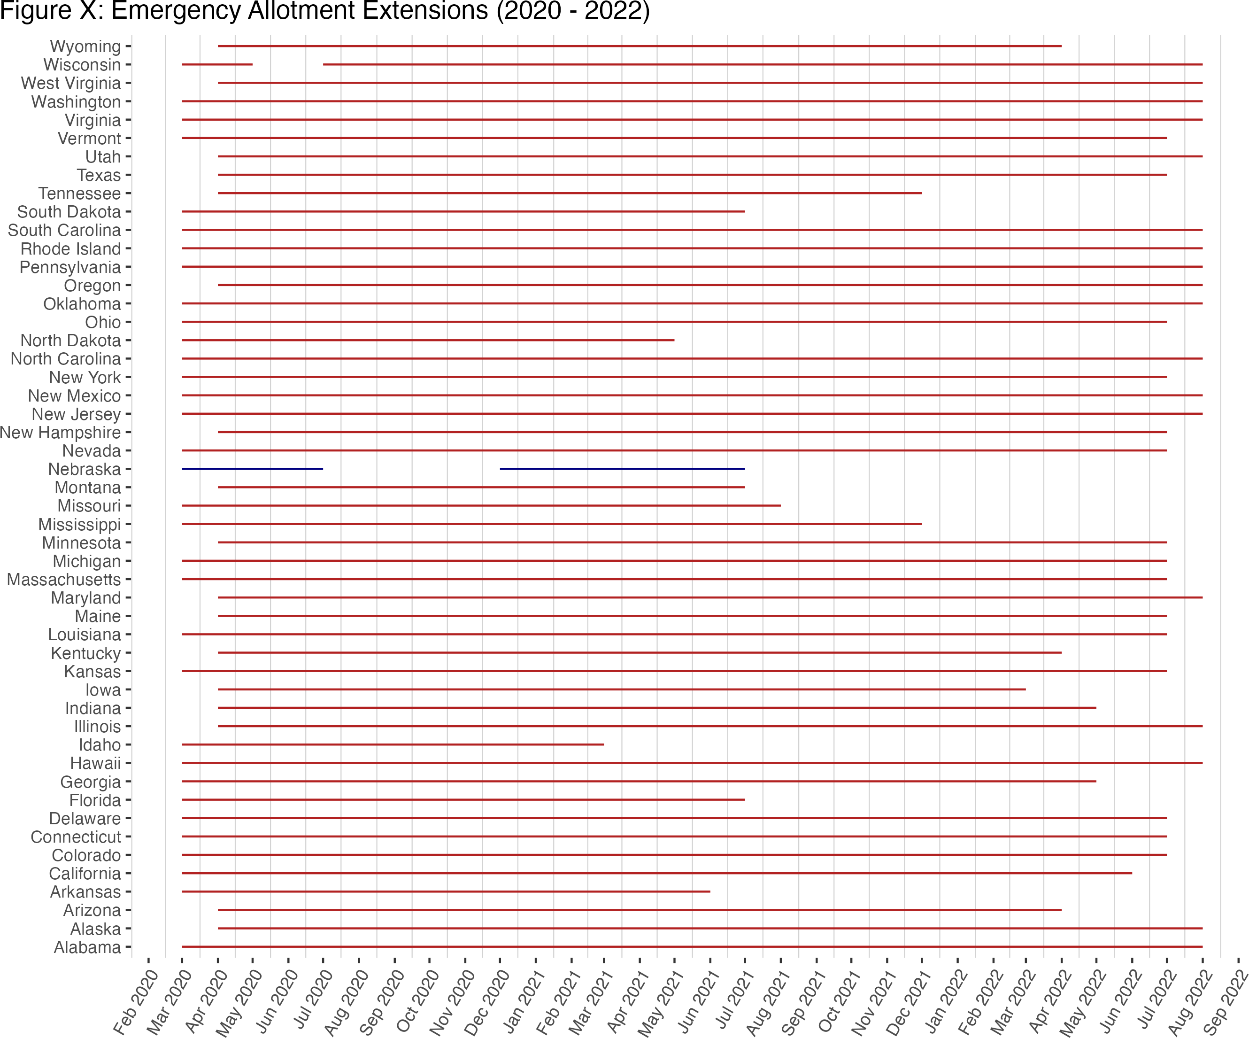

this is a caption

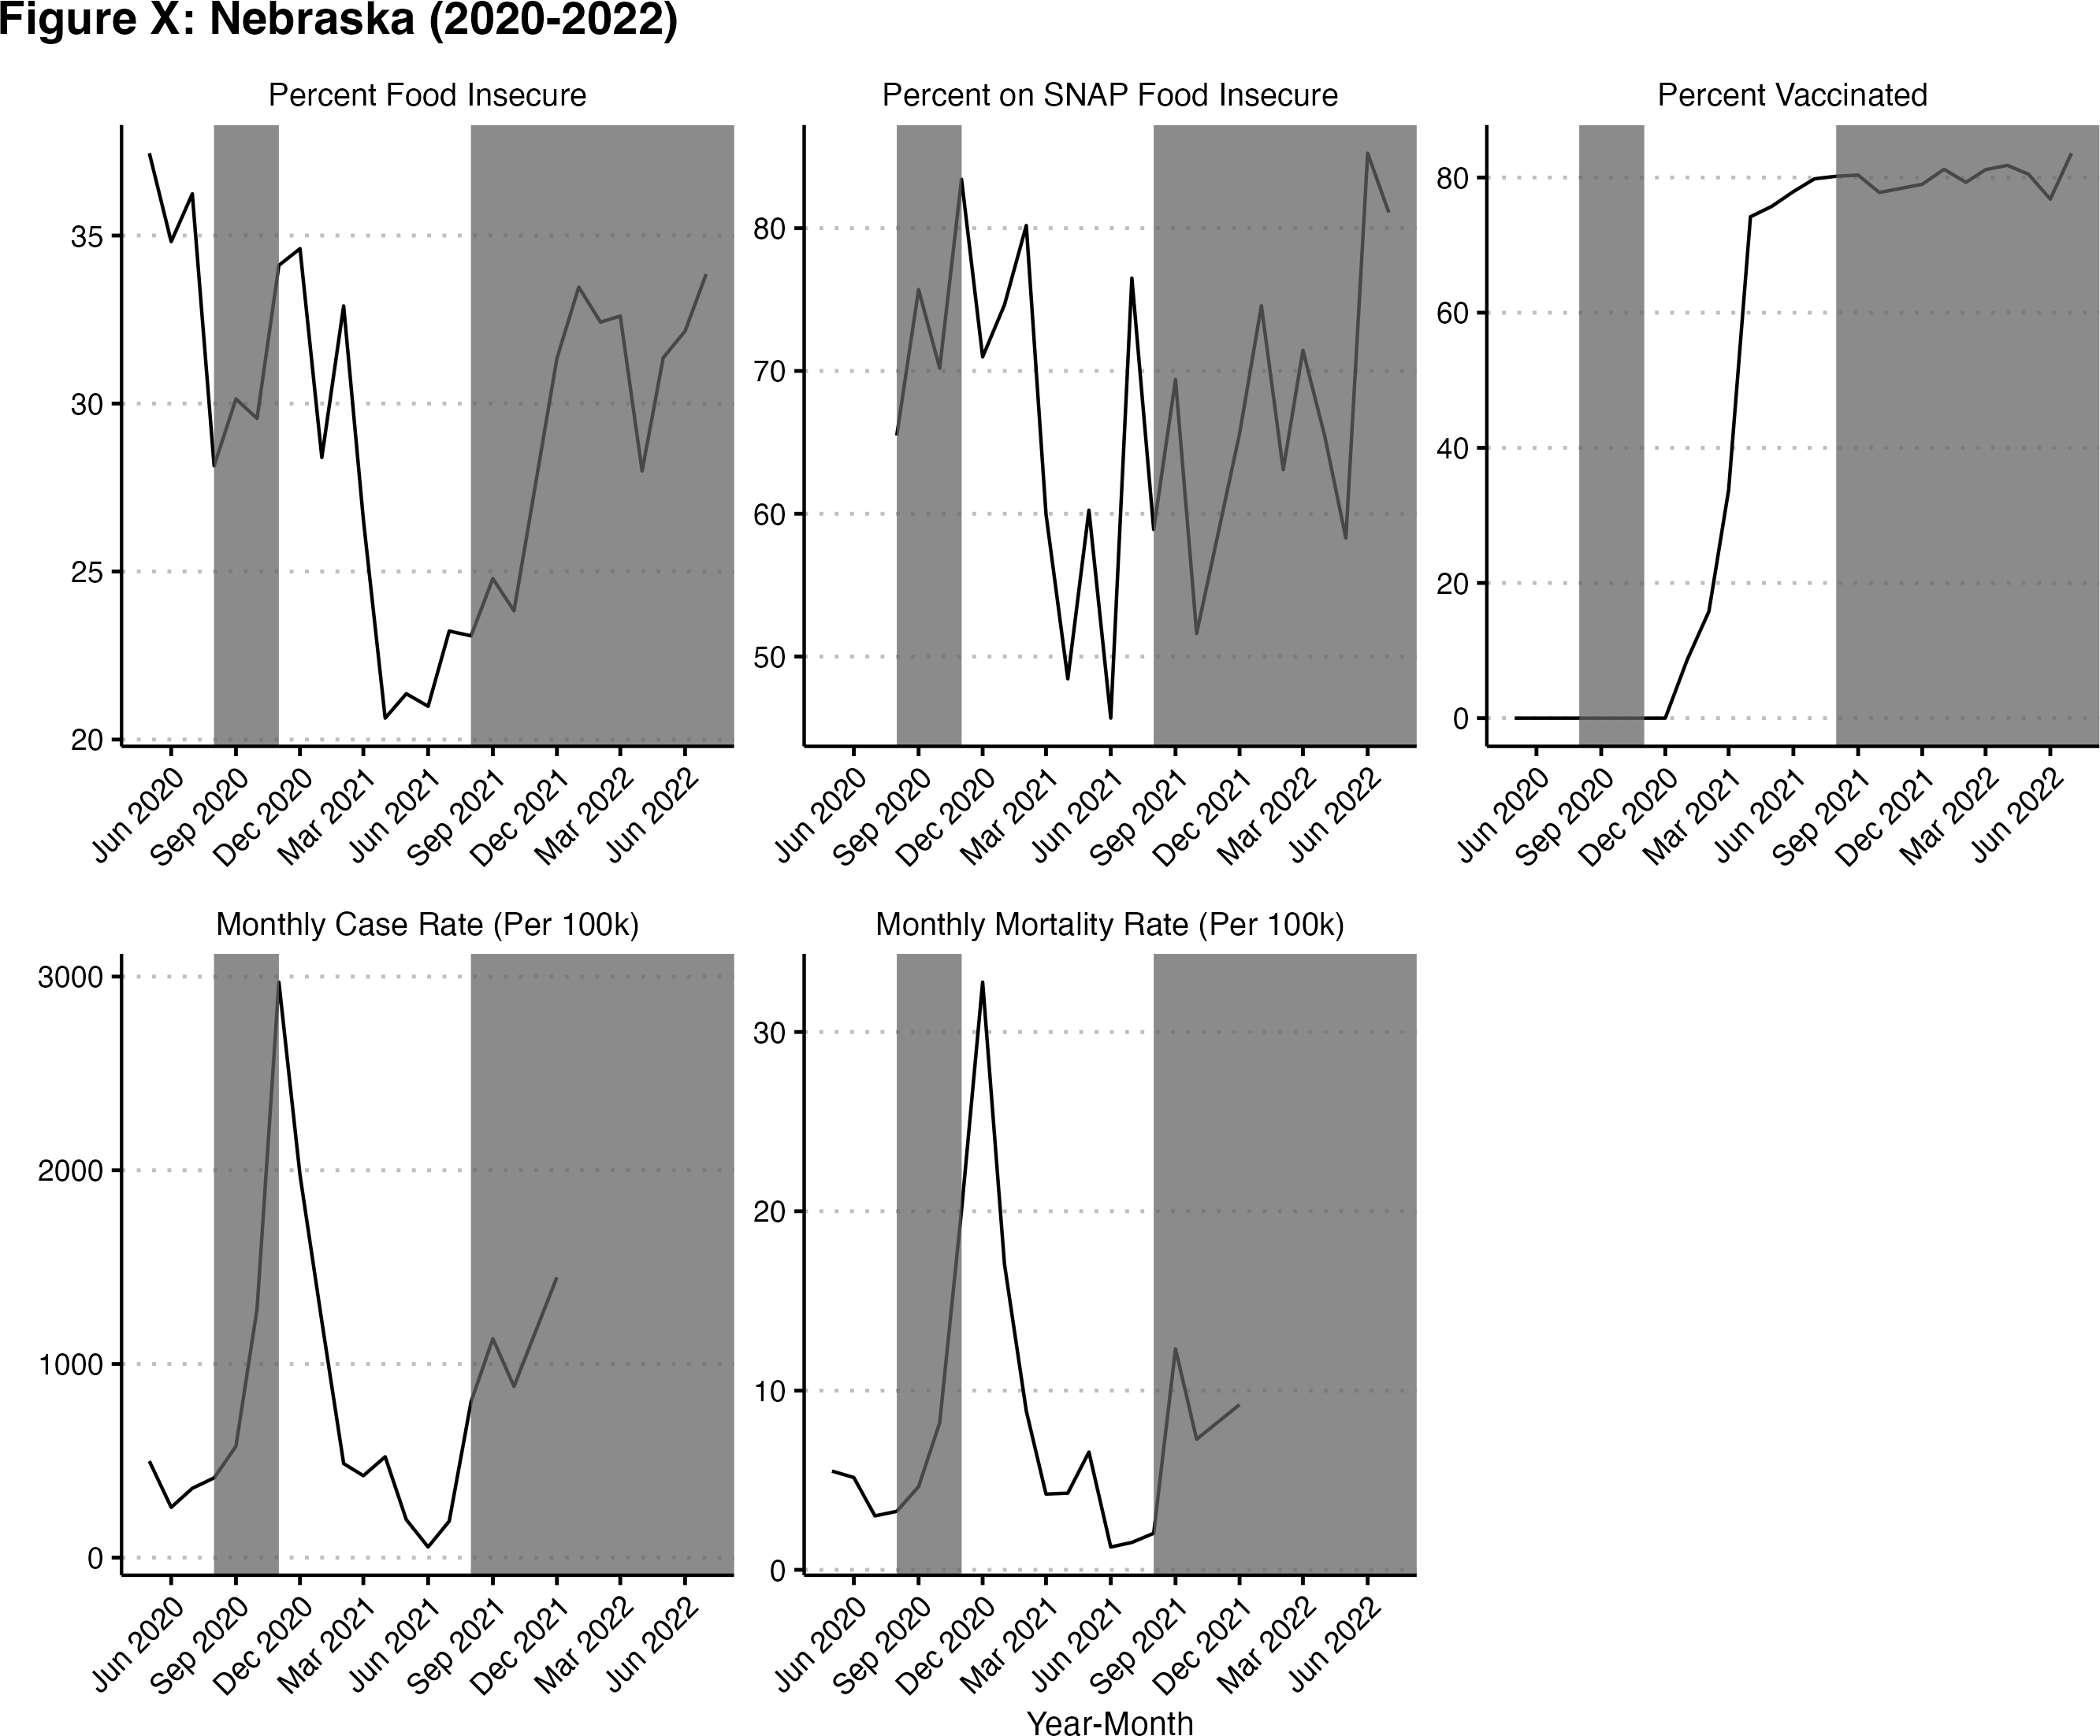

Shaded regions represent when Emergency allotments were inactive for Nebraska.

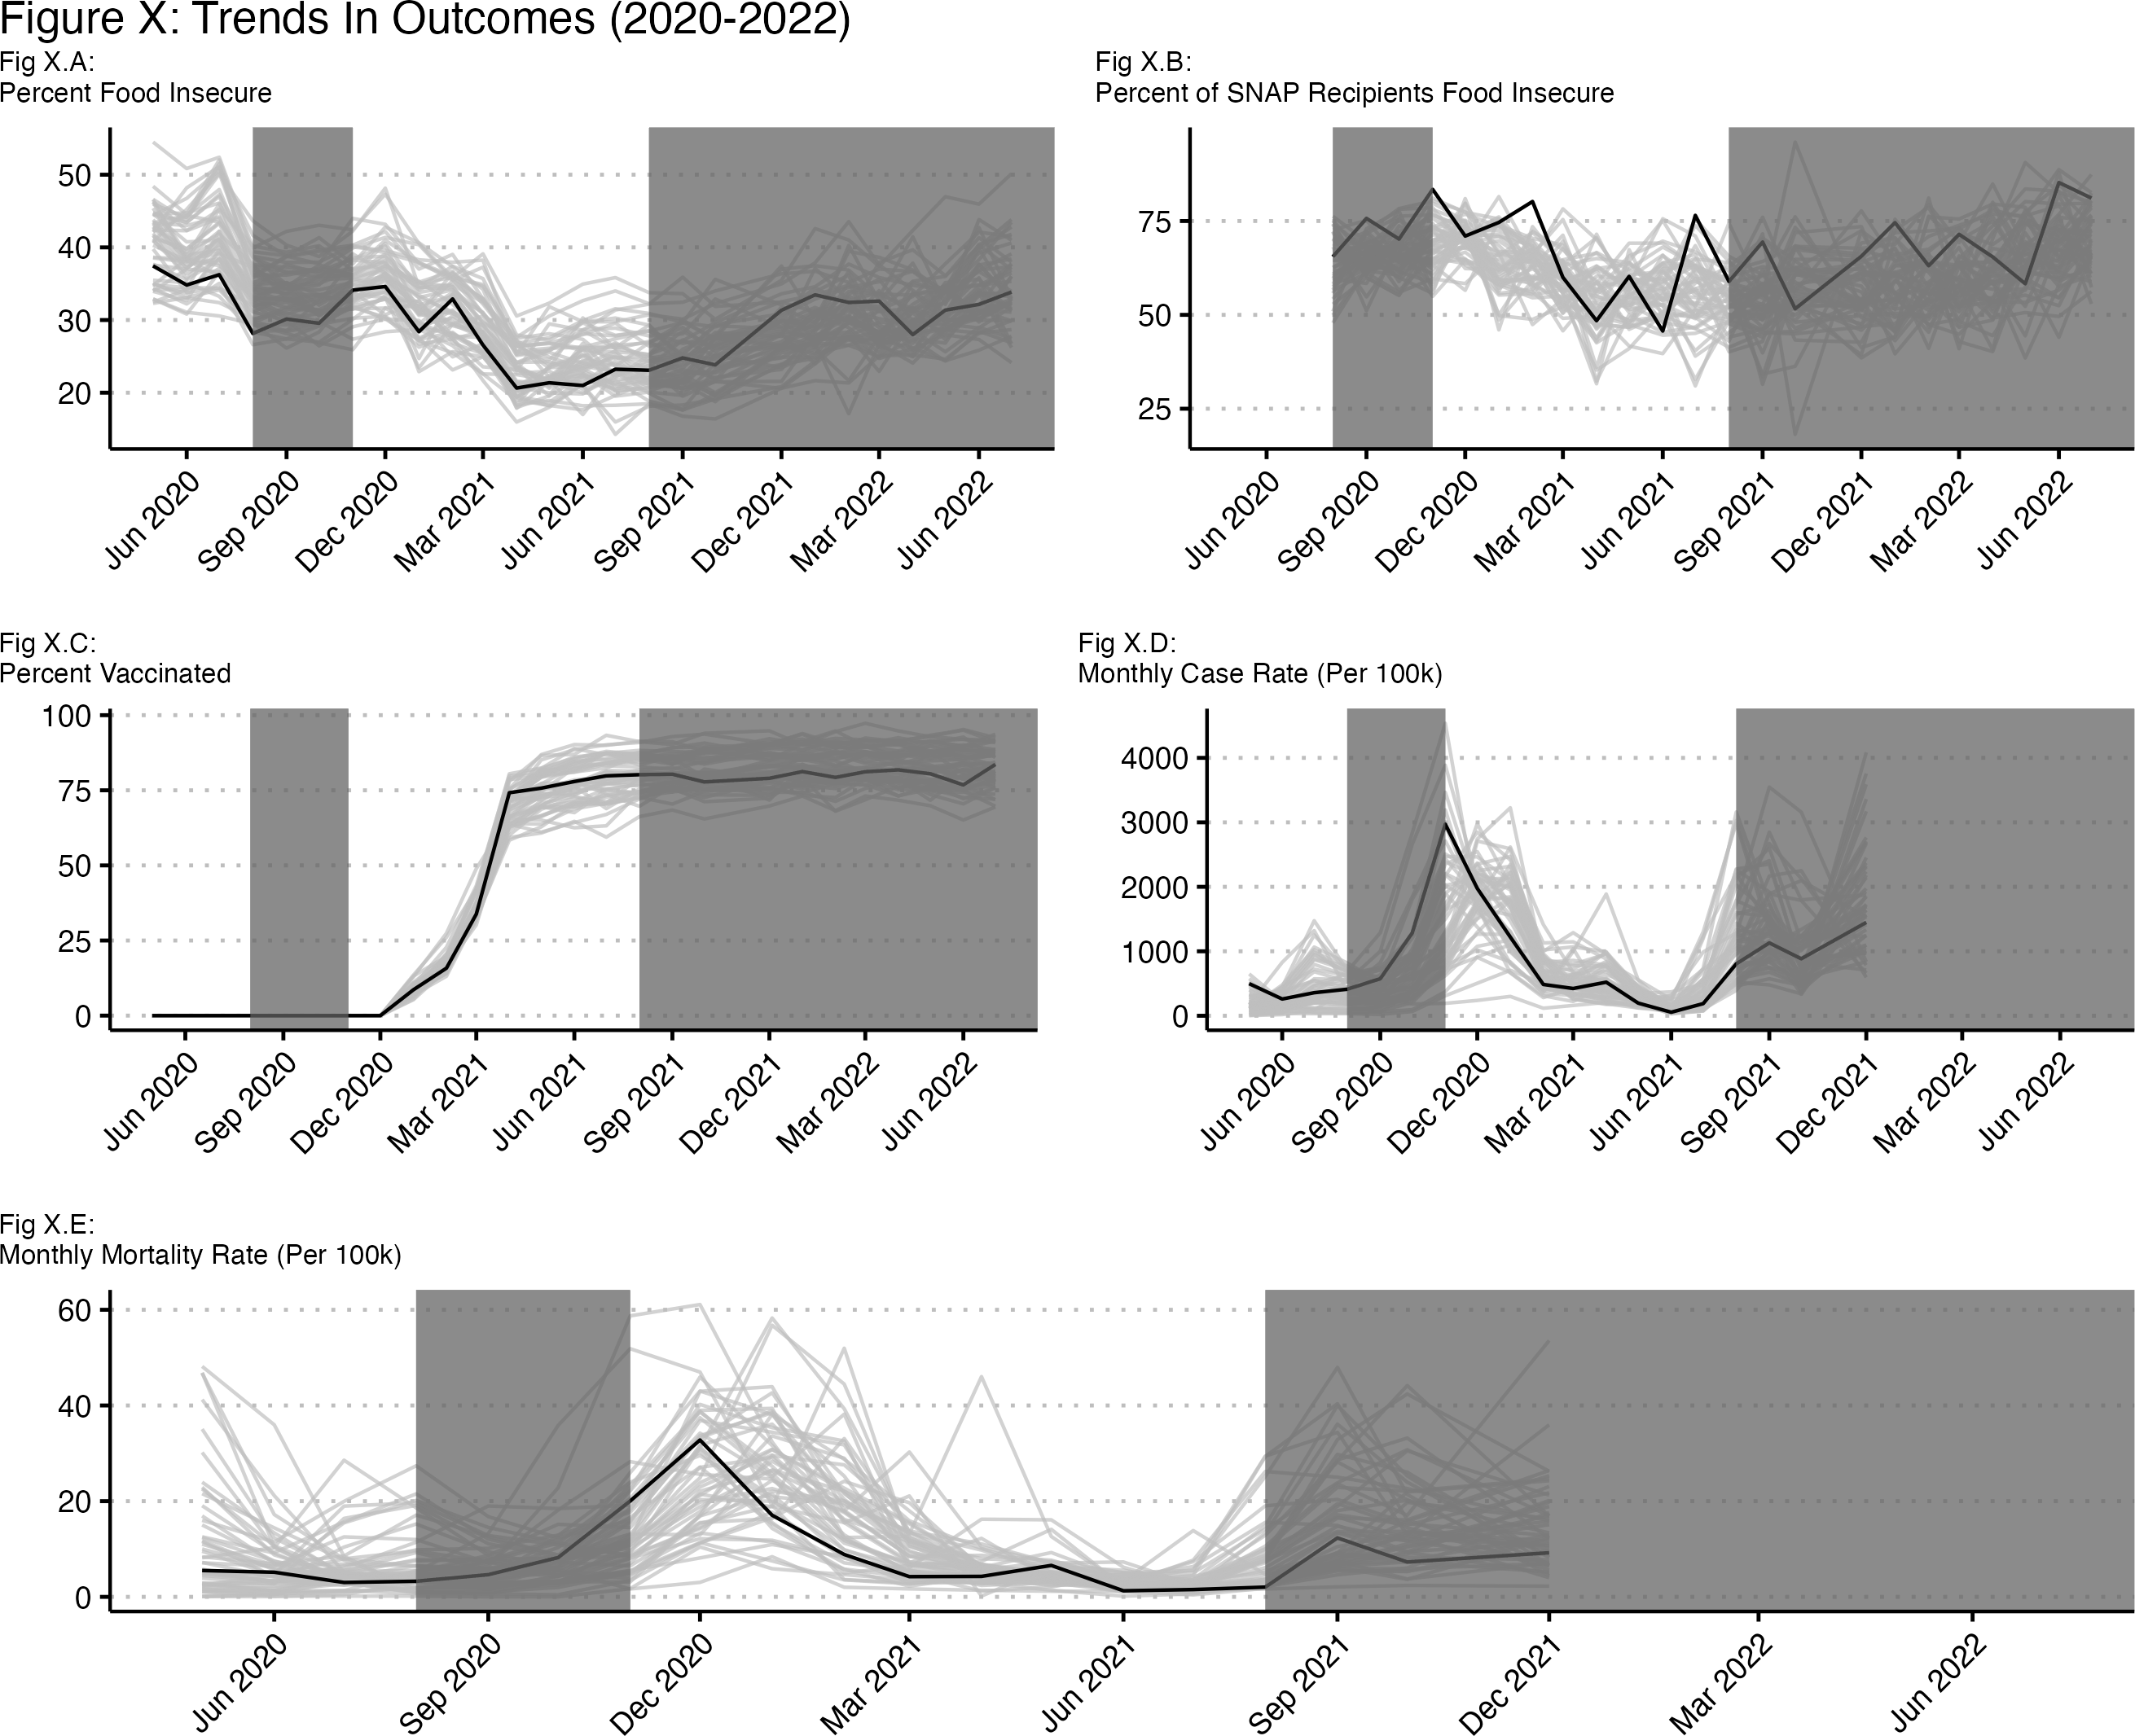

Black line is Nebraska. Shaded regions represent when Emergency allotments were inactive for Nebraska.

# References

1 Coley RL, Baum CF. [Expression of Concern About: Trends in Mental Health Symptoms, Service Use, and Unmet Need for Services among US Adults through the First Nine Months of the COVID-19 Pandemic](https://doi.org/10.1093/tbm/ibab082). *Translational Behavioral Medicine* 2021; **11**: 1963.