­

2022

ASSIGNMENT

COMPUTER NETWORK

section 2

ID: 4211063

NAME: MOHAMED RAMADAN

GROUP: A1

DR. Doniya Mohamed Abd-elhady

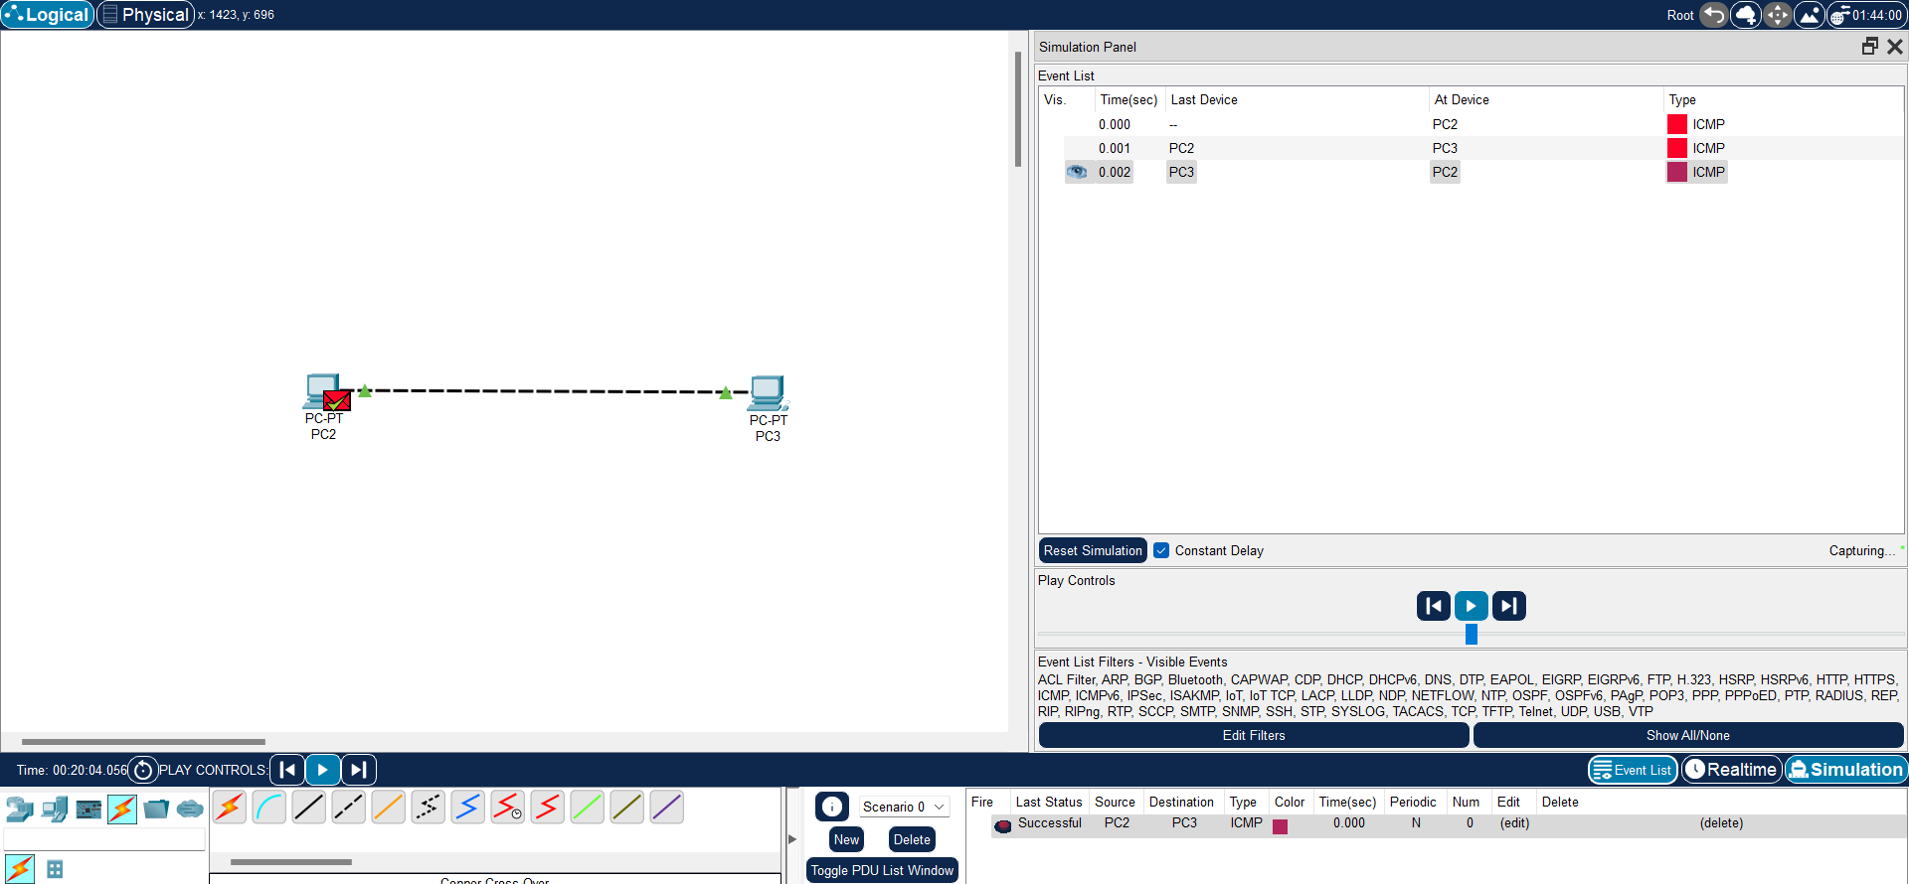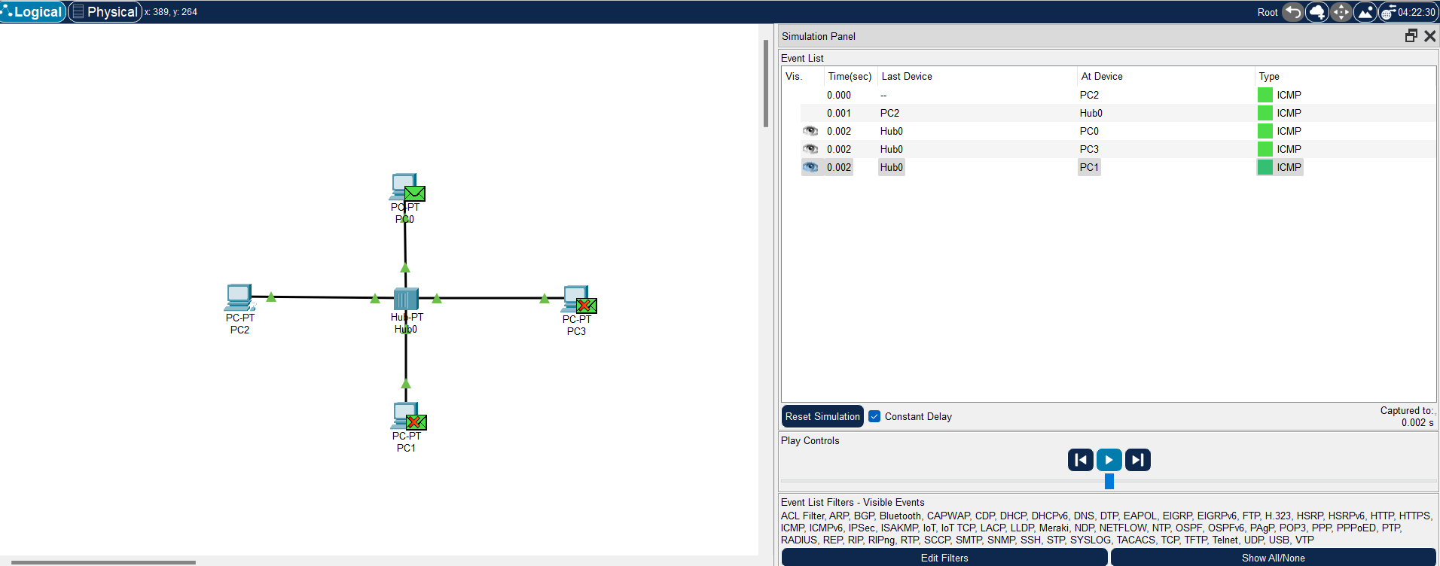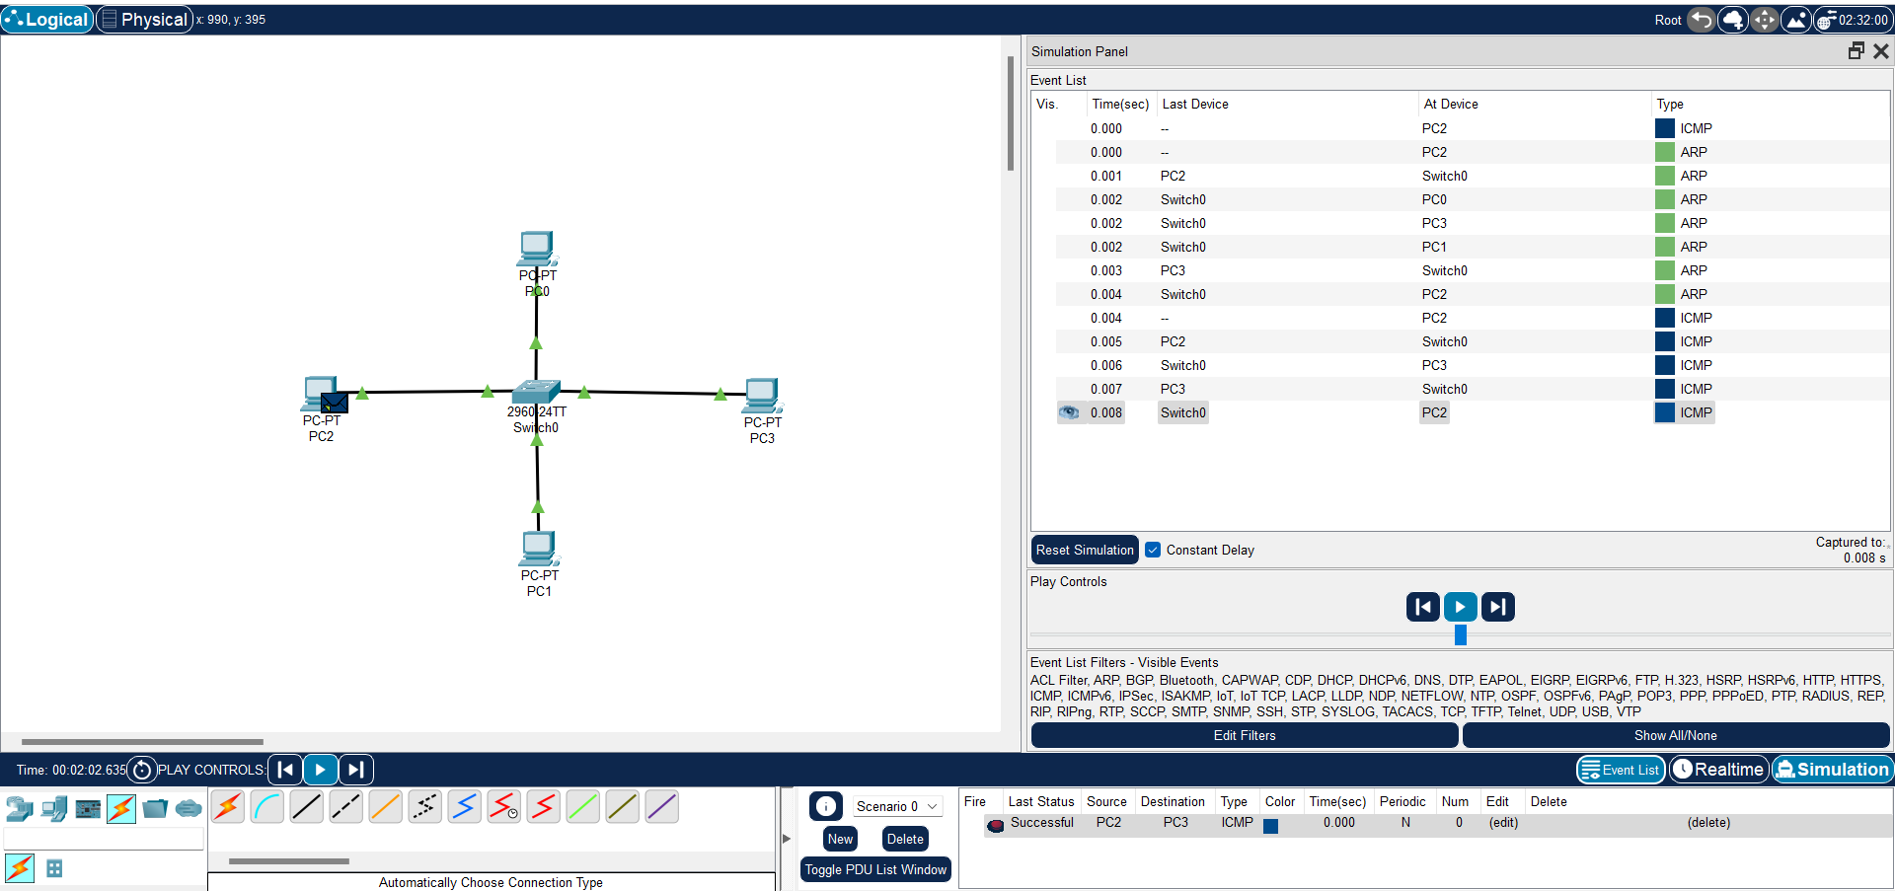

Git hub link: