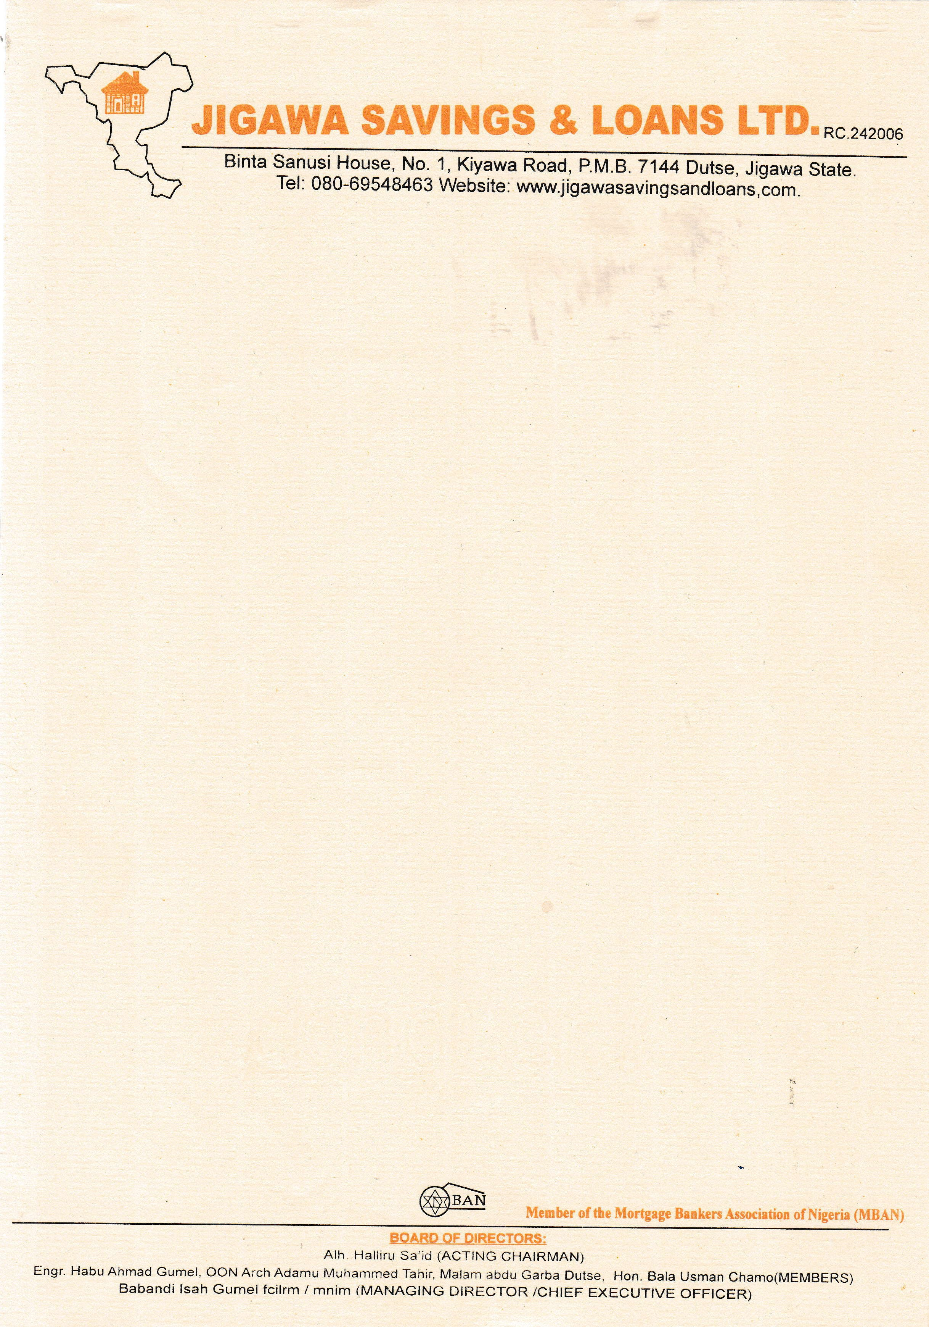

12th September, 2025

The Managing Director

OAK PENSIONS LIMITED,

266 Muritala Mohammed Way,

Yaba,

Lagos.

# VERIFICATION OF PROPERTY OFFER LETTER FOR THE SALE OF A 2 BEDROOMS BUNGALOW RESIDENTIAL PROPERTY AT RANGAZA QUARTERS, KANO STATE.

The above subject matter refers.

The property was visited on the 10th September, 2025 to ascertain the availability of the property.

The property is **2 BEDROOMS BUNGALOW RESIDENTIAL PROPERTY AT RANGAZA QUARTERS, KANO STATE** offered to **JOHN MICHAEL DOE.**

The sale value of the property as of date is **N3,000,000.00**

In view of foregoing, **‘We confirm the authenticity of the property offer letter and other documents’** as well as the availability of the property for sale.

Thanks for your usual co-operation. **Yours faithfully,**

# For: Jigawa Savings and Loan Ltd.

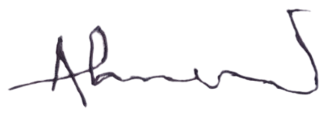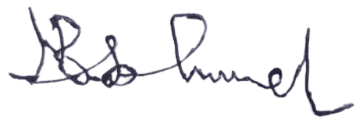

Ahmed Musa Faruk Babandi Isah Gumel

**Head of Mortgages** **Managing Director/CEO**