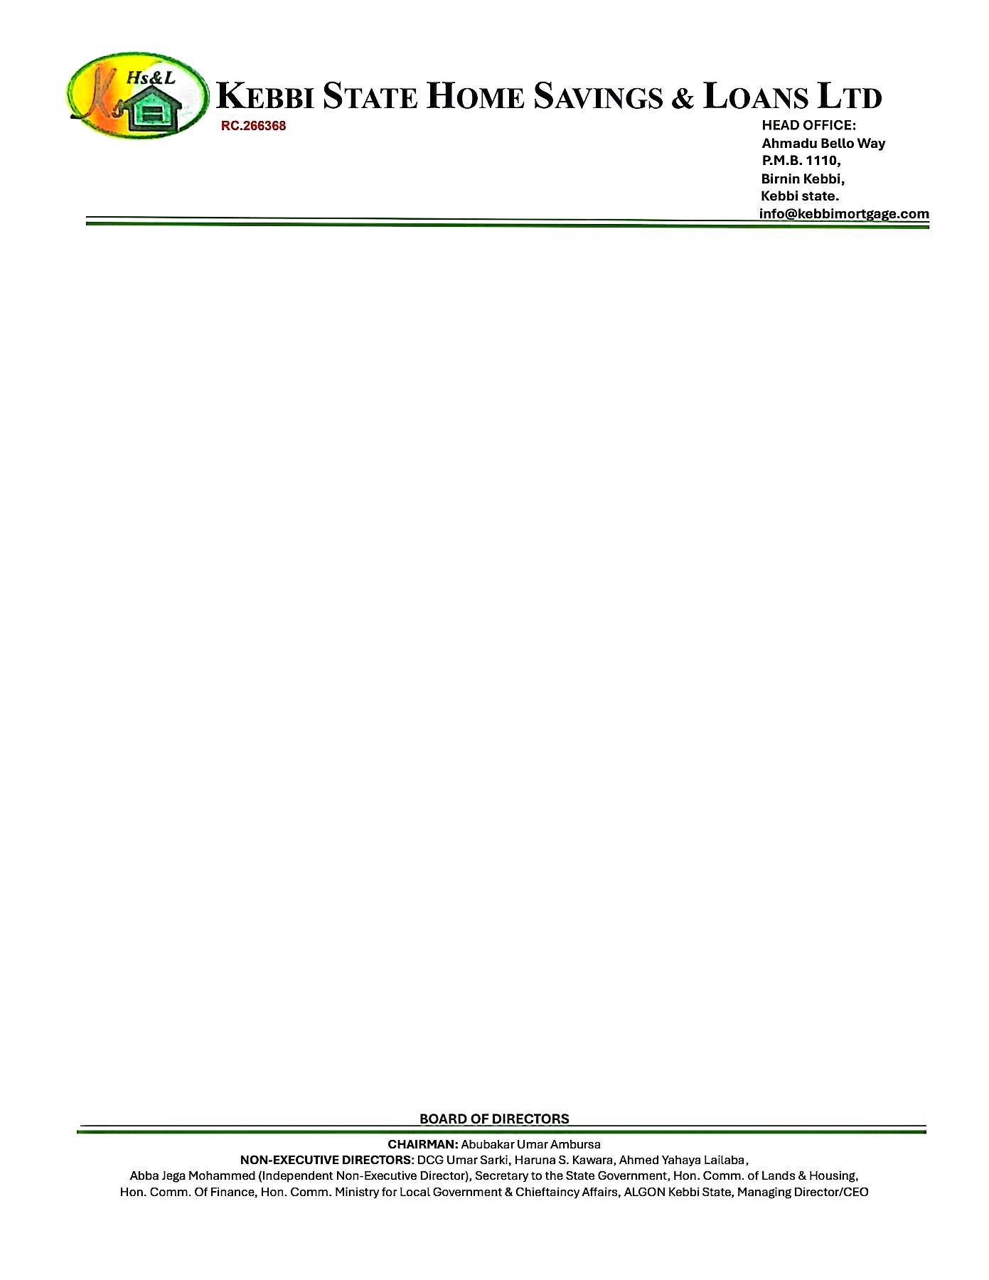

19th September, 2025

The Managing Director



NPF PENSIONS LIMITED,

Plot 3820,

R.B. Dikko Street,

Off Shehu Shagari Way,

Opposite Force Headquarters,

Central Business District (Cbd),

Abuja.

Dear Sir,

**CONFIRMATION OF PROPERTY TITLE**

We refer to the above subject and wish to confirm that the **2 BEDROOMS BUNGALOW RESIDENTIAL AT RANGAZA QUARTERS, KANO STATE.**

Which **JOHN MICHAEL DOE** intends to purchase is still available.

The property has also been confirmed to have a REGISTERED DEED OF ASSIGNMENT No.**KN0851.**

We do hope this will assist you in final processing of **JOHN MICHAEL DOE** while we appreciate you for your anticipated cooperation, please note that we are duly prepared for immediate disbursement of the funds to the rightful beneficiary.

Thanks for your usual co-operation.

Yours faithfully,

# **For: Kebbi State Home Savings & Loans Ltd**.

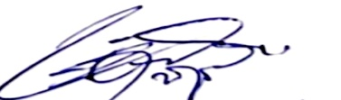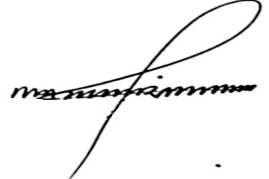

Shehu Mohammed Dr. Ahmed Musbahu

**Head of Credit Managing Director/CEO**