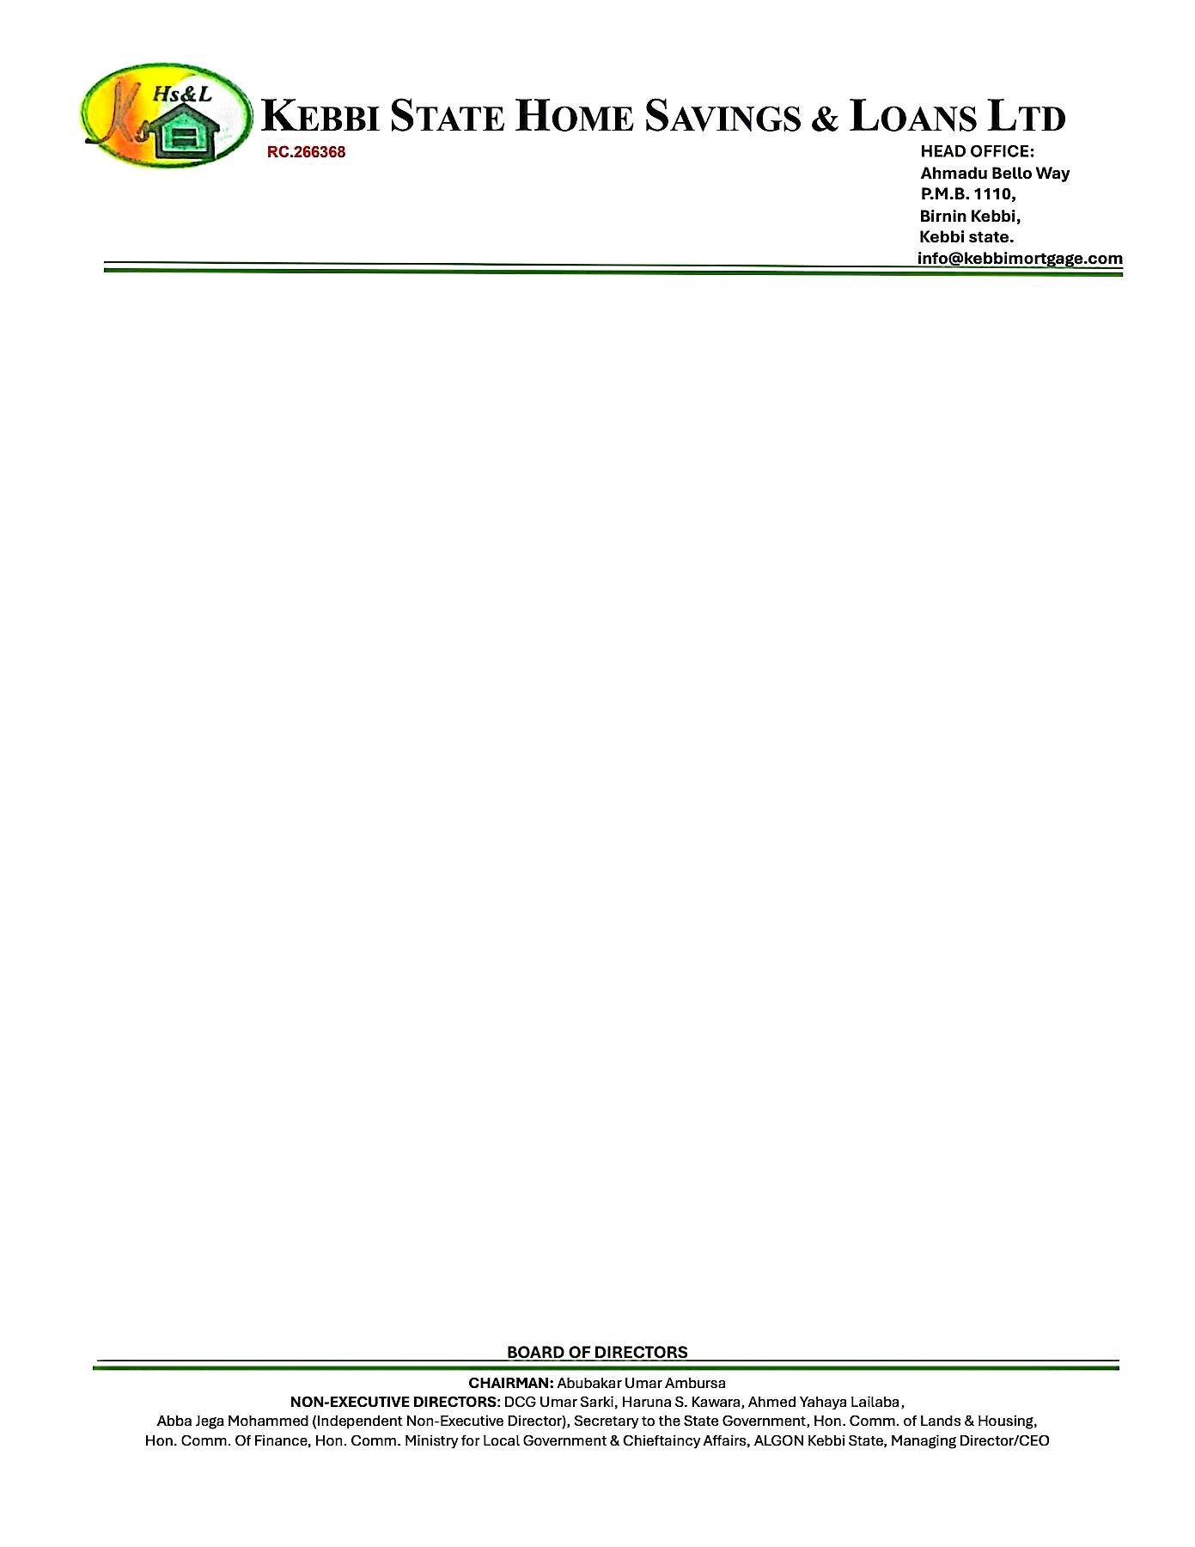

# LEGAL SEARCH REPORT IN RESPECT OF THE KANO STATE GOVERNMENT OF NIGERIA CERTIFICATE OF OCCUPANCY NO. LKN/AG/RC/81/36 DATED 19TH JUNE, 1978 AND REGISTERED AS NUMBER 43 AT PAGE 43 IN VOLUME 88 OF THE CERTIFICATE OF OCCUPANCY REGISTER IN THE LANDS REGISTRY OFFICE, KANO, KANO STATE

1. Date of Search: 19th September, 2025
2. Place of Search: Lands Registry Office, Kano, Kano State
3. Full Description of Land: All that parcel of land lying, being and situate

Rangaza, Kano State

1. Parties: 1. Kano State Government of Nigeria And

# 2. Alhaji Adamu Jibrin

1. Description of Title Document: The Kano State Government of Nigeria Certificate of

Occupancy No. KN0851 dated 19th June, 1978 and registered as Number 43 at Page 43 in Volume 88 of the Certificate of Occupancy Register in the Lands Registry Office, Kano, Kano State

1. Term/Commencement Date: ninety-nine (99) years commencing from the 19th day of February, 1982.
2. Purpose Residential Use
3. Notable/Special Terms Clause 4 of the Title Document search provides that

within 2 years from the commencement of the Right of Occupancy, the Grantee must erect buildings on the land in conformity with the purpose for which the land was granted.

Clause 6 of the Title Document search provides that upon the expiration of the 40-year term granted, the holder shall deliver up possession to the Kano State Government.

Clause 7 of the Title Document search provides that the holder shall not build or permit to be built on the said land any buildings other than those covenanted to be built under the aforementioned Title Document.

Clause 9 of the Title Document search provides that the holder is not to alienate the right of occupancy granted either by way of sale, assignment, mortgage or sublease (*inter alia)* without the prior written consent of the Governor.

9. Charges/Encumbrance: AS at the date and time of this search, there is no

evidence at the Lands Registry Office, Kano, Kano State of any charges/encumbrances against the Title Document which will prevent the alienation and transfer of a portion of the land with the building thereon by Alhaji Adamu Jibrin in favour of **JOHN MICHAEL DOE.**

# Conclusion:

We conclude that Alhaji Adamu Jibrin has good title to the land search and its power to alienate its interest in a portion of the said land **JOHN MICHAEL DOE is** unencumbered.

Search report Prepared by:

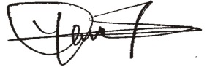uleiman

# Yahaya Tanimu

Legal Practitioner

