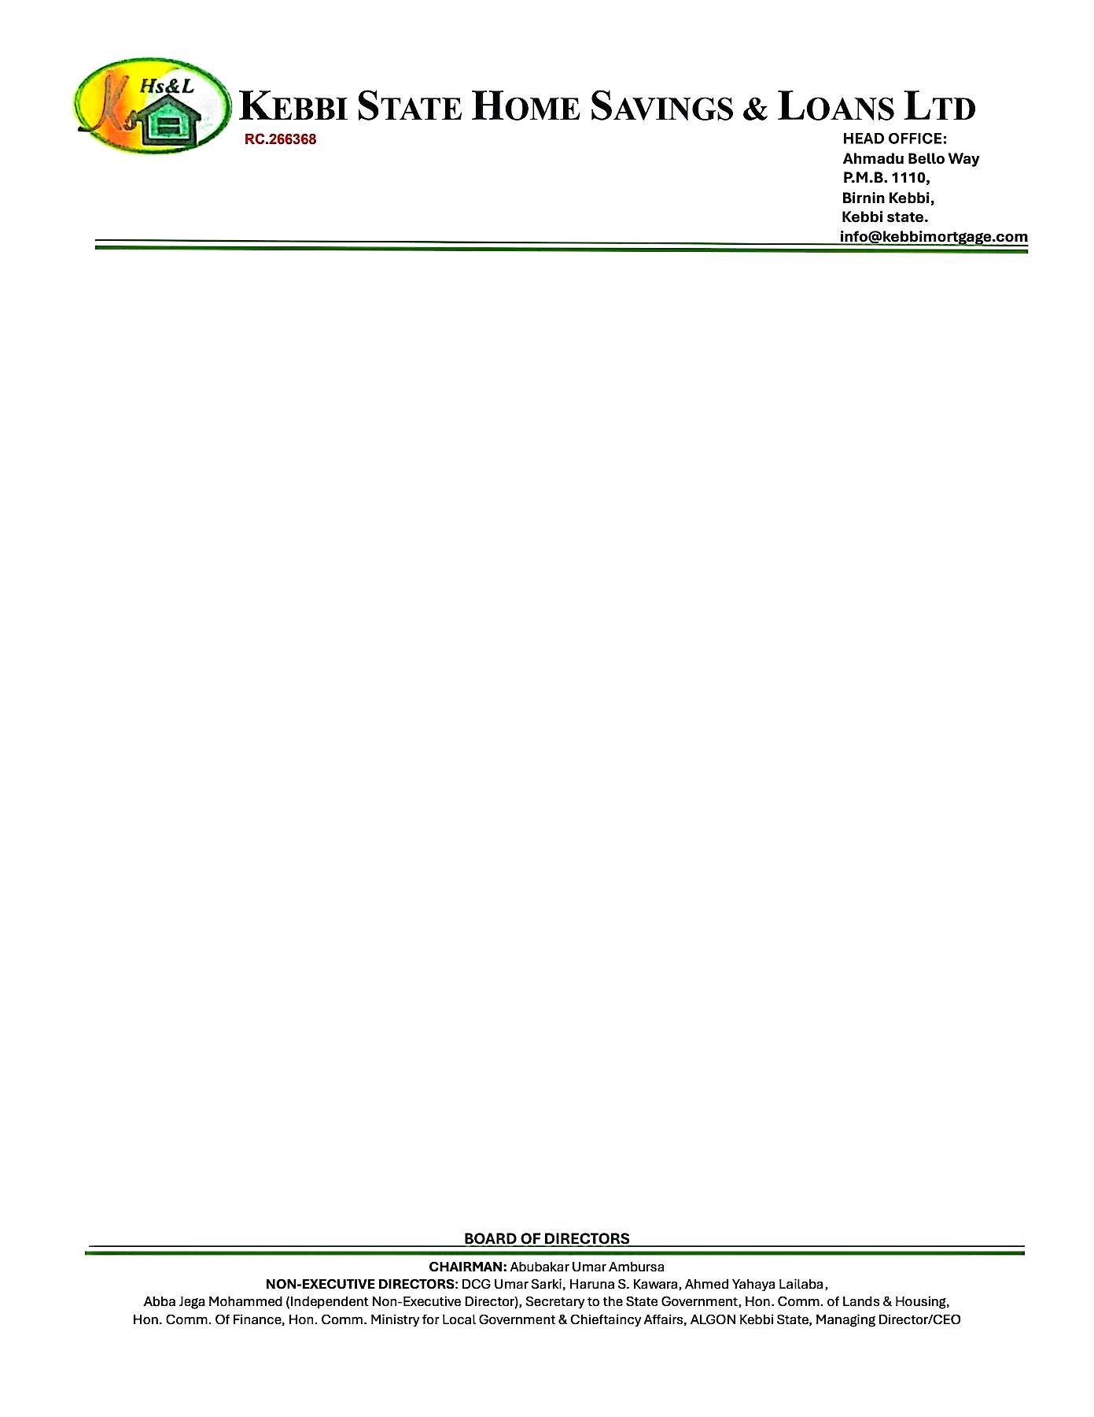

19th September, 2025



The Managing Director

NPF PENSIONS LIMITED,

Plot 3820,

R.B. Dikko Street,

Off Shehu Shagari Way,

Opposite Force Headquarters,

Central Business District (Cbd),

Abuja.

Dear Sir,

**EXPRESSION OF READINESS TO DISBURSE LOAN**

We hereby express our readiness as a Mortgage Bank to disburse a loan sum **N2,250,000.00 (Two Million Two Hundred Fifty Thousand Naira Only)** to **JOHN MICHAEL DOE** with Jigawa Savings and Loans Ltd Account Number- **0123456789.**

Kindly credit the customer’s account details stated above with the sum **N 750,000.00 (Seven Hundred Fifty Thousand Naira Only),** being his 25% retirement savings, as an equity contribution for the purchase of a **2 BEDROOMS BUNGALOW AT RANGAZA QUARTERS KANO STATE.**

Thanks for your usual co-operation

Yours faithfully,

# **For: Kebbi State Home Savings & Loans Ltd**.

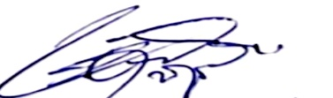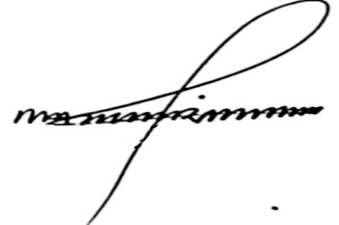

Shehu Mohammed Dr. Ahmed Musbahu

**Head of Credit Managing Director/CEO**