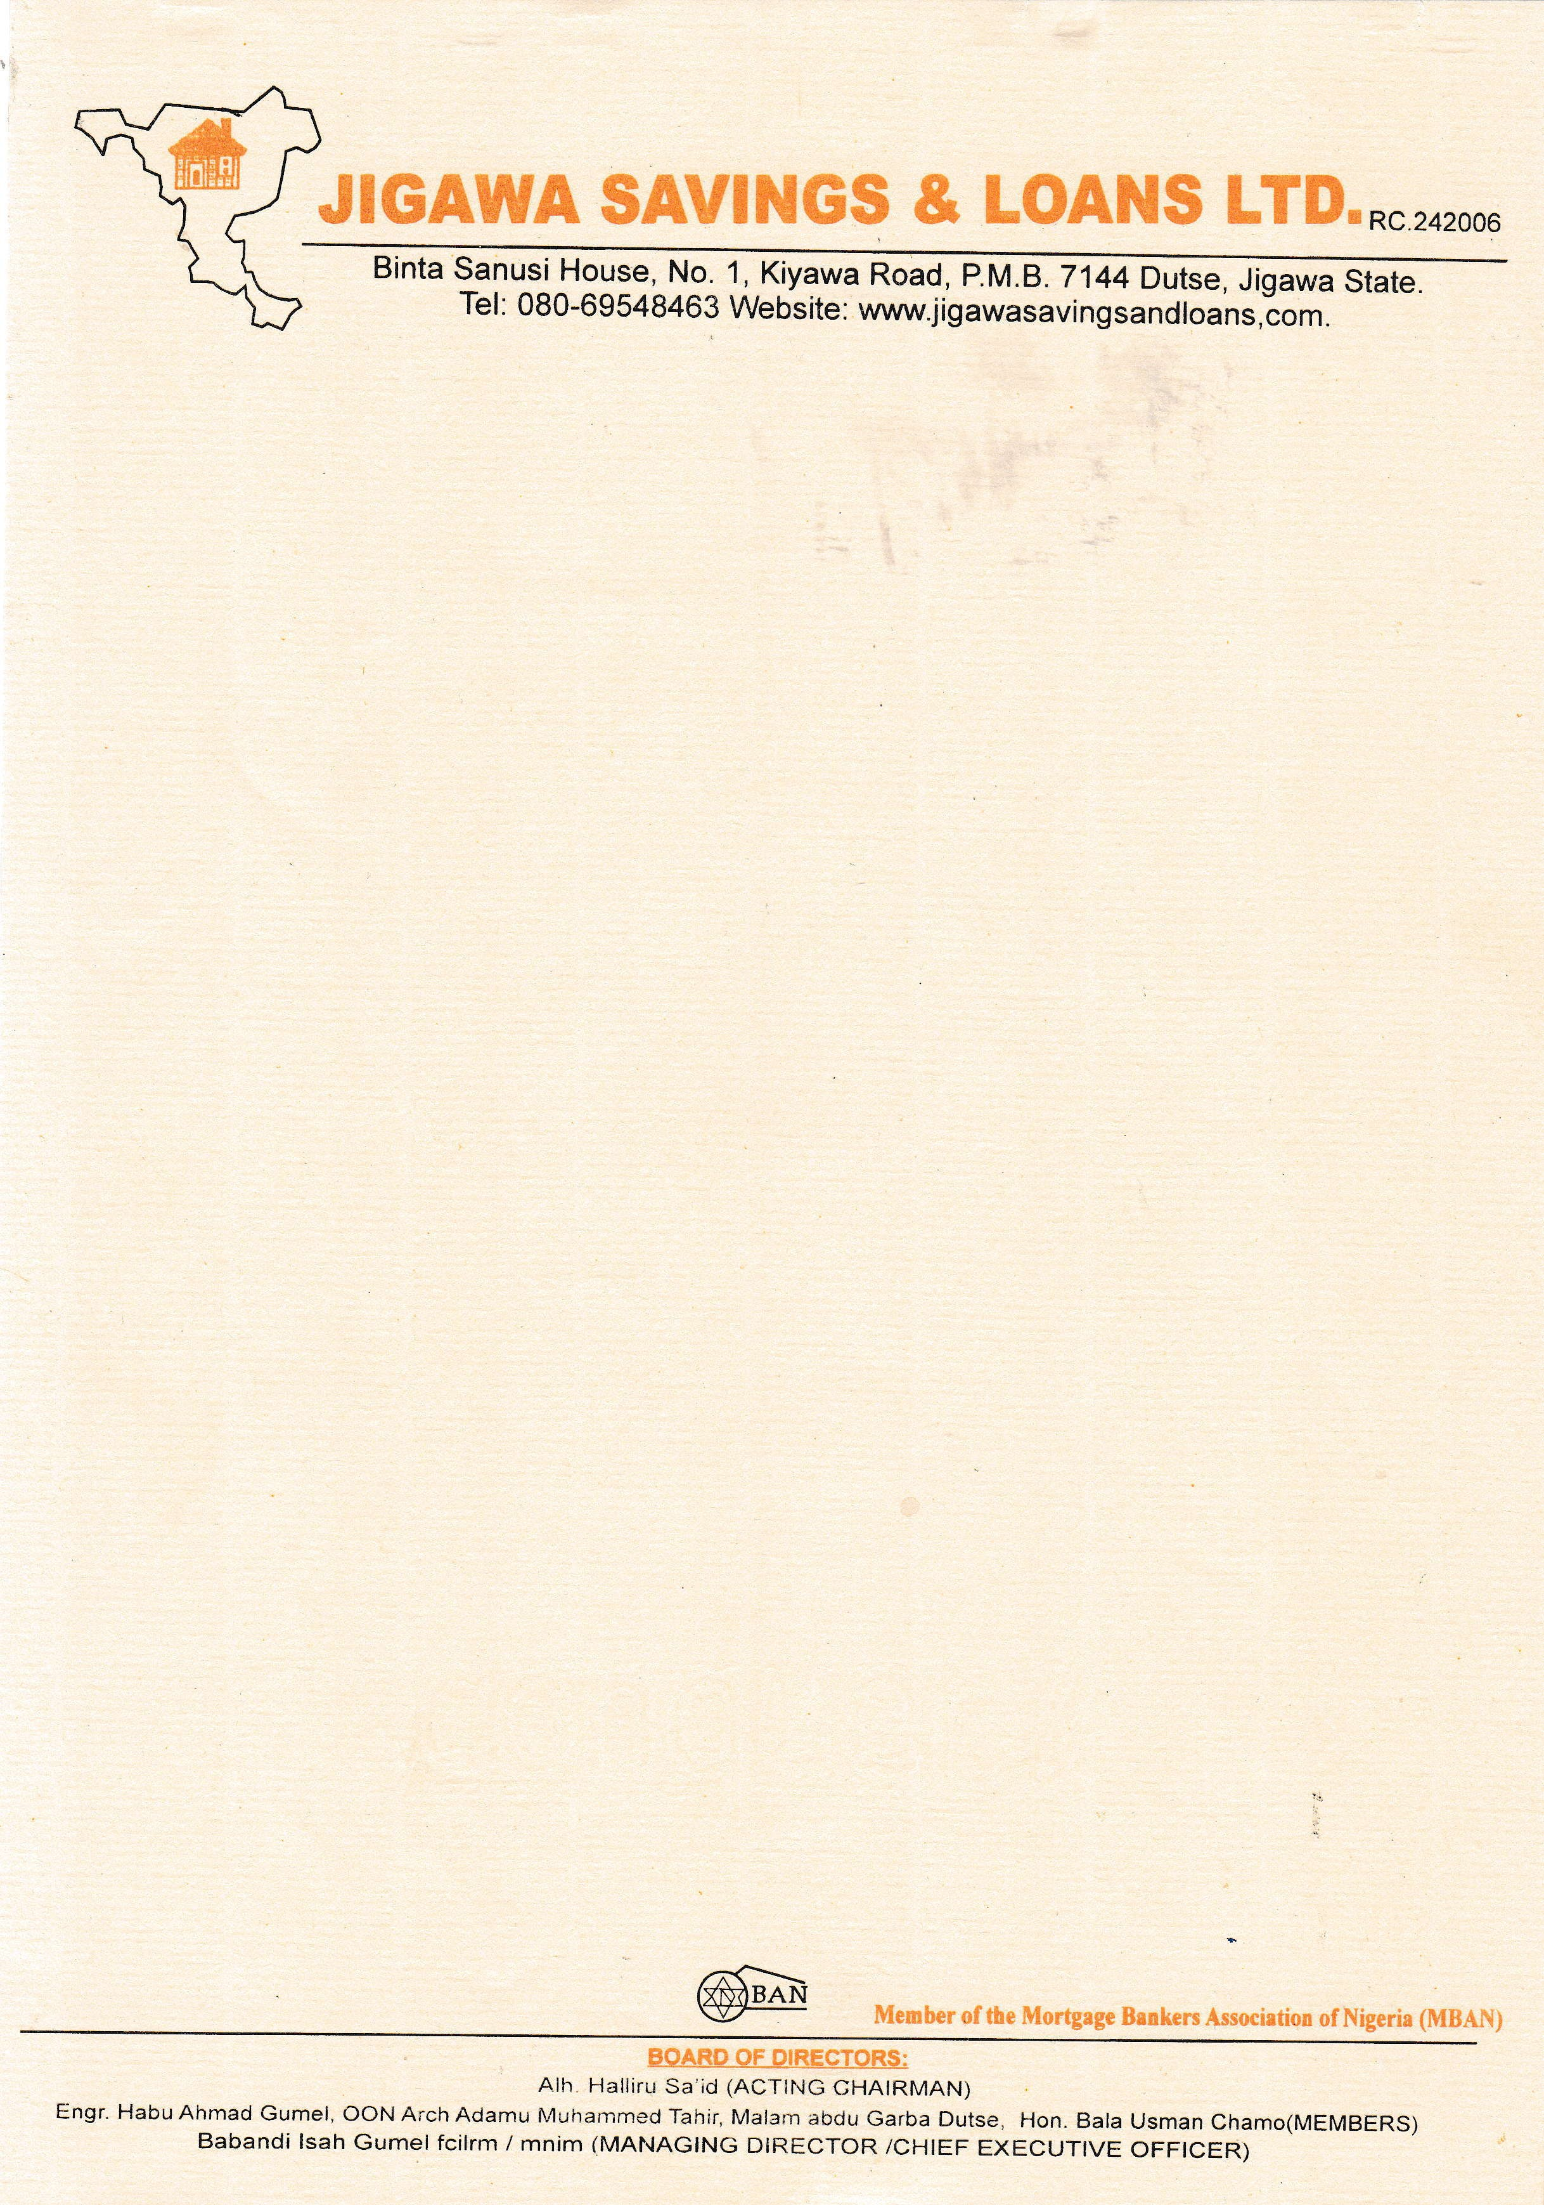

# TO:

12th September, 2025

The Managing Director



NPF PENSIONS LIMITED,

Plot 3820,

R.B. Dikko Street,

Off Shehu Shagari Way,

Opposite Force Headquarters,

Central Business District (Cbd),

Abuja.

# LETTER OF INDEMNITY IN RESPECT OF RETIREMENT SAVINGS ACCOUNT EQUITY CONTRIBUTION

**THIS INDEMNITY** is issued by Jigawa Savings and Loans Limited of Binta Sanusi House, No.1 Kiyawa Road, P.M.B 7144 Dutse, Jigawa (hereinafter called “Indemnifier” which expression shall where the context so admits include its successors-in-title and assigns), to **NPF PENSIONS LIMITED** having its Head Office at **PLOT 3820, R.B. DIKKO STREET, OFF SHEHU SHAGARI WAY, OPPOSITE FORCE HEADQUARTERS, CENTRAL BUSINESS DISTRICT (CBD), ABUJA.** (hereinafter called “indemnified PFA” which expression shall where the context so admits include its successors-in-title and assigns)

# WHEREAS:

1. **NPF PENSIONS LIMITED** is a Pension Fund Administrator licensed by the

National Pension Commission (“the Commission”) to manage individual Retirement Savings Accounts (RSA) in accordance with the provisions of the Pension Reform Act, 2014 (“the Act”);

1. Pursuant to the Act, the Commission has issued Guidelines on Accessing RSA Balance towards Payment of Equity Contributions for Residential Mortgage (“Guidelines”) which Guidelines permit RSA Account Holders to access a portion of their RSA balance as equity contribution towards acquiring a residential property from a licensed financial institution;
2. The Indemnifier is duly licensed by the Central Bank of Nigeria (CBN) and meets all the eligibility criteria for the provision of mortgage lending services to RSA holders under the Guidelines issued by the Commission.
3. The Indemnifier has received applications from several RSA holders who maintain RSAs with **NPF PENSIONS LIMITED** and in line with the Guidelines, the indemnifier has agreed to finance the purchase of a residential property on behalf of the RSA holders, subject to the execution of relevant mortgage contracts.

Page **1** of **2 Confidential**

1. **JOHN MICHAEL DOE**, the RSA holder has requested and authorized that a portion of his/her RSA balance should be utilized as equity contribution to facilitate his/her mortgage and has applied to **NPF PENSIONS LIMITED** to release to the indemnifier, a portion not more than 25% of his/her RSA balance as equity contribution towards the acquisition of a residential mortgage.
2. The Indemnifier has conducted all requisite due diligence to confirm the authenticity of the RSA holder’s intended acquisition of a residential property and undertakes to **NPF PENSIONS LIMITED** that the portion of the RSA holder’s fund which shall be released to the Indemnifier on the RSA holder’s request shall be applied solely as equity contribution towards the acquisition of a residential mortgage, under the mortgage agreement between the Indemnifier and the RSA holder; and shall not, under any condition, be released to the RSA holder or any third party for any other purpose.
3. **NPF PENSIONS LIMITED** agrees to release the relevant portion of the RSA holder’s fund to the Indemnifier and has requested that the Indemnifier provides this indemnity in favour of **NPF PENSIONS LIMITED** in the manner hereinafter stated.

**NOW THEREFORE**, in consideration of indemnified PFA effecting the transfer of the portion of the RSA holder’s balance to the Indemnifier as equity contribution by the RSA holder whose RSA PIN herein appears, towards acquisition of residential property in accordance with the Guidelines, **We, Jigawa Savings and Loans Limited** hereby irrevocably and unconditionally covenant that we shall at all times hereafter, indemnify **NPF PENSIONS LIMITED** and keep **NPF PENSIONS LIMITED** fully indemnified against all claims, demands, liabilities, actions, damages, penalties and legal proceedings (including any cost of litigation) which may be incurred by **NPF PENSIONS LIMITED** in the event that the fund so released by **NPF PENSIONS LIMITED** is not utilized as equity contribution towards the purchase of a residential property on behalf of the RSA holder.

**Furthermore**, Jigawa Savings and Loans undertakes to pay **NPF PENSIONS LIMITED** on demand without cavil or contention, all payments, liabilities, damages and expenses (including but not limited to legal fees) incurred by the **NPF PENSIONS LIMITED** from acceding to the RSA holder’s request to release funds from his/her RSA, in the event that the fund so released by **NPF PENSIONS LIMITED** is not utilized as equity contribution towards the purchase of a residential property on behalf of the RSA holder.

This Indemnity shall be a continuing security and shall be enforceable from the date of disbursement of the portion of the RSA holder’s balance to the Indemnifier and shall inure to the benefit of **NPF PENSIONS LIMITED** up until the utilization of the funds so released, as equity contribution towards the acquisition of the residential property in favour of the RSA holder by the Indemnifier.

This Indemnity shall not be enforceable against the Indemnifier for any claims, demands, liabilities, losses, actions, damages, penalties, and legal proceedings (including any cost of litigation), arising from any dispute or breach howsoever, in the contractual relationship between the **NPF PENSIONS LIMITED** and the RSA holder.

The indemnification provided under this Indemnity by the Indemnifier shall be completely discharged upon the utilization of the portion of the RSA holder’s balance towards the purchase of a residential property in favour of the RSA holder by the Indemnifier.

|  |  |
| --- | --- |
| **RSA HOLDER** | **RSA PIN** |
| **JOHN MICHAEL DOE** | **PEN-48291736** |

This indemnity shall be governed by and construed in accordance with the extant laws of the Federal Republic of Nigeria.THE COMMON SEAL of the within named INDEMNIFIER **JIGAWA SAVINGS & LOANS LIMITED** was hereunto affixed in the presence

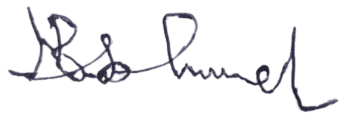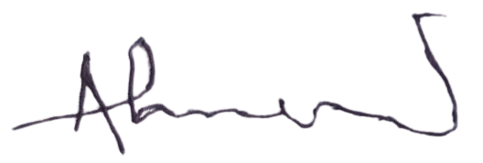

**Director Director/Secretary**