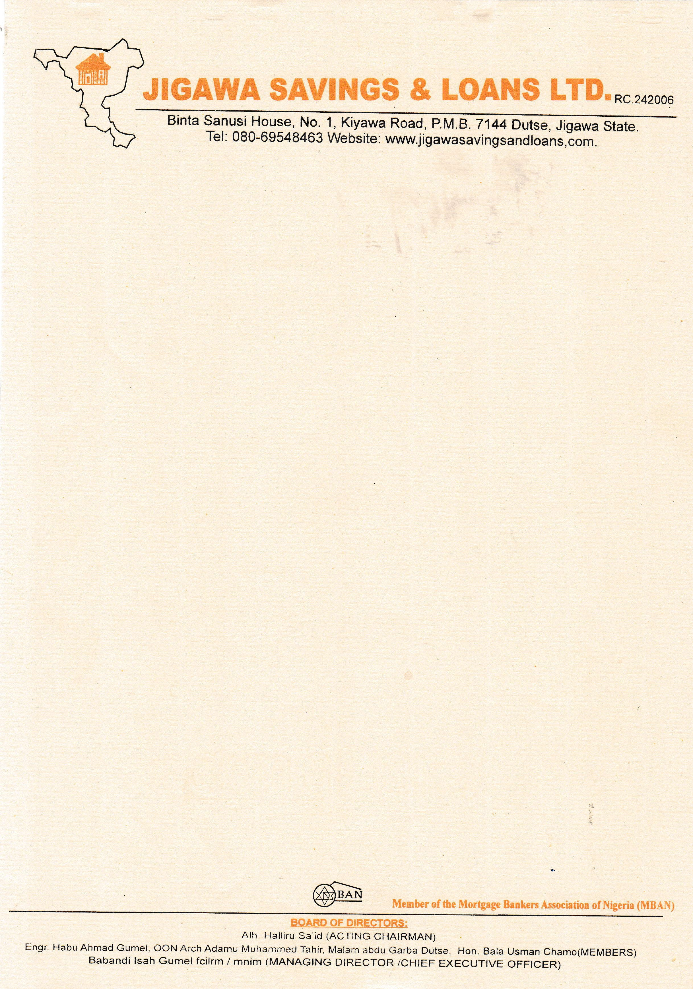

September 7th, 2025



The Managing Director

NPF PENSIONS LIMITED,

Plot 3820,

R.B. Dikko Street,

Off Shehu Shagari Way,

Opposite Force Headquarters,

Central Business District (Cbd),

Abuja.

Dear Sir/Ma

**CONFIRMATION OF THE PROPERTY AVAILABILITY FOR JOHN MICHAEL DOE**

We hereby write to official confirm that the property **2 BEDROOMS BUGALOW AT RANGAZA QUARTERS, KANO STATE**

# Offered to JOHN MICHAEL DOE is very much available. Please go ahead with his 25% RSA Residential Mortgage.

Thank you for your co-operation

Thanks for your usual co-operation.

Yours faithfully,

# For: Jigawa Savings and Loan Ltd.

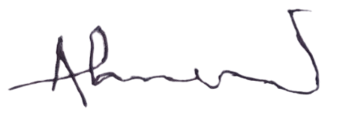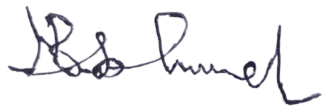

Ahmed Musa Faruk Babandi Isah Gumel

**Head of Mortgages** **Managing Director/CEO**