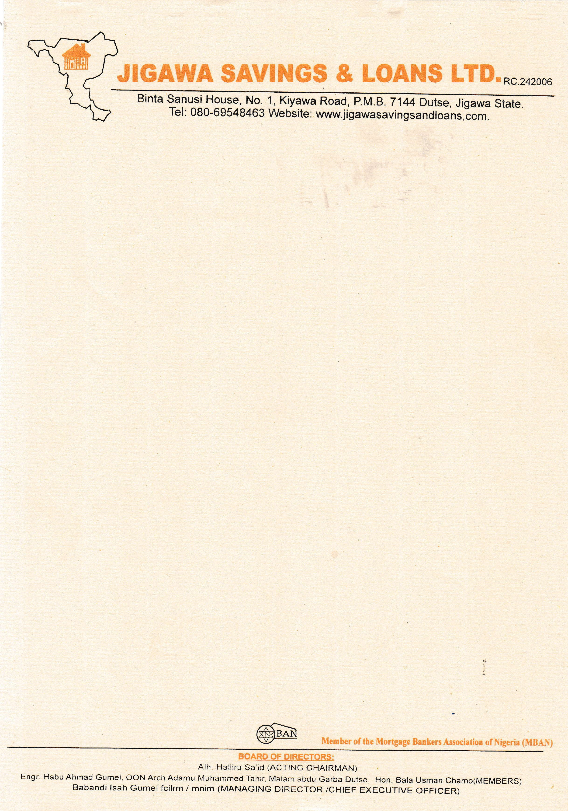

September 7th, 2025



The Managing Director

NPF PENSIONS LIMITED,

Plot 3820,

R.B. Dikko Street,

Off Shehu Shagari Way,

Opposite Force Headquarters,

Central Business District (Cbd),

Abuja.

Dear Sir,

# RE: CONFIRMATION OF PROPERTY TITLE

We refer to the above subject and wish to confirm that the A **2 BEDROOMS BUNGALOW RESIDENTIAL AT RANGAZA QUARTERS, KANO STATE.**

Which **JOHN MICHAEL DOE** intends to purchase is still available.

The property has also been confirmed to have a REGISTERED DEED OF ASSIGNMENT No. **LKN/AG/RC/81/36.**

We do hope this will assist you in final processing of **JOHN MICHAEL DOE** while we appreciate you for your anticipated cooperation, please note that we are duly prepared for immediate disbursement of the funds to the rightful beneficiary.

Thanks for your usual co-operation.

Yours faithfully,

# For: Jigawa Savings and Loan Ltd.

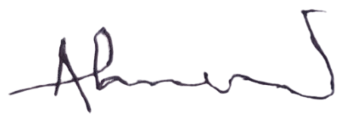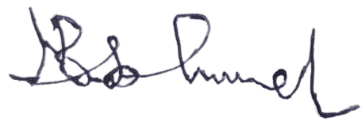

Ahmed Musa Faruk Babandi Isah Gumel

**Head of Mortgages** **Managing Director/CEO**