9th September, 2025

The Managing Director



LEADWAY PENSURE PFA LIMITED,

121/123 Funsho Williams Avenue,

Surulere,

Lagos.

Dear Sir,

# EXPRESSION OF READINESS TO DISBURSE LOAN

We hereby express our readiness as a Mortgage Bank to disburse a loan sum **N1,468,790.62 (One Million Four Hundred Sixty Eight Thousand Seven Hundred Ninety Naira, Sixty Two Kobo Only)** to **DOCAS MASOYE** with Jigawa Savings and Loans Ltd Account Number- **0001001230.**

Kindly credit the customer’s account details stated above with the sum **N 4,531,209.39 (Four Million Five Hundred Thirty One Thousand Two Hundred Nine Naira, Thirty Nine Kobo Only),** being his 25% retirement savings, as an equity contribution for the purchase of a **2 BEDROOMS BUNGALOW AT RANGAZA QUARTERS KANO STATE.**

Alternatively, you can transfer the funds to our **GT bank Plc**. account details below: Account Name: **Jigawa Savings and Loans Limited** Account Number: **0000883899** Narration: 25% equity contribution **DOCAS MASOYE** – **0001001230.**

Thanks for your usual co-operation

Yours faithfully,

# For: Jigawa Savings and Loan Ltd.

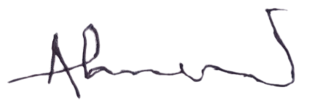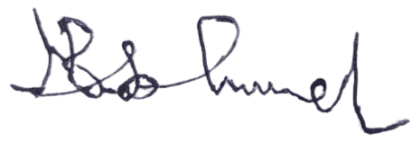

Ahmed Musa Faruk Babandi Isah Gumel

**Head of Mortgages** **Managing Director/CEO**

