18th September, 2025

The Managing Director



NPF PENSIONS LIMITED,

Plot 3820,

R.B. Dikko Street,

Off Shehu Shagari Way,

Opposite Force Headquarters,

Central Business District (Cbd),

Abuja.

Dear Sir,

# EXPRESSION OF READINESS TO DISBURSE LOAN

We hereby express our readiness as a Mortgage Bank to disburse a loan sum **N2,250,000.00 (Two Million Two Hundred Fifty Thousand Naira Only)** to **JOHN MICHAEL DOE** with Jigawa Savings and Loans Ltd Account Number- **0123456789.**

Kindly credit the customer’s account details stated above with the sum **N 750,000.00 (Seven Hundred Fifty Thousand Naira Only),** being his 25% retirement savings, as an equity contribution for the purchase of a **2 BEDROOMS BUNGALOW AT RANGAZA QUARTERS KANO STATE.**

Alternatively, you can transfer the funds to our **GT bank Plc**. account details below: Account Name: **Jigawa Savings and Loans Limited** Account Number: **0000883899** Narration: 25% equity contribution **JOHN MICHAEL DOE** – **0123456789.**

Thanks for your usual co-operation

Yours faithfully,

# For: Jigawa Savings and Loan Ltd.

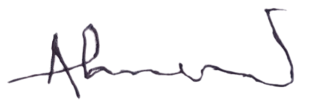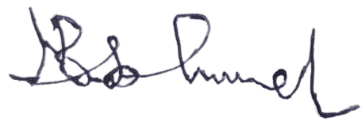

Ahmed Musa Faruk Babandi Isah Gumel

**Head of Mortgages** **Managing Director/CEO**

