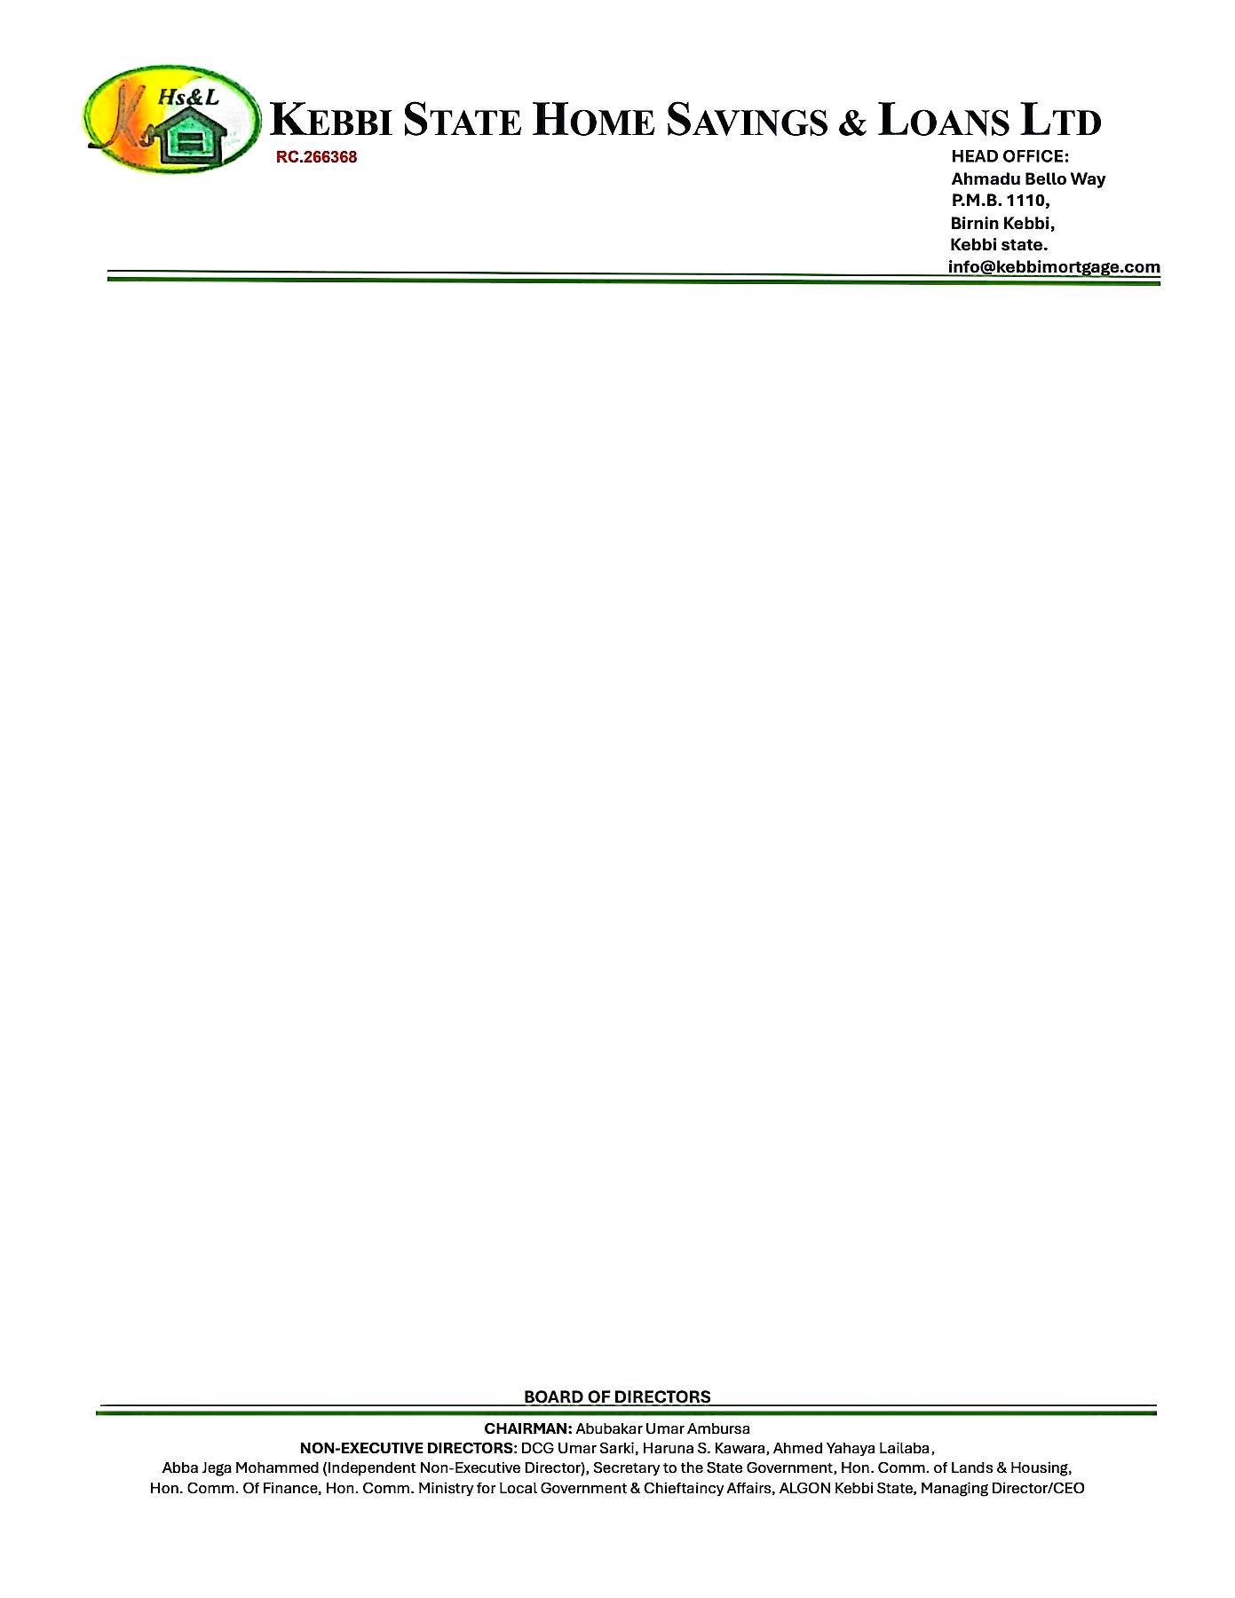

22nd September, 2025

The Managing Director



NORRENBERGER PENSIONS LIMITED,

No. 22 Otukpo Street,

Off Gimbiya Street,

Area 11,

Garki,

Abuja.

Dear Sir/Ma

**CONFIRMATION OF THE PROPERTY AVAILABILITY FOR JOHN MICHAEL DOE**

We hereby write to official confirm that the property **2 BEDROOMS BUGALOW AT RANGAZA QUARTERS, KANO STATE**

Offered to **JOHN MICHAEL DOE** is very much available. Please go ahead with his 25% RSA Residential Mortgage.

Thanks for your usual co-operation.

Yours faithfully,

# **For: Kebbi State Home Savings & Loans Ltd**.

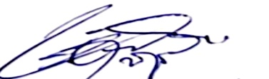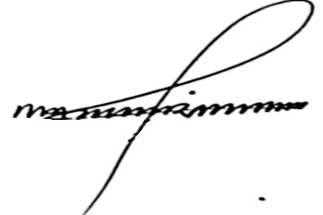

Shehu Mohammed Dr. Ahmed Musbahu

**Head of Credit Managing Director/CEO**