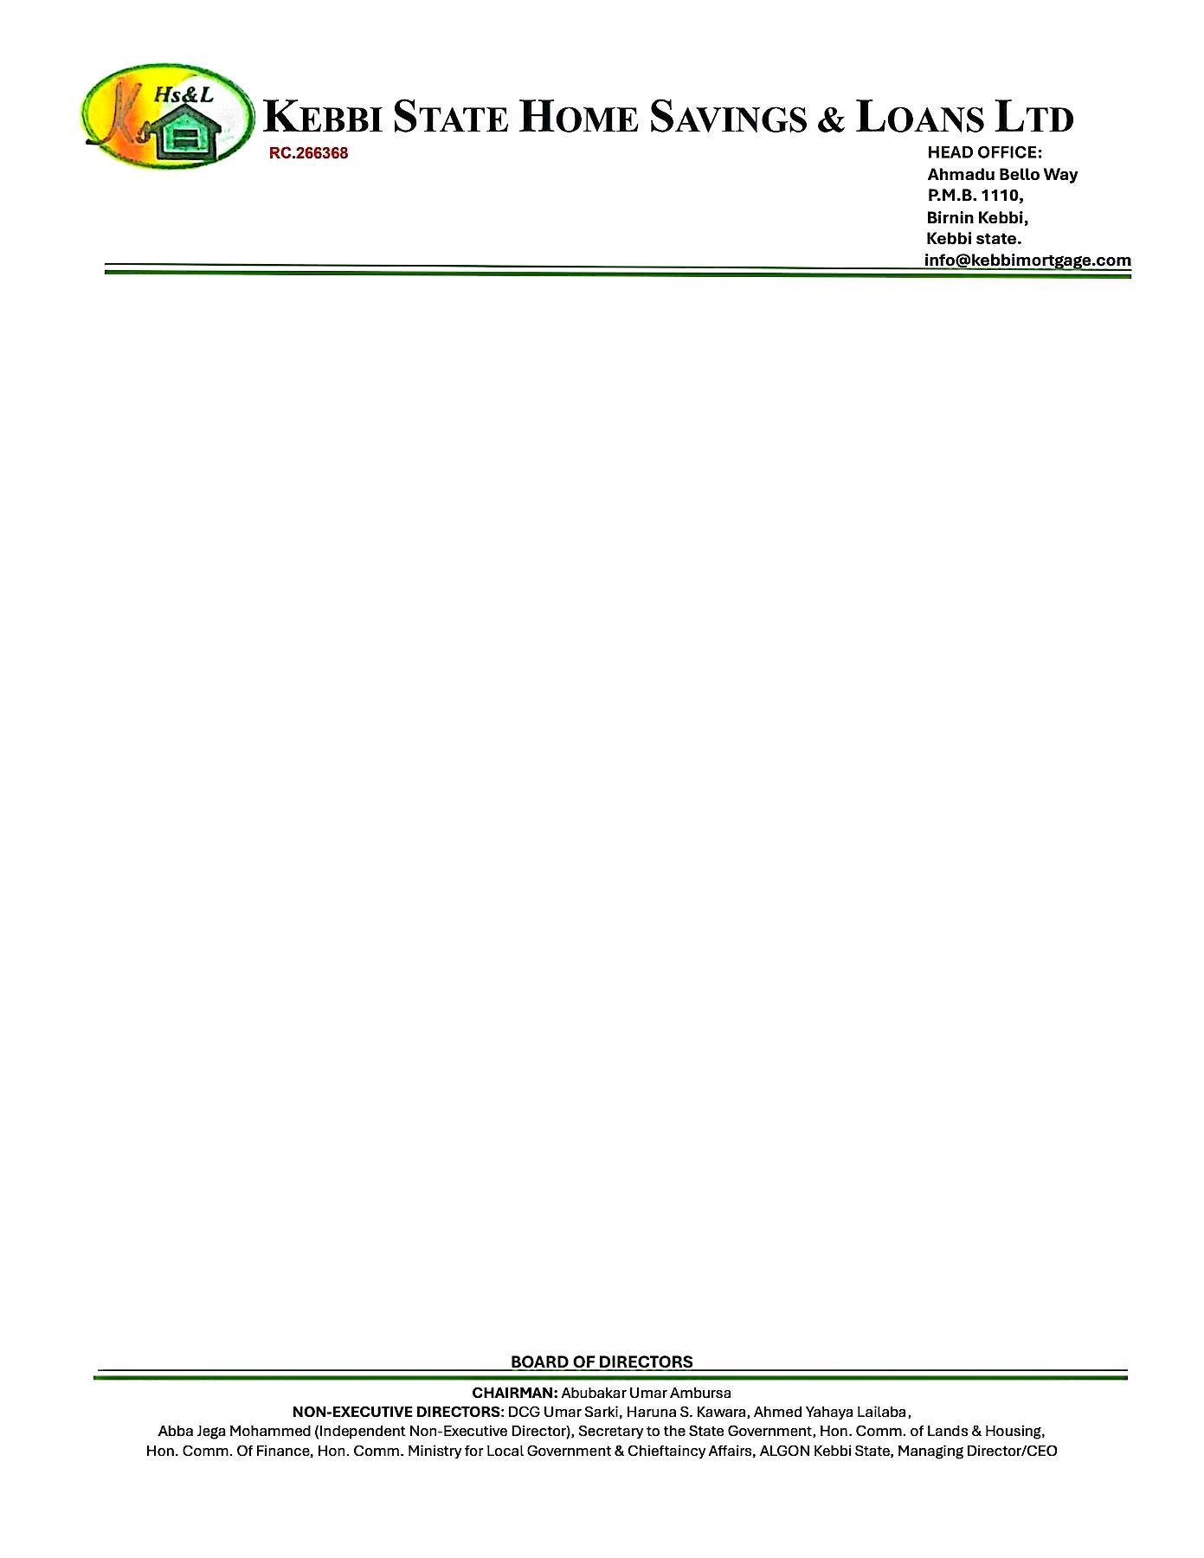

15th September, 2025

The Chief Executive

NORRENBERGER PENSIONS LIMITED,

No. 22 Otukpo Street,

Off Gimbiya Street,

Area 11,

Garki,

Abuja.

**VERIFICATION OF PROPERTY OFFER LETTER FOR THE SALE OF A 2 BEDROOMS BUNGALOW RESIDENTIAL PROPERTY AT RANGAZA QUARTERS, KANO STATE**.

The above subject matter refers.

The property was visited on the 12th September, 2025 to ascertain the availability of the property.

The property is **2 BEDROOMS BUNGALOW RESIDENTIAL PROPERTY AT RANGAZA QUARTERS, KANO STATE** Offered to **JOHN MICHAEL DOE.**

The sale value of the property as of date is **N3,000,000.00**

In view of foregoing, **‘We confirm the authenticity of the property offer letter and other documents’** as well as the availability of the property for sale.

Thanks for your usual co-operation.

**Yours faithfully,**

# **For: Kebbi State Home Savings & Loans Ltd**.

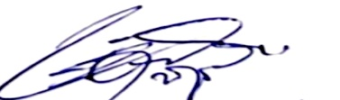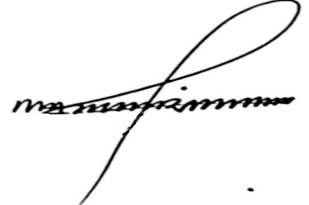

Shehu Mohammed Dr. Ahmed Musbahu

**Head of Credit Managing Director/CEO**