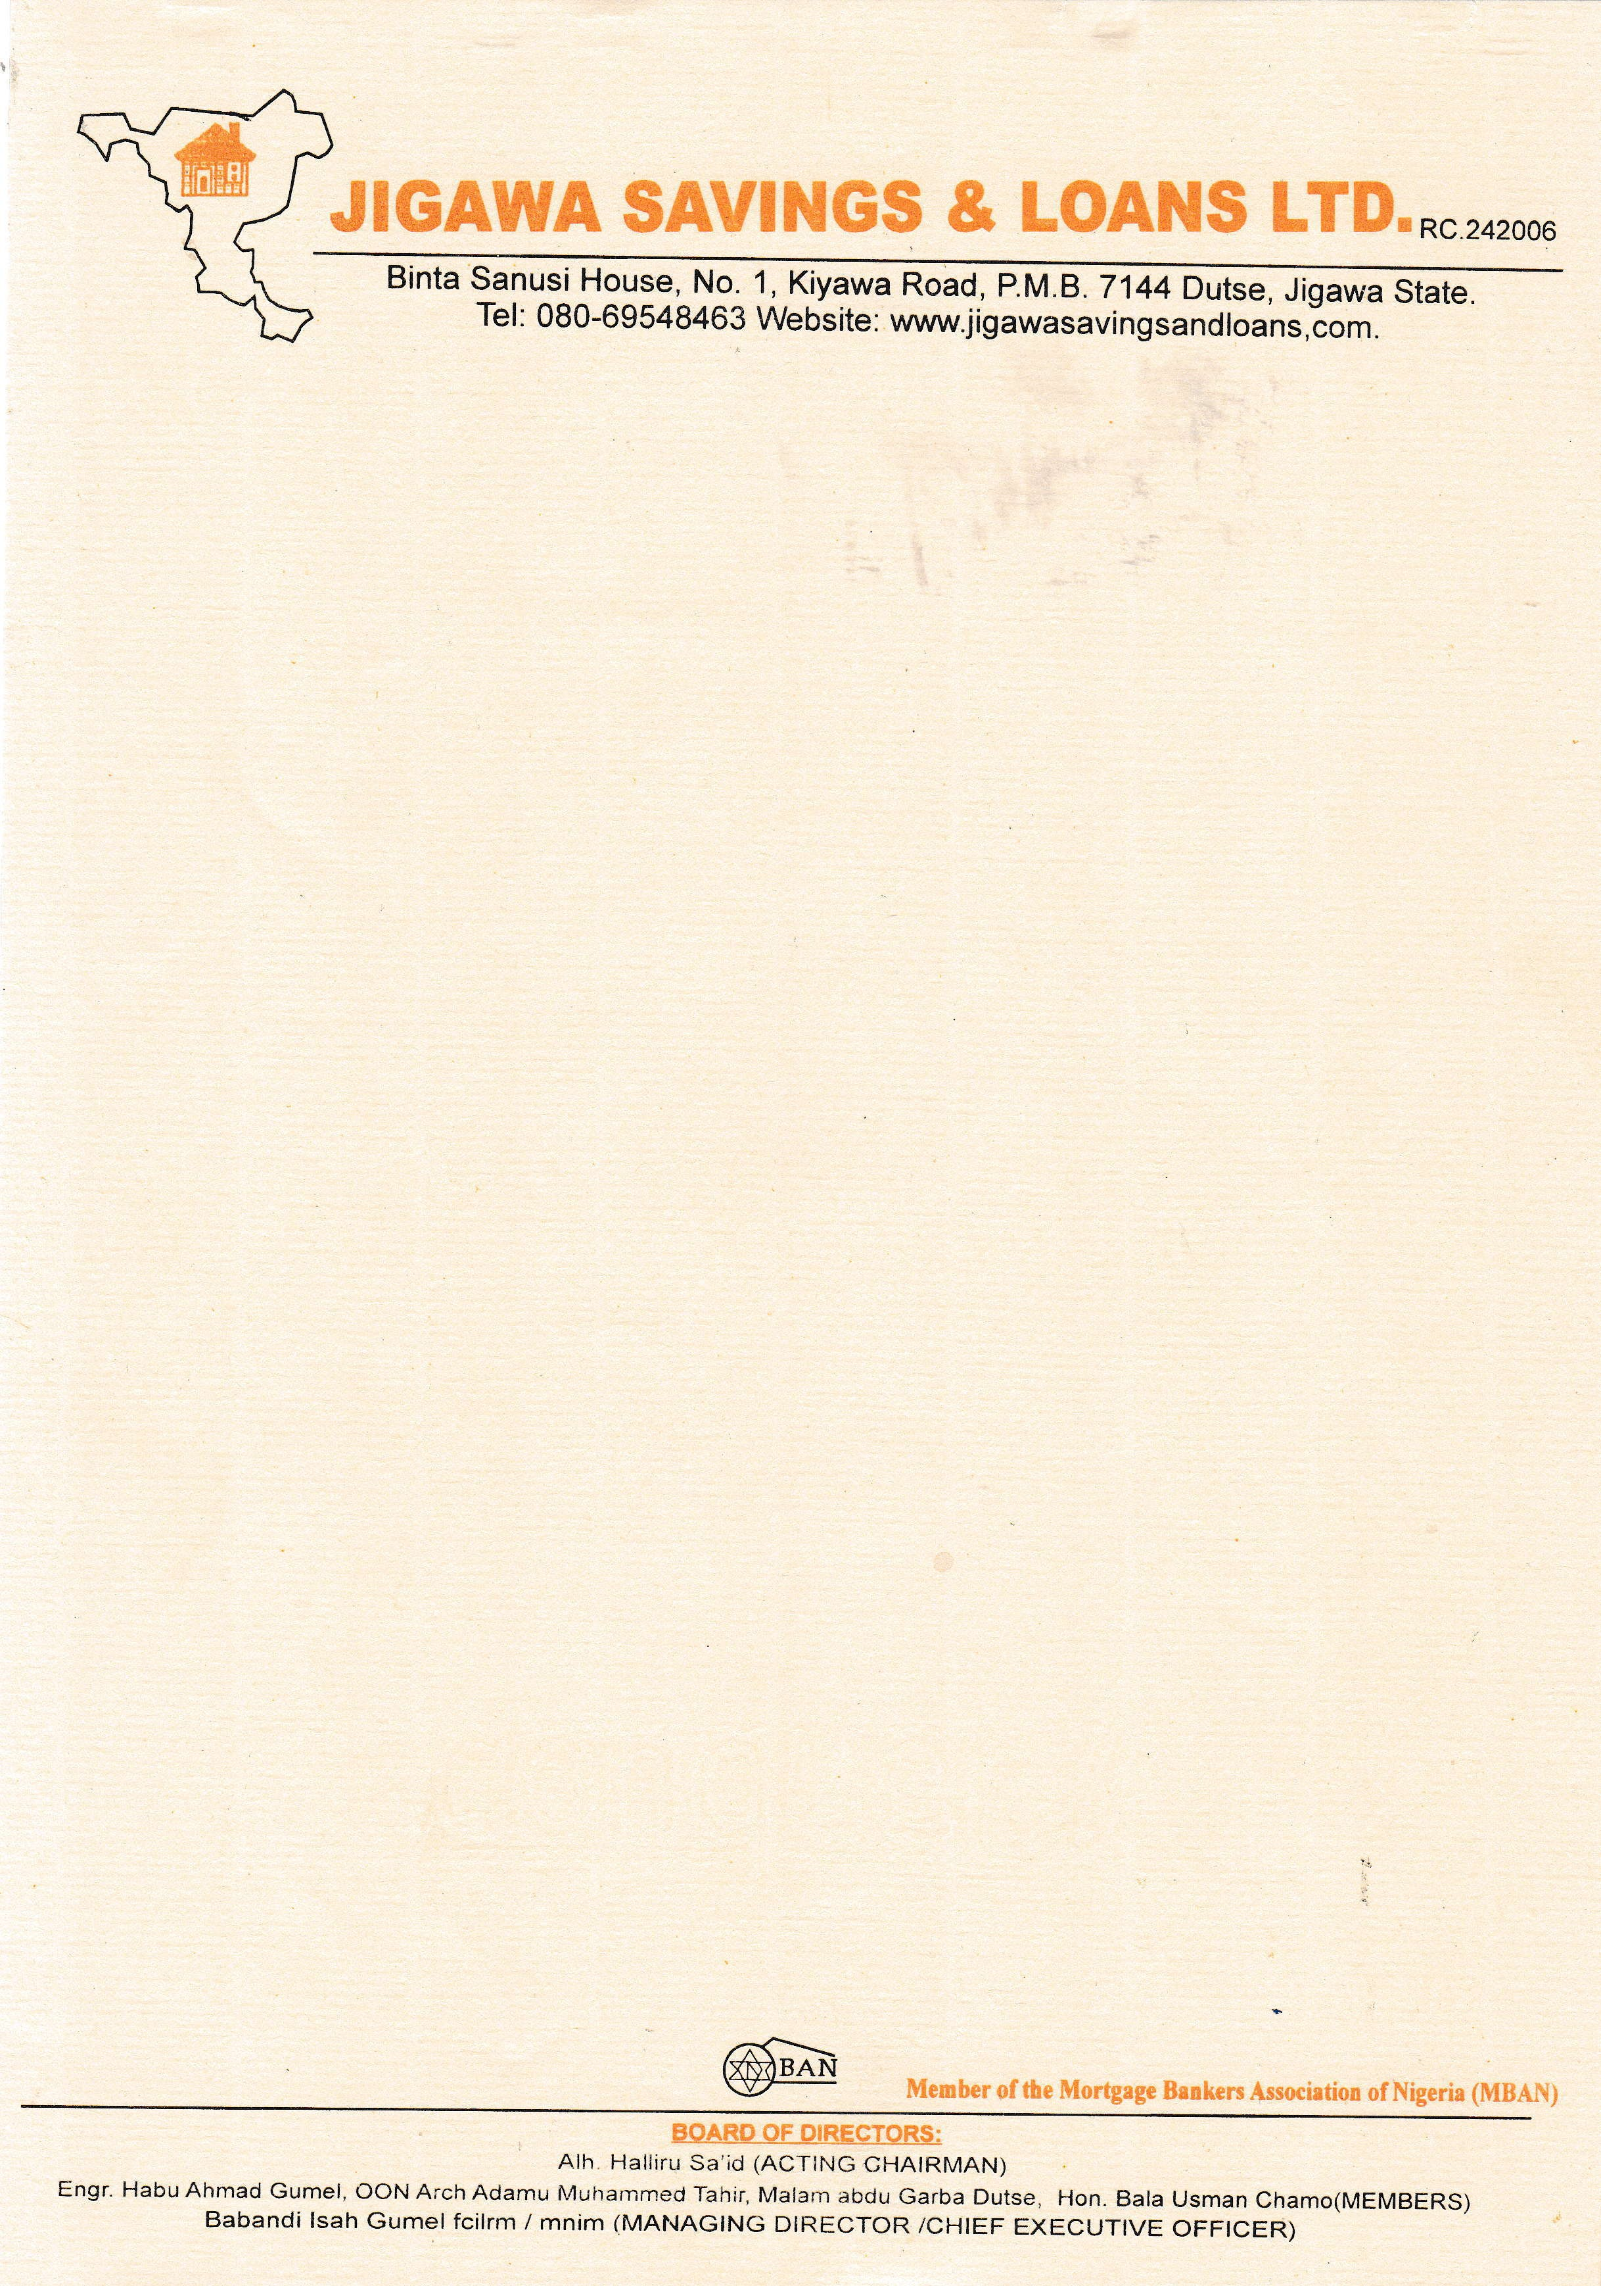

{DATE_A}



The Managing Director

{PENSION_COMPANY},

{PENSION_COMPANY_ADDR_ONE}

{PENSION_COMPANY_ADDR_TWO}

{PENSION_COMPANY_ADDR_THREE}

{PENSION_COMPANY_ADDR_FOUR}

{PENSION_COMPANY_ADDR_FIVE}

{PENSION_COMPANY_ADDR_SIX}

Dear Sir/Ma

**CONFIRMATION OF THE PROPERTY AVAILABILITY FOR {NAME}**

We hereby write to official confirm that the property **{NO_OF_BEDROOM} BEDROOMS BUGALOW AT RANGAZA QUARTERS, KANO STATE**

# Offered to {NAME} is very much available. Please go ahead with his 25% RSA Residential Mortgage.

Thank you for your co-operation

Thanks for your usual co-operation.

Yours faithfully,

# For: Jigawa Savings and Loan Ltd.

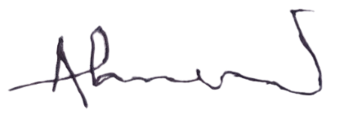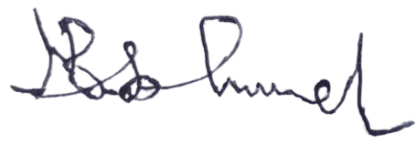

Ahmed Musa Faruk Babandi Isah Gumel

**Head of Mortgages** **Managing Director/CEO**