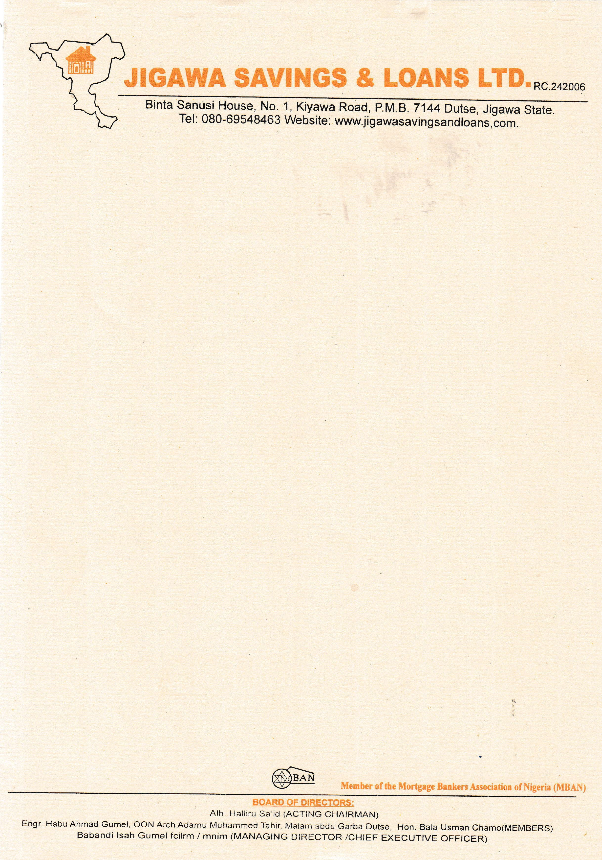

{DATE_A}



The Managing Director

{PENSION_COMPANY},

{PENSION_COMPANY_ADDR_ONE}

{PENSION_COMPANY_ADDR_TWO}

{PENSION_COMPANY_ADDR_THREE}

{PENSION_COMPANY_ADDR_FOUR}

{PENSION_COMPANY_ADDR_FIVE}

{PENSION_COMPANY_ADDR_SIX}

Dear Sir,

# RE: CONFIRMATION OF PROPERTY TITLE

We refer to the above subject and wish to confirm that the A **{NO_OF_BEDROOM} BEDROOMS BUNGALOW RESIDENTIAL AT RANGAZA QUARTERS, KANO STATE.**

Which **{NAME}** intends to purchase is still available.

The property has also been confirmed to have a REGISTERED DEED OF ASSIGNMENT No. **KN0851.**

We do hope this will assist you in final processing of **{NAME}** while we appreciate you for your anticipated cooperation, please note that we are duly prepared for immediate disbursement of the funds to the rightful beneficiary.

Thanks for your usual co-operation.

Yours faithfully,

# For: Jigawa Savings and Loan Ltd.

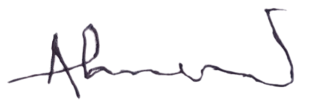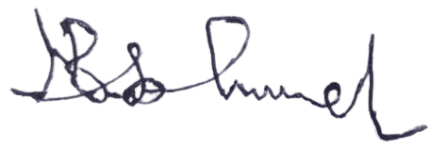

Ahmed Musa Faruk Babandi Isah Gumel

**Head of Mortgages** **Managing Director/CEO**