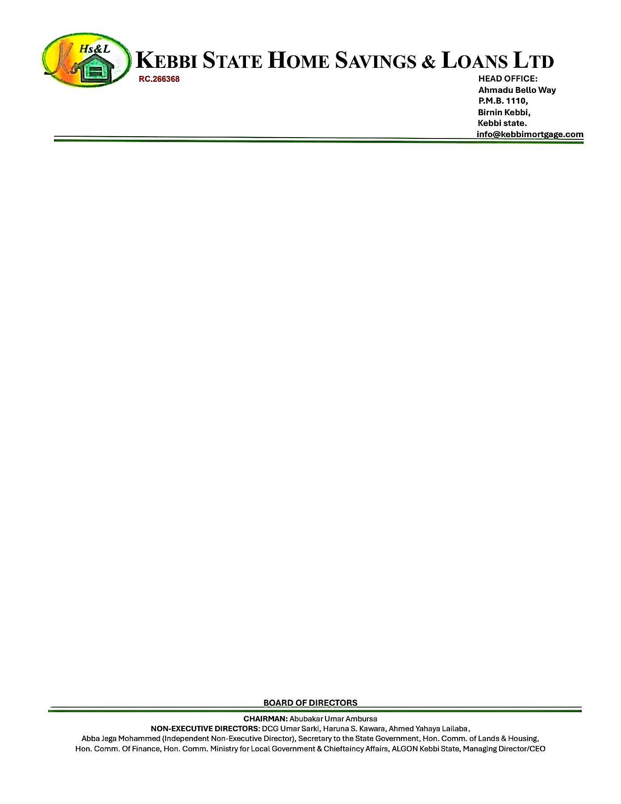

{DATE_A}

The Managing Director



{PENSION_COMPANY},

{PENSION_COMPANY_ADDR_ONE}

{PENSION_COMPANY_ADDR_TWO}

{PENSION_COMPANY_ADDR_THREE}

{PENSION_COMPANY_ADDR_FOUR}

{PENSION_COMPANY_ADDR_FIVE}

{PENSION_COMPANY_ADDR_SIX}

Dear Sir/Ma

**CONFIRMATION OF THE PROPERTY AVAILABILITY FOR {NAME}**

We hereby write to official confirm that the property **{NO_OF_BEDROOM} BEDROOMS BUGALOW AT RANGAZA QUARTERS, KANO STATE**

Offered to **{NAME}** is very much available. Please go ahead with his 25% RSA Residential Mortgage.

Thanks for your usual co-operation.

Yours faithfully,

# **For: Kebbi State Home Savings & Loans Ltd**.

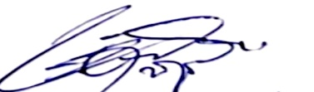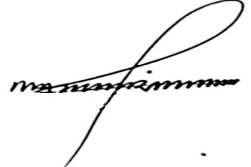

Shehu Mohammed Dr. Ahmed Musbahu

**Head of Credit Managing Director/CEO**