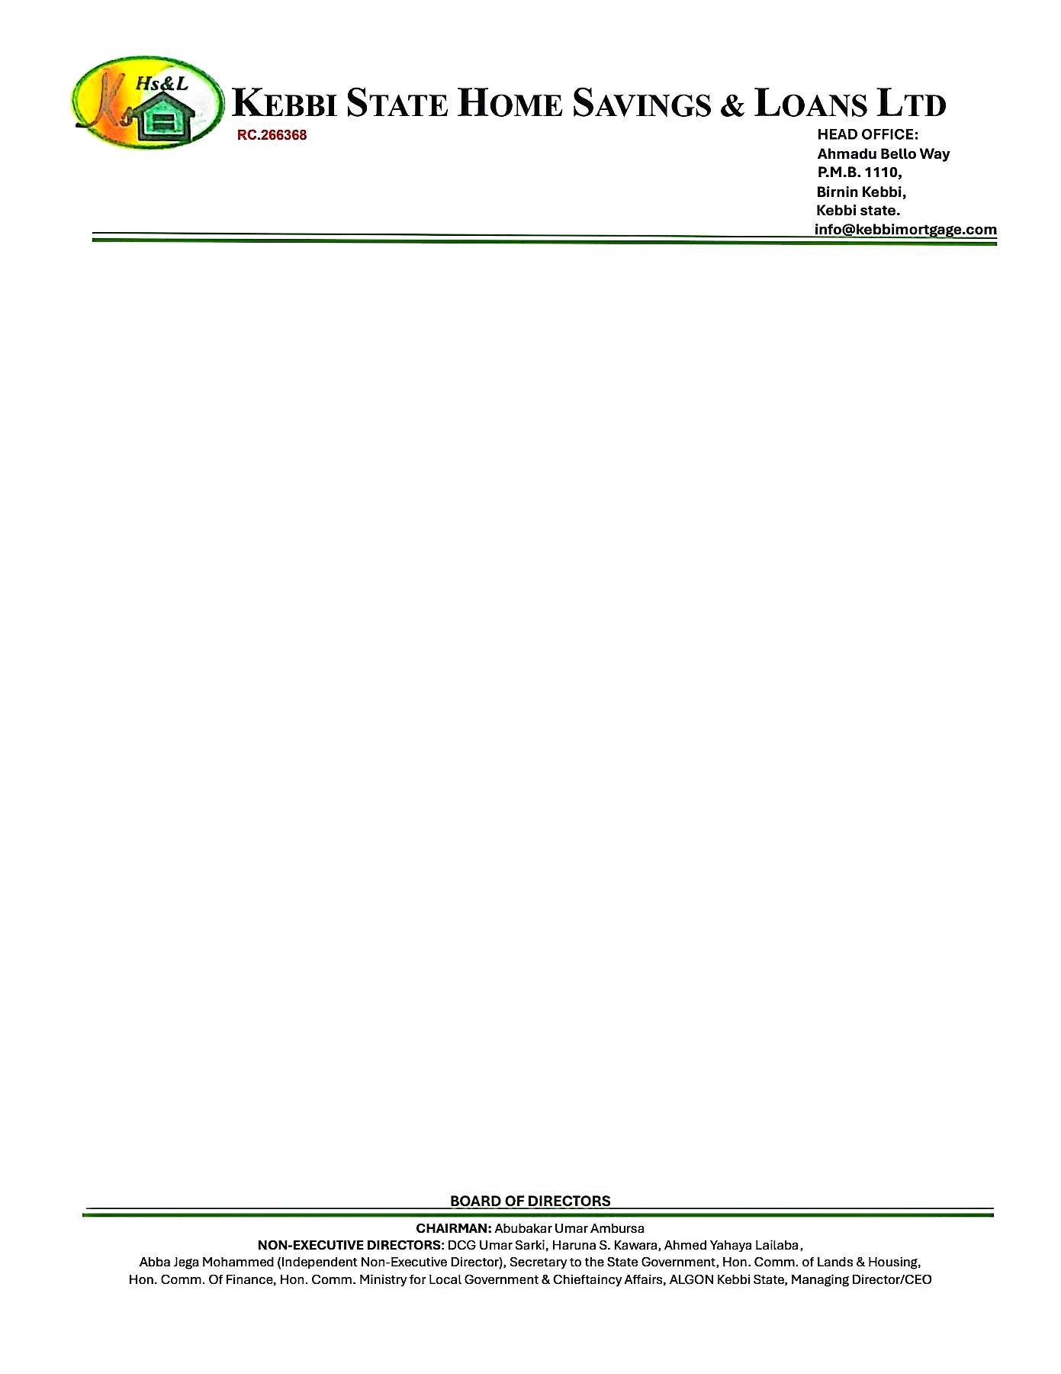

{DATE_B}



The Managing Director

{PENSION_COMPANY},

{PENSION_COMPANY_ADDR_ONE}

{PENSION_COMPANY_ADDR_TWO}

{PENSION_COMPANY_ADDR_THREE}

{PENSION_COMPANY_ADDR_FOUR}

{PENSION_COMPANY_ADDR_FIVE}

{PENSION_COMPANY_ADDR_SIX}

**LETTER OF INDEMNITY IN RESPECT OF RETIREMENT SAVINGS ACCOUNT EQUITY CONTRIBUTION**

**THIS INDEMNITY** is issued by Kebbi State Home Savings & Loans Ltd of Ahmadu Bello Way P.M.B. 1110, Birnin Kebbi, Kebbi state (hereinafter called “Indemnifier” which expression shall where the context so admits include its successors-in-title and assigns), to **{PENSION_COMPANY}** having its Head Office at **Pascal Bafyau Labour House, Plot 820/821 Central District, FCT Abuja.** (hereinafter called “indemnified PFA” which expression shall where the context so admits include its successors-in-title and assigns)

WHEREAS:

1. **{PENSION_COMPANY}** is a Pension Fund Administrator licensed by the National Pension Commission (“the Commission”) to manage individual Retirement Savings Accounts (RSA) in accordance with the provisions of the Pension Reform Act, 2014 (“the Act”);
2. Pursuant to the Act, the Commission has issued Guidelines on Accessing RSA Balance towards Payment of Equity Contributions for Residential Mortgage (“Guidelines”) which Guidelines permit RSA Account Holders to access a portion of their RSA balance as equity contribution towards acquiring a residential property from a licensed financial institution;
3. The Indemnifier is duly licensed by the Central Bank of Nigeria (CBN) and meets all the eligibility criteria for the provision of mortgage lending services to RSA holders under the Guidelines issued by the Commission.
4. The Indemnifier has received applications from several RSA holders who maintain RSAs with **{PENSION_COMPANY}** and in line with the Guidelines, the indemnifier has agreed to finance the purchase of a residential property on behalf of the RSA holders, subject to the execution of relevant mortgage contracts.

Page **1** of **2 Confidential**

1. **{NAME}**, the RSA holder has requested and authorized that a \portion of his Mortgage and has applied to **{PENSION_COMPANY}** to release to the indemnifier, a portion not more than 25% of his/her RSA balance as equity contribution towards the acquisition of a residential mortgage.
2. The Indemnifier has conducted all requisite due diligence to confirm the authenticity of the RSA holder’s intended acquisition of a residential property and undertakes to **{PENSION_COMPANY}** that the portion of the RSA holder’s fund which shall be released to the Indemnifier on the RSA holder’s request shall be applied solely as equity contribution towards the acquisition of a residential mortgage, under the mortgage agreement between the Indemnifier and the RSA holder; and shall not, under any condition, be released to the RSA holder or any third party for any other purpose
3. **{PENSION_COMPANY} agrees** to release the relevant portion of the RSA holder’s fund to the Indemnifier and has requested that the Indemnifier provides this indemnity in favour of **{PENSION_COMPANY} in** the manner hereinafter stated.

**NOW THEREFORE**, in consideration of indemnified PFA effecting the transfer of the portion of the RSA holder’s balance to the Indemnifier as equity contribution by the RSA holder whose RSA PIN herein appears, towards acquisition of residential property in accordance with the Guidelines, **We, Kebbi State Home Savings & Loans Ltd** hereby irrevocably and unconditionally covenant that we shall at all times hereafter, indemnify **{PENSION_COMPANY}** and keep **{PENSION_COMPANY}** fully indemnified against all claims, demands, liabilities, actions, damages, penalties and legal proceedings (including any cost of litigation) which may be incurred by **{PENSION_COMPANY}** in the event that the fund so released by **{PENSION_COMPANY}** is not utilized as equity contribution towards the purchase of a residential property on behalf of the RSA holder.

**Furthermore**, Kebbi State Home Savings & Loans Ltd undertakes to pay **{PENSION_COMPANY}** on demand without cavil or contention, all payments, liabilities, damages and expenses (including but not Limited to legal fees) incurred by the **{PENSION_COMPANY}** from acceding to the RSA holder’s request to release funds from his/her RSA, in the event that the fund so released by **{PENSION_COMPANY}** is not utilized as equity contribution towards the purchase of a residential property on behalf of the RSA holder.

This Indemnity shall be a continuing security and shall be enforceable from the date of disbursement of the portion of the RSA holder’s balance to the Indemnifier and shall inure to the benefit of **{PENSION_COMPANY} up** until the utilization of the funds so released, as equity contribution towards the acquisition of the residential property in favour of the RSA holder by the Indemnifier.

This Indemnity shall not be enforceable against the Indemnifier for any claims, demands, liabilities, losses, actions, damages, penalties, and legal proceedings (including any cost of litigation), arising from any dispute or breach howsoever, in the contractual relationship between the**{PENSION_COMPANY} and** the RSA holder.

The indemnification provided under this Indemnity by the Indemnifier shall be completely discharged upon the utilization of the portion of the RSA holder’s balance towards the purchase of a residential property in favour of the RSA holder by the Indemnifier.

|  |  |
| --- | --- |
| **RSA HOLDER** | **RSA PIN** |
| **{NAME}** | **PEN-{PENSION_NO}** |

This indemnity shall be governed by and construed in accordance with the extant laws of the Federal Republic of Nigeria.

THE COMMON SEAL of the within named INDEMNIFIER **KEBBI STATE HOME SAVINGS AND LOANS LIMITED** was hereunto affixed in the presence

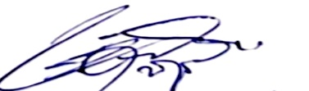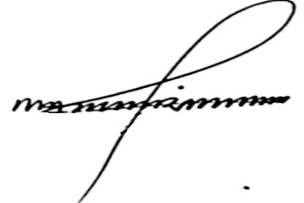

Shehu Mohammed Dr. Ahmed Musbahu

**Head of Credit Managing Director/CEO**