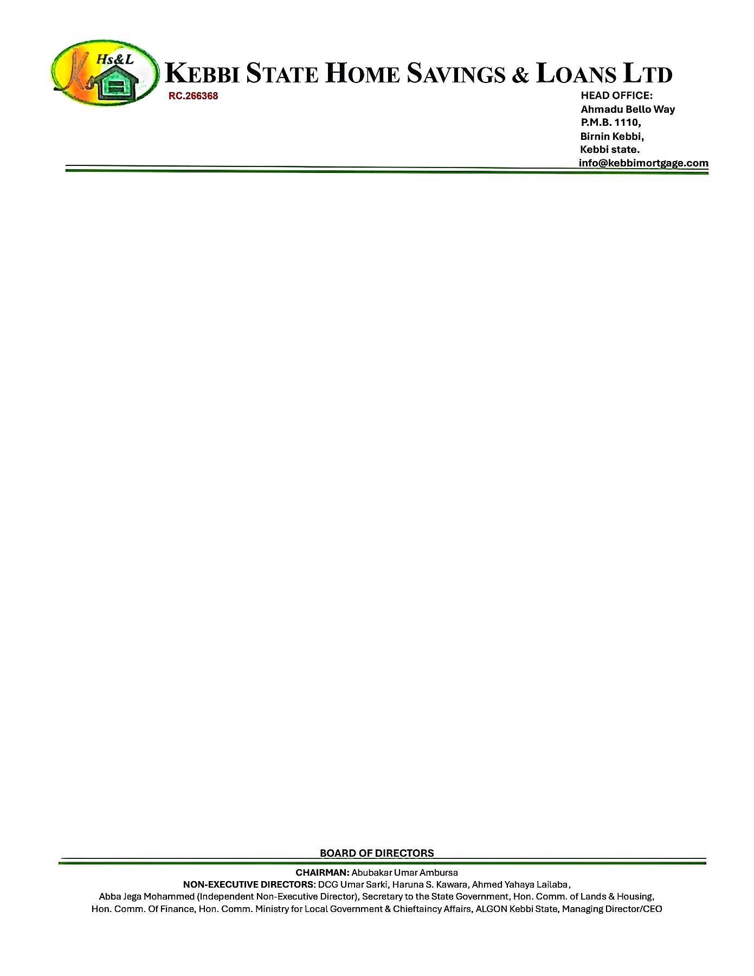

{DATE_A}



The Managing Director

{PENSION_COMPANY},

{PENSION_COMPANY_ADDR_ONE}

{PENSION_COMPANY_ADDR_TWO}

{PENSION_COMPANY_ADDR_THREE}

{PENSION_COMPANY_ADDR_FOUR}

{PENSION_COMPANY_ADDR_FIVE}

{PENSION_COMPANY_ADDR_SIX}

Dear Sir,

**EXPRESSION OF READINESS TO DISBURSE LOAN**

We hereby express our readiness as a Mortgage Bank to disburse a loan sum **N{LOAN_AMOUNT} ({LOAN_AMOUNT_IN_WORDS})** to **{NAME}** with Kebbi State Home Savings & Loans Limited Account Number- **{ACCOUNT_NO}.**

Kindly credit the customer’s account details stated above with the sum **N {EQUITY_AMOUNT} ({EQUITY_AMOUNT_IN_WORDS}),** being his 25% retirement savings, as an equity contribution for the purchase of a **{NO_OF_BEDROOM} BEDROOMS BUNGALOW AT RANGAZA QUARTERS KANO STATE.**

Thanks for your usual co-operation

Yours faithfully,

# **For: Kebbi State Home Savings & Loans Ltd**.

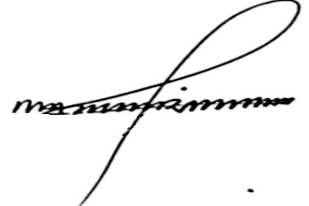

Shehu Mohammed Dr. Ahmed Musbahu

**Head of Credit Managing Director/CEO**