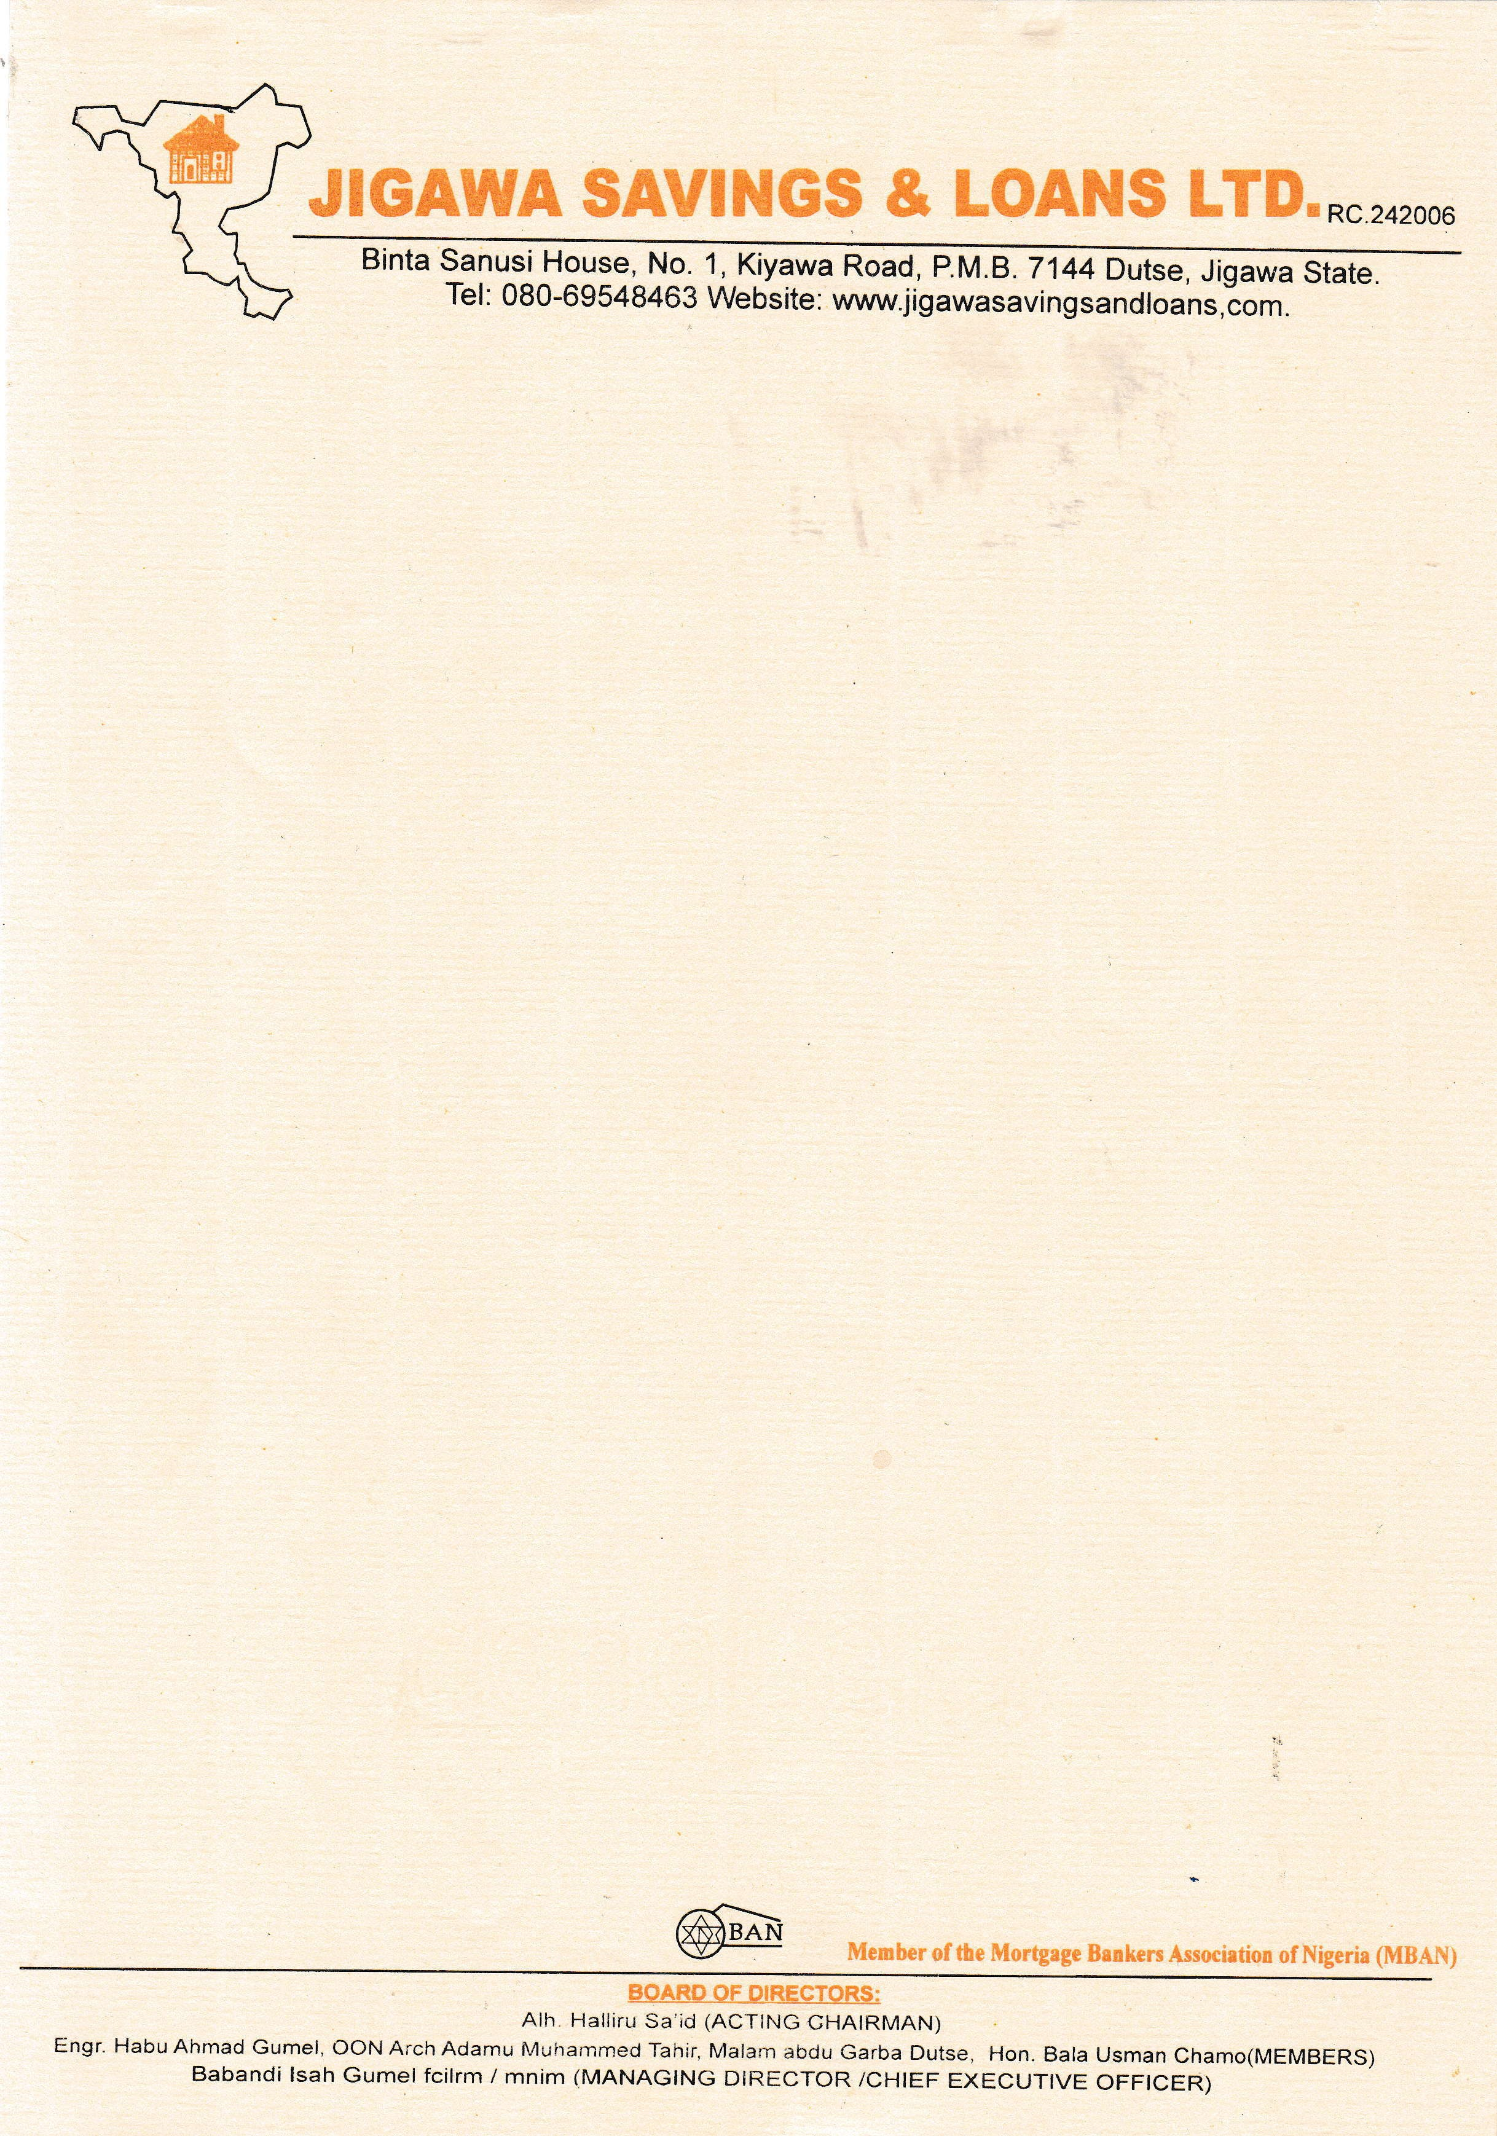

{DATE_B}

The Managing Director

{PENSION_COMPANY},

{PENSION_COMPANY_ADDR_ONE}

{PENSION_COMPANY_ADDR_TWO}

{PENSION_COMPANY_ADDR_THREE}

{PENSION_COMPANY_ADDR_FOUR}

{PENSION_COMPANY_ADDR_FIVE}

{PENSION_COMPANY_ADDR_SIX}

# VERIFICATION OF PROPERTY OFFER LETTER FOR THE SALE OF A {NO_OF_BEDROOM} BEDROOMS BUNGALOW RESIDENTIAL PROPERTY AT RANGAZA QUARTERS, KANO STATE.

The above subject matter refers.

The property was visited on the {DATE_E} to ascertain the availability of the property.

The property is **{NO_OF_BEDROOM} BEDROOMS BUNGALOW RESIDENTIAL PROPERTY AT RANGAZA QUARTERS, KANO STATE** offered to **{NAME}.**

The sale value of the property as of date is **N{PROPERTY_AMOUNT}**

In view of foregoing, **‘We confirm the authenticity of the property offer letter and other documents’** as well as the availability of the property for sale.

Thanks for your usual co-operation. **Yours faithfully,**

# For: Jigawa Savings and Loan Ltd.

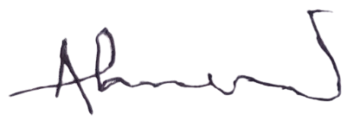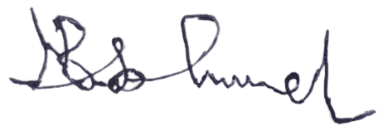

Ahmed Musa Faruk Babandi Isah Gumel

**Head of Mortgages** **Managing Director/CEO**