1. SELECT COUNT(Country) FROM [Customers] WHERE Country='Germany'

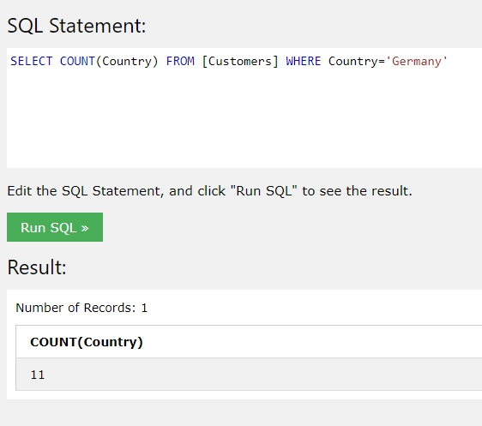

1. SELECT COUNT(ContactName) FROM [Customers] WHERE ContactName LIKE '%e %'

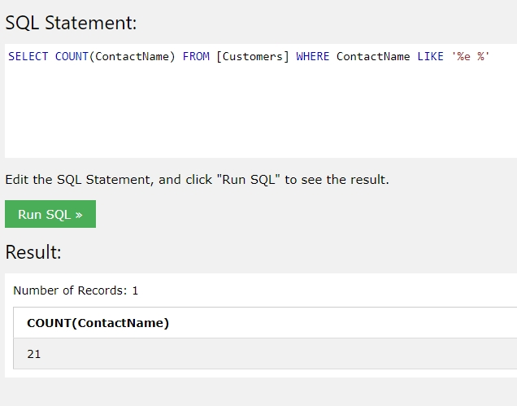

1. INSERT INTO Customers (ContactName)

Values ('Maksim Lakhadynov')

Select \* From Customers WHERE ContactName='Maksim Lakhadynov'

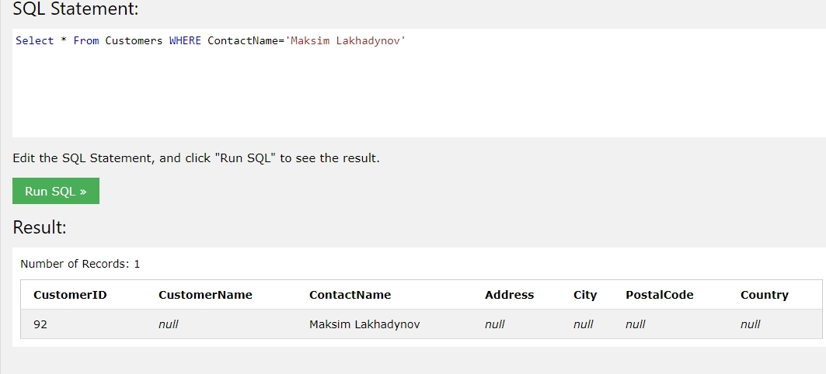

1. Update Customers Set ContactName='Максим Лахадынов' Where CustomerID='92'

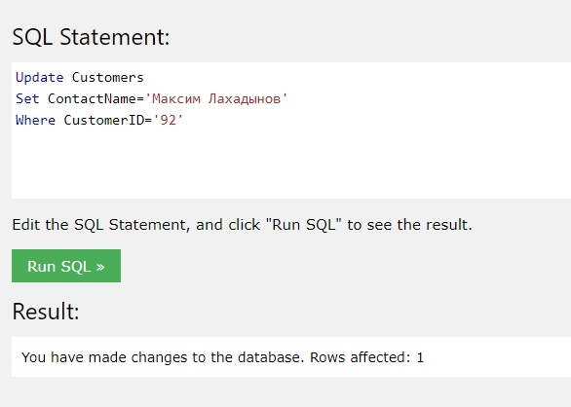

Select \* From Customers WHERE ContactName='Максим Лахадынов'

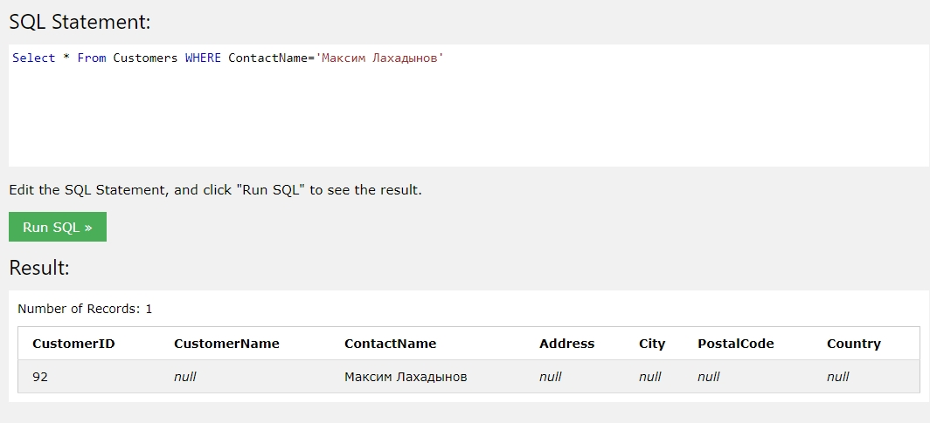

1. DELETE FROM [Customers] WHERE city='Nantes'

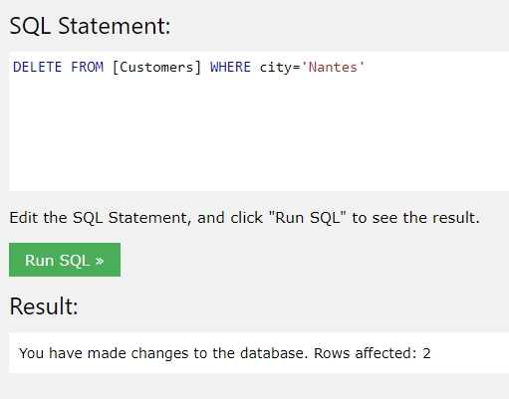

SELECT COUNT(City) FROM [Customers] WHERE City='Nantes'

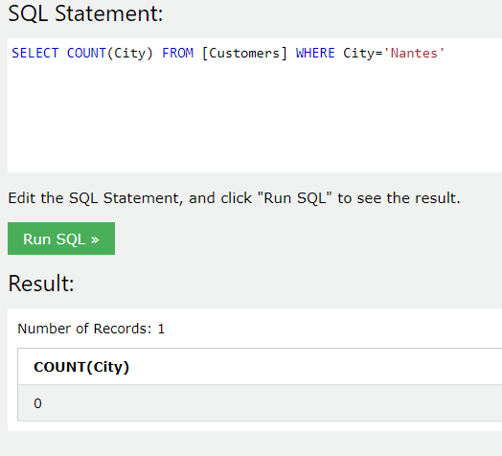

1. Select Employees.FirstName, Orders.OrderID

FROM Orders

INNER JOIN Employees ON Orders.EmployeeID=Employees.EmployeeID

Where Employees.FirstName='Steven'

