Name: Abul Hasan Shaik
Course: CSC474/574 Computer Networks
Assignment: Programming Assignment 1 – Cloud/Network File System
Semester: Spring 2025

1. How to Compile
Open PowerShell or Command Prompt in the project directory and run:
g++ server.cpp file_system.cpp -o server.exe -lws2_32 -std=c++17
g++ client.cpp -o client.exe -lws2_32 -std=c++17
These commands will generate server.exe and client.exe using MinGW on Windows.

2. How to Run
Step 1: Start the server
./server.exe
Output:
Server listening on port 8080...
Step 2: Start the client
Open a second terminal and run:
./client.exe
You'll see:
php-template

Connected to server. Type commands (mkdir <dir>, ls <dir>, write <file> <data>, read <file>, move <src> <dest>, exit):

3. Supported Commands
Command Example | Description
mkdir testdir | Creates a directory named testdir
write testdir/file1.txt HelloWorld | Writes HelloWorld to file1.txt
read testdir/file1.txt | Reads content from file1.txt
ls testdir | Lists all files inside testdir
move testdir/file1.txt testdir/file2.txt | Renames or moves file1.txt to file2.txt
exit | Gracefully closes the connection

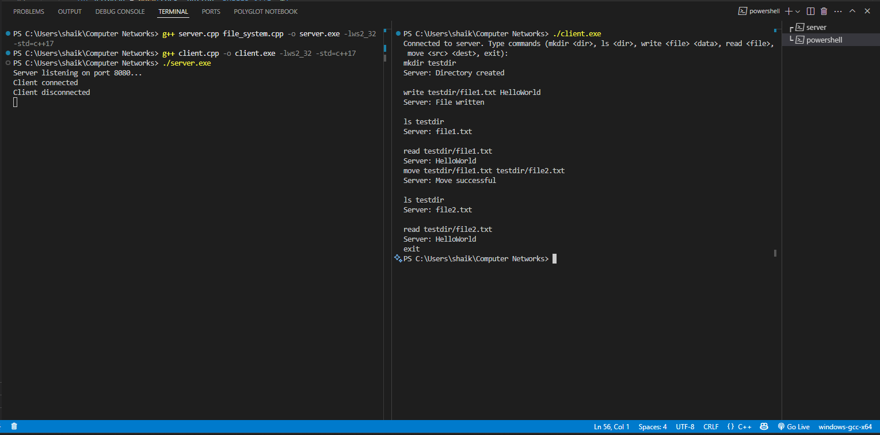

4. Features Implemented
- TCP socket communication using Winsock on Windows
- Multi-client support via multithreaded server
- File system operations using std::filesystem:
  - Create directories
  - Write to and read from files
  - List files in a directory
  - Move or rename files
- Clean server-client protocol with newline-based parsing
- Proper error handling (e.g., file not found, invalid input)

5. Project Management Tool Used
Used Git locally to track file versions and manage project changes. Commands used:
- git init
- git add, git commit
- .gitignore created to exclude binaries

6. Testing Summary
All commands were tested in sequence:

mkdir testdir
write testdir/file1.txt HelloWorld
ls testdir
read testdir/file1.txt
move testdir/file1.txt testdir/file2.txt
ls testdir
read testdir/file2.txt
exit
All commands worked as expected with correct server responses.
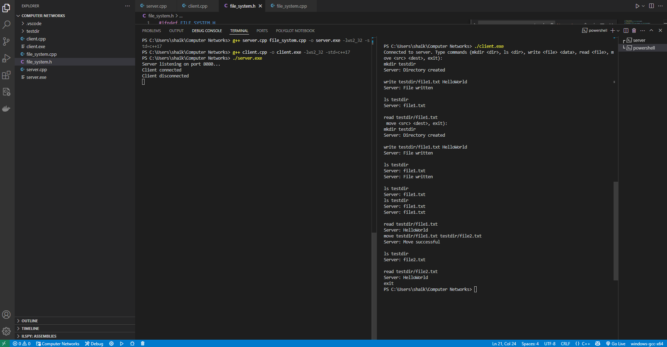

7. Files Included in Submission

CSC474_574_ProAssgn_AbulHasanShaik/
├── client.cpp
├── server.cpp
├── file_system.cpp
├── file_system.h
└── report.pdf

8. Known Limitations
- Does not support subdirectory recursion (e.g., nested ls)
- File uploads/downloads via binary stream not implemented (only text supported)
- Basic plain-text command interface (no encryption/authentication)

9. 📚 References
- https://www.geeksforgeeks.org/network-file-system-nfs/
- https://people.cs.rutgers.edu/~pxk/416/notes/18-nfs.html
- https://github.com/dmonaldo/simple-network-file-system

