Growthpoint Knowledge Assistant — Solution Overview
Table of Contents

Growthpoint Knowledge Assistant — Solution Overview
A Retrieval-Augmented Generation (RAG) proof of concept Built on AWS Bedrock Knowledge Bases with Amazon S3 Vectors · with an equivalent Azure design
Document purpose | Explain the demo, the RAG concepts behind it, the AWS implementation in detail, and how the same solution would be built on Azure
Status | Proof of concept with mock data. Real Growthpoint documents to be ingested later
Audience | Growthpoint technical and business stakeholders

Table of contents
- What the demo does
- RAG concepts explained
- Chunking in depth
- Embeddings in depth
- The retrieval and generation process
- How AWS implements this
- AWS architecture
- Enforcing the guardrails
- The same solution on Azure
- Azure architecture
- AWS to Azure service mapping
- Operational considerations
- Sources

1. What the demo does
The Growthpoint Knowledge Assistant is a chat interface that answers questions about Growthpoint's own documents — leases, policies, standard operating procedures (SOPs) and technical runbooks. It does not answer from the open internet and it does not rely on what the language model happens to remember from its training data.

The four capabilities
Capability | What it means in practice
Answers from your content | Policies, lease and property documents, SOPs and technical runbooks are retrieved from a document store and used to compose the answer, rather than guessed at
Shows its working | Every answer displays the documents it drew from — document title, reference number, section and an extract — so a reader can verify the claim
Respects who is asking | Permission-aware retrieval. A user only ever retrieves documents their role is entitled to see
Improves with use | Thumbs up / down feedback on each answer surfaces knowledge gaps and poor answers, so the knowledge base can be improved over time

The three guardrails
Guardrail | Implementation
Closed corpus | Only the ingested documents are searched. There is no open-web fallback and no tool that can reach the internet
No public training | Content stays inside the AWS account boundary. Amazon Bedrock does not use customer inputs or outputs to train its foundation models
Cited or silent | If retrieval returns nothing relevant, the assistant declines to answer rather than inventing one. No source means no answer

Demonstration data
The PoC ships with 25 fictional Growthpoint documents written for demonstration purposes, spread across four categories and three access levels:
Category | Count | Examples
Policy | 9 | Tenant Parking & Access, Sustainability & Green Building, Arrears & Credit Control
Lease Document | 5 | Standard Office Lease — Operating Costs, Lease Renewal & Early Termination
SOP | 6 | Tenant Maintenance Request, Emergency Evacuation, New Tenant Onboarding
Technical Runbook | 5 | HVAC/BMS Fault Response, Loadshedding & Generator, Solar PV & Backup Power

Access level | Count | Who sees it
public | 9 | Tenants and the general public
staff | 13 | Growthpoint staff (plus everything public)
management | 3 | Management (plus everything staff and public)

Demonstrating the guardrails
The demo is designed so each guardrail can be proven in a live session:
Ask this | As this role | Expected behaviour
"How is tenant parking allocated?" | Tenant / Public | Answers, citing the Tenant Parking & Access Policy
"How are operating costs calculated in an office lease?" | Tenant / Public | Declines — the lease document is staff-level
Same question | Growthpoint Staff | Answers, citing the Standard Office Lease
"What is the arrears collection process?" | Growthpoint Staff | Declines — the arrears policy is management-only
Same question | Management | Answers, citing the Arrears & Credit Control Policy
"What is the capital of France?" | Any | Declines — outside the closed corpus

2. RAG concepts explained

The problem RAG solves
A large language model (LLM) such as Claude is trained on a large, general body of text up to a fixed cut-off date. That creates three problems for enterprise use:
- It has never seen your private documents. Growthpoint's lease clauses and internal runbooks were not in the training data, so the model cannot know them.
- It cannot cite a source. The model's knowledge is distributed across its weights, not stored as retrievable documents, so it cannot tell you where an answer came from.
- It will answer anyway. Asked a question outside its knowledge, a model will often produce a fluent, confident and wrong answer — a hallucination. For a lease clause or a safety procedure, that is unacceptable.
The naive fix is to fine-tune the model on your documents. That is expensive, slow to update, still cannot cite sources, and bakes the content into model weights. Retrieval-Augmented Generation takes a different approach.

The core idea
Instead of asking the model what it knows, find the relevant passages first, then ask the model to answer using only those passages.
RAG splits the problem into retrieval (a search problem) and generation (a language problem). The model is reduced from an oracle to a careful reader and summariser of text you supply. Because the passages are real documents you control, the answer can be cited, the corpus can be closed, and the content can be permission-filtered before the model ever sees it.

The two phases
Every RAG system has an offline phase that prepares the data and an online phase that answers a question.
Phase 1 — Ingestion (offline, runs when documents change)
Documents ──▶ Parse ──▶ Chunk ──▶ Embed ──▶ Store vectors + metadata
- Parse — extract plain text from the source files (PDF, DOCX, HTML, TXT).
- Chunk — split the text into passages small enough to embed meaningfully.
- Embed — convert each chunk into a numeric vector using an embedding model.
- Store — write the vectors, the original text and the metadata to a vector index.
Phase 2 — Retrieval and generation (online, runs per question)
Question ──▶ Embed ──▶ Vector search (+ filters) ──▶ Top-K chunks
│
┌──────────────┘
▼
Prompt = instructions + chunks + question ──▶ LLM ──▶ Answer + citations
- Embed the question with the same embedding model used at ingestion.
- Search the vector index for the chunks whose vectors are nearest the question vector, applying any access filters.
- Assemble a prompt containing the retrieved chunks as context, the user's question, and instructions constraining the model to that context.
- Generate the answer and return it with the citations.

Why vectors
Keyword search matches characters. If a tenant asks "how many parking bays do I get?" and the policy says "allocated at a ratio of 1 bay per 25 square metres of leased GLA", a keyword search for "how many" finds nothing useful.
An embedding maps text to a point in high-dimensional space such that texts with similar meaning land close together, regardless of the words used. The question and the policy clause end up near each other because they are about the same concept. This is semantic search, and it is what makes RAG work on natural-language questions.

3. Chunking in depth

Why chunk at all
Three independent constraints force documents to be split:
Constraint | Explanation
Embedding model input limit | Titan Text Embeddings V2 accepts up to 8,192 tokens (about 50,000 characters) per call. Longer documents simply cannot be embedded in one piece (AWS docs)
Retrieval precision | One vector per 50-page document averages away all the detail. A query about parking would match a facilities manual weakly and unhelpfully. Smaller chunks produce sharper matches
Prompt economy | The retrieved text is pasted into the prompt and billed as input tokens. Returning whole documents is slow and expensive; returning the relevant clause is neither
The trade-off runs in both directions. Chunks that are too small lose the context needed to make sense (a clause that says "this does not apply to B-grade buildings" is meaningless alone). Chunks that are too large dilute the embedding and waste prompt budget. The goal is one coherent idea per chunk.

The strategies Amazon Bedrock supports
Amazon Bedrock Knowledge Bases offers several built-in approaches. Content is split into chunks, converted to embeddings and written to the vector index while preserving a mapping back to the source document (AWS docs).
Strategy | How it works | Best suited to
Default | Splits text into chunks of roughly 300 tokens, respecting sentence boundaries so sentences are never cut in half | General-purpose text; a sound starting point
Fixed-size | You specify the token count per chunk and an overlap percentage between consecutive chunks | Tuning when you know your document structure; overlap preserves context across boundaries
Semantic | Uses embeddings to detect topic shifts between sentences and breaks where meaning changes. Tunable via maximum tokens, a buffer of surrounding sentences, and a breakpoint percentile threshold | Flowing prose where topics change at unpredictable points. Note: incurs extra cost because it uses a foundation model
Hierarchical | Builds nested parent and child chunks. Retrieval matches on the small, precise child chunks but substitutes the larger parent chunk to give the model fuller context | Long structured documents where precision and context are both needed
No chunking | Each document is treated as a single chunk. Expects you to have pre-split the files yourself | Content already split into small, self-contained files
An important caveat for our design: AWS advises that hierarchical chunking is not recommended when using an S3 vector bucket, because parent-child relationships are held as metadata and large combined token counts can exceed S3 Vectors' metadata size limits.

What this demo uses, and why
The implementation does not set a chunking configuration, so the knowledge base applies default chunking — approximately 300 tokens per chunk, honouring sentence boundaries.
This is deliberate and appropriate here, for a specific reason: each mock document is a single focused clause or procedure of roughly 90 to 130 words. Most therefore fit comfortably inside one 300-token chunk. The effect is that one document equals one chunk, which is ideal for this PoC because:
- Each retrieved chunk is a complete, self-contained policy clause or procedure.
- Citations map cleanly to one source document, with nothing truncated mid-thought.
- Access-level metadata applies unambiguously to the whole chunk.
When real Growthpoint documents arrive, this will need revisiting. A 40-page lease agreement or a full technical manual will span many chunks, and the default strategy may split a clause across a boundary. The recommendation at that point is to evaluate fixed-size chunking with overlap (so a clause broken across a boundary still appears whole in one of the two chunks), or semantic chunking for flowing prose. The chunking strategy cannot be changed after a data source is created, so it must be chosen before the real ingestion — changing it means recreating the data source and re-ingesting.

4. Embeddings in depth

What an embedding is
An embedding model converts a piece of text into a fixed-length list of numbers — a vector. The model is trained so that semantically similar texts produce vectors that point in similar directions. A 1,024-dimension vector is a point in 1,024-dimensional space; "proximity" in that space approximates similarity of meaning.
A simplified illustration of the principle:
"parking bays per square metre" ──▶ [ 0.021, -0.118, 0.043, ..., 0.009 ] (1,024 numbers)
"how many parking spots do I get" ──▶ [ 0.019, -0.121, 0.038, ..., 0.011 ] ← very close
"fire evacuation assembly point" ──▶ [-0.084, 0.203, -0.157, ..., -0.066 ] ← far away

The model used here
This solution uses Amazon Titan Text Embeddings V2 (amazon.titan-embed-text-v2:0).
Property | Value | Notes
Maximum input | 8,192 tokens / ~50,000 characters | Per AWS documentation
Output dimensions | 1,024 (configured) | V2 also supports 512 and 256
Data type | float32 | S3 Vectors supports floating-point vectors; binary vectors are not supported
Distance metric | Cosine (configured) | Measures angle between vectors, ignoring magnitude
Languages | 100+
Titan V2's configurable output size is a genuine cost/accuracy dial. AWS reports that reducing from 1,024 to 512 dimensions retains roughly 99% of retrieval accuracy, and reducing to 256 dimensions retains about 97% (AWS announcement). Smaller vectors mean less storage and faster queries.
Why 1,024 was chosen here: the corpus is tiny, so storage and query cost are negligible, and maximum retrieval accuracy is worth more than a marginal saving. At Growthpoint's real scale — potentially hundreds of thousands of chunks — 512 dimensions would be worth benchmarking, since it roughly halves vector storage for about 1% accuracy loss.
Why Titan rather than a third-party model: Amazon's first-party embedding models are the most cost-effective option on Bedrock, and Titan V2 is explicitly optimised for retrieval tasks.

The critical rule
The same embedding model must be used for ingestion and for queries.
Vectors from different models are not comparable — they describe different spaces. Changing the embedding model, or its dimension count, requires re-embedding the entire corpus. This is why the embedding model is the most consequential and least reversible choice in a RAG system.

Cosine similarity
Cosine similarity measures the angle between two vectors rather than the distance between their endpoints, which makes it insensitive to document length:
- 1.0 — identical direction (same meaning)
- 0.0 — orthogonal (unrelated)
- −1.0 — opposite direction
A long document and a short query about the same topic point the same way even though their magnitudes differ greatly. This is why cosine is the conventional choice for text retrieval.

5. The retrieval and generation process
This section traces one question end to end, as the implementation actually performs it.

Step 1 — The user asks a question
A tenant, signed in at the public access level, asks:
"How is tenant parking allocated?"

Step 2 — Retrieval with a permission filter
The application calls the Bedrock Retrieve API. Behind that single call, Bedrock embeds the question with Titan V2 and runs a nearest-neighbour search against the S3 Vectors index.
Critically, a metadata filter is applied as part of the search:
# public -> ["public"]
# staff -> ["public", "staff"]
# management -> ["public", "staff", "management"]
{"in": {"key": "access_level", "value": allowed_levels}}
A user at a given level may retrieve documents at their level and below. The filter is applied inside the search, not after it, so restricted chunks are never returned to the application, never placed in a prompt, and never sent to the model. This is the mechanism behind "respect who is asking", and the ordering matters: filtering at the datastore is an access control, whereas filtering after retrieval would merely be a display preference.
The call requests the top 5 results and returns, for each: the chunk text, a relevance score, and the metadata (title, category, document reference, section, access level).

Step 3 — The cited-or-silent decision
Retrieval happens before generation, deliberately. If the filtered search returns no results, the application returns a decline immediately and never calls the language model at all. This makes "no source, no answer" a structural property of the system rather than a request to the model, and it avoids paying for a generation call that should not happen.

Step 4 — Grounded generation, streamed
When chunks are found, they are assembled into a prompt alongside a system instruction that constrains the model:
Answer the question using ONLY the information in the provided context. Do not use any outside knowledge and do not guess. If the context does not contain the answer, reply that you cannot find it in the Growthpoint knowledge base...
The prompt is sent to Claude Haiku 4.5 via the Bedrock ConverseStream API, which returns the answer incrementally as it is generated. The interface renders each fragment as it arrives, so the user sees the answer forming rather than waiting at a blank screen. Generation parameters are set for factual consistency rather than creativity:
Parameter | Value | Reason
temperature | 0.1 | Near-deterministic. High temperature invites embellishment, which is the opposite of what a citation-bound assistant needs
maxTokens | 1000 | Sufficient for a thorough procedural answer
numberOfResults | 5 | Enough context to answer without flooding the prompt

Step 5 — Refusal detection
Vector search always returns its nearest neighbours, even when nothing is truly relevant — ask about the capital of France and it will still return the five least-unrelated property documents. In that situation the model, following its instructions, correctly replies that it cannot find the answer.
The application detects these refusals and treats them as silence: the answer is flagged as unanswered and the source cards are suppressed. Without this, the interface would display a refusal alongside three confident-looking citations, implying the documents supported an answer they did not. This is a small detail with a real integrity benefit.

Step 6 — Presenting the citations
A successful answer is displayed with a numbered source list, each entry showing the document title, its access-level badge, the document reference and section (for example GP-POL-001 v3.2 · Section 4 — Visitor & Tenant Parking), and a short extract of the exact text retrieved. A reader can take that reference straight to the source document and check it.

6. How AWS implements this

Why a managed knowledge base
The ingestion pipeline described in section 2 — parse, chunk, embed, store — can be built by hand. Amazon Bedrock Knowledge Bases provides it as a managed service instead: point it at a data source and it fetches the content, converts it to text, chunks it, generates embeddings and writes them to the vector index, then exposes query APIs that return answers with citations (AWS docs).
The practical consequences:
- No ingestion code, embedding service or vector database to operate.
- Citations are a first-class feature of the API, not something to reconstruct.
- Scaling, patching and availability are AWS's responsibility.
- Re-ingestion is one API call when documents change.

Why S3 Vectors as the vector store
Bedrock Knowledge Bases supports several vector stores — OpenSearch Serverless, Aurora PostgreSQL, Pinecone, MongoDB Atlas and Amazon S3 Vectors. This solution uses S3 Vectors.
S3 Vectors introduces vector buckets, a bucket type with dedicated APIs for storing and querying vectors with no infrastructure to provision. AWS positions it as the first cloud object store with native vector support at scale, and reports that it can reduce the cost of uploading, storing and querying vectors by up to 90% compared with alternatives (AWS blog).
Why it suits this use case:
Requirement | How S3 Vectors fits
Lowest possible cost for a PoC | No always-on cluster. OpenSearch Serverless bills for provisioned capacity whether queried or not
Document retrieval over policies and manuals | AWS names this as a target use case for the integration
Sub-second latency acceptable | Cold queries sub-second, warm queries as low as ~100 ms — ample for a chat interface
Metadata filtering for permissions | Supports filterable metadata, which is what enforces access control
The trade-offs to be aware of:
- Semantic search only. S3 Vectors does not support hybrid search (combining keyword and vector matching). For queries containing exact identifiers — a document reference such as GP-POL-001, or a specific building name — hybrid search is often better. If Growthpoint's users search by reference number, OpenSearch Serverless becomes the stronger choice.
- Metadata limits. Up to 1 KB of custom metadata and 35 metadata keys per vector, which constrains how much can be stored for filtering.
- Latency floor. Fine for chat; not intended for ultra-low-latency workloads.

Why Claude Haiku 4.5
Haiku is Anthropic's smallest and cheapest model tier on Bedrock, and the brief called for the cheapest Claude. One correction discovered during the build: Claude 3 Haiku reached end of life in September 2026, so the current cheapest active Haiku is Claude Haiku 4.5. It is served through a cross-region inference profile rather than as a direct on-demand foundation model, which changes the ARN format the application must construct.
The model choice is deliberately low-stakes. In RAG the model is not the source of knowledge — it reads supplied passages and writes a grounded summary. That is a comparatively easy task, so a small fast model performs well, and it can be swapped for a newer or cheaper one through configuration alone, with no re-ingestion required.

The build in concrete terms
Component | Service / resource
Document store | Amazon S3 bucket, documents/ prefix, each file with a .metadata.json sidecar
Chunking | Bedrock default (~300 tokens, sentence-aware)
Embeddings | Amazon Titan Text Embeddings V2, 1,024 dimensions, float32
Vector store | Amazon S3 Vectors — vector bucket + index, cosine distance
Orchestration | Amazon Bedrock Knowledge Base (Retrieve)
Generation | Claude Haiku 4.5 via Bedrock ConverseStream
Access control | access_level filterable metadata + retrieval filter
Application | Streamlit (Python), hosted on Streamlit Community Cloud
Identity | Scoped IAM user limited to this knowledge base and these two models

Document metadata
Each document is uploaded with a sidecar file named <document>.txt.metadata.json carrying the attributes Bedrock indexes for filtering:
{
"metadataAttributes": {
"access_level": "staff",
"title": "Standard Office Lease — Operating Costs & Recoveries",
"category": "Lease Document",
"doc_ref": "GP-LSE-STD-OFF v5.1",
"section": "Clause 12 — Operating Costs"
}
}
access_level drives the permission filter. The remaining fields populate the citation cards. The vector index is configured so that Bedrock's own large chunk fields (AMAZON_BEDROCK_TEXT, AMAZON_BEDROCK_METADATA) are non-filterable, which keeps them out of the filterable-metadata budget and leaves room for these business attributes.

7. AWS architecture

Ingestion pipeline (offline)
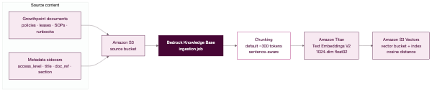
Figure 1 — AWS ingestion pipeline (offline)

Query pipeline (runtime)
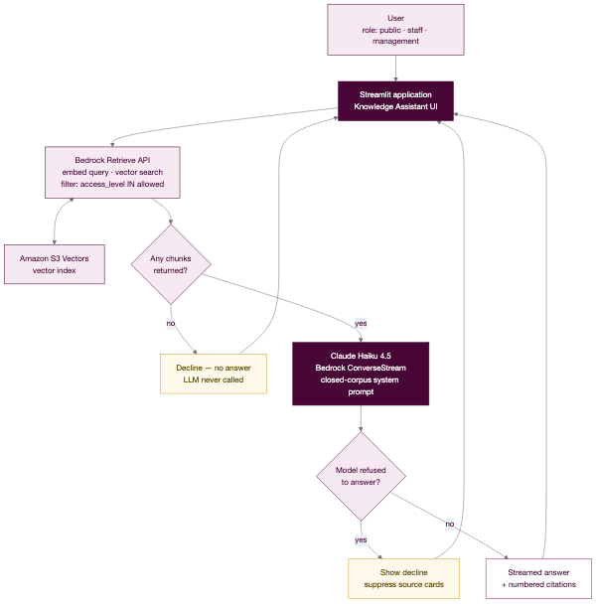
Figure 2 — AWS query pipeline (runtime)

End-to-end sequence
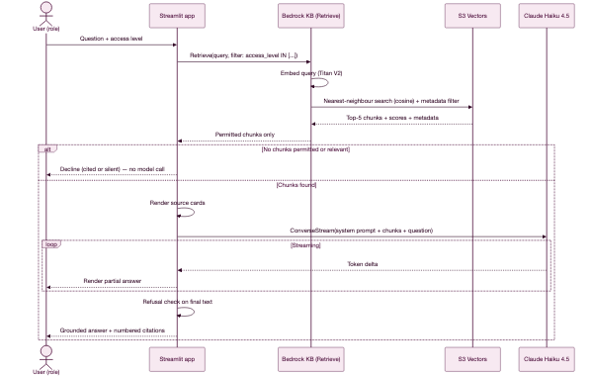
Figure 3 — AWS end-to-end sequence

8. Enforcing the guardrails
How each stated guardrail is actually enforced in the architecture, rather than merely promised:

Closed corpus
Layer | Enforcement
Architecture | The only data source is the S3 bucket. No web crawler, no internet-capable tool is configured
Retrieval | Retrieve queries the knowledge base only. There is no fallback path if it returns nothing
Prompt | The system prompt instructs the model to use only the provided context and not outside knowledge
Application | If retrieval is empty, the model is never invoked, so there is no opportunity to answer from training data

No public training
Amazon Bedrock does not use customer prompts or completions to train its foundation models, and inference traffic stays within the AWS account and region boundary. There is no data egress to a third-party model provider. For the hosted demo, the one deliberate exception is documented below under Operational considerations.

Cited or silent
Enforced at three independent points, so a failure at one does not defeat it:
- Pre-generation gate — empty retrieval returns a decline without calling the model.
- Prompt instruction — the model is told to decline rather than guess.
- Post-generation check — a detected refusal suppresses the source cards so no answer is ever displayed as though documents supported it.

Permission-aware retrieval
The filter is applied as a condition of the vector search itself. A public user's query physically cannot return a management chunk, which means restricted content never enters a prompt and never reaches the model. Access control sits at the datastore, which is the only place it is trustworthy.
An honest limitation of the PoC. The access level is currently selected from a dropdown in the interface — it is a demonstration of permission-aware retrieval, not an authenticated identity. In production the role must be derived from a verified sign-in (see Operational considerations). The retrieval mechanism is production-shaped; the identity is not.

9. The same solution on Azure
The RAG pattern is platform-independent: store documents, chunk them, embed them, search semantically, generate a grounded answer. Azure provides a direct equivalent for every component.

The Azure approach
The natural Azure build pairs Azure AI Search as the retrieval engine with Azure OpenAI for embeddings and generation.
Azure AI Search provides integrated vectorization, which is the closest counterpart to a Bedrock Knowledge Base. It brings chunking and vector conversion into a single indexing flow, reducing the manual work at both ingestion and query time (Microsoft docs).
Its mechanics map closely onto the AWS pipeline:
- An indexer pulls documents from a data source such as Azure Blob Storage.
- A skillset performs the processing. The Text Split skill (or the Document Layout skill) handles chunking, and an embedding skill attached to a supported model vectorises each chunk (Microsoft docs).
- The chunked, vectorised content is written to a vector index.
- A vectorizer attached to the index embeds incoming queries at search time with the same model — Azure's enforcement of the "same model for both phases" rule.

Component choices
Concern | Azure choice | Notes
Document store | Azure Blob Storage (or ADLS Gen2, SharePoint) | ADLS Gen2 is preferable if you want to inherit file ACLs for security trimming
Chunking | Text Split skill in a skillset | Configurable page length and overlap — comparable to fixed-size chunking with overlap
Embeddings | Azure OpenAI text-embedding-3-large (or -small) | The Titan V2 equivalent. Also supports dimension reduction
Vector store | Azure AI Search vector index | HNSW indexing; supports vector, keyword and hybrid search
Retrieval | Azure AI Search query with filters | Hybrid search plus an L2 semantic ranker for re-ranking
Generation | Azure OpenAI (GPT-4o mini or GPT-4.1 mini for the cheapest tier) | Supports streaming, the equivalent of ConverseStream
Orchestration | Azure OpenAI On Your Data, or custom code / Semantic Kernel | On Your Data is the fastest managed route
Application host | Azure App Service or Container Apps | Both run a long-lived Streamlit process, unlike static-only hosting
Identity | Microsoft Entra ID + Managed Identity | Entra gives real authenticated roles; Managed Identity removes stored keys

Permission-aware retrieval on Azure
This is the component that most needs explaining, because Azure's model differs from the AWS metadata filter and is in one respect more capable.
Azure AI Search does not vary results by user permission natively. The established approach is the security filter pattern: the application passes a user or group identity into the query as a filter, and documents that do not match are excluded from results (Microsoft docs). Security identifiers are carried in the index as filterable fields and act as a proxy for access rights. The principle is identical to our access_level IN [...] filter: security metadata travels with the document into the index, and queries always filter on it.
Azure additionally offers a more sophisticated option. Microsoft Entra-based document-level security allows an indexer to ingest ACL and RBAC permission metadata from ADLS Gen2 alongside the content, so retrieval obeys the file-level permissions already configured at the source (Microsoft announcement).
This is a meaningful advantage for Growthpoint. Rather than tagging every document with an access_level by hand, permissions could be inherited from existing file shares and Entra groups — so a lease document restricted to the leasing team in SharePoint stays restricted in the assistant, automatically, with no separate tagging exercise to maintain.

Where Azure differs in substance
Area | Difference and why it matters
Hybrid search | Azure AI Search supports vector, keyword and hybrid search with semantic re-ranking. S3 Vectors is semantic-only. If users search by document reference (GP-POL-001) or exact building names, this is a real advantage
Permissions | Azure can inherit ACLs from the source via Entra. AWS requires explicit metadata you manage yourself
Cost model | Azure AI Search bills per provisioned service tier (an always-on cost, similar to OpenSearch Serverless). S3 Vectors is pay-for-what-you-store-and-query, which is markedly cheaper at small scale
Managed RAG | Bedrock Knowledge Bases wraps retrieval and generation in one RetrieveAndGenerate call. Azure's closest equivalent is Azure OpenAI On Your Data; otherwise the orchestration is yours to write

10. Azure architecture

Ingestion pipeline (offline)
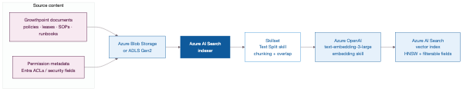
Figure 4 — Azure ingestion pipeline (offline)

Query pipeline (runtime)
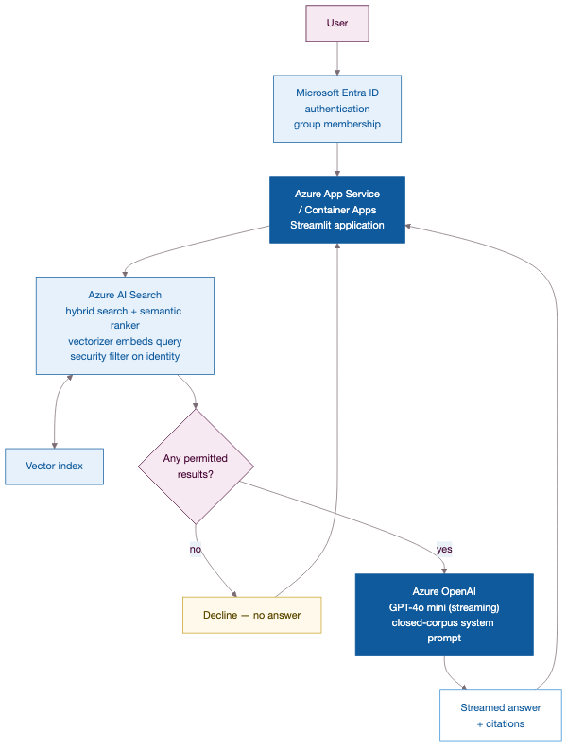
Figure 5 — Azure query pipeline (runtime)

Azure sequence, with authenticated identity
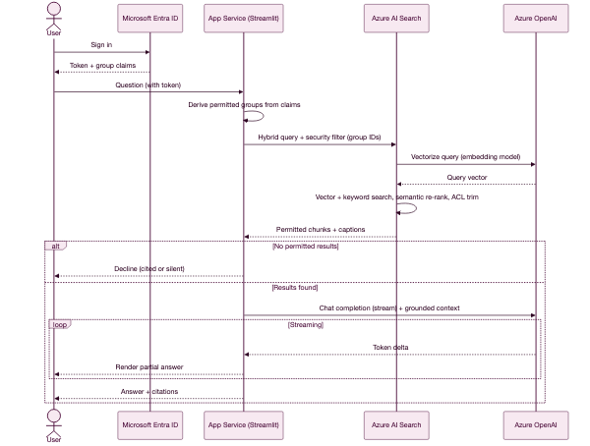
Figure 6 — Azure sequence with authenticated identity

11. AWS to Azure service mapping
Function | AWS (this build) | Azure equivalent
Document storage | Amazon S3 | Azure Blob Storage / ADLS Gen2
Ingestion orchestration | Bedrock Knowledge Base ingestion job | Azure AI Search indexer
Chunking | Bedrock default chunking (~300 tokens) | Text Split skill / Document Layout skill
Embedding model | Amazon Titan Text Embeddings V2 (1024-dim) | Azure OpenAI text-embedding-3-large / -small
Vector store | Amazon S3 Vectors | Azure AI Search vector index (HNSW)
Vector search | S3 Vectors cosine similarity (semantic only) | Azure AI Search vector / hybrid + semantic ranker
Managed RAG call | Bedrock RetrieveAndGenerate | Azure OpenAI On Your Data
Retrieval-only call | Bedrock Retrieve | Azure AI Search query API
Generation model | Claude Haiku 4.5 | Azure OpenAI GPT-4o mini / GPT-4.1 mini
Streaming generation | Bedrock ConverseStream | Azure OpenAI streaming chat completions
Permission filtering | access_level metadata filter | Security filter pattern / Entra document-level security
Identity | IAM (scoped user or role) | Microsoft Entra ID + Managed Identity
Application hosting | Streamlit Community Cloud (PoC) / App Runner (AWS-native) | Azure App Service / Container Apps
Secrets management | AWS Secrets Manager / IAM roles | Azure Key Vault + Managed Identity
Monitoring | Amazon CloudWatch | Azure Monitor + Application Insights
Content safety | Amazon Bedrock Guardrails | Azure AI Content Safety

12. Operational considerations

Ingesting the real Growthpoint documents
The design anticipates this. When documents arrive:
- Place them in the S3 source bucket under the documents/ prefix.
- Provide an access_level for each (public, staff, management) plus title, category, reference and section, as a metadata sidecar.
- Run the ingestion job. Bedrock detects and indexes the changes.
- The running application picks up the updated knowledge base immediately — no redeployment, because it queries the knowledge base live.
Two decisions to make before that ingestion, both consequential:
- Chunking strategy. The strategy cannot be changed after a data source is created. Real documents are longer and more structured than the mock set, so fixed-size-with-overlap or semantic chunking should be evaluated against a representative sample first.
- Embedding dimensions. Still cheap to change now, requires full re-embedding later. At large corpus sizes, 512 dimensions is worth benchmarking against 1,024 for the ~1% accuracy trade.

Production gaps in the current PoC
Stated plainly, so nothing is assumed to be production-ready that is not:
Gap | Current state | Needed for production
Authentication | Access level chosen from a dropdown | Real sign-in (Entra ID / AWS IAM Identity Center / Cognito) with the role derived from verified group claims
Hosting | Streamlit Community Cloud, public URL | Private hosting inside the customer boundary — App Runner/ECS on AWS, App Service/Container Apps on Azure
Credentials | Scoped IAM access key stored in the host's secrets | Managed identity or IAM role, with no long-lived keys
Audit | None | Log who asked what and which documents were returned — important for a permission-aware system
Feedback loop | Captured in session only | Persist feedback to a store so knowledge gaps can be analysed and acted on
Content safety | Prompt-level instruction only | Add Bedrock Guardrails or Azure AI Content Safety for defence in depth

A note on the hosted demo
The PoC is hosted on Streamlit Community Cloud so a URL can be shared quickly. That is a third-party host outside the AWS account, which is why it needs a stored access key. The key belongs to a scoped IAM user permitted only to query this one knowledge base and invoke these two models — if it leaked, the blast radius is limited to reading fictional demo data, and it can be rotated or deleted at any time.
This is an acceptable trade for a demo containing only mock data. It would not be acceptable for real Growthpoint documents. Before ingesting genuine content, hosting should move inside the customer boundary (AWS App Runner or Azure App Service), where a managed identity replaces stored keys entirely.

Cost shape
Cost element | Characteristic
Embeddings | One-off per ingestion, re-incurred only when documents change
Vector storage | S3 Vectors is the low-cost option — AWS cites up to 90% savings on vector upload, storage and query
Retrieval | Per query, low
Generation | Per query, dominated by input tokens (the retrieved context). Haiku is the cheapest Claude tier
Idle cost | Near zero with S3 Vectors — a significant advantage over OpenSearch Serverless or an Azure AI Search tier, both of which bill while idle

13. Sources
Technical claims in this document are drawn from the following vendor documentation. Content has been paraphrased and summarised for compliance with licensing restrictions.
AWS
- How content chunking works for knowledge bases
- Using S3 Vectors with Amazon Bedrock Knowledge Bases
- Amazon Titan Text Embeddings models
- ChunkingConfiguration API reference
- Introducing Amazon S3 Vectors
- Building cost-effective RAG applications with Bedrock Knowledge Bases and S3 Vectors
- Titan Text Embeddings V2 for Bedrock Knowledge Bases
- Selecting a vector store for Amazon Bedrock Knowledge Bases
Azure
- Integrated vectorization overview
- Integrated vectorization using REST APIs
- Document-level access control in Azure AI Search
- Security filter pattern
- Generate embeddings in Azure AI Search
- Entra-based document-level security in Azure AI Search
- Azure OpenAI On Your Data configuration
Growthpoint background
- Growthpoint Properties — South Africa's largest primary JSE-listed REIT, with a diversified portfolio across office, retail, logistics and industrial, healthcare and student accommodation sectors

