This to certify that Mr. Onyeodizielu Abundance.

Has successfully Designed and Developed:

Nicon Places App. (a hotel and sales management desktop application)

Submitted by:

Mr. Onyeodizielu Abundance.

Date of Issue: ___________________________________

Authorized Signature: ____________________________

Annexure A

With the rise in customers, hotel need to maintain a record of every transaction made in the hotel, whether it is booking of rooms, buying foods or products. In addition, these operation have to be efficient and should be documented properly. Many business organization nowadays are using some standard management mythologies relevant to their type. There is a need to offer a software solution to offset cost by substituting paper based expenses with increased control, efficiency, productivity and live documentation.

This software will enable to add, modify and view customer details and product details. It will also help to perform product sales and transaction. Also the software should be able to store, retrieve and manipulate data in appropriate database tables.

End users of this software are customers who will book rooms and make purchases.

**Details of the software solution or application are as follows:**

* An Admin is the person with rights and permission to all tasks in the software application system. Admin can register himself/herself with the application. This registration will enable him/her to log into the system and use the application.
* An Admin table in the database will store the login details of the admin person such as first name, last name, user name, email and password.
* Admin user should login before using the application. The admin user would input user name and password which would be matched against the stored user name and password in the database.
* Admin user should enter food and product details into the respective tables. The application should be capable of displaying products belonging to a specific category.
* Customer are people who actually buy products and make bookings in the store, there details are accurately recorded in the database.
* The application should auto-generate a customer id for uniquely identifying the customer before saving customer details.
* Once registered, the customer details can be used to perform transaction through sales module. The sales module will also use product and category details.
* Whenever a sales of product is made to a customer, the data should be updated in the database
* All the product details should be stored in onlinestores database tables. This table can include productID, productName, productPrice, image.
* The application should display the current price of selected products that the customer wants to buy and should accept quantity, for these selected products whether is be food items or just ordinary products in the online store table. The application should then compute and display total price of all the items and products selected buy the customer. This has to be computed and displayed by the application.
* Upon successful sale, customer id, product name , price would be recorded in the appropriate transaction in the database whether for the restaurant table of the online store table.

**Proposed Solution**

The proposed solution of the project is a desktop application named Nicon places.

The entry point will be a login screen which is responsible for validating the users. The application will allow the admin to login to the system with specified user name and password. After logging in, admin can add/updated customer details, hotel details and product details. Admin will also be responsible for managing the sales made within the application.

Database table will also be used to store information related to customers, hotels rooms, food, products and sales information.

Nicon places is management application that is used to bring about effective management in a hotel environment such as hotel booking, sailing of food and products offered by the hotel to its customers.

Project Specifications

The application is developed for windows platform using java SE 8, NetBeans 8.2 and SQL server 2016

The application should perform the following functions:

* Store information for managing hotel bookings in database tables
* Registers a new admin user
* Allow login for registered Admin
* Following option should be available only to the Admin

Hotel room management

Customer information management

Restaurant information management

Product management

* Register a customer
* Search for a particular customer’s information
* View detailed customer information such as:
* Customer information:
  + Customer id, first name, last name, user name, email, and password.
* Customer purchase list:
  + Customer id, product name, price, etc
* Update Customer information
* Perform sales of product
* View product information

**Hints for developing the solution:**

Create a desktop application that would have menu option and screen for all these task that should be performed by the application. Implement the logic and functionality

ACKNOWLEGEMENT

I would like to acknowledge my family for the support and help given to me to make this project a success.

I also express my sincere gratitude to my brother for his valuable guidance and support towards the completion of this project.

Problem definition

With the rise in customers hotel need to maintain a record of every transaction made in the hotel, whether it is booking of rooms, buying foods or products. In addition, these operation have to be efficient and should be documented properly. Many business organization nowadays are using some standard management methologies relevant to their type. There is a need to offer a software solution to offset cost by substituting paper based expenses with increased control, efficiency, productivity and live documentation.

This software will enable to add, modify and view customer details and product details. It will also help to perform product sales and transaction. Also the software should be able to store, retrieve and manipulate data in appropriate database tables.

End users of this software are customers will to book rooms and make purchases.

Customer Requirement Specification

**Client: Nicon Places Application**

**Project Objective:**

Develop a hotel management software system that helps customers to book rooms and make reservations. This software should also be able to buy items and food offered by the hotel besides making reservations. This software solution is an end to end suite designed for multi-channel customers that will enhance customer service across channels, while driving growth and increasing revenue.

**Inputs provided by the Client:**

Inputs to the existing system

Outputs from the existing system

Process involved in the application

List of deliverables

**Hardware Requirements:**

Intel Core i3 Processor or higher

4 GB Ram or above

Color SVGA

120 GB Hard Disk space

**Software Requirements:**

Microsoft Windows 7 or Microsoft Windows 8.1 or higher

Java SE 8, NetBeans 8.2, and SQL server 2016.

**Scope of the Work:**

Depending on the decision taken by the management as regards to Nicon Places application, following are the requirement based on which the software needs to be developed:

The application should perform the following functions:

* Allow login for Admin
* Store information for managing the product sales and purchase in database table
* Following options should be available to the Admin

Product management

Customer information management

* Register a Customer
* Search for a particular customer information
* View detailed customer information. The information should include:

Customer information:

Customer ID, Customer Name, Gender, Email, Password, Customer’s balance.

Customer Purchase list

Customer ID, Product name, Price.

* Update customer information
* Perform sales of product
* View products information

Architecture and Design of the Project

Figure1 below displays the application architecture.

Figure 2 below show the login page of the application

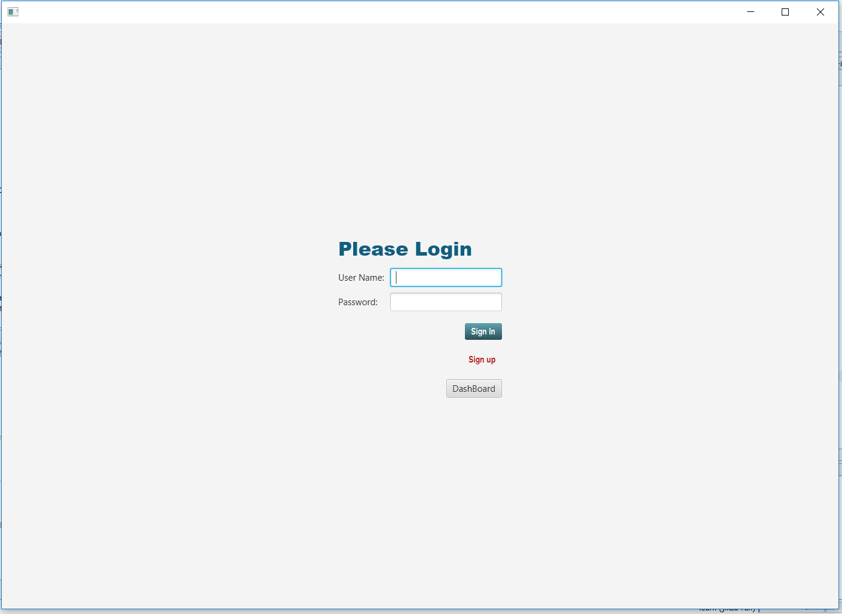

Figure 3 show the various view for the customers after a successful login

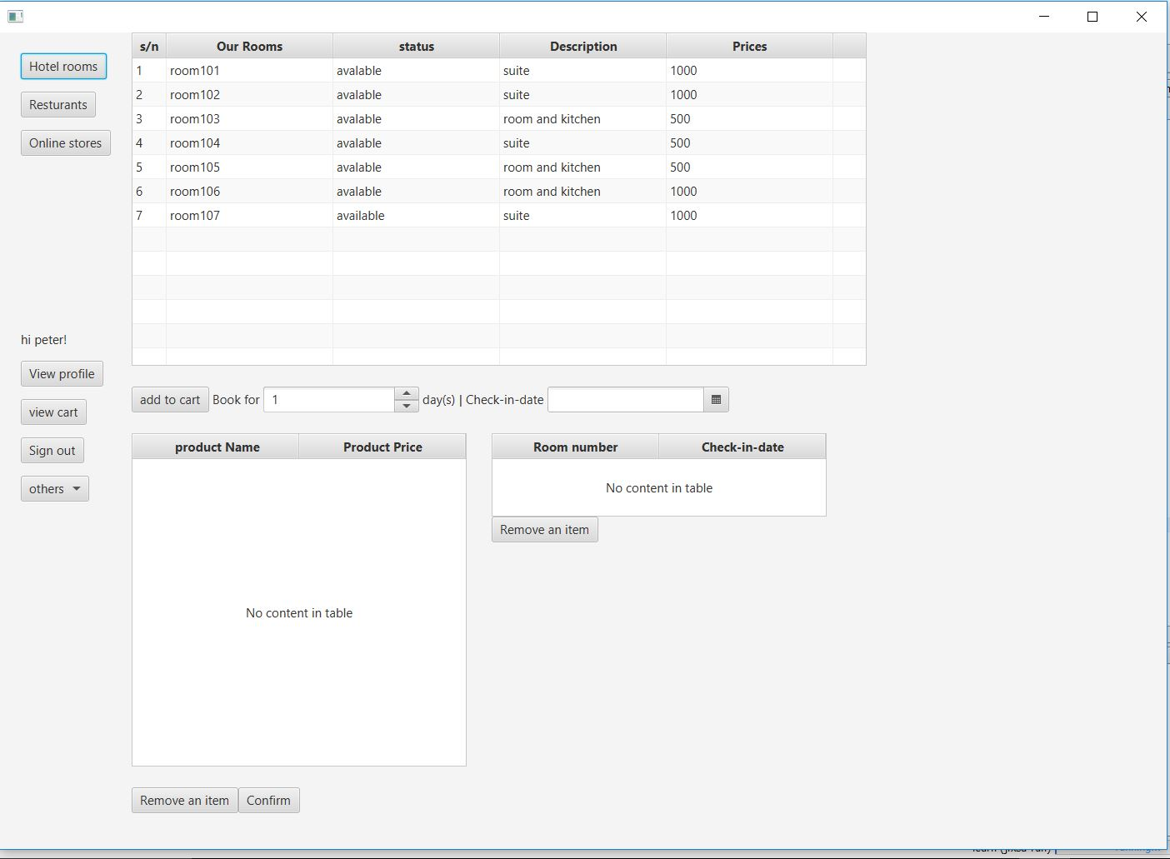

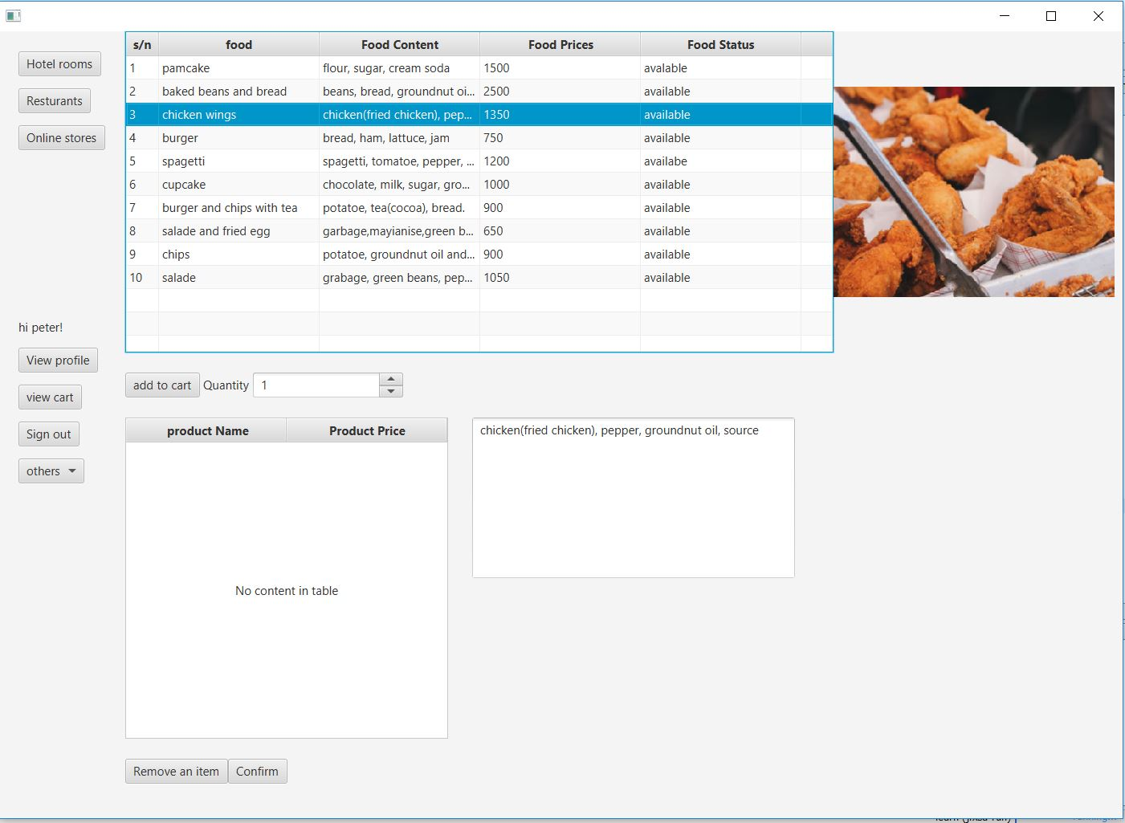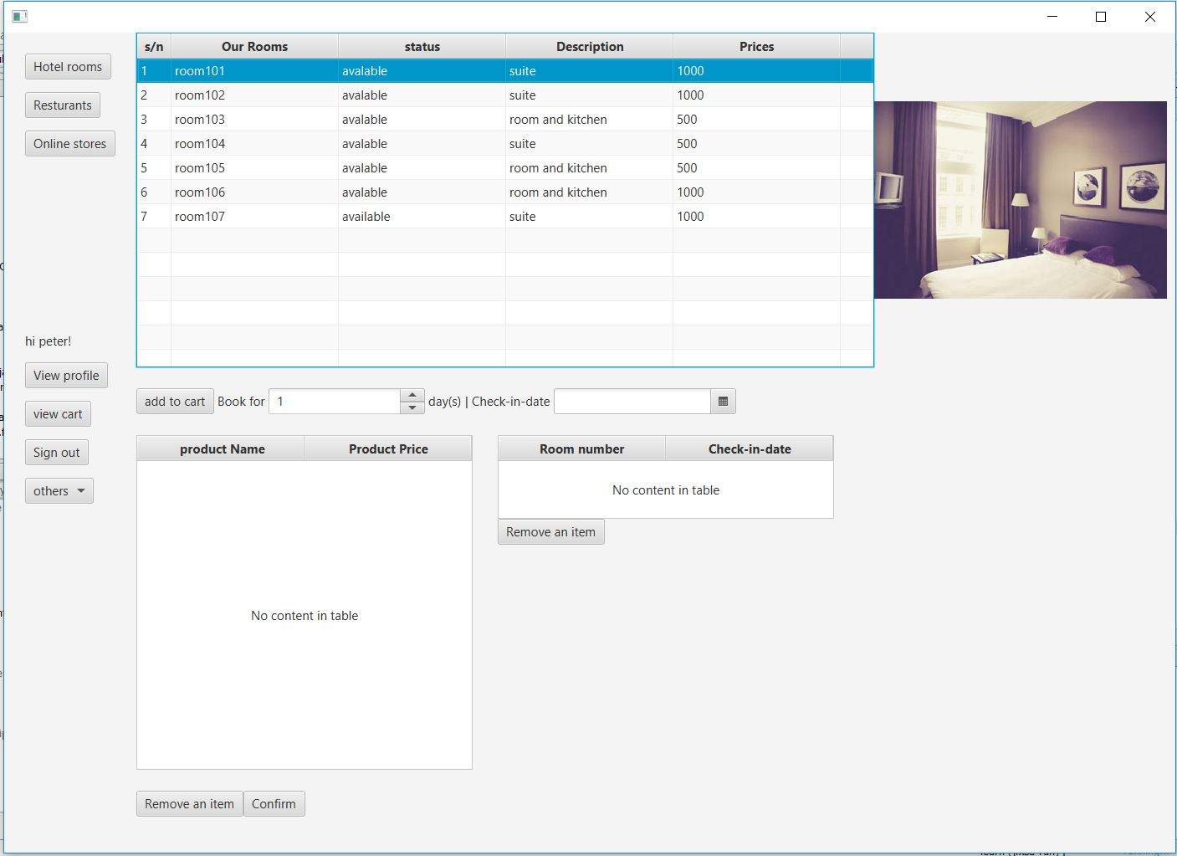

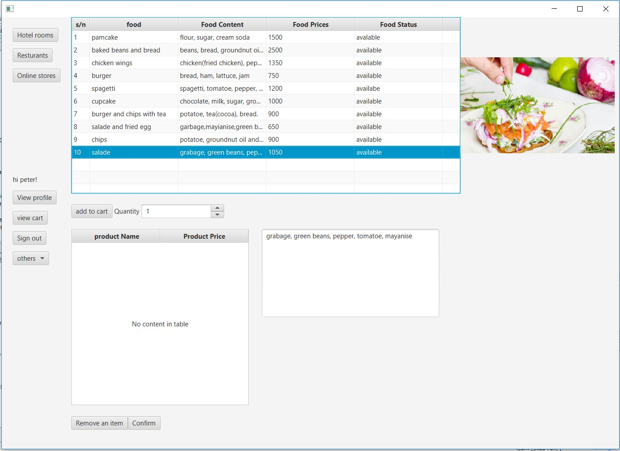

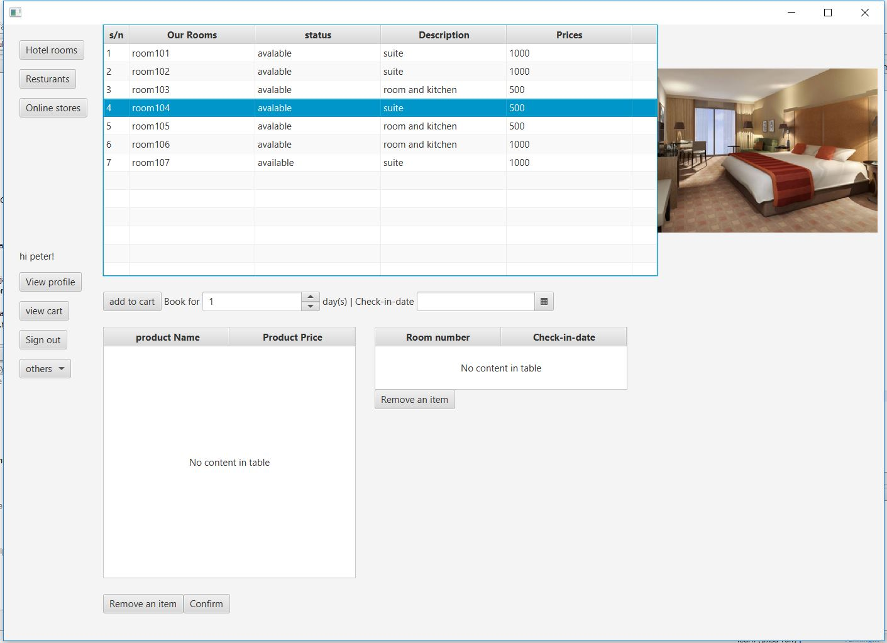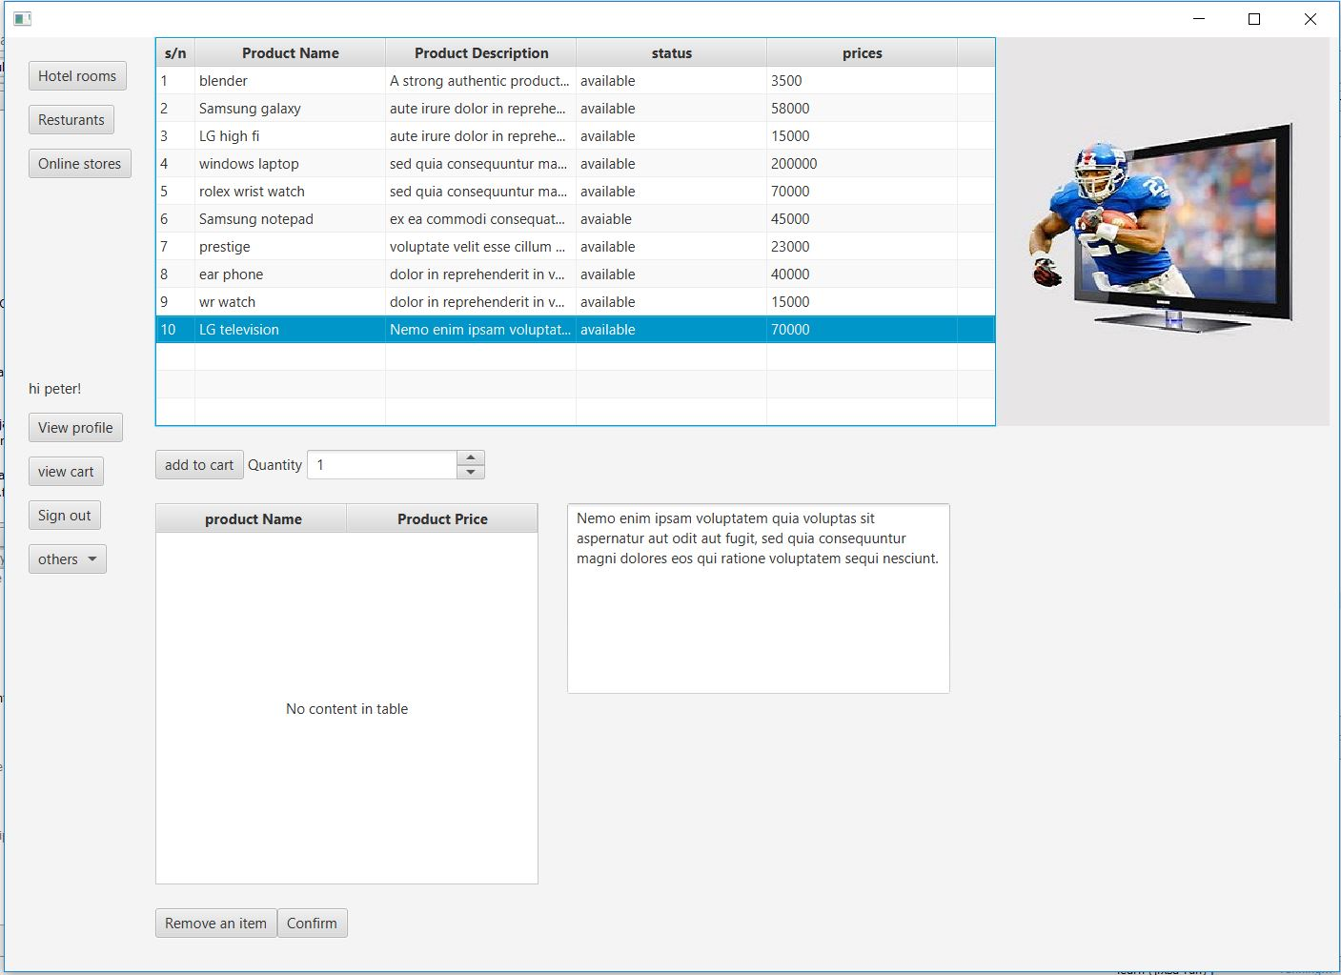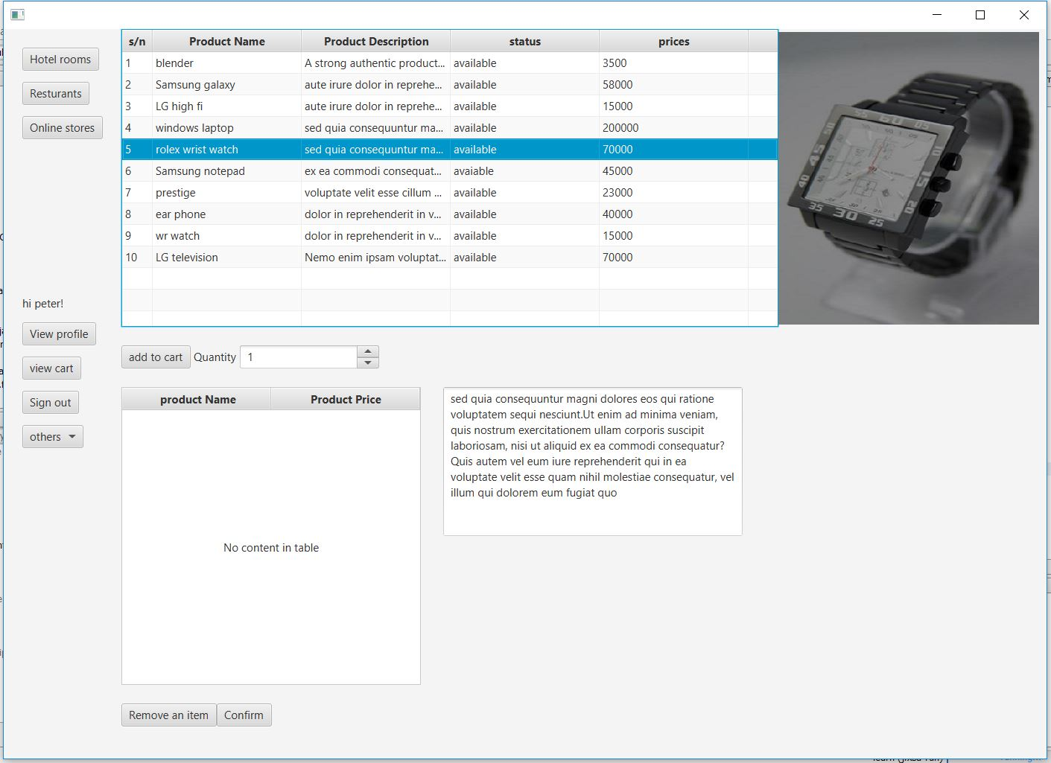

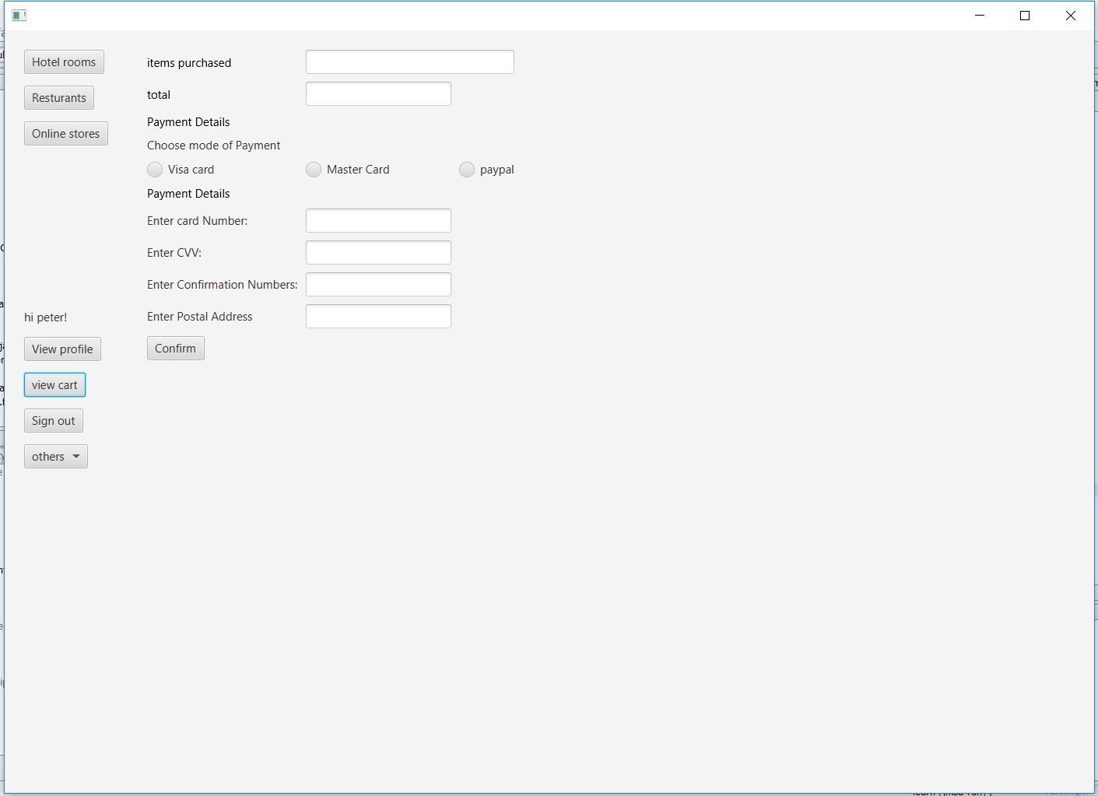

Figure 4 show the view for the Admin after a successful login

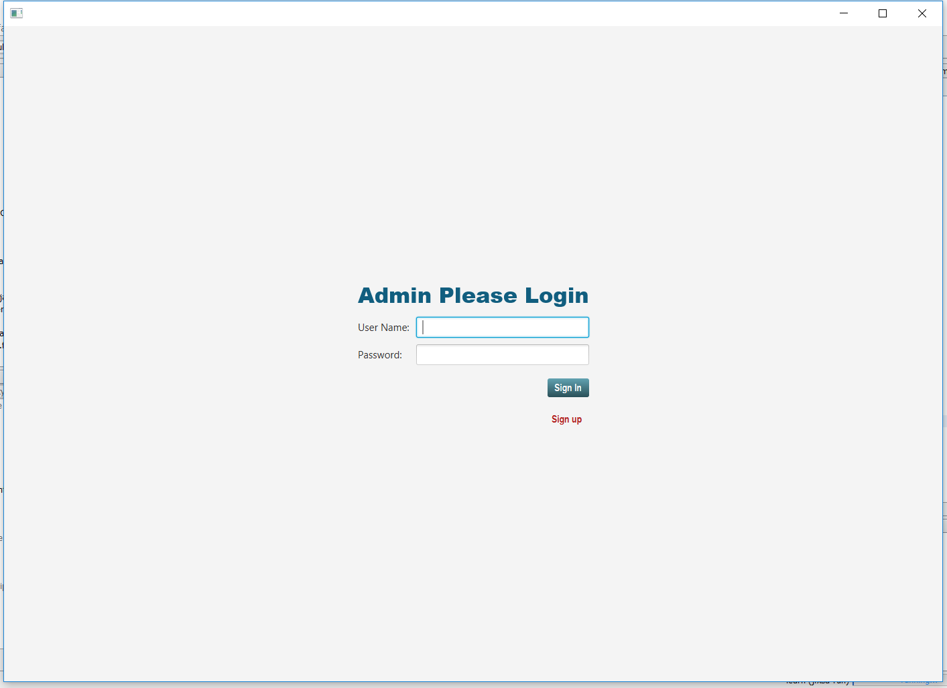

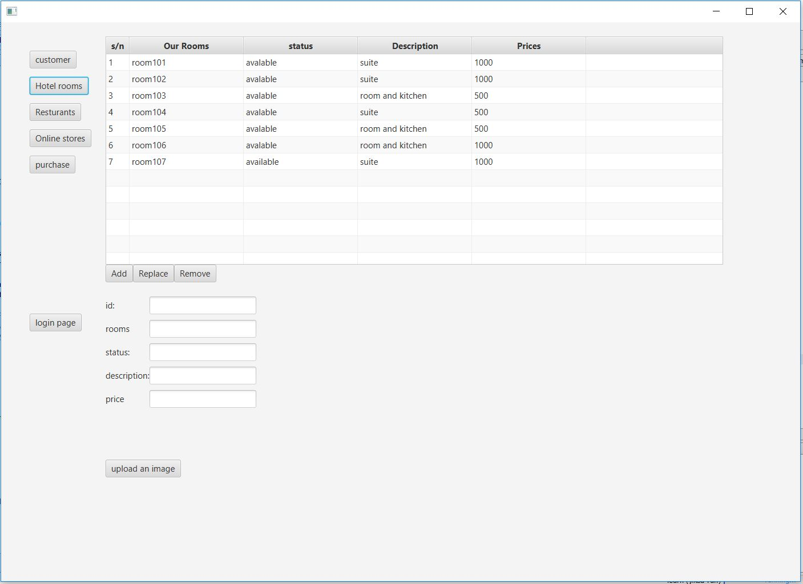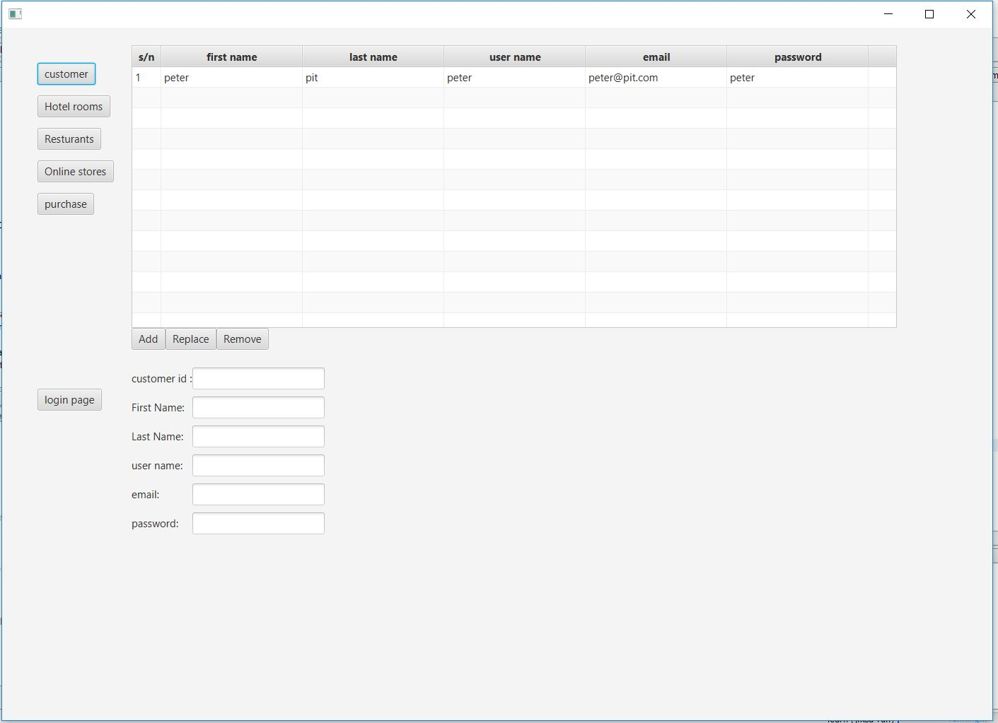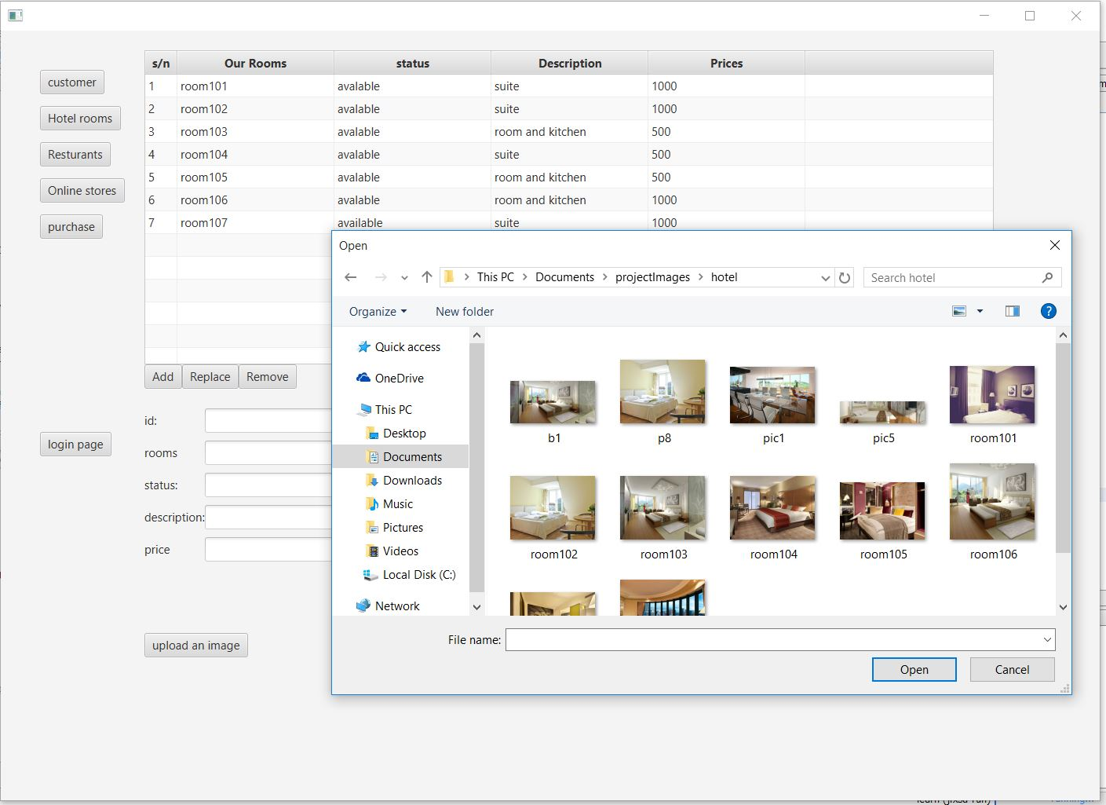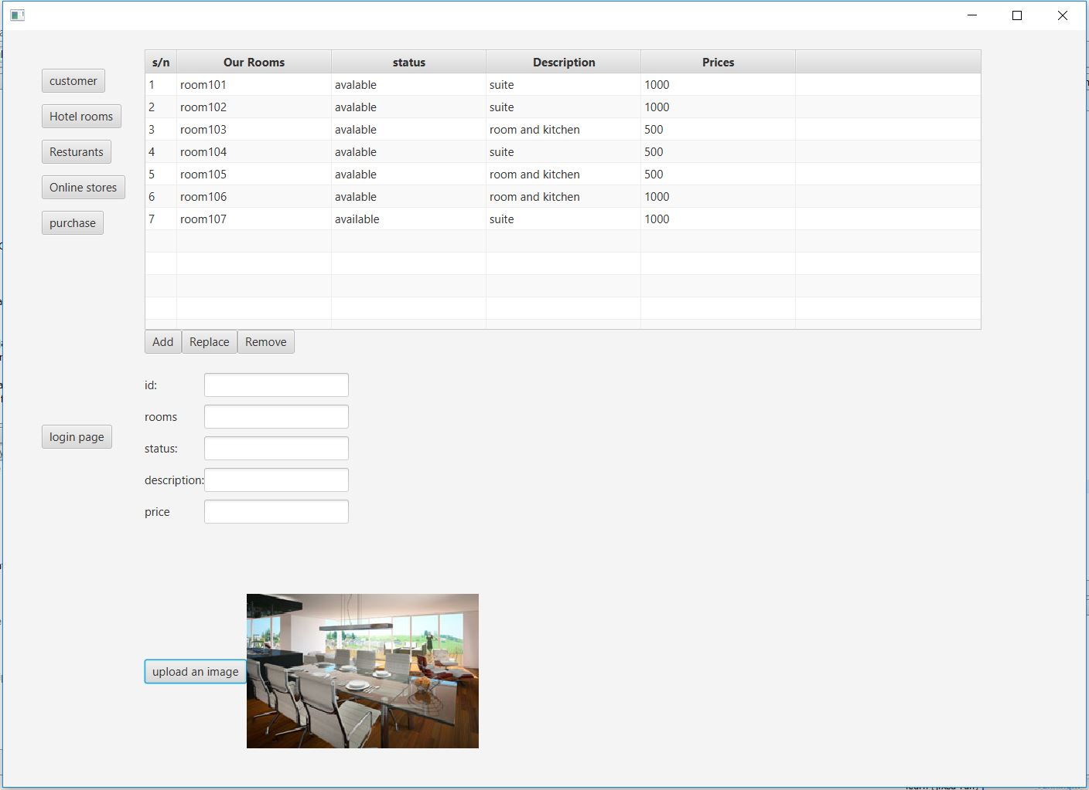

Flow Chart

Figure 1 shows the different activities associated with the application.

Accept user choice

Accept user choice

Is Admin detail valid

No

A

yes

Is customer details selected

yes

B

No

Is product details selected

yes

C

No

No

Is logout selected

yes

stop

Figure 2 shows the different Admin activates associated with the application

A

Admin Login

Add,delete,modify customer details

yes

B

Add,delete,modify hotel details

yes

C

View transaction details

yes

Display information

no

Is logout selected

stop

Figure 3 shows the application flow for selling products.

C

Display product for sell

Select product with mouse

Display image and description of product

Enter product quantity

Check quatity greater than other

no

yes

Display product transaction

Process product sales

D

Calculate product price

Store transaction in db

Figure 4 below shows the application flow for addition of customers

B

Display customer details screen

Add customer details

Modify details

no

Are details correct

yes

yes

Save details to db

Is logout selectedd

yes

stop

Data Flow Diagram

Figure1 displays the context level diagram of the application.

Customer details customer details

Customer/user

database

Displays hotel products and services LoginID and password

Figure 2 displays the first level of data flow diagram.

Admin details

Admin details

Admin

database

LoginID and password

Display information

Customer,product and service details

Customer,product and service details

database

Admin

Customer,product and service details

Customer,product and service details

Figure 3 displays the first level of data flow diagram of product transaction

Customertb DB

Customer details

Customer,restaurant and hotel details

Restaurant details

Admin

Restaurant DB

Returant details and transaction

Customer,restaurant and hotel details and transaction

Hotel details and transaction

Hotel details

Hotel DB

Figure 4 shows the use case of the application.

Database Design/Structure

Database structure of the different Tables is given in the following sections:

* **Customer Details**

Customer Details table stores the customer details.

|  |  |  |  |
| --- | --- | --- | --- |
| **Field Name** | **Data Type** | **PK/FK** | **Description** |
| custId | Int | PK | Generates Customer ID |
| firstName | nvarchar(max) |  | Stores customer first name for given ID |
| lastName | nvarchar(max) |  | Stores customer last name for given ID |
| Username | nvarchar(max) |  | Stores customer username name for given ID |
| Email | nvarchar(max) |  | Stores customer email for given ID |
| Password | nvarchar(max) |  | Stores customer password for given ID |

* **Admin Details**

Customer Details table stores the customer details.

|  |  |  |  |
| --- | --- | --- | --- |
| **Field Name** | **Data Type** | **PK/FK** | **Description** |
| adminID | Int | PK | Generates Admin ID |
| firstName | nvarchar(max) |  | Stores Admin first name for given ID |
| lastName | nvarchar(max) |  | Stores Admin last name for given ID |
| Username | nvarchar(max) |  | Stores Admin username name for given ID |
| Email | nvarchar(max) |  | Stores Admin email for given ID |
| Password | nvarchar(max) |  | Stores Admin password for given ID |

* **Hotel Details**

Hotel Details table stores the Hotel details.

|  |  |  |  |
| --- | --- | --- | --- |
| **Field Name** | **Data Type** | **PK/FK** | **Description** |
| roomsID | Int | PK | Generates room ID |
| Rooms | nvarchar(max) |  | Stores room name for given ID |
| Status | nvarchar(max) |  | Stores room status for given ID |
| Description | nvarchar(max) |  | Stores room description for given ID |
| productPrice | Int |  | Stores room price for given ID |
| Image | Varbinary(max) |  | Stores room image view for given ID |

* **Restaurant Details**

RestaurantDetails table stores the Restaurantdetails.

|  |  |  |  |
| --- | --- | --- | --- |
| **Field Name** | **Data Type** | **PK/FK** | **Description** |
| foodID | Int | PK | Generates food ID |
| foodName | nvarchar(max) |  | Stores food name for given ID |
| foodContent | nvarchar(max) |  | Stores food content for given ID |
| foodPrice | Int |  | Stores food price for given ID |
| foodStatus | nvarchar(max) |  | Stores food status for given ID |
| Image | Varbinary(max) |  | Stores food image for given ID |

* **Online stores Details**

Online storesDetails table stores the online storesdetails.

|  |  |  |  |
| --- | --- | --- | --- |
| **Field Name** | **Data Type** | **PK/FK** | **Description** |
| productID | Int | PK | Generates product ID |
| productName | nvarchar(max) |  | Stores product name for given ID |
| productDescription | nvarchar(max) |  | Stores product description for given ID |
| productStatus | nvarchar(max) |  | Stores product status for given ID |
| productPrice | Int |  | Stores product price for given ID |
| Images | Varbinary(max) |  | Stores product image for given ID |

* **Hotel Sales Details**

Online storesDetails table stores the online storesdetails.

|  |  |  |  |
| --- | --- | --- | --- |
| **Field Name** | **Data Type** | **PK/FK** | **Description** |
| hotelSalesID | Int | PK | Generates product ID |
| custId | Int | FK | Stores Customer ID |
| hotelRoom | nvarchar(max) |  | Stores booked rooms |
| Price | Int |  | Stores price |
| checkInDate | nvarchar(max) |  | Stores Check in dates |

Task Sheet

|  |  |  |  |  |  |  |  |
| --- | --- | --- | --- | --- | --- | --- | --- |
| Project Ref.No.:  Nicon Soft application | | Project Title | Activity Plan Prepared By: | Date of Preparation of Activity Plan: | | | |
| Sr.No. | Task | Actual Start Date | Actual Days | Team Mate Names | Status |
| 1  2  3)  4) | Login form design and coding  Product page(hotel  Services,  Restaurant services ,and store services)  Admin dashboard  Final touches | Nicon places  Application  Nicon places  Application  Nicon places  Application  Nicon places  Application | Abundance  Abundance  Abundance  Abundance | 25-Aug-2017  8-Sept-2017  15- Sept -2017  1- Oct-2017 | 1  14  7  14 | Abundance  Abundance  Abundance  Abundance | Completed  Completed  Completed  Completed |

Checklist of Validations

|  |  |
| --- | --- |
| **Options** | **Validation** |
| Dose the administrator have all the rights to create and delete the records? | Yes |
| Are all the record properly fed into the appropriate database? | Yes |
| Do all numeric variables have a default value of zero? | Yes |
| Have all the modules been properly integrated and are completely functional? | Yes |
| Is the design consistent all over? | Yes |
| Is the navigation sequence correct through all the screens in the application? | Yes |
| Are all the program codes working? | Yes |
| Have all the design and coding standards been followed and implemented? | Yes |
| Is exception handling mechanism implemented in all the screens? | Yes |

Submission Checklist

|  |  |  |  |  |  |
| --- | --- | --- | --- | --- | --- |
| Sr.No | Particular | Yes | No | NA | Comments |
| 1 | Have all the modules been properly integrated and are they completely functional? | yes |  |  |  |
| 2 | Dose each unit meet its objective and purpose?  Are all the validation happening as specified in process Design? | yes |  |  |  |
| 3 | Have all the design and coding standards been followed and implemented? | yes |  |  |  |
| 4 | Is the GIU design consistent all over? | Yes |  |  | Consistency is ensured. |
| 5 | Are the code working as per the specification? | Yes |  |  |  |
| 6 | Dose the application’s functionality resolve the client problem and satisfy his/her needs completely | yes |  |  |  |
| 7 | Have the hardware and software been correctly chosen? | Yes |  |  |  |
| 8 | Additional features and utilities that give value addition to the entire project. | Yes |  |  |  |

User Guide

1. System Requirements:

|  |  |  |
| --- | --- | --- |
| No. | Items | Description |
| 1 | Operating System | Microsoft Windows 7 or Microsoft Windows 8.1 or higher. Screen size of 1400 and 980 |
| 2 | Database | SQL server |
| 3 | Software | Java SE 8 and NetBeans 8.2 |

1. Install and Run Application:

Step 1: Install SQL server on your local system.

Step 2: Create appropriate database and tables as per the specification given.

Step3: Execute the application.