Germán Martínez Cagigas
DAW
Azure virtual machine domain

INDEX

Sumario
INDEX 2
INTRODUCTION 3
EXERCISE 4
Creating domain. 4
Result. 5
2.1. What was the most challenging part of this activity? How did you manage to solve it? 6
2.2. Look for a paid domain provider and try to register your own domain name with a popular extension (such as .es, .com,…). Check the price for a 1-year suscrption. Investigate which organization is handling the extension you have choose 6
BIBLIOGRAFIA 8

INTRODUCTION

Making a domain on the web for our server to find it through a name instead a ip.

EXERCISE

Creating domain.

I have thew mine already created on page: freedns.afraid.org figure 1.
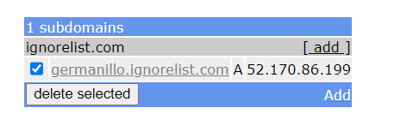Figura 1

But to reach that point you only need to log in on the web and create a new domain, tyou will see the next page on figure 2.
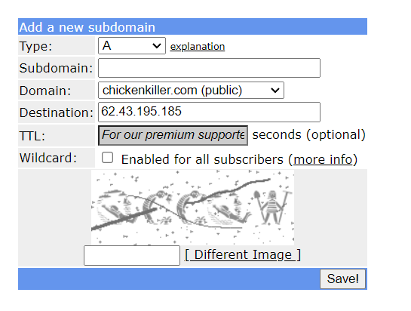Figura 2

Now we fill it with the data we want (figure 3).
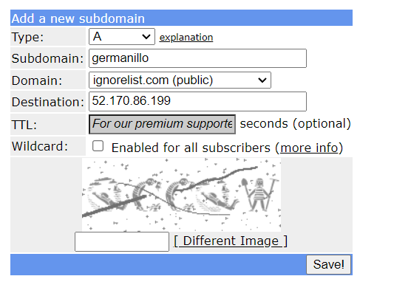Figura 3

domain is the final route for say it in some way of our server, and the subdomain is what will go before it so in that case the route to my server will be, germanillo.ignorelist.com.
Destination is the ip of our pc, in this case azure says that that ip is the one of my virtual machine so i just added.

Result.

Now we start up our virtual machine with xamp, after that we gonna make a search on our browser with the domain generated url.

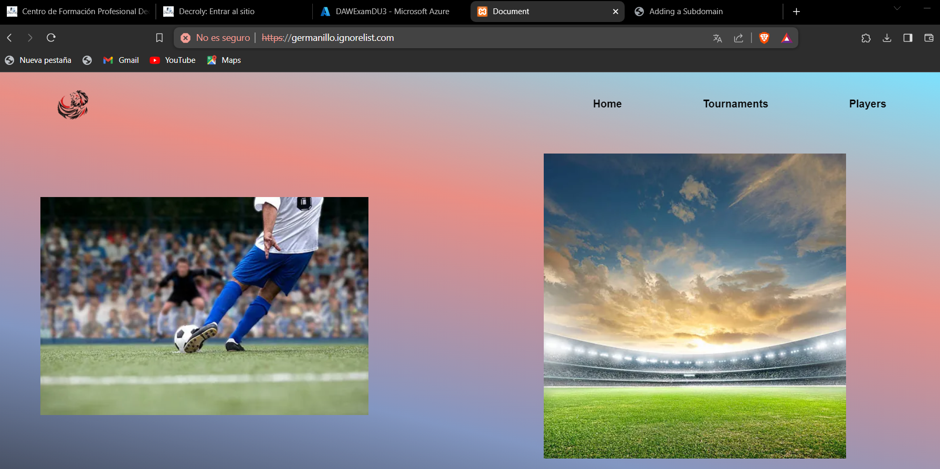Figura 4
Now in figure 4 we see that we can access to our page in our virtual machine through a domain, instead of use the ip.

2.1. What was the most challenging part of this activity? How did you manage to solve it?

Nothing actually, very intuitive.

2.2. Look for a paid domain provider and try to register your own domain name with a popular extension (such as .es, .com,…). Check the price for a 1-year suscrption. Investigate which organization is handling the extension you have choose

First of all not all suplliers charge the same amount, it depends of each one, the support they give etc.

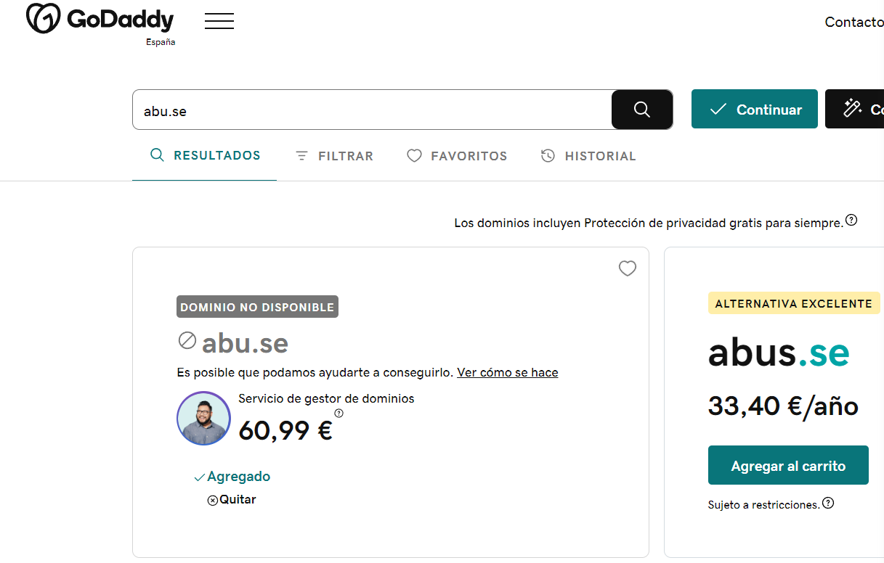Figura 5
On figure 5 i tried to find on godaddy domain supplier abu.se which is in use or need a intermediate to buy it, but we can see that the alternative abus.se th epricce per year is 33.40€, but normally suppliers gave 2 years contract, the first one cheaper than the second.

The organization that control in some way all root domains, .com, .es, .tv, etc is ICANN, and they give this end point to different companies or organizations to manage it, like Verisign with .tv or .com. Called also superior domains, also there is diferences between them like geolocated like .es from spain, etc.
In Spain first ICANN gave the control of that geolocated root to REDIRIS, but nowdays it is managed by RED.es.
.se is from sweden, and it is managed by Internet Infrastructure Foundation .
There is also other examples like .tv from Tuvalu, they are in an agreement where every year they receive millions by giving the manage of their superior domain to Verisign and Verisign sell .tv domains for a big quantity of money.

BIBLIOGRAFIA

https://es.wikipedia.org/wiki/.es

