Germán Martínez Cagigas
DAW
CRT installation

INDEX

Sumario
INDEX 2
INTRODUCTION 2
EXERCISE 4
Path. 4
2.1. What was the most challenging part of this activity? How did you manage to solve it? 8
2.2. Can you investigate about any paid SSL certificate? Who provides it? How much it costs? 9
2.3. Your web browser may identify this certificate as unsafe. Could you explain why? 9
CONCLUSION 10
BIBLIOGRAFIA 11

INTRODUCTION

Installation of certificates for a page hosted in Apache server.

EXERCISE

Path.
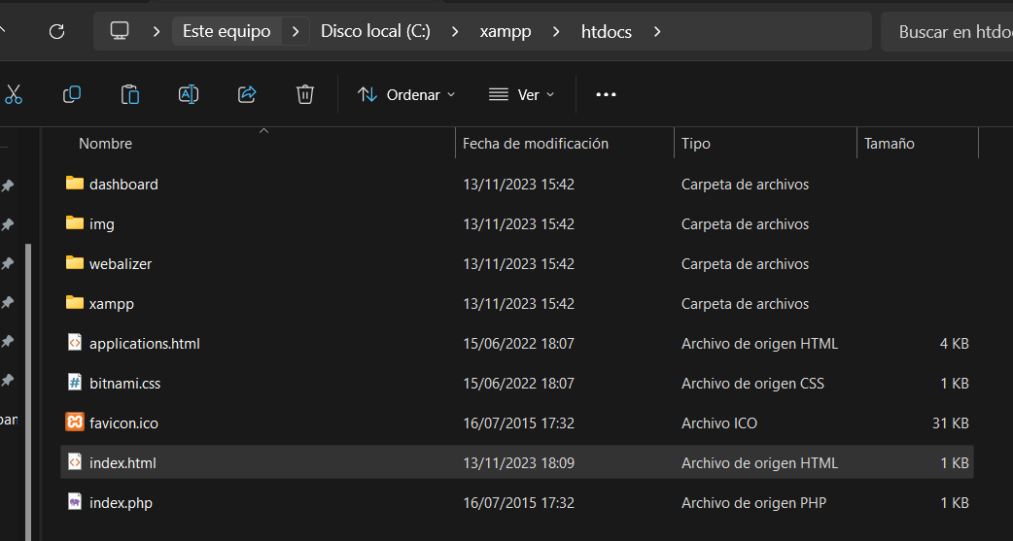Figure 1
I already have a html document called index.html on figure 1 inside xammp htcdocs.

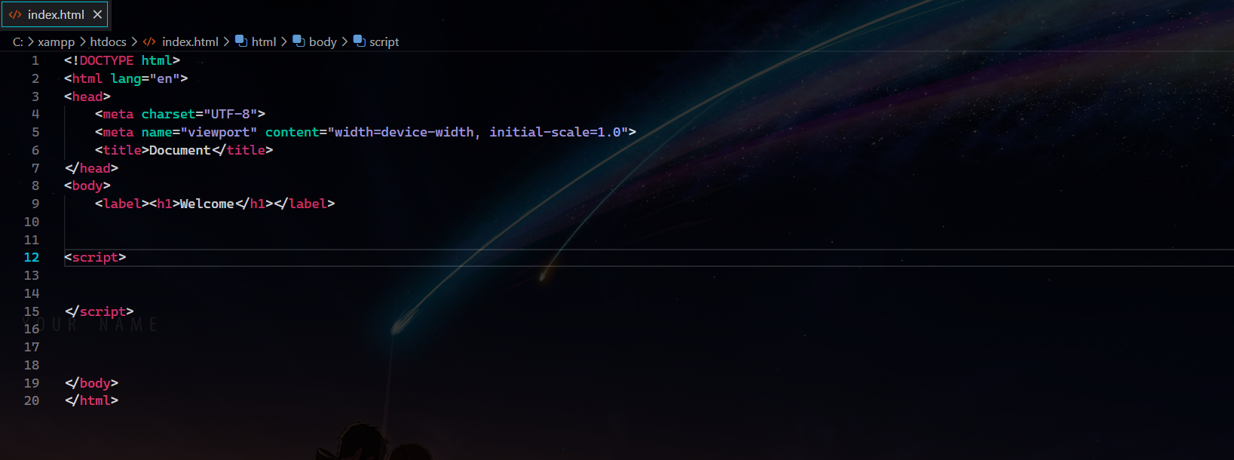Figure 2
The document it self doesnt have nothing more than a sad welcome word as you can see in figure 2.

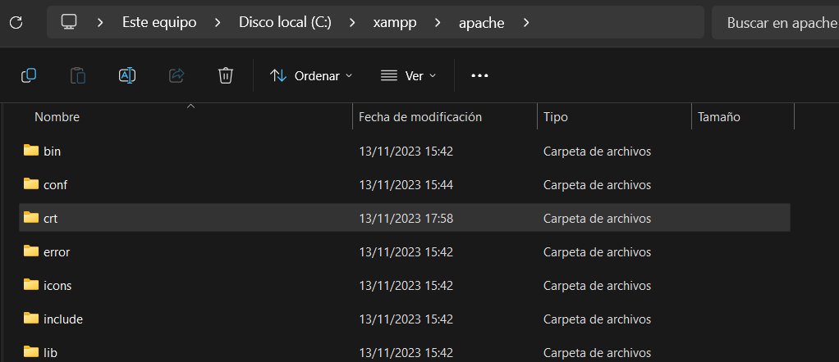Figure 3
Now in figure 3 i created a folder on apache folder called crt.

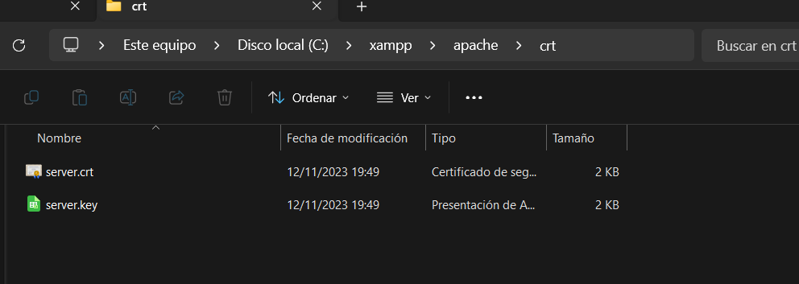Figure 4
Inside it, (Figure 4), i added the documents provide, the key and the crt.

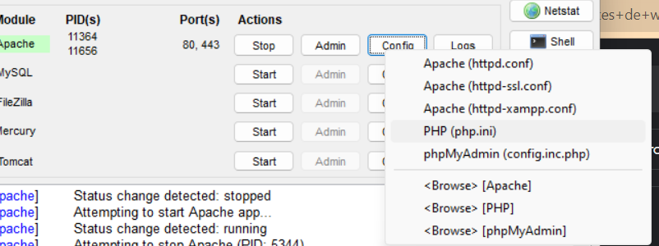Figure 5
On figure 5 ill go to the option httpd-xampp.conf to add the next code at the end of the document. (Figure 6)
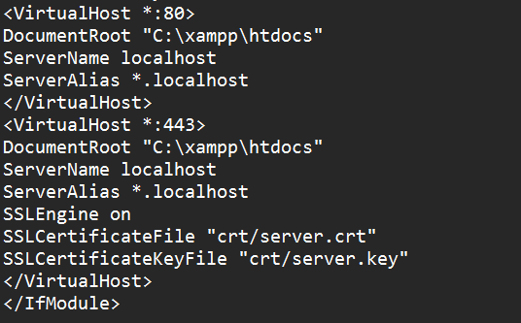Figure 6

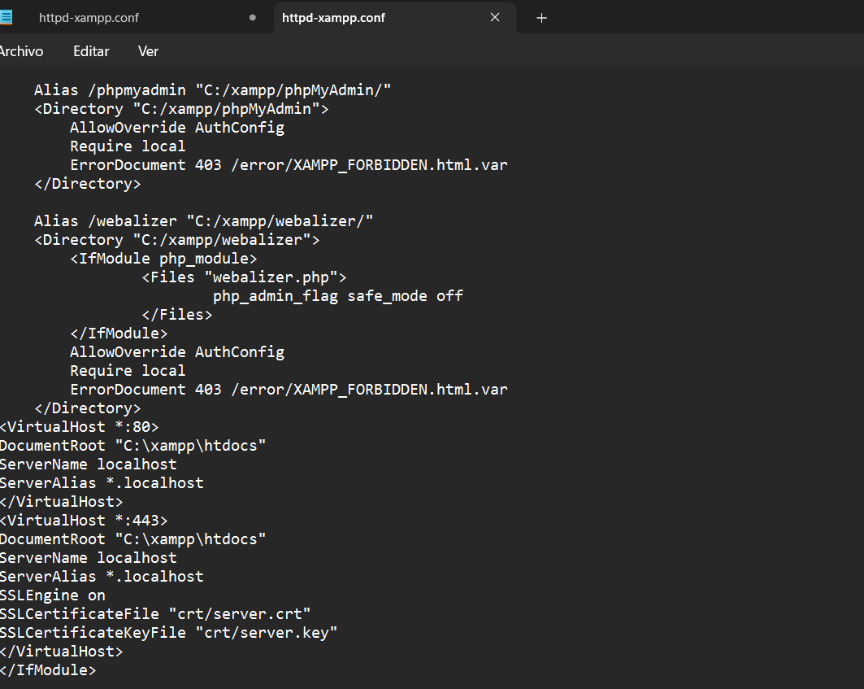Figure 7
On figure 7 that is how looks now the document.
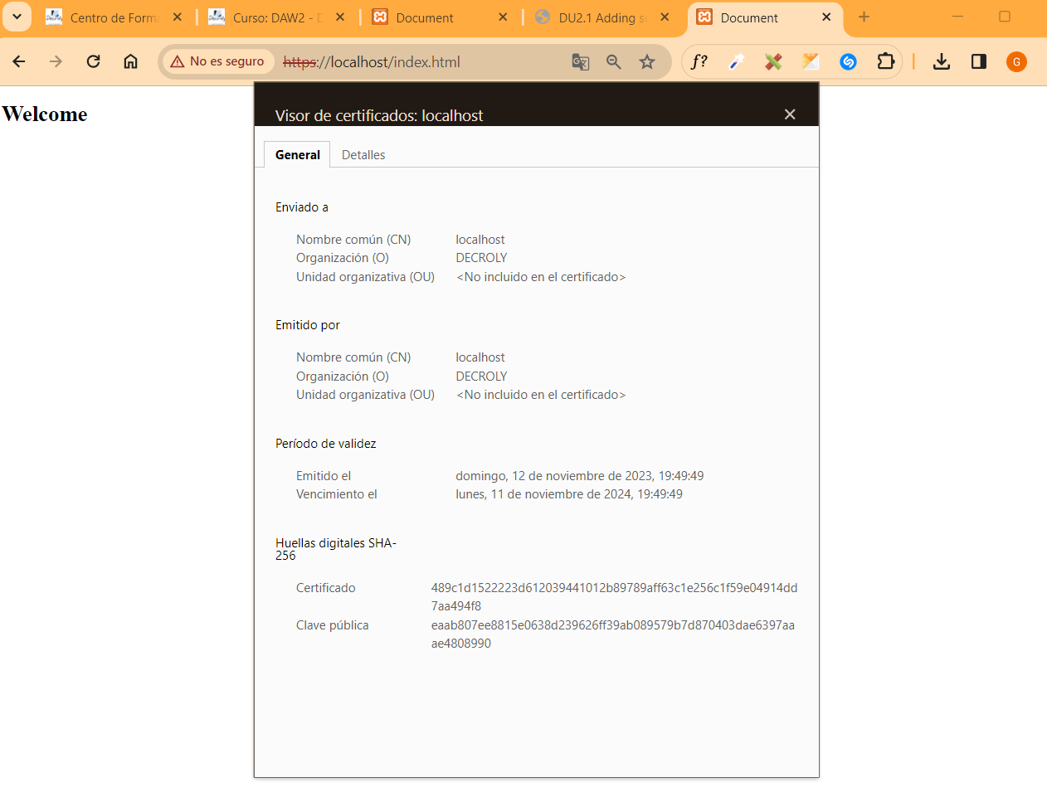Figure 8

The certificate is not valid and google knows it, but now in figure 8 we can see how it looks installed now on our apache server in our page index.html.

2.1. What was the most challenging part of this activity? How did you manage to solve it?

I did and activity close to this on medium grade, installing crt in iis grom microsoft i think it was the platform or iies something like that, we had to write it and use it, anyways this activity was well explained and i just had to follow the pdf.

2.2. Can you investigate about any paid SSL certificate? Who provides it? How much it costs?

Digicert, it cost 290 $ arround 180 €, it has warranty of 1.5 millions, and other plans qith diferents prices.

The ssl certificate says that meets the standard use, in software/industry X.509.
Encryption symetric of 156-bits.
Its compatible with all major browsers.

2.3. Your web browser may identify this certificate as unsafe. Could you explain why?

Ill say what i remember of this, the date is correct, so one is the domain, we are using the cerficate in a diferent domain that is related with, actually it doesnt have a domain related, so there is one issue, other is that the cerificate is not signed by a trusted company and i dont remember more.

CONCLUSION
Not much to add about this activity, the pdf explain everything properly so there isnt any issue doing the activity.

BIBLIOGRAFIA

https://www.digicert.com/tls-ssl/basic-tls-ssl-certificates

