Germán Martínez Cagigas
DAW
Evaluating performance

INDEX

Sumario
INDEX 2
INTRODUCTION 3
EXERCISE 4
Our Website. 4
Website on folder. 4
VirtualHost 5
Text added. 6
System 32. 8
Hosts. 9
Virtual host. 9
Final though. 10
2.1. What was the most challenging part of this activity? How did you manage to solve it? 11
2.2. What are the main differences between a physical host and a virtual host in terms of resources and management, and how might this affect the performance and scalability of a web application? 12
CONCLUSION 13
BIBLIOGRAFIA 14

INTRODUCTION

Simulating acces to our Webpage to see the performance of this.

EXERCISE

First Webpage.

Figure 1
On figure 1 you can see a size arround 6mb on our heavy size web.

Second Webpage.

Figure 2
On the other hand we have a sadly 1 kb web.

Ligth page.

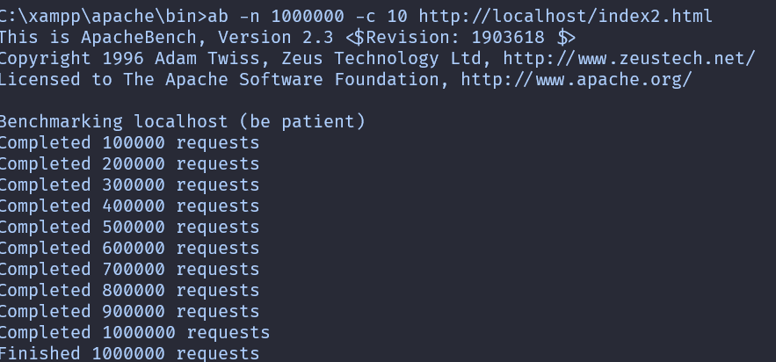Figure 3

On figure 3 i did a million requests and 10 concurrent users to our index2 html page.

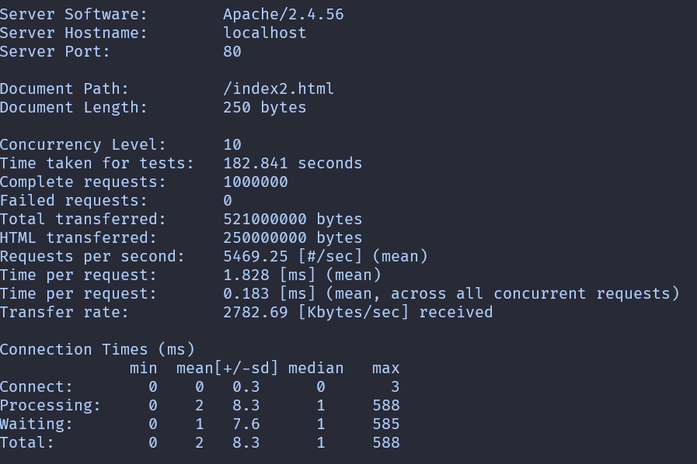Figure 4
We can see on picture 4 that it says that took arround 3 minits to complete the test.
First of all, mean means the sum of each request divided by all requests.
Means across all concurrent requests means the time that the test needed divided by all requests.
So we can see an average of 1.8 secs per request and 0.1 secs per test.

CONCLUSION
Anothe rsmall step through a simple to “deploy ” our virtual server, touching important things like dns, or where assign them.

BIBLIOGRAFIA

file:///C:/Users/abuse/Downloads/DU2.2%20Working%20with%20hosts.pdf

