Germán Martínez Cagigas
DAW
FTP

INDEX

Sumario
INDEX 2
INTRODUCTION 2
EXERCISE 3
Practice. 3
2.1. What was the most challenging part of this activity? How did you manage to solve it? 12
2.2. Can you investigate about secure file transfer protocols? Comment briefly on one of them 13
BIBLIOGRAFIA 14

INTRODUCTION

Transfering files throught ftp protocol, mainly through filezilla server and client.

EXERCISE

Practice.

First of all we will start filezilla on our xammp.

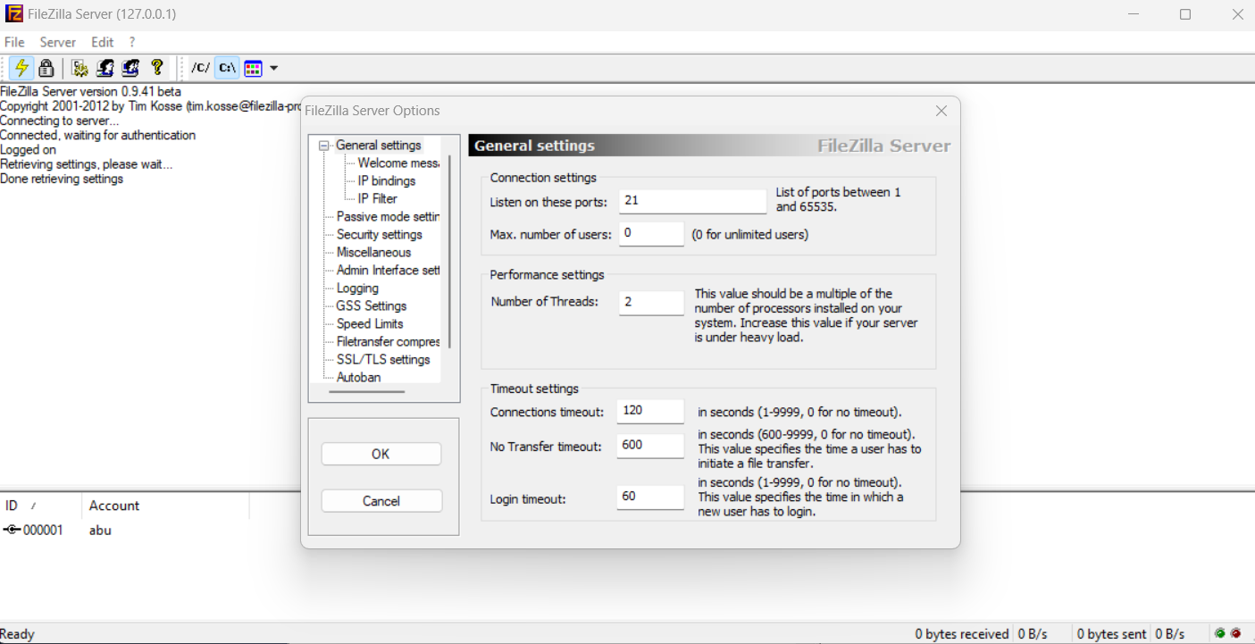Figure 1
First of all we will see on the edit settings the port that filezilla server is listening, 21 by default, we could change it if we want do it as we can see on figure 1.

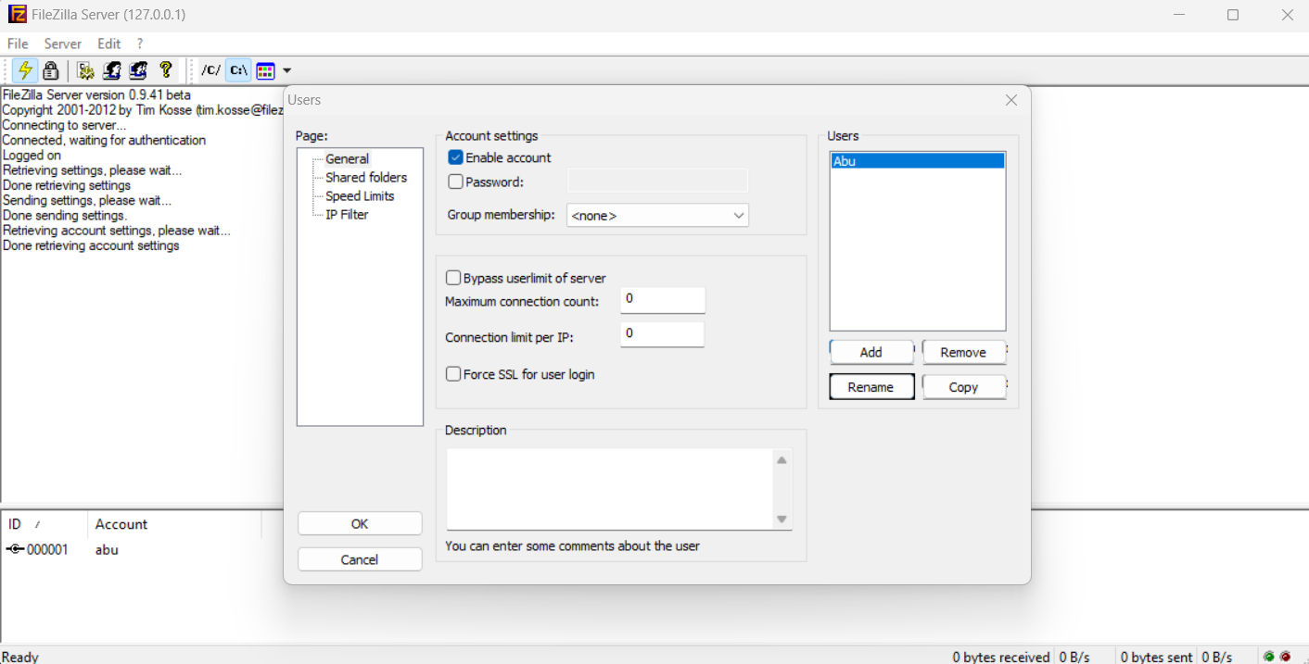Figure 2
Now in figure 2 we go to edit => user, and we will create a new one because it is empty, we add the name, password and we could add a group if we have one create, that is mainly for privilegies, you give all privis that you want to the group and you add the people that will have that privis there instead of give the same privis one by one.

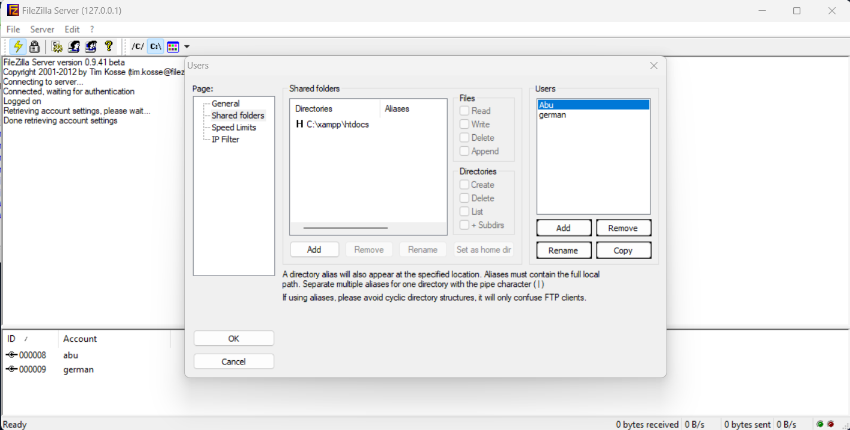Figure 3

Now in figure 3 we are defining the which part of the three our user will have access, this means that he wont see nothing above his route, only can “go” down, in some way its like activity directories enviroment on microsoft, where you create your folder three system, and the admin have access to anything, the secretary only to secretary folder, economist to finance folder and so, this is in some way like that, we are defining for one user where he will have access on the server.
This first one abu will have access to htdocs to see an example of this with our second user created.

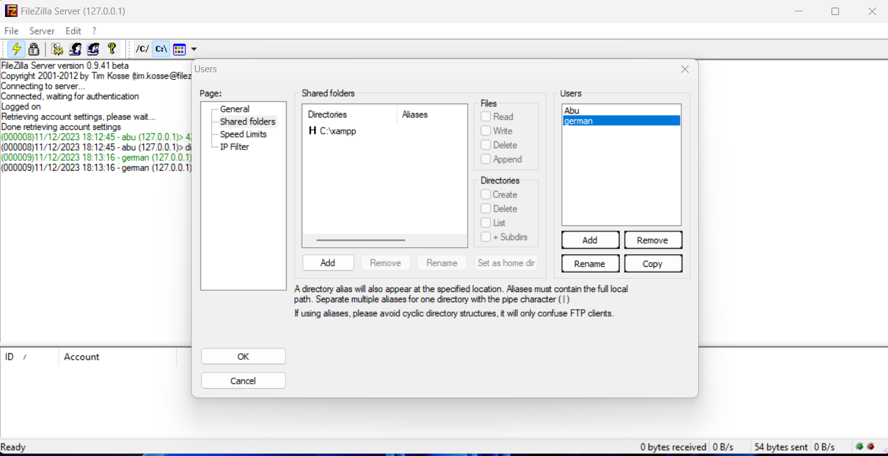Figure 4
On figure 4 i created a second user that will have access since xampp, so we will see when starts each one and what they can see.

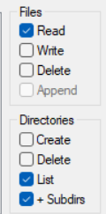Figure 5

On figure 5 we can see the privis that we can give to the users, i gave total control to user abu and nothing to user german.

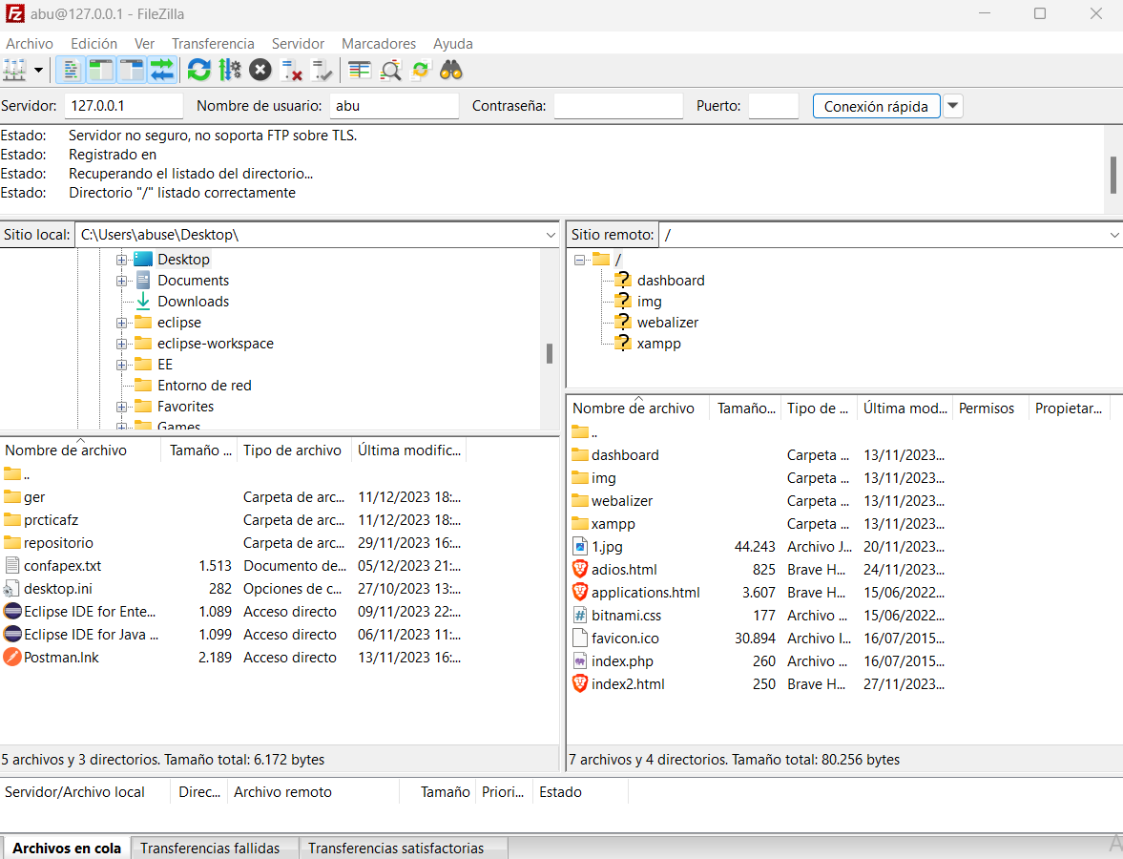Figure 6

On figure 6 first of all we need to download the Filezilla client, everything next and now we have to fill this row:

the port went empty once you did the conection, but there is the port 21 that it is listening as we saw before, and also i we gave password to the user, once you click connect you will get a pop up asking for the user password.

And after that as we saw in figure 6, the user route “starts” where we defined it, on htdocs and if we click on .., we can go back.

Figure 7
Figure 7 saw how i connected also with german user.

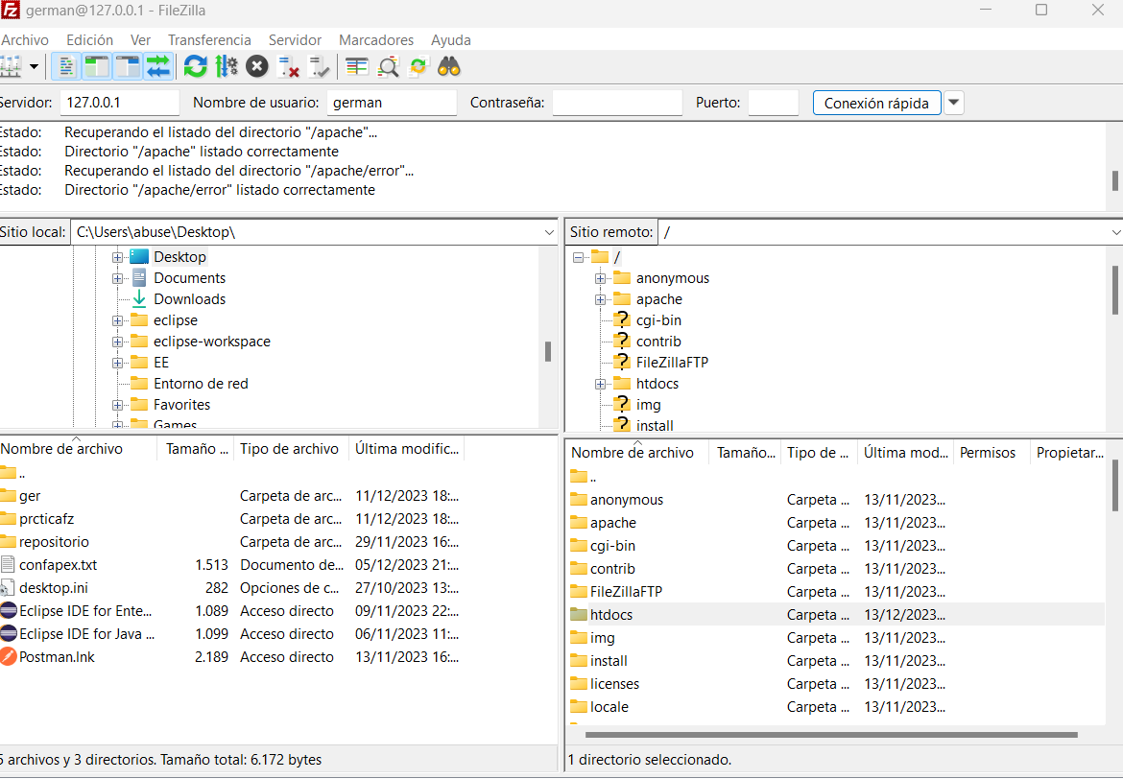Figure 8

On figure 8 we see that german have access since xammp folder while abu user cant go back to this folder, this german user can go both, to abu folder access route and this one.

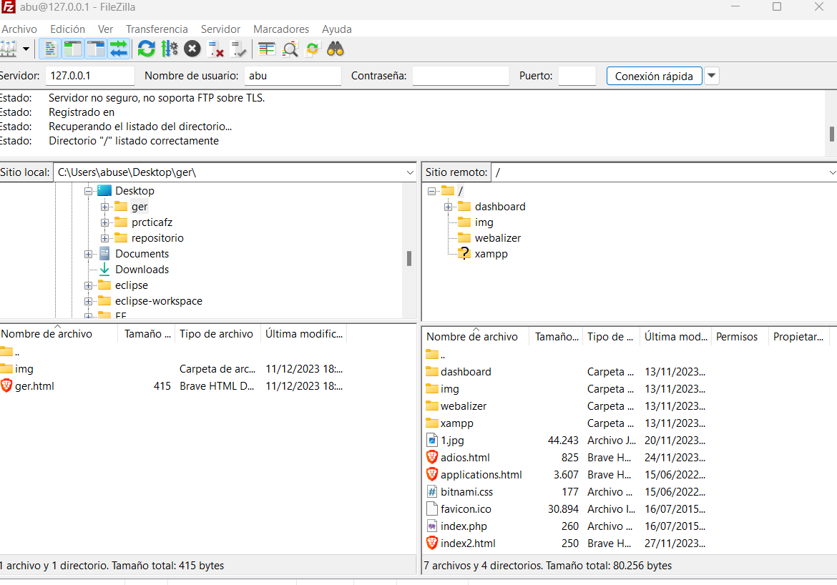Figure 9
Well, on figure 9 i opened my folder on the desktop called ger to see what it has in.
It has the folder img and the index.html that i called ger to make more clear the practice.

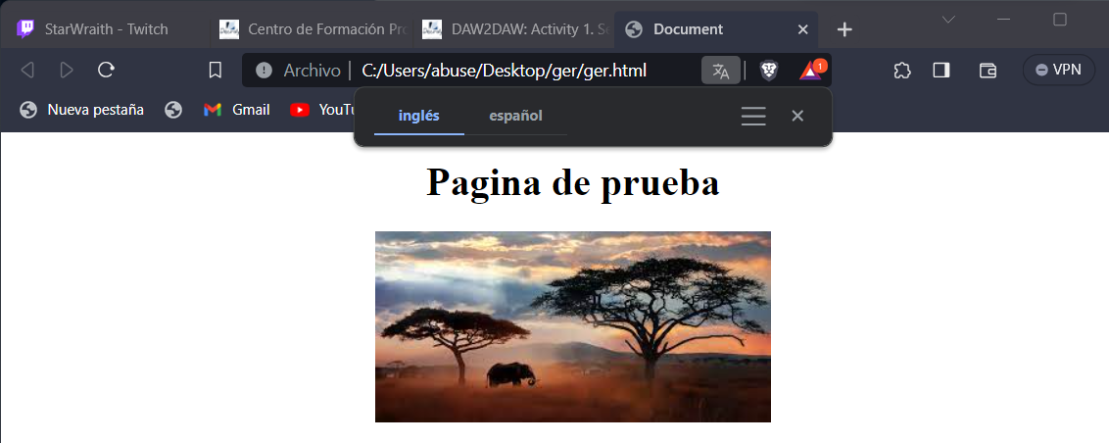Figure 10

On figure 10 we see how the page looks on the browser.

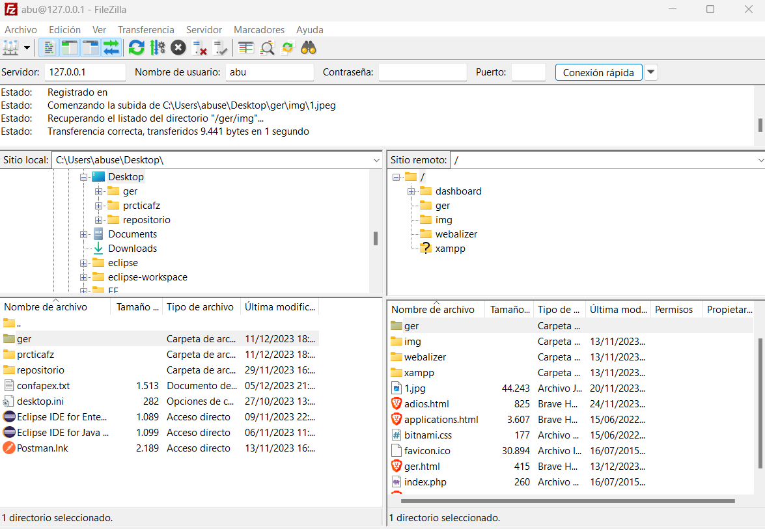Figure 11
On figure 11, i dragged the ger folder from desktop to the htdocs with abu privis, remember that we are logged with abu with total privis.
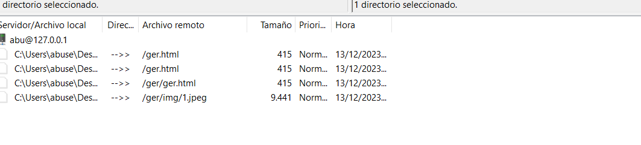Figure 12
We have on figure 12 the bottom tab where we can see if the transfer was good or bad.

Figure 13

Now we run the apache and writte the figure 13 sentence on the browser.

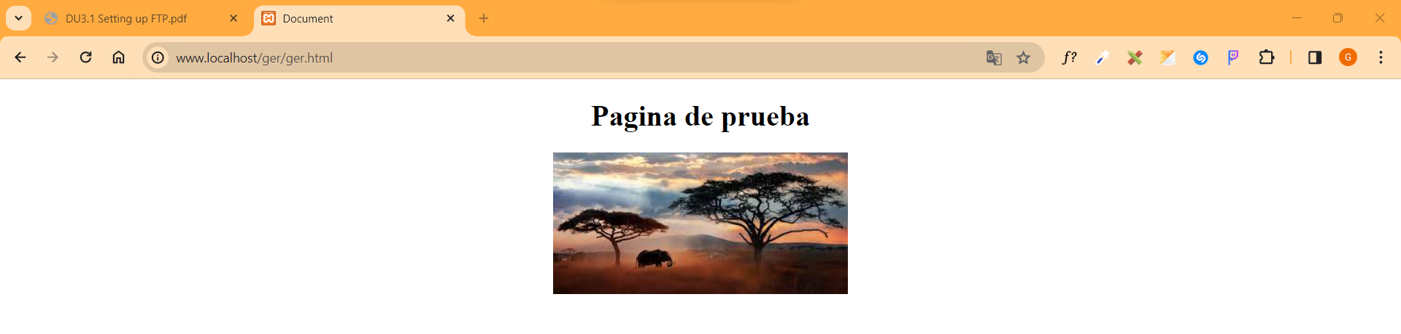Figure 14
And now we can see our page on apache after sending it through filezilla, figure 14.

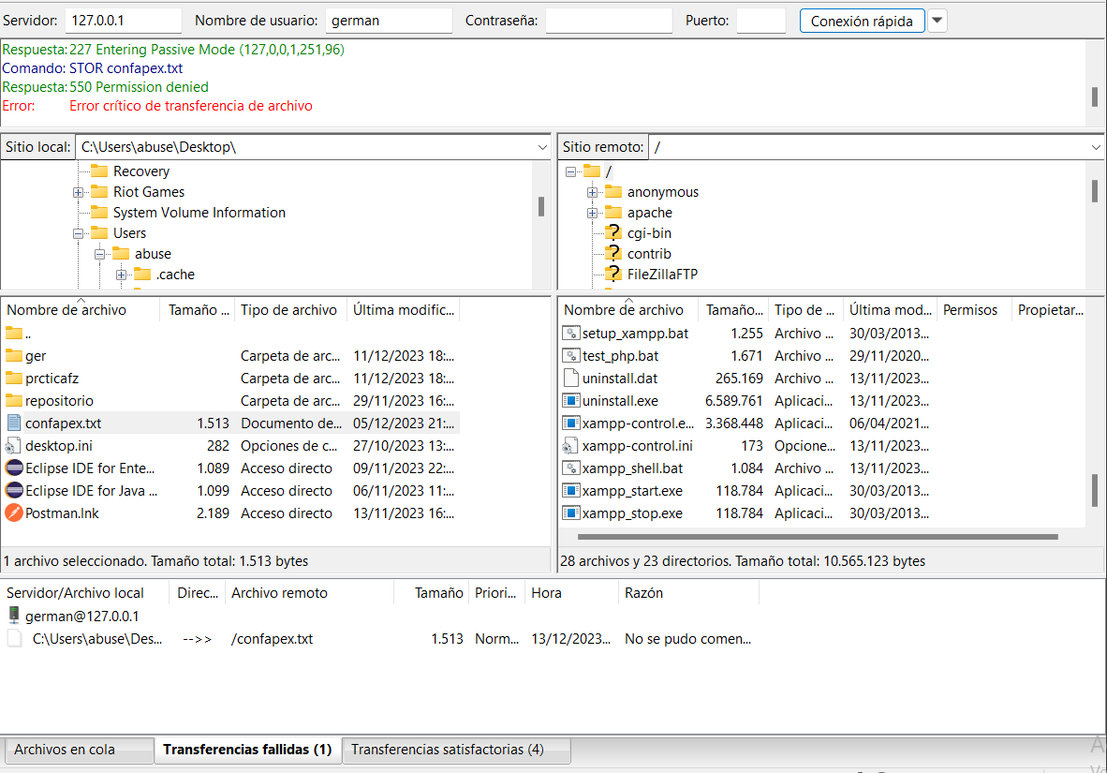Figure 15

And now on figure 15 i tried with german user that doesnt have any privi to transfer a txt, as we can see, the tab says us that it was not posible.

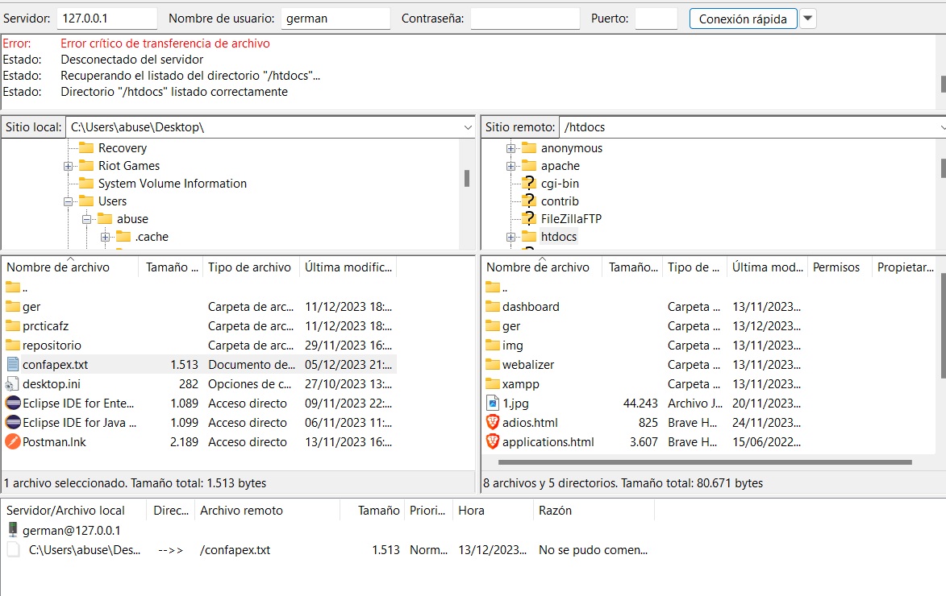Figure 16
But we can go deeper on the three at least with this user and see the content like in figure 16 where we can see the changes made by abu ser, watching the ger folder that we added before.

2.1. What was the most challenging part of this activity? How did you manage to solve it?

I did this on medium grade, so, nothing actually.

2.2. Can you investigate about secure file transfer protocols? Comment briefly on one of them

I know that sftp protocol is the one that has the security, and if i remember well and didnt change it, with a sniffer like whiteshark or something like that, when i did the conection with abu user or german, with the sniffer we could see everything, the user, the password and the port, because that information is not going encrypted trough the “lane”, kin the other hand, with sftp, all that information would be encapsulated and encrypted making it “invisible” or not accesible through the same sniffer program of this example.

BIBLIOGRAFIA

file:///C:/Users/abuse/Downloads/DU3.1%20Setting%20up%20FTP.pdf

