Germán Martínez Cagigas
DAW
FTPS

INDEX

Sumario
INDEX 2
INTRODUCTION 3
EXERCISE 4
Practice. 4
Part 2. 10
Final Questions. 11
2.1. What was the most challenging part of this activity? How did you manage to solve it? 11
2.2. Can you investigate about SFTP? How does SSH encryption works? 11
BIBLIOGRAFIA 12

INTRODUCTION

Adding security to our ftp server.

EXERCISE

Practice.

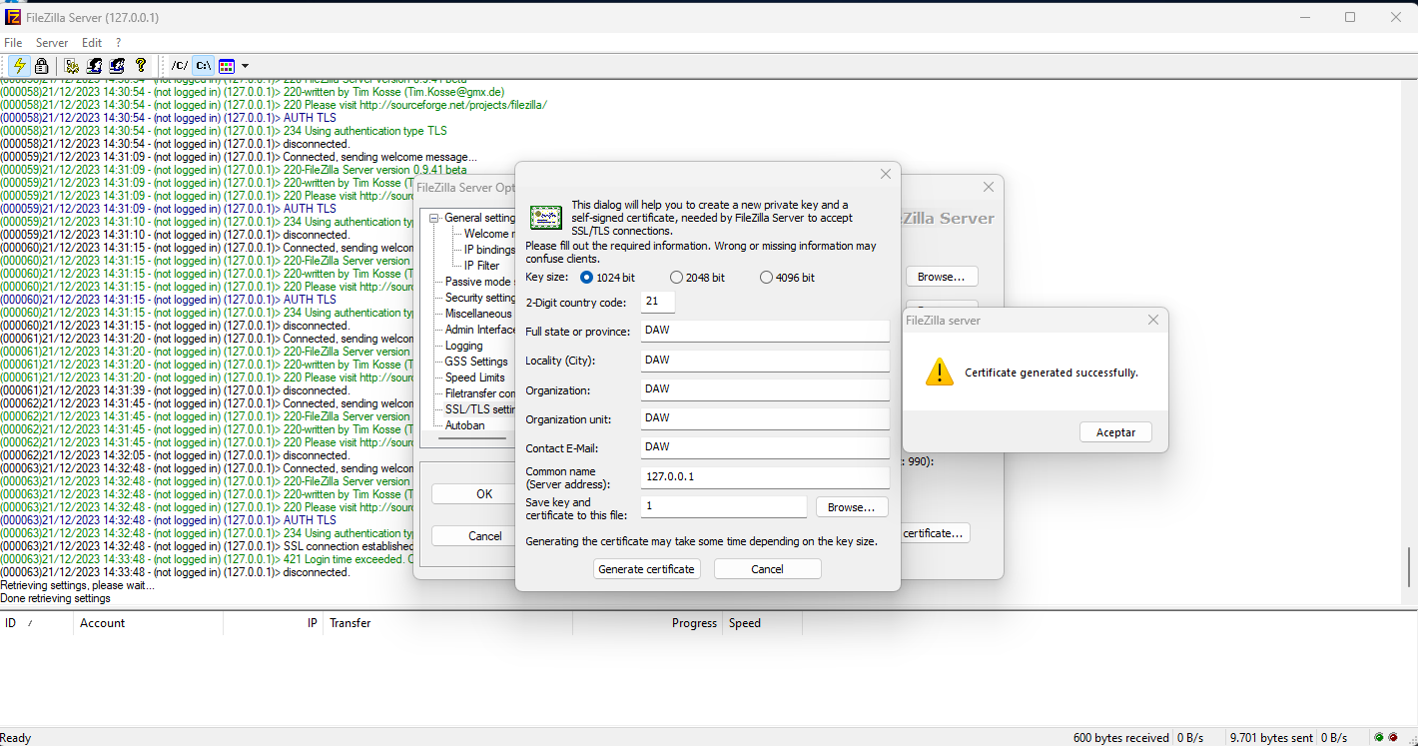Figure 1

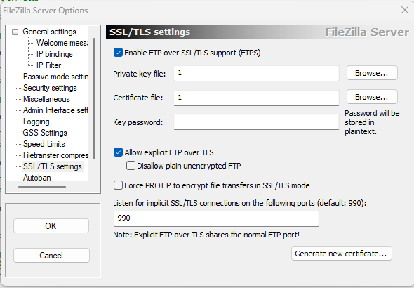Figure 2

On figure 1 we have my crt created for this exercise and in figure 2 it show where you have to create it, on settings SSL/TLS and generating new cewrtificate in my case.
Now we need to do a few thing on our client.

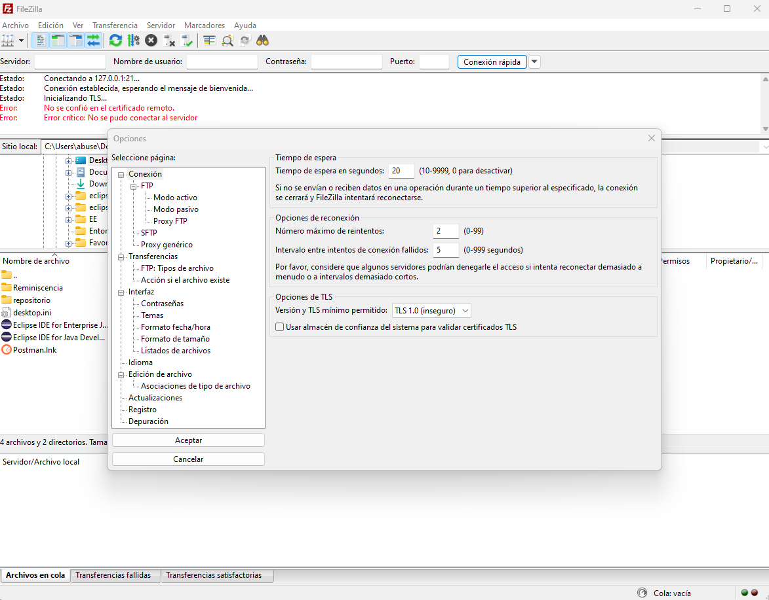Figure 3

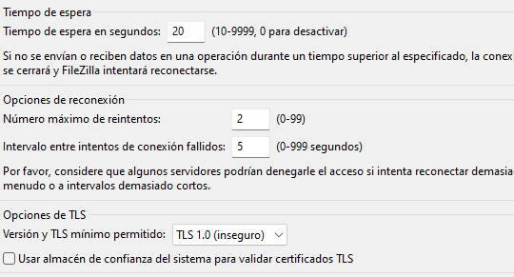Figure 4

On our client in editing, conection ftp, we have to choose TLS 1.0 or 1.1 otherwhise it will give an error, crt invalid/client version deprecated and others, it doesnt specific what is the actual problem, so, tls 1.0.

Figure 3 gives a general view of where is the option, and the figure 4 shows it more clearly.

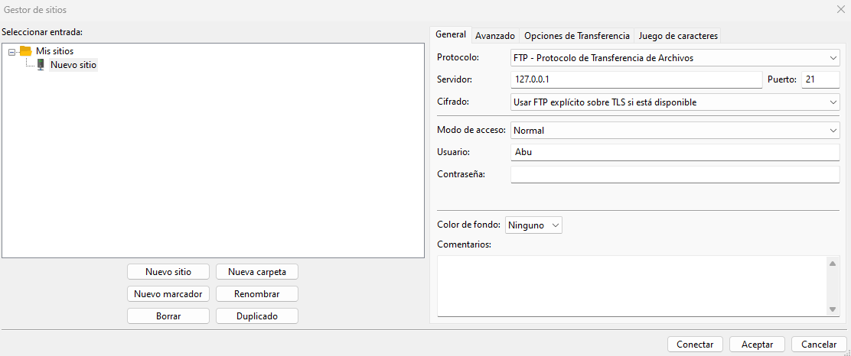Figure 5
Now in archive/site managment i used ftp protocol, the server ip that in this case is the same, port 21 (default) and encrypt use FTP over TLS that will search the crt on the server, conexión normal and a user created on the server fromt he last exercise Abu. Figure 5.
Now we press connect.

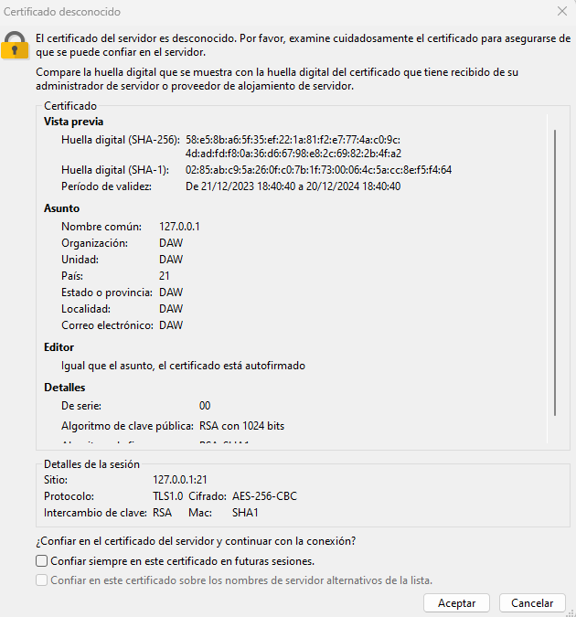Figure 6
And figure 6 shows that after connect to the server it shows the certificate it has, obviously unknow but it works.

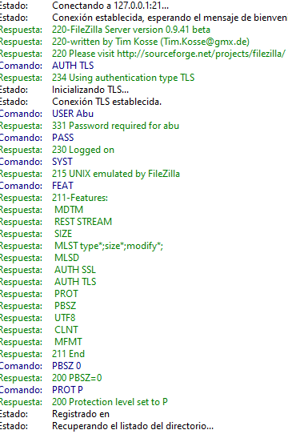Figure 7

And figure 7 to see the conecction progress and everything was ok.

So we are already in again, and our data sent will be encrypted now.
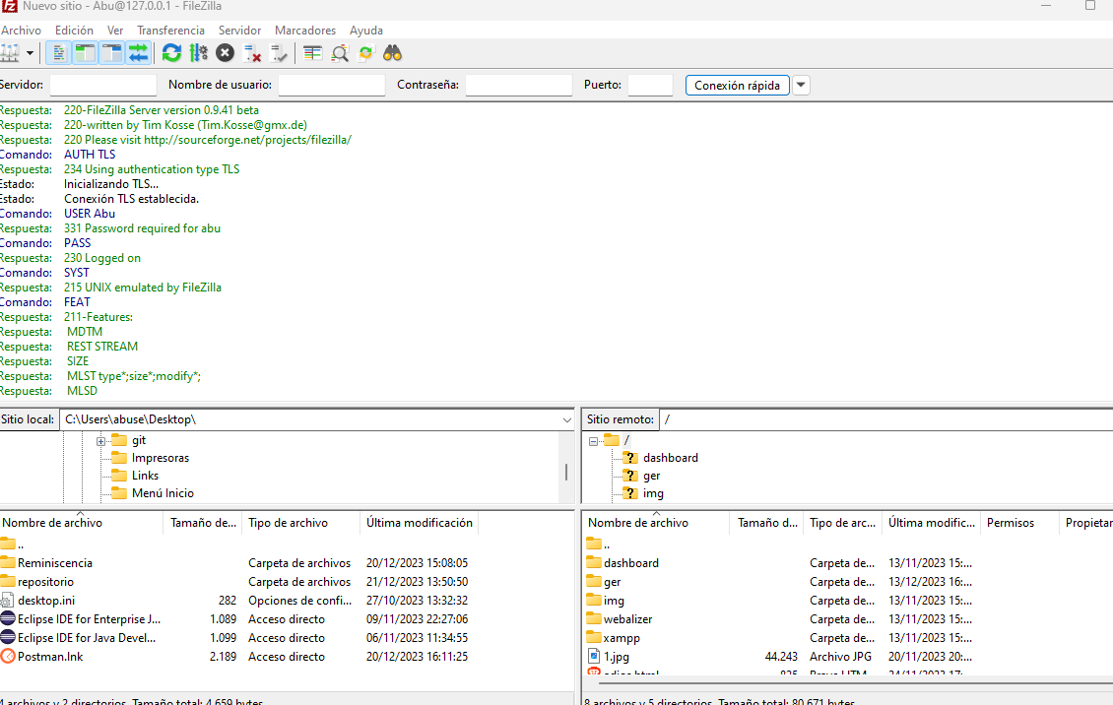Figure 8
Figure 8 saying that we are already conected to our apache directory through the user of last exercise.

Now we are in the same point of previous exercise so we can do the same than there here.

Part 2.

In class it would be the same, we need two pc connected to the same LAN, like the class computers that will be in the same range, so in our server we add 127.0.0.1 again, use ip config to know which ip it has and in our client pc we add the server ip the one that gave ip config to us, it doesnt have any mistery.
The clean way, will be through dhcp server exclude some range ips, and give a static one to our server, so instead of give 127.0.0.1 we could use the static ip, and througt the client we add that ip to connect to the ftp server because no matter if it shut down, when it will be ready again, the dhcp will give the same ip to it.

Final Questions.

2.1. What was the most challenging part of this activity? How did you manage to solve it?

Put tls 1.0 or 1.1, i had to read the pdf fullto realize about that, no more challenge than that.

2.2. Can you investigate about SFTP? How does SSH encryption works?

SFTP is exactly the same but through commands using ssh protocol, it has two principal way of encryption , symmetric an asymmetric, first of all, you need as we did, a credentials, the user, password, then if we have symmetric ecryption the client will generate a key and use the server key to encrypt the message now the server with his private key open the encrypt message and now the server has the client key so it opens like a tunel to comunicate them.

Asymmetric, the client catch the public key from the server and now the client generate a symmetric key to stablish the comunication with the server, the server open the encrypt message again na dboth uses now the same “channel/tunel to comunicate”.
On linux also you could create the keys, save it on etc folder and that staffs but i dont remember to much about that.

BIBLIOGRAFIA

file:///C:/Users/abuse/Downloads/DU3.2%20Adding%20security%20to%20our%20FTP%20server.pdf

