Germán Martínez Cagigas
DAW
Azure virtual machine FTP

INDEX

Sumario
INDEX 2
INTRODUCTION 3
EXERCISE 4
Creating virtual machine. 4
Conf XAMMP on virtual machine and making a transfer. 9
What was the most challenging part of this activity? How did you manage to solve it? 14
Is there life outside AWS and Azure? Is it any good? Provide at least an example and talk briefly about its pros and cons 15
BIBLIOGRAFIA 16

INTRODUCTION

In this active I will create a virtual machine on microsoft azure platform, after that ill intall xammp app there and make the necesary requirement to transfer a file from my pc to there.

EXERCISE

Creating virtual machine.

First of all after you will need an azure account and credits, you can have credits after complete a brief aplication student form in my case.
Once we have it we can start creating our virtual machine.

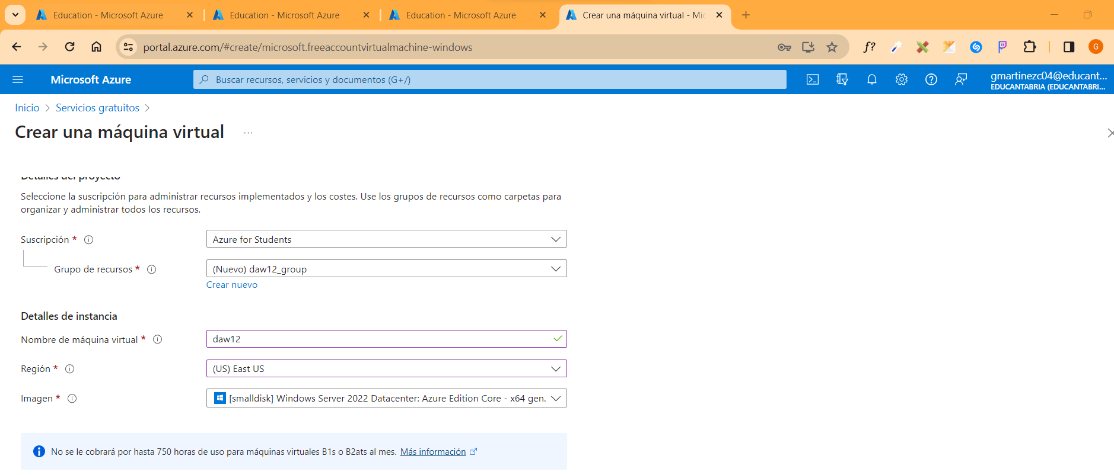Figure 1
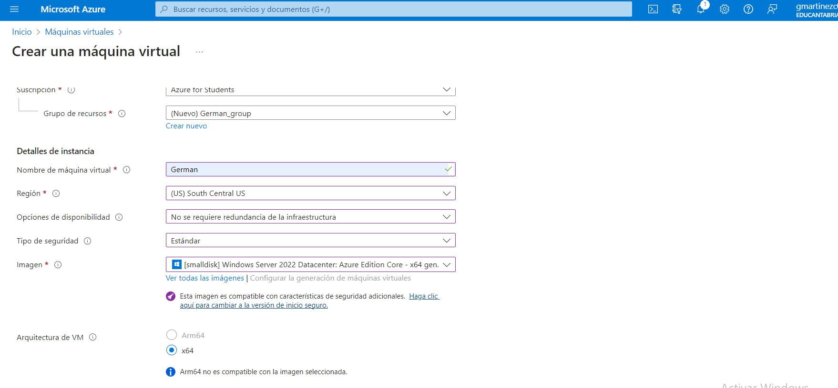Figure 2

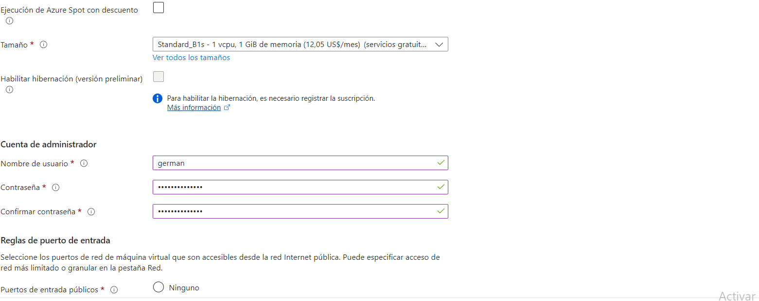Figure 3
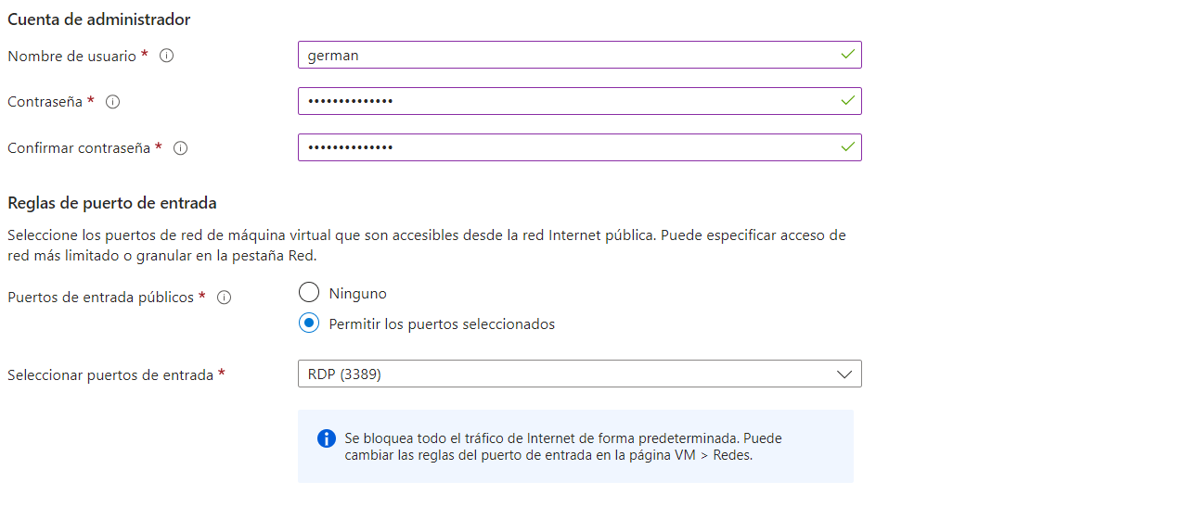Figure 4
From figure 1 to 4, that was the params that i chose, only i had to change the image, because in that example i selected a datacenter image, that works on a terminal and i need user interface to do the activity, so i remade everything and selected windows 11 pro image.

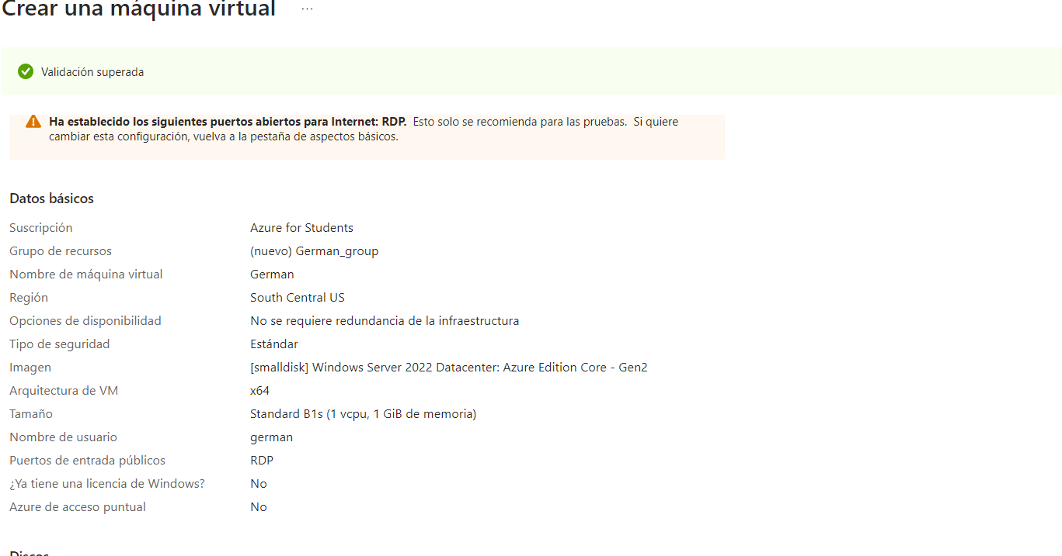Figure 5
On figure 5 we see that the verification was correct.

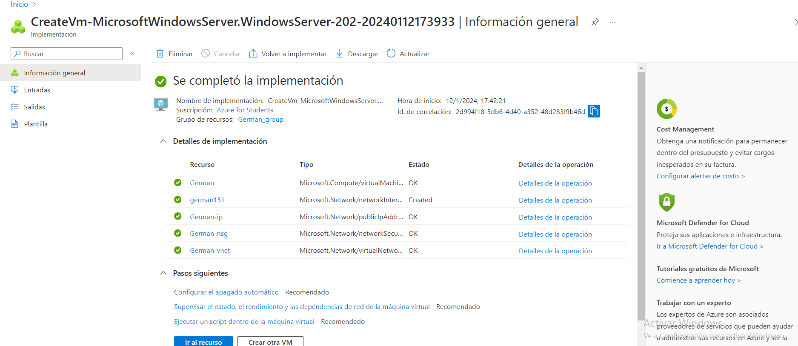Figure 6
So after the verification, the machine was created perfectly as we see on fogure 6.

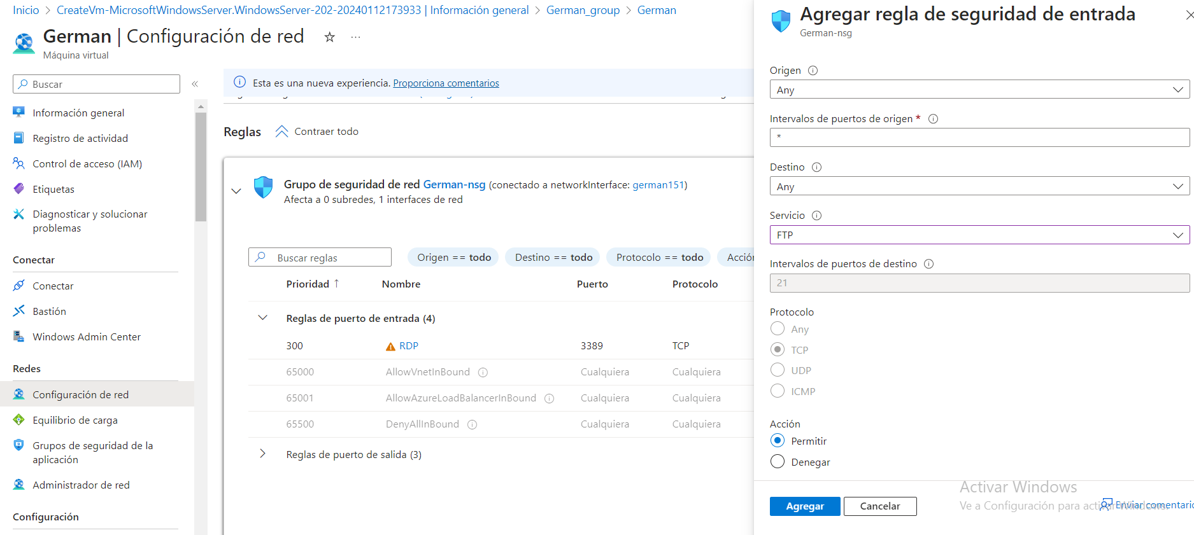Figure 7
Now first things first, we gonna use port 21 in this activity, if we want security using sftp, we have to open also port 22 that is which works on it, we could change it also to other port on ftp server but this is a practice we dont need that, on reality the ports normally change like in ssh to avoid posible attacks changing “pre-fabric” ports.

So, we open port 21 to ftp protocol.
We also will need open the pasive port of the server for the transer of files, otherwhise it will disconnect us.
Figure 8
On figure 8 we added 37352 ftp port also to the virtual machine, so the initial configuration is done.
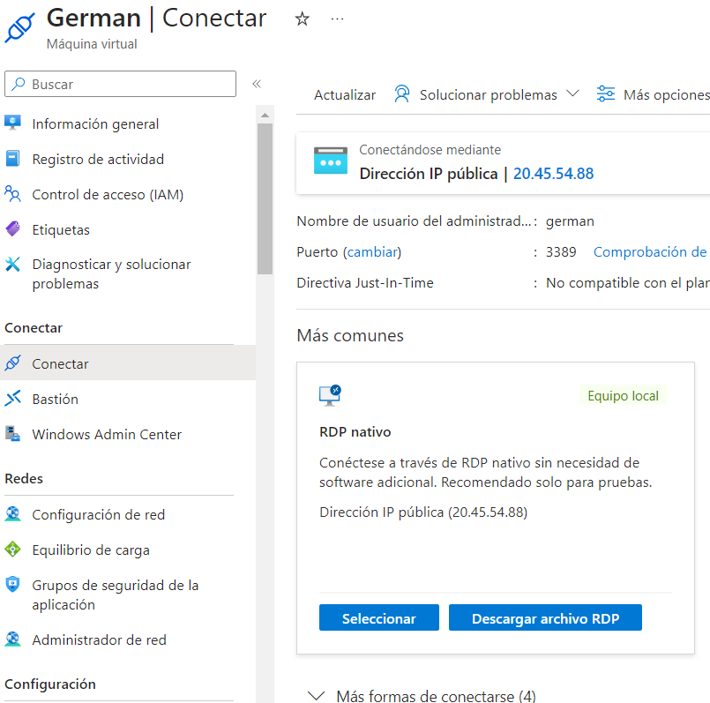Figure 9
Now we only need the rdp remote desk protocol i guess it will be the name, its just an executable that able us to connect to our desktop, a way more simply than do with 3 party app like team viewer, or ssh protocol in my opinion, but less secure, if someone have acces to this file que will have access directly to the virtual machine so at least use a password on windows sesion from virtual machine.

Conf XAMMP on virtual machine and making a transfer.
First open your rdp file, and insert your credentials.
Now we have a virtual machine so we only need open our browser, go to xammp home page and download it, after it, just install it.

In figure 10 it shows that we have it already installed so just start xammp and open filezilla, this is a virtual machine but at the end, it is just another desktop, so we have to do the same as in pther practices from now.
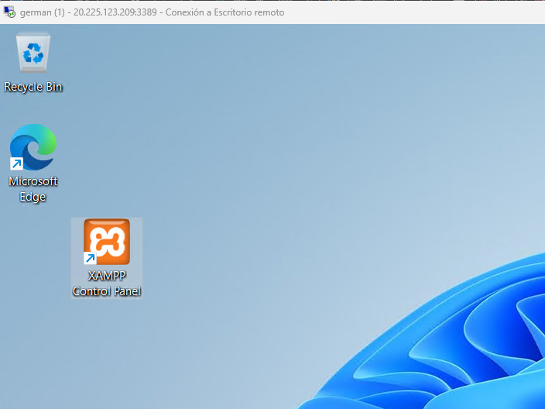Figure 10
Go to filezilla admin an lets create an user that will connect to the server.

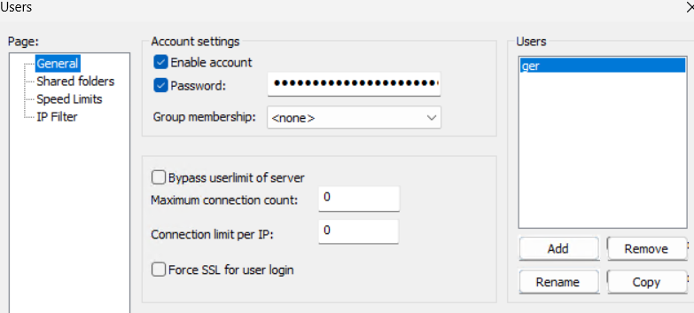Figure 11
Figure 11 shows my user ger, that will have all privileges and access to the htcdocs on xamp figure 12.
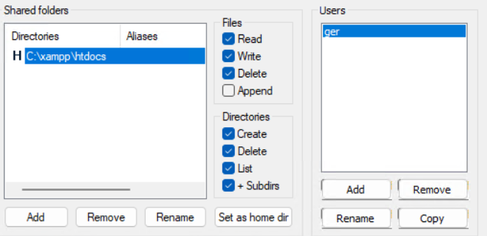Figure 12
Now our server is done, we are working on port 21 so we dont need add a crt so just lets open our client and open site manager files, transfer options.

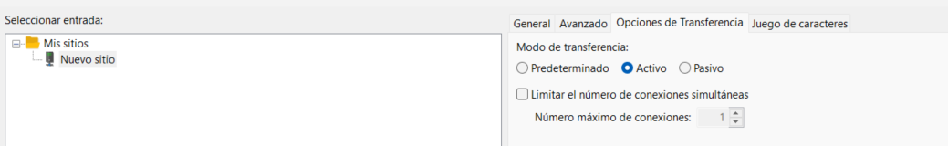Figure 13
We need mark active, otherwise the server will recognise us yes, but will disconnect us, i understand that this option is saying that us as a client will be making active transfer of files, dragging in my case, otherwise the server will understand that the transfer will be automatically (pasive) wont find nothing, and will disconect us, i dont know if that is correct but i dont find other explanation for this.
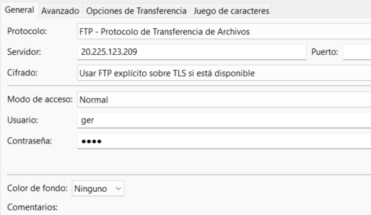Figure 14
Now we only need to add the classic data for the conection, ip of the server, port 21 as figure 14 shows, after that click connect.

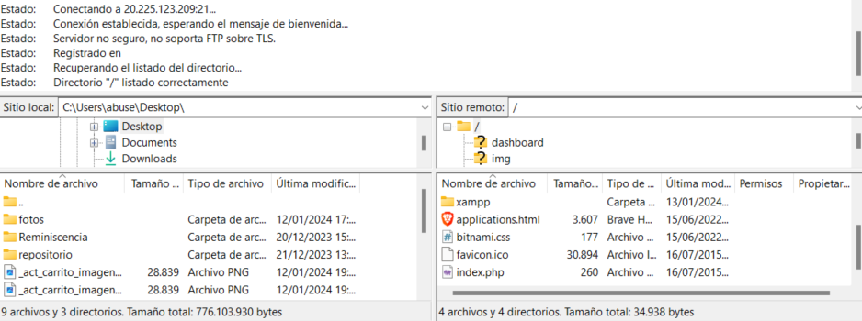Figure 15
And now ill just trasnfer a random file, the 2 carrito imagen for example and the activity pdf.
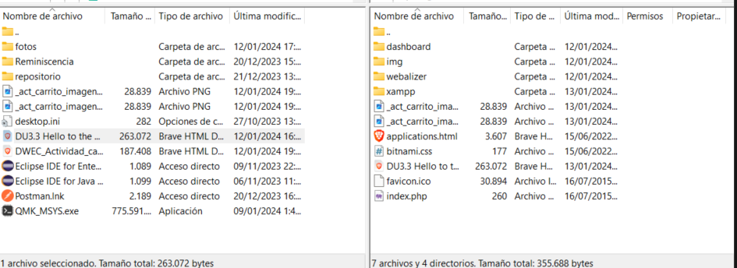Figure 16
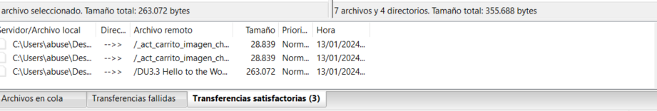Figure 17
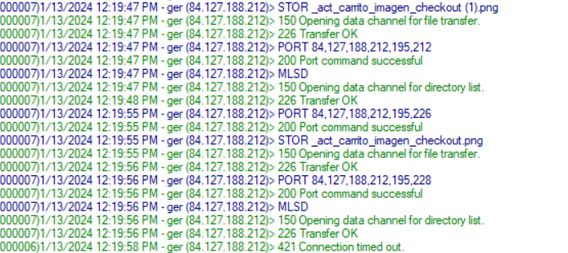Figure 18
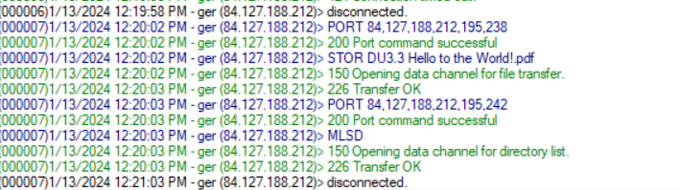Figure 19
Figure 15, 16, 17, shows in our client how the transfer was ok, and 18, 19 shows the same on server side, so we only need now open on oour server the htcdocs and see if there is thenew files.

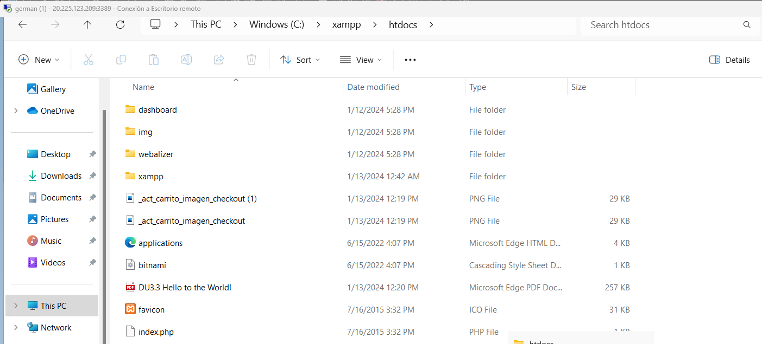Figure 20
As we can see on figure 20, there is the files that i transfered.

What was the most challenging part of this activity? How did you manage to solve it?

First read the pdf properly to use the active transfer on the ftp client.
Second, active the port 37352, that was easy to find the solution, because i just pasted the pid issue on chatgpt, i mean, for this kind of things i think its a tool that it has to be used yes or yes, it has no sense find the filezilla docs to find what means this pid problem.
(000016)1/13/2024 0:34:07 AM - ger (84.127.188.212)> PORT 84,127,188,212,253,73.
But I have to admit that the answer didnt make me happy, because i understand that im making a request on that ports but are closed so if i open any of that ports it should be work also, but i didnt try.

Is there life outside AWS and Azure? Is it any good? Provide at least an example and talk briefly about its pros and cons

This question forgot Google cloud platform that in analytics the people says it is really good, also i wanna understand that in infrastructure also, but it wont be better than AWS and Microsoft for one simple thing, money invested, AWS are the more powerfull sevrers if i remember well, microsoft infrastructure is well know that it is insane.
But nowdays the is a stream i dont know if it is accurate that says that the companies are slowly going outside of that cloud enviroment because the price is progrissively increasing and some companies prefer do their own CPD than rent it on the cloud, i dont know how truth tha is, but i dont see it as a crazy thing, so there is live outside, but it will be harder, good luck handling/investing in a CPD, more luck if the CPD is tier 4.

BIBLIOGRAFIA

https://chat.openai.com/c/e944e629-3fa1-45d4-91fd-12f797754e11

