German Martinez Cagigas

DAW

Activity 3. Web architectures

# Index

Content

Index 1

Introduction 2

Exercise 3

Apache, Tomcat, jsp and Servlet. 3

Node 7

Conclusion 14

Bibliography 15

# Introduction

Exercise about deploy a static web on Apache and link it through tomcat with a jsp that is related with the Servlet.

Also doing the same with static html on Apache and node js.

# Exercise

# Apache, Tomcat, jsp and Servlet.

Well the start doesn’t have any mistery.

I created a html and added on xammp htdocs to open it as static page with apache on localhost 8081/hola.html

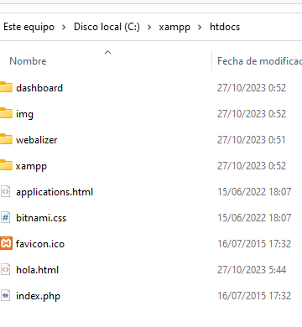

First of all, I wanted to do something different and more related with what we are watching with Anuar in some way, the static page will be the client, the jsp the business layer and the Servlet the dd.bb(in this example a repository).

So, first I needed a button to link with the jsp.



The button has a simple function that when you click on it….

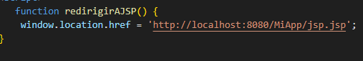

It will redirect to the jsp url storaged on tomcat.

The jsp its just a bridge between start and end point, so this jsp redirect to the class MyServlet, to ask for something, in this case obtain the “data of a data base”.

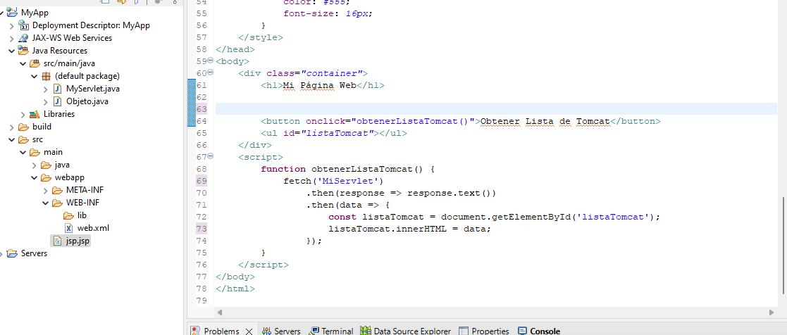

Here is a closest view.

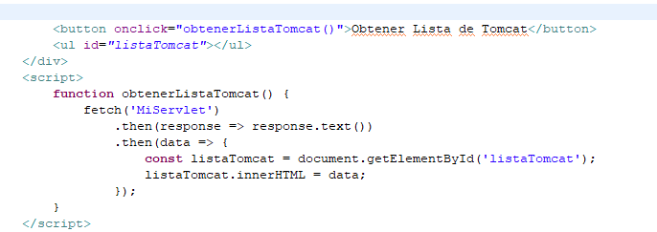

Now the ServLet is who really do the logic here, this is a simple one I created an object class and generated two objects on servlet class.

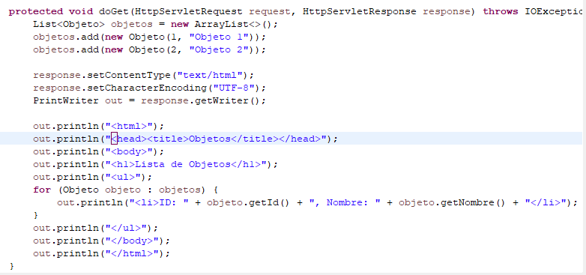

After create the objects the class gave it back on text mode (I couldn’t use json, I don’t know too much about it and I was getting pissed off with red text over and over).

The object class doesn’t have any mystery a constructor with name and id.

And this is how this looks.

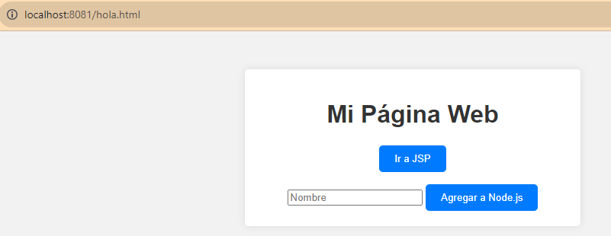

Go to JSP…

Now I realized that I did this bad, this should be in the shadows without redirect here, just see the result on the static page… I fixed it on the node method.

Anyways on this jsp now we ask for all id.

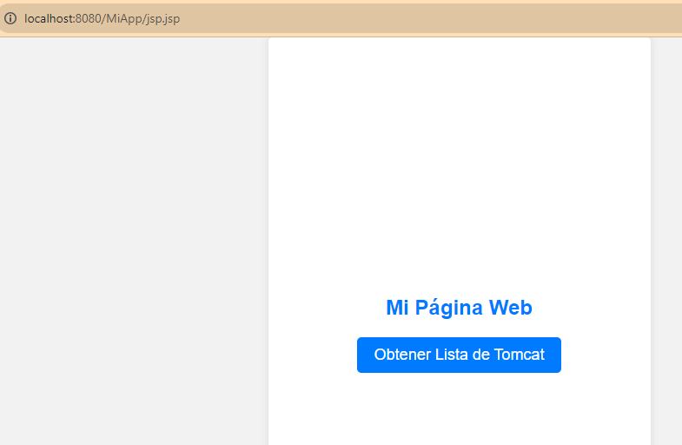

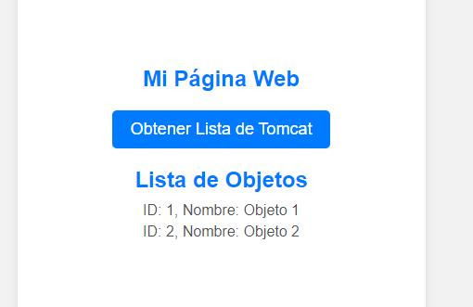

And the Servlet do the logic and give us the answer in text.

# Node

Well, as always, new folder, npm init, file.js that will be the server, install express and node + app to run it.

I created my file server.js on my node folder for the proyect.

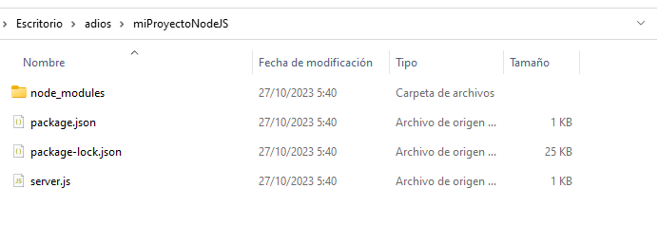

Because my static page is on 8081 port and node server is in 3000 I had to enable corps because otherwise I cant send nothing due to HTTP will block it to prevent malicious attacks.

The rest is just a clasic install.

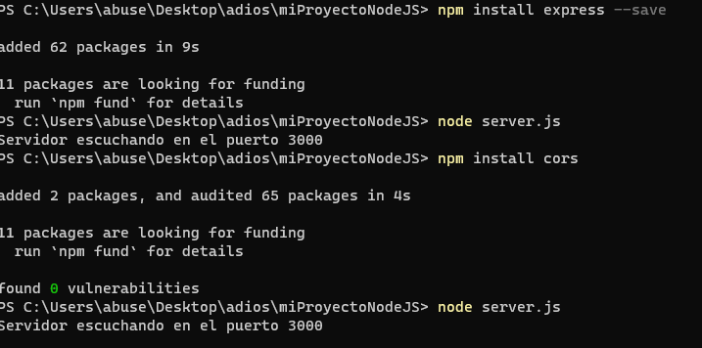

Ok, what will do the node server…

The client will send from static page names through method post, this name will be storaged on the server.

The static page will have also a get method to obtain this added names.

So I did the easiest thing, two buttons, one for post and one for get each one related with the onclick function.

The get will be viewed on a table.

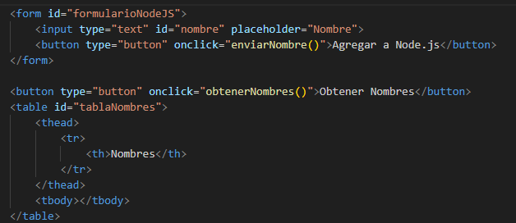

Post method.

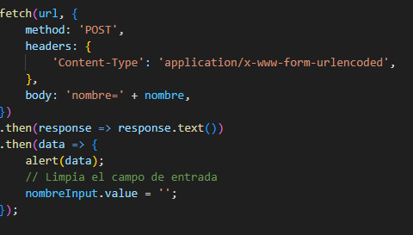

Get method, I can explain more on this.

The function get the answer throught a json file, and with DOM takings id, creating elements of the table and adding them to the table cell, this function is generating the table with all the data.

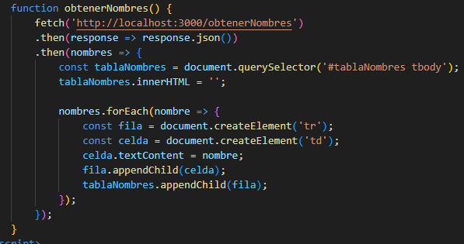

This is how it looks, the css changed because I was getting really frustrated and I went for something simple.

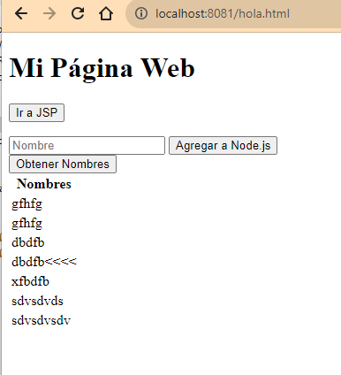

Obviously I was testing that everything was going correct….

So, now I add my name.

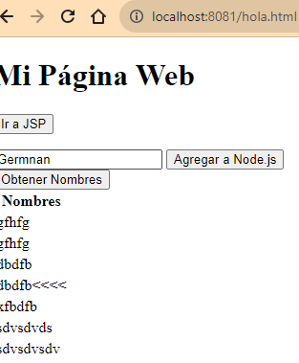

Send it.

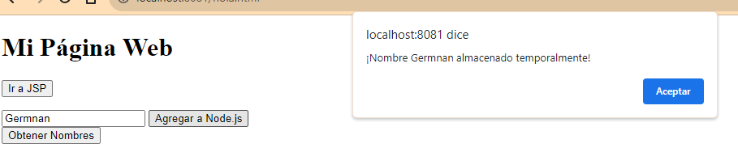

There is an alert that says everything was correct.

And now, after do the post I did the get obtained also my recently added name.

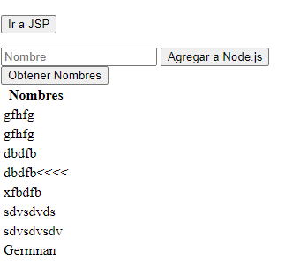

And here is the code on node server with the url mapped on /MyServlet for post method and /obtnerNombres for get method.

Al names are being storaged on an Array, the alert is do it by a res.send and the get method gave the answer directly on a json without convert it, that thing is more easy than in Java.

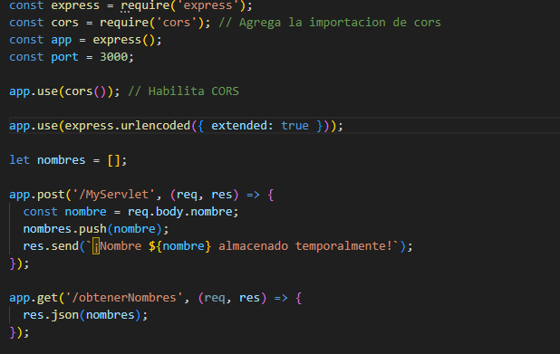

And here I forget to remove my trail of cumbs to see that im going step by step doing the things correctly.

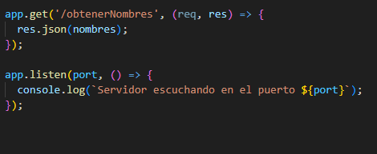

# Conclusion

I had to use ChatGpt on this exercise because I was to lost, no sense the HTTP protocol that was blocking the requests, I was getting crazy, I mean I was following guides, videos, but I was having problems everywhere, maybe I wanted to do something more complicated that the activity was planed to be, but I don’t know, I was too missed to do something different that we did on the last activity.

# Bibliography

<https://developer.mozilla.org/es/docs/Web/HTTP/CORS>

https://chat.openai.com/

https://developer.mozilla.org/en-US/docs/Web/API/Fetch_API/Using_Fetch

https://www.ionos.es/digitalguide/paginas-web/desarrollo-web/nodejs-para-una-pagina-web-con-apache-en-ubuntu/

https://es.stackoverflow.com/questions/470653/como-redireccionar-mi-dominio-a-mi-sitio-web-en-nodejs-en-mi-servidor-vps-hosti

https://es.stackoverflow.com/questions/32741/redirigir-con-servlet-y-jsp

https://programandojava.webnode.es/products/a13-la-redireccion-de-peticiones-con-servlets/