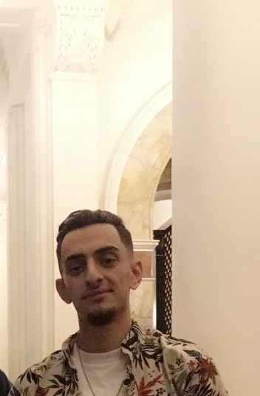

Zaid Abusheikha | 2027478183 | Abusheikha17@gmail.com

# About me

I am currently employed at United Airlines, where I contribute to the exciting and dynamic field of aviation. Beyond my professional endeavors, I have a passion for coding. Exploring the world of programming and software development is not just a job for me; it's a hobby that I truly love. I find joy in the creative process of writing code, solving problems, and building applications. Whether I'm soaring through the skies in my work at United Airlines or diving into lines of code, I'm fueled by a curiosity for learning and a love for what I do.

# Work Experience

**United Airline**  *07/17/2023- Current*In my role at United Airlines as a member of the safety staff, I have had the privilege of contributing to the airline's unwavering commitment to passenger safety and operational excellence. With a keen eye for detail and a deep understanding of safety protocols, my responsibilities encompassed monitoring and enforcing safety measures across various operational areas. Whether conducting safety inspections, analyzing data, or participating in safety briefings, I played a vital role in ensuring compliance with industry standards and regulations.

**Abusheikha for exchange** *2012-2015*It was my first ever job at the family compnay.

# Skills

* CODING
* I do speak: ENglish, Spanish, Arabic.
* Fast learner with the ability to adapt to new technologies and concepts quickly.