K. J. Somaiya School of Engineering, Mumbai · Somaiya Vidyavihar University
Artificial Intelligence (216U41C501) · Lab CA Mini-Project · TY CCE (EXTC) · Sem V · 2025-26
ClauseGuard: Detecting Unfair Clauses in Terms & Conditions with NLP
Name: ____________________ Roll No.: ________ Division: ____ Faculty: Mr. Ankit Khivasara

Abstract
People routinely accept terms and conditions without reading them. ClauseGuard is an NLP system that reads a document and flags clauses that are potentially unfair to the user. We trained and compared three classifiers on the UNFAIR-ToS dataset (9,414 sentences from 50 online terms of service, 8 unfair-clause types): TF-IDF with Logistic Regression, TF-IDF with a Linear SVM, and a fine-tuned DistilBERT transformer. On the held-out test set the best model (TF-IDF + Logistic Regression) reached a macro F1 of 0.775 and an F1 of 0.802 for separating fair from unfair clauses. The model is deployed in a web app that accepts PDFs, scanned documents, Word files, photos, camera shots, links and pasted text, highlights risky clauses with plain-English explanations and computes a 0–100 risk score.

1. Problem statement
Terms of service, rental agreements and offer letters are long and written in legal language, so most people agree without reading them. A Deloitte survey of 2,000 US consumers found that 91% accept legal terms without reading them (97% of 18–34 year olds) [4]. In a study by Obar and Oeldorf-Hirsch, 98% of students missed a clause that gave away their first-born child [5], and reading every privacy policy a person meets in a year would take about 76 working days [6]. Users therefore unknowingly accept arbitration instead of courts, one-sided termination and changes, liability waivers, auto-renewals and penalties. The goal is a tool that automatically points out such clauses and quantifies the overall risk before the user agrees.

2. Dataset
We used UNFAIR-ToS from the LexGLUE benchmark [2], built on the CLAUDETTE corpus [1]. It contains 9,414 sentences from 50 terms of service (e.g. of large online platforms), labelled by legal experts with zero or more of 8 unfair types: limitation of liability, unilateral termination, unilateral change, content removal, contract by using, choice of law, jurisdiction and arbitration. We kept the official splits: 5,532 training, 2,275 validation and 1,607 test sentences. Only 11.4% of training sentences are unfair, so the data is strongly imbalanced; 63 sentences carry two labels. We framed the task as 9-class classification (Fair + 8 types); multi-label training sentences were duplicated once per label.

3. Methodology
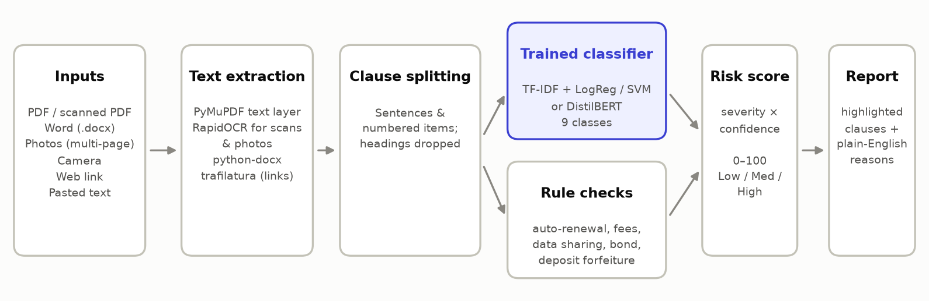
Figure 1. ClauseGuard pipeline.
- Text extraction: PyMuPDF for PDFs; pages with no text layer are rendered and read with RapidOCR (also used for photos and the camera, with up-scaling and a word-segmentation fix for merged words); python-docx for Word files; trafilatura for web pages.
- Clause splitting: a rule-based splitter on sentence ends and numbered items that drops headings.
- Classical models: TF-IDF features (word 1–2-grams + character 3–5-grams, sub-linear TF) with Logistic Regression and with a Linear SVM (probabilities via Platt-style calibration). Both use class_weight = balanced to counter the imbalance.
- Rule checks: 5 transparent keyword rules for patterns outside the dataset that students often meet (auto-renewal, hidden fees, data sharing, bond / lock-in, deposit forfeiture), always labelled separately from model predictions.
- Risk score: each finding contributes risk = severity of its type × model confidence; score = 100 × (1 − e^(−Σ risk / 2.5)), giving Low (0–29), Medium (30–60) or High (61–100).

4. Results
All metrics are on the official test split, which was not used for training or model selection.
Model | Accuracy | Macro P | Macro R | Macro F1 | Unfair-only macro F1 | Fair vs unfair F1 | Train time
TF-IDF + Logistic Regression (best) | 0.946 | 0.736 | 0.845 | 0.775 | 0.750 | 0.802 | 6 s
TF-IDF + Linear SVM | 0.955 | 0.874 | 0.714 | 0.779 | 0.754 | 0.800 | 2 s

Accuracy is high for every model because about 89% of test sentences are fair, so macro F1 (all 9 classes weighted equally) is the main metric. TF-IDF + Logistic Regression was selected for the app because it has the best validation macro F1 (0.718). On the test set TF-IDF + Linear SVM scores slightly higher (0.779 vs 0.775), so the two are close. Per class, it is strongest on Choice of law (F1 0.92) and weakest on Arbitration (F1 0.64, 7 test sentences). For TF-IDF + Logistic Regression, 49 fair sentences were flagged as unfair (false alarms) and 24 unfair sentences were missed. The most common mix-up between unfair types was Unilateral change predicted as Unilateral termination (5 sentences).

5. Application
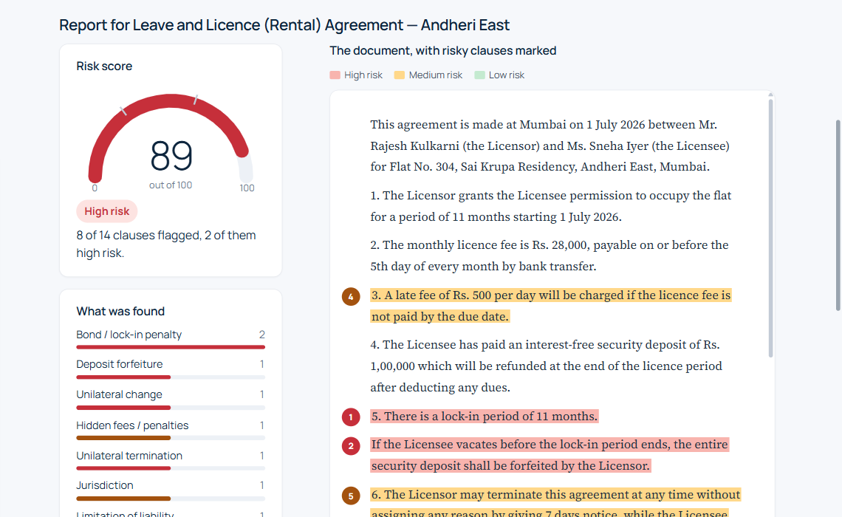
Figure 4. ClauseGuard web app: risk score, category summary and the document with risky clauses highlighted.
The Streamlit app offers tabs for PDF, Word, multiple images, camera, link and pasted text, three built-in sample documents (app terms, a rental agreement and an internship offer letter), a downloadable HTML report and a model-performance page. It runs on a laptop and on phones over the same Wi-Fi. All seven input types were tested end-to-end with automated browser tests, alongside a pytest suite for extraction, clause splitting, rules and scoring.

6. Conclusion and future scope
ClauseGuard shows that a model trained on a modest labelled dataset can reliably flag unfair clauses and make long legal documents understandable in seconds. Its main limitation is domain: it learned from English online terms of service, so it is less accurate on Indian rental agreements and offer letters, where the rule checks help. Future work: collect and label Indian contracts (rent, employment, loan apps), support Hindi and Marathi, fine-tune a legal-domain model such as LegalBERT, suggest fairer rewordings of risky clauses, and ship a browser extension that scans terms before the user clicks "I agree". ClauseGuard is not legal advice.

References
[1] M. Lippi et al., "CLAUDETTE: an automated detector of potentially unfair clauses in online terms of service," Artificial Intelligence and Law, vol. 27, pp. 117–139, 2019.
[2] I. Chalkidis et al., "LexGLUE: A Benchmark Dataset for Legal Language Understanding in English," in Proc. ACL, 2022.
[3] V. Sanh, L. Debut, J. Chaumond and T. Wolf, "DistilBERT, a distilled version of BERT: smaller, faster, cheaper and lighter," arXiv:1910.01108, 2019.
[4] Deloitte, 2017 Global Mobile Consumer Survey (US edition), as reported by Business Insider, Nov. 2017.
[5] J. A. Obar and A. Oeldorf-Hirsch, "The biggest lie on the Internet: ignoring the privacy policies and terms of service policies of social networking services," Information, Communication & Society, 23(1), 2020.
[6] A. M. McDonald and L. F. Cranor, "The Cost of Reading Privacy Policies," I/S: A Journal of Law and Policy for the Information Society, 4(3), 2008.

