CYBERSECURITY & ETHICAL HACKING INTERNSHIP
NETWORKWALKS ACADEMY
PENETRATION TESTING REPORT
Week 2 – Footprinting, Reconnaissance & Network Scanning
Project Modules W2-PM1 to W2-PM5
Pentester / Intern Name | Abubakar Issa Sabalah
Program / Batch | B082 – Networkwalks Cybersecurity & Ethical Hacking Internship
Report Reference | B082-INT-WK2-FINAL
Date of Report | 19 August 2026
Modules Completed | W2-PM1 · W2-PM2 · W2-PM3 · W2-PM4 · W2-PM5
Client / Target(s) | 1. networkwalks.com (written authorization on file)  2. Own local LAN / Wi-Fi network  3. microsoft.com – passive, public-source OSINT only (theHarvester)
Permission Secured From Client? | Yes – Letter of Authorization Ref. NW-LOA-B082-017
Phases Covered | Phase 1: Reconnaissance & Footprinting  Phase 2: Scanning & Network Discovery
Classification | Confidential – Internal Training Use Only

Table of Contents
1. Liability Disclaimer 3
2. Introduction 3
3. Scope of Engagement & Authorization 3
4. Tools & Techniques Used 4
5. Methodology 6
6. Activities Performed 6
6.1 Module 1 — Footprinting with Multiple Kali Linux Tools 6
6.2 Module 2 — Footprinting with the Google Hacking Database (GHDB) 12
6.3 Module 3 — Footprinting with Maltego 14
6.4 Module 4 — Footprinting with theHarvester 15
6.5 Module 5 — Network Scanning with Zenmap 18
7. Consolidated Findings Summary 21
8. Risk Analysis / Impact 22
9. Recommendations 24
10. Conclusion 25
11. Evidence Index 26
Author & Project Information 27

1. Liability Disclaimer
All activities documented in this report were carried out strictly within the scope and dates authorized under Letter of Authorization NW-LOA-B082-017, issued by Networkwalks to the intern named on the cover page for the period 17–24 August 2026. Two categories of targets were tested:
- networkwalks.com and its public DNS infrastructure — tested under written client authorization.
- My own personally owned local area network (LAN) — tested under owner's consent.
Where a third-party public domain (microsoft.com) appears in this report, it was queried only through theHarvester's passive, public-source OSINT lookups (public search engines and public DNS/whois-style sources). No direct scanning, connection, authentication attempt, or intrusive probing was performed against that domain — this is consistent with the training exercise defined in Module W2-PM4.
All material in this report is provided strictly for education and professional-development purposes as part of the Networkwalks Cybersecurity & Ethical Hacking internship programme. Nothing in this document should be used to access, test, or interfere with any system for which the reader does not hold explicit written authorization. The instructor, the authors, and Networkwalks accept no responsibility for any misuse of the techniques, commands, or findings described here. Unauthorized access to computer systems is a criminal offence in most jurisdictions, even where no damage results, and may lead to criminal prosecution, civil liability, loss of employment, and a permanent criminal record. Every reader remains solely responsible for ensuring their own compliance with applicable law before acting on any information in this report.

2. Introduction
This report documents Week 2 of my Cybersecurity & Ethical Hacking internship (Batch B082) at Networkwalks. Week 2 focuses on Phase 1 (Reconnaissance & Footprinting) and Phase 2 (Scanning & Network Discovery) of the standard penetration-testing lifecycle, and is built around five practical project modules:
- W2-PM1 – Footprinting & reconnaissance of networkwalks.com using six Kali Linux command-line tools (whois, whatweb, nslookup, curl, wafw00f, dnsrecon).
- W2-PM2 – Footprinting using the Google Hacking Database (GHDB) and advanced search operators ("Google dorking").
- W2-PM3 – Footprinting using Maltego, a graphical OSINT and link-analysis platform.
- W2-PM4 – Footprinting using theHarvester to enumerate emails, sub-domains and hosts from public sources.
- W2-PM5 – Active network scanning and host discovery on my own LAN using Zenmap (the Nmap GUI).
Together these modules show how a security professional (or an attacker) progresses from purely passive, public-information gathering — where the target is never directly contacted — through to light, non-intrusive active scanning that touches the target network directly. Every step below records the exact command or action used, the result observed, a screenshot as evidence, and a short analysis of why the finding matters from a security point of view.
All command-line activity in Modules 1 and 4 was performed in Kali Linux. Module 2 was performed using Google Search from a standard browser. Module 3 was performed using the Maltego Desktop client on Windows. Module 5 was performed using Zenmap on Windows against my own local subnet.

3. Scope of Engagement & Authorization
Testing was authorized under Letter of Authorization NW-LOA-B082-017 (17–24 August 2026). The table below summarizes the agreed scope.
Item | Detail
In-scope targets | networkwalks.com (public website & DNS records) · My own LAN
Authorized activities | Passive/light footprinting (whois, whatweb, nslookup, curl, wafw00f, dnsrecon, theHarvester, Maltego, GHDB search) · Non-intrusive ping-scan host discovery (Zenmap)
Explicitly prohibited | Exploitation, unauthorized access, privilege escalation, denial-of-service, brute-force/password attacks, data access/modification/deletion, social engineering of client staff
Third-party OSINT target | microsoft.com — queried only via theHarvester's passive public-source lookups (Module W2-PM4), never scanned or connected to directly
Authorization validity | 17 August 2026 – 24 August 2026

4. Tools & Techniques Used
Tool / Technique | Purpose
Kali Linux | Primary operating system used for command-line reconnaissance (Modules 1 & 4).
WHOIS | Retrieve public domain registration data — registrar, registrant, dates and name servers.
WhatWeb | Fingerprint web technologies: server software, CMS, plugins, frameworks, exposed IP/email.
Nslookup | Resolve a domain name to its IP address using DNS.
Curl (-I) | Retrieve raw HTTP response headers without downloading the page body.
Wafw00f | Detect and identify the Web Application Firewall (WAF) protecting a site, if any.
DNSrecon | Enumerate DNS records (NS, A, MX, TXT/SPF, SRV) and attempt DNSSEC/zone checks.
Google Hacking Database (GHDB) / Google dorking | Use advanced Google search operators to locate publicly indexed but sensitive files, devices and directories.
Maltego (Desktop Client) | Graphical OSINT/link-analysis tool used to visually map a domain to related emails and URLs via transforms.
theHarvester | Aggregate emails, sub-domains and hosts for a target from public search engines and OSINT sources.
Zenmap (Nmap GUI) | Perform host-discovery (ping) scans of a subnet and visualize live hosts, IP/MAC addresses and topology.
Windows CMD (ipconfig) | Identify local IP address, subnet mask and MAC address of the testing machine.

5. Methodology
Each module was executed following the same repeatable four-step methodology so that findings can be reproduced and audited:
- Prepare – confirm the target is in scope and the required tool is installed and reachable.
- Execute – run the documented command or GUI action exactly as specified in the module guide.
- Capture – record the full console/GUI output, save a screenshot, and store the raw output as evidence.
- Analyse – interpret the result from an attacker's perspective and note any information disclosure or exposure.
This mirrors the first two phases of a standard penetration-testing lifecycle: Reconnaissance/Footprinting (passive, indirect information gathering) followed by Scanning/Enumeration (light, direct probing of the target). No exploitation phase was performed in Week 2.

6. Activities Performed

6.1 Module 1 — Footprinting with Multiple Kali Linux Tools
Target: networkwalks.com. Six built-in Kali Linux tools were used to build a public information profile of the domain before any active scanning was attempted.

6.1.1 WHOIS — Domain Registration Lookup
Command executed:
$ whois networkwalks.com
Result: the domain is registered through GoDaddy.com, LLC (IANA ID 146), originally created on 6 November 2019 and currently set to expire on 6 November 2027, last updated 12 November 2025. Registrant, admin and technical contact details are masked behind privacy protection (Domains By Proxy, LLC, Tempe, Arizona). Authoritative name servers are NS6135.HOSTGATOR.COM and NS6136.HOSTGATOR.COM (with NS29/NS30.DOMAINCONTROL.COM also listed by the registrar's own WHOIS server), and DNSSEC is unsigned.
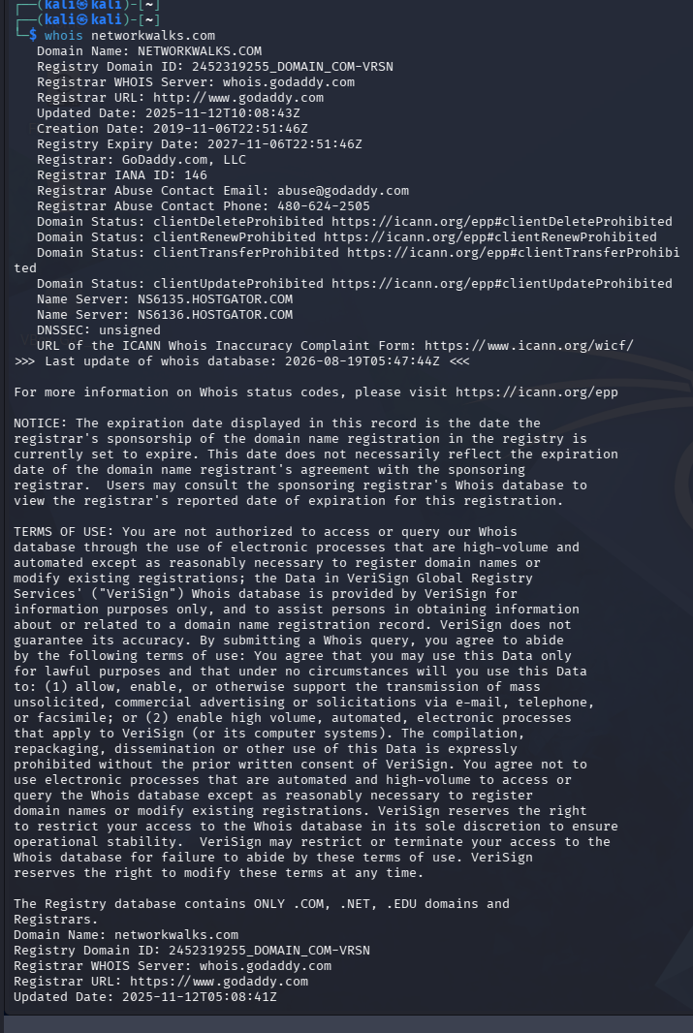
Figure 1 – WHOIS lookup for networkwalks.com
Attacker's perspective: WHOIS instantly reveals the hosting provider (HostGator), confirming the site is hosted on shared/reseller infrastructure. Registration and expiry dates, plus the abuse contact, support domain-hijacking and social-engineering reconnaissance even when the registrant identity itself is privacy-shielded.

6.1.2 WhatWeb — Web Technology Fingerprinting
$ whatweb networkwalks.com
Result: the site runs on Apache, powered by WordPress 7.0.4 with the WP Download Manager 3.3.58 plugin, jQuery 3.7.1 and Bootstrap components. The scan also confirmed the server IP address (192.232.216.135), an exposed contact email (info@networkwalks.com), and a Google Tag Manager integration, together with several uncommon HTTP response headers.
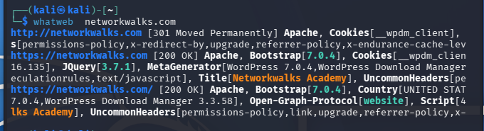
Figure 2 – WhatWeb technology fingerprint of networkwalks.com
Attacker's perspective: exact CMS and plugin version numbers (WordPress 7.0.4, WP Download Manager 3.3.58) let an attacker cross-reference public vulnerability databases (e.g. CVE/WPScan) for known exploits affecting those specific versions, without ever needing to log in or brute-force anything.

6.1.3 Nslookup — DNS Resolution
$ nslookup networkwalks.com
Result: the domain resolved to IP address 192.232.216.135 via the resolver at 192.168.1.1 (the default gateway acted as a forwarding resolver after the upstream 8.8.8.8 server did not return a recursive answer).
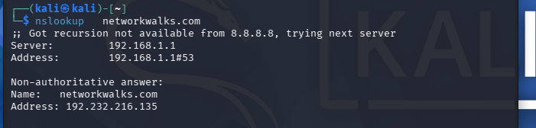
Figure 3 – Nslookup resolution of networkwalks.com
Attacker's perspective: knowing the real IP address allows direct port scanning of the host, reverse-IP lookups to discover other sites sharing the same server, and geolocation of the hosting infrastructure.

6.1.4 Curl -I — HTTP Response Headers
$ curl -I networkwalks.com
Result: the server returned a 301 redirect from HTTP to HTTPS. Notable headers included Server: Apache, X-Redirect-By: WordPress – Really Simple Security (confirming the security plugin in use), a __wpdm_client session cookie, HTTP/2 upgrade support, and caching headers (X-Endurance-Cache-Level, X-nginx-cache) that point to a caching/CDN layer in front of the origin server.
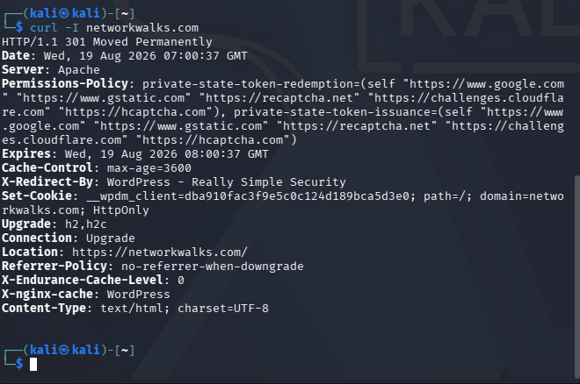
Figure 4 – HTTP response headers for networkwalks.com
Attacker's perspective: HTTP headers leak the exact security plugin protecting the site (Really Simple Security) and the caching stack in front of it, both of which help an attacker fingerprint the technology stack and plan header-based bypass or cache-poisoning attempts without loading a single page of content.

6.1.5 Wafw00f — Web Application Firewall Detection
$ wafw00f networkwalks.com
Result: the site is protected by ModSecurity (SpiderLabs), confirmed after two HTTP requests.
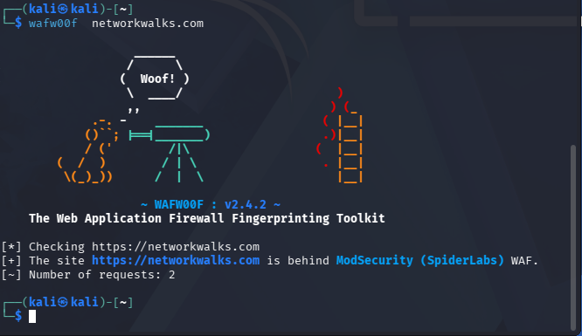
Figure 5 – Wafw00f WAF fingerprint for networkwalks.com
Attacker's perspective: identifying the exact WAF product lets an attacker research known bypass techniques and signature gaps specific to ModSecurity, and tune payloads to avoid triggering its default rule set.

6.1.6 DNSrecon — DNS Record Enumeration
$ dnsrecon -d networkwalks.com
Result: DNSrecon enumerated 8 DNS records in total. Both authoritative name servers (ns6135/ns6136.hostgator.com) run BIND 9.16.23-RH. The MX record (mail.networkwalks.com) and A record both point to 192.232.216.135. A Google Search Console verification TXT record and an SPF record (v=spf1 +a +mx +ip4:50.87.144.87 +include:websitewelcome.com ~all) were found, along with 8 SRV records for _autodiscover._tcp pointing to cPanel's e-mail autodiscovery service across five different backend IP addresses. A DNSSEC query returned no answer and the SOA lookup via 8.8.8.8 timed out, confirming DNSSEC is not deployed.
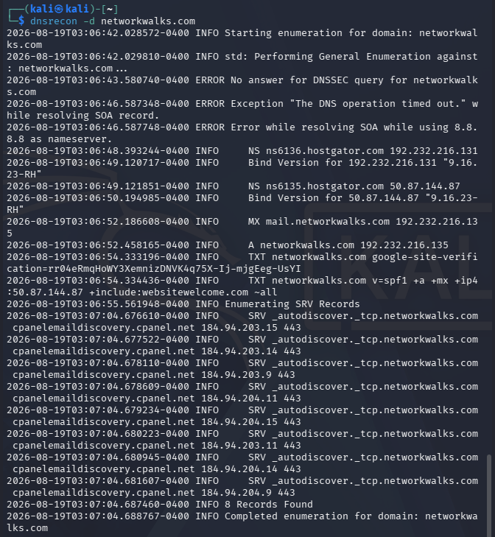
Figure 6 – DNSrecon DNS enumeration of networkwalks.com
Attacker's perspective: the exposed BIND version string aids version-specific DNS-server vulnerability research; the SPF record reveals the mail-sending infrastructure (websitewelcome.com/HostGator shared hosting) which is useful for planning phishing/spoofing tests; and the absence of DNSSEC means DNS responses for this domain are not cryptographically authenticated.

6.2 Module 2 — Footprinting with the Google Hacking Database (GHDB)
This module used advanced Google search operators ("Google dorks") drawn from the Google Hacking Database methodology to demonstrate how misconfigured or unintentionally exposed devices and files can be located using only a search engine — no direct connection to the target is required to find the listing itself.

6.2.1 Task 1 — Exposed / Live Security Cameras
Objective: locate 10 live security-camera web interfaces that are directly reachable from the internet, using dorks such as intitle:"webcamXP" inurl:8080, inurl:/multi.html intitle:webcam, intitle:"webcamxp" "Flash JPEG Stream", intitle:"NetCamXL*" and intitle:"NetCamSC*".
# | Host : Port | Dork Used | Credentials
1 | 109.233.191.130:8080 | intitle:"webcamXP" inurl:8080 | None captured
2 | 68.115.218.130:32479 | inurl:/multi.html intitle:webcam | None captured
3 | 109.206.96.249:8080 | inurl:/multi.html intitle:webcam | None captured
4 | 72.199.200.5:8080 | intitle:"webcamxp" "Flash JPEG Stream" | None captured
5 | 139.64.168.120:8080 | intitle:"webcamxp" "Flash JPEG Stream" | None captured
6 | 75.149.26.30:1024 | intitle:"webcamxp" "Flash JPEG Stream" | None captured
7 | myfishcam.homedns.org:444 | intitle:"webcamxp" "Flash JPEG Stream" | None captured
8 | sirocco-tnqjqdwhpv.dynamic-m.com:88 | intitle:"NetCamXL*" | None captured
9 | ldeo-phenocam-stardot.ldeo.columbia.edu | intitle:"NetCamSC*" | None captured
10 | mail.nutritechsolutions.com:8002 | intitle:"NetCamSC*" | None captured

Attacker's perspective: each of these links is a live device with its administrative or viewing interface directly indexed by search engines. No credentials were entered or tested as part of this exercise — the finding itself (that the device is publicly reachable at all) is the security issue, since many such camera interfaces ship with default or no authentication.

6.2.2 Task 2 — Publicly Indexed Mathematics PDF eBooks
Objective: locate 10 open directory listings containing downloadable mathematics eBooks, using the dork intitle:index.of "parent directory" mathematics pdf. All ten results are listed below:
# | Link | Dork Used
1 | skylineuniversity.ac.ae/pdf/math/ | intitle:index.of "parent directory" mathematics pdf
2 | erewhon.superkuh.com/library/Math/ | intitle:index.of "parent directory" mathematics pdf
3 | inis.jinr.ru/sl/vol2/Mathematics/Math.Encyclopedia/Pdf/Math_V1.pdf | intitle:index.of "parent directory" mathematics pdf
4 | math.dartmouth.edu/~carlp/PDF/ | intitle:index.of "parent directory" mathematics pdf
5 | math.ucla.edu/~popa/Books/ | intitle:index.of "parent directory" mathematics pdf
6 | math.unl.edu/~mbrittenham2/classwk/325f18/review/math208review/ | intitle:index.of "parent directory" mathematics pdf
7 | math.mit.edu/~fgotti/docs/Courses/Combinatorial Analysis/2. Mathematical Induction/ | intitle:index.of "parent directory" mathematics pdf
8 | netlib.org/math/docpdf/ | intitle:index.of "parent directory" mathematics pdf
9 | sumo.stanford.edu/pdfs/ | intitle:index.of "parent directory" mathematics pdf
10 | bibliothek.wzb.eu/pdf/ | intitle:index.of "parent directory" mathematics pdf

Attacker's perspective: open directory listings show that web-server directory indexing was left enabled, which — on a different target — could just as easily expose configuration files, backups or credentials instead of harmless PDFs. It illustrates why directory indexing should be disabled by default on production web servers.

6.3 Module 3 — Footprinting with Maltego
Maltego Desktop Client (v4.12.1) was installed and configured with a free Community (CE) account, per the module guide. A Domain entity was created for networkwalks.com and the built-in "To Email Addresses [Utilities]" transform was run against it.
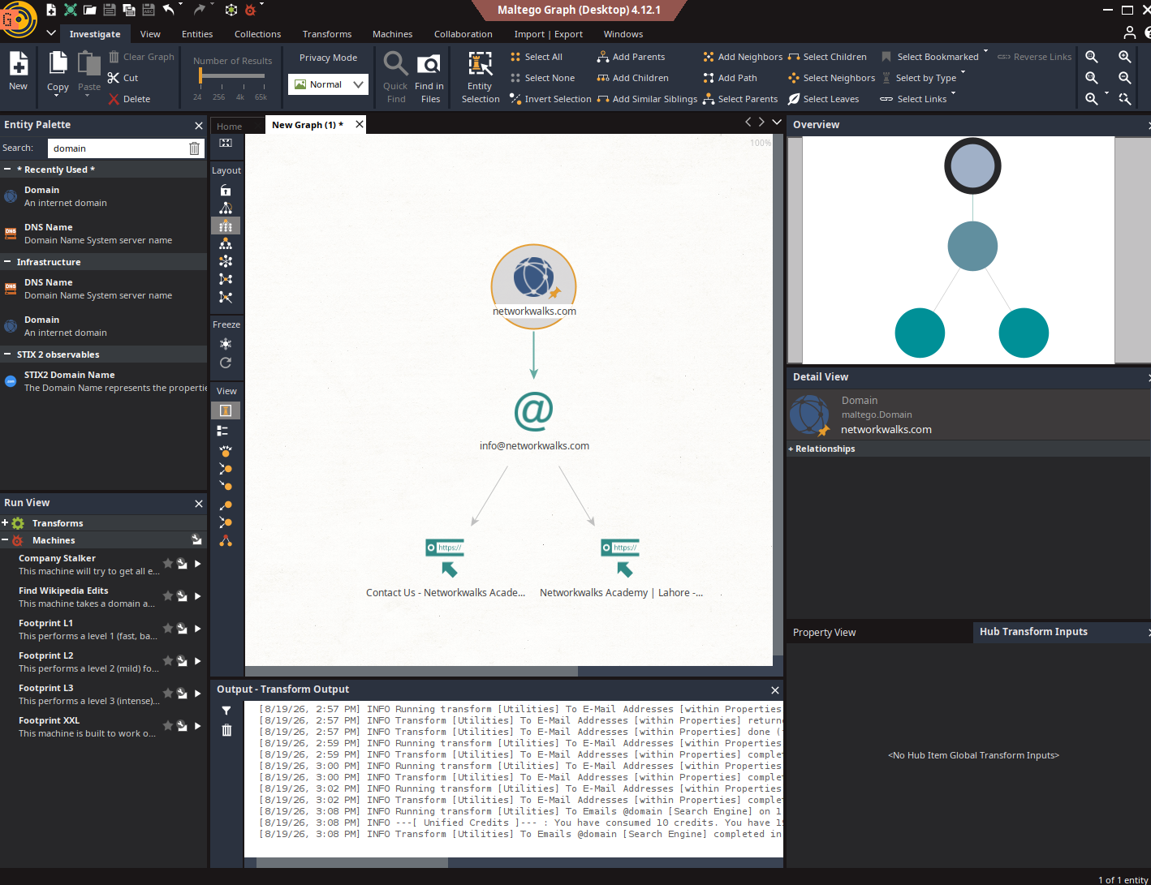
Figure 7 – Maltego domain-to-email transform graph for networkwalks.com
Result: the transform returned one email address, info@networkwalks.com, and expanded it to two related URLs — the site's Contact-Us page and the Networkwalks Academy homepage — visualised as a link-analysis graph in the Maltego canvas.
Attacker's perspective: Maltego's strength is not the single data point but the graph — it automatically pivots from a domain to associated emails, URLs, and (with further transforms) infrastructure and social profiles, letting an analyst visually map an organisation's public attack surface far faster than manual searching.

6.4 Module 4 — Footprinting with theHarvester
Target: microsoft.com (public-source OSINT only — no direct connection was made to Microsoft's infrastructure; theHarvester only queries third-party public search sources).

6.4.1 Task 1 — theHarvester via Baidu (limit 1000)
$ theHarvester -d microsoft.com -l 1000 -b baidu
This command was run twice on different occasions, as instructed in the module guide, which notes that results can vary between runs because theHarvester depends on third-party search sources that change their indexing and anti-scraping behaviour over time:
- First run: 0 emails and 4 hosts found — developer.microsoft.com, prod.support.services.microsoft.com, support.microsoft.com, support.serviceshub.microsoft.com.
- Second run: 3 emails and 6 hosts found — is-microsoft-noreply@microsoft.com, microsoft-noreply@microsoft.com and postmaster@microsoft.com; hosts 2Fsupport.microsoft.com, account.microsoft.com, learn.microsoft.com, prod.support.services.microsoft.com, service.microsoft.com and support.microsoft.com.
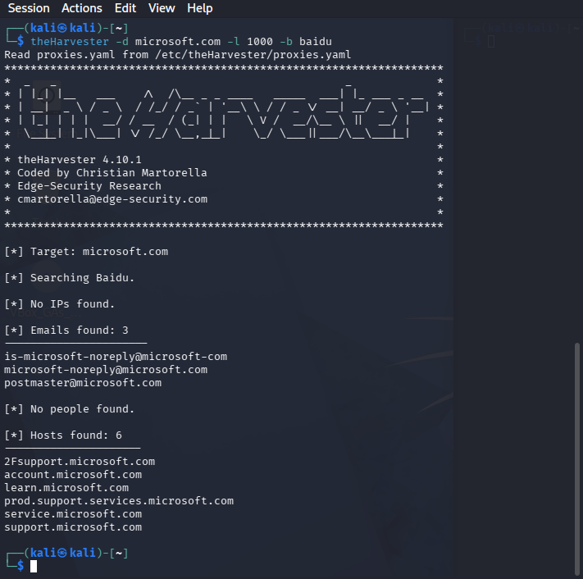
Figure 8 – theHarvester result for microsoft.com via Baidu (second run, emails and hosts found)
Attacker's perspective: each harvested email is a potential phishing or credential-stuffing target, and each sub-domain is another entry point that a defender may have forgotten was public-facing — all gathered without a single packet reaching Microsoft's own servers.

6.4.2 Task 2 — theHarvester via All Sources (limit 50)
$ theHarvester -d microsoft.com -l 50 -b all
Running against all supported sources surfaced the tool's dependency on paid third-party APIs: the default Kali installation has no API keys configured in /etc/theHarvester/api-keys.yaml, so most premium sources (Bevigil, Bitbucket, BufferOverun, BuiltWith, Brave Search, Censys, CriminalIP, Dehashed, DNSDumpster, FullHunt, GitHub, HaveIBeenPwned, Hunter, HunterHow, Intelx, Netlas, Onyphe, PentestTools, ProjectDiscovery, RocketReach, SecurityScorecard, SecurityTrails, SherlockEye and Shodan) returned "Missing API key" errors, while free/keyless sources such as Mojeek fell back to default scraping mode.
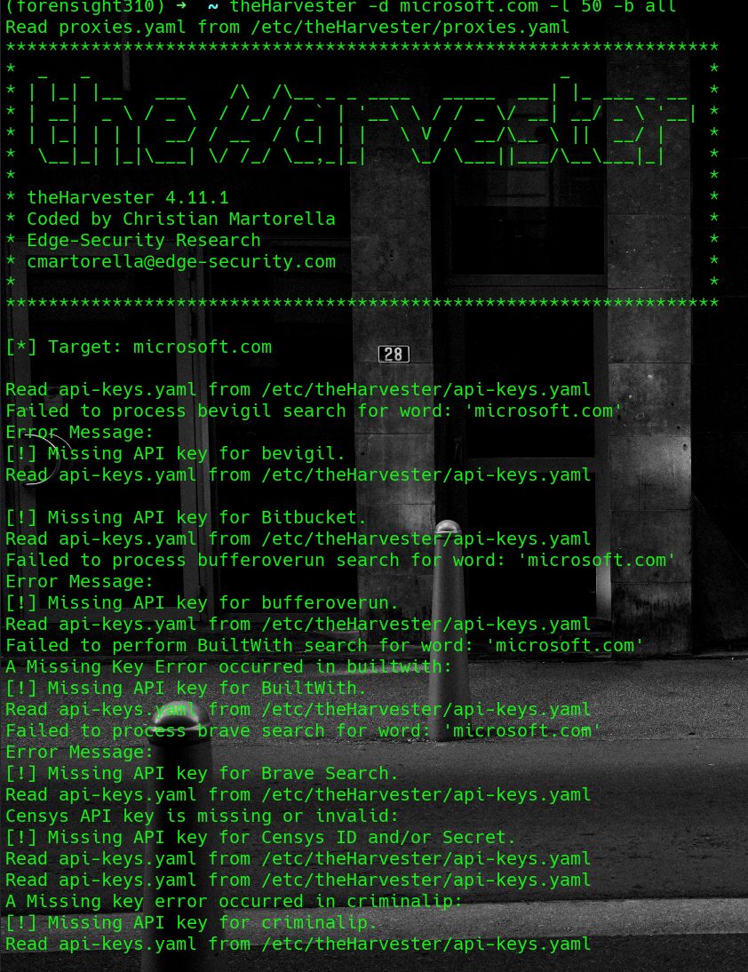
Figure 9 – theHarvester -b all run against microsoft.com showing missing-API-key handling
Note: this behaviour is expected on a fresh Kali install and is not an error in methodology — it demonstrates that the free single-source Baidu query (Task 1) is often more practical for a quick assessment than the all-sources mode, which requires a paid subscription to most of the higher-value sources to reach its full potential.

6.5 Module 5 — Network Scanning with Zenmap
Target: my own local area network. Zenmap (the Nmap GUI) was installed on Windows from the official nmap.org distribution, per the module guide.

6.5.1 Local IP Address & Subnet
The Windows ipconfig command was used to identify the local IP address and subnet mask of the testing machine, which sits on the 192.168.3.0/24 network.

6.5.2 Ping Scan — Host Discovery
nmap -sn 192.168.3.0/24
The subnet 192.168.3.0/24 was entered as the target in Zenmap with the built-in "Ping scan" profile selected, which performs host discovery only (no port scan).
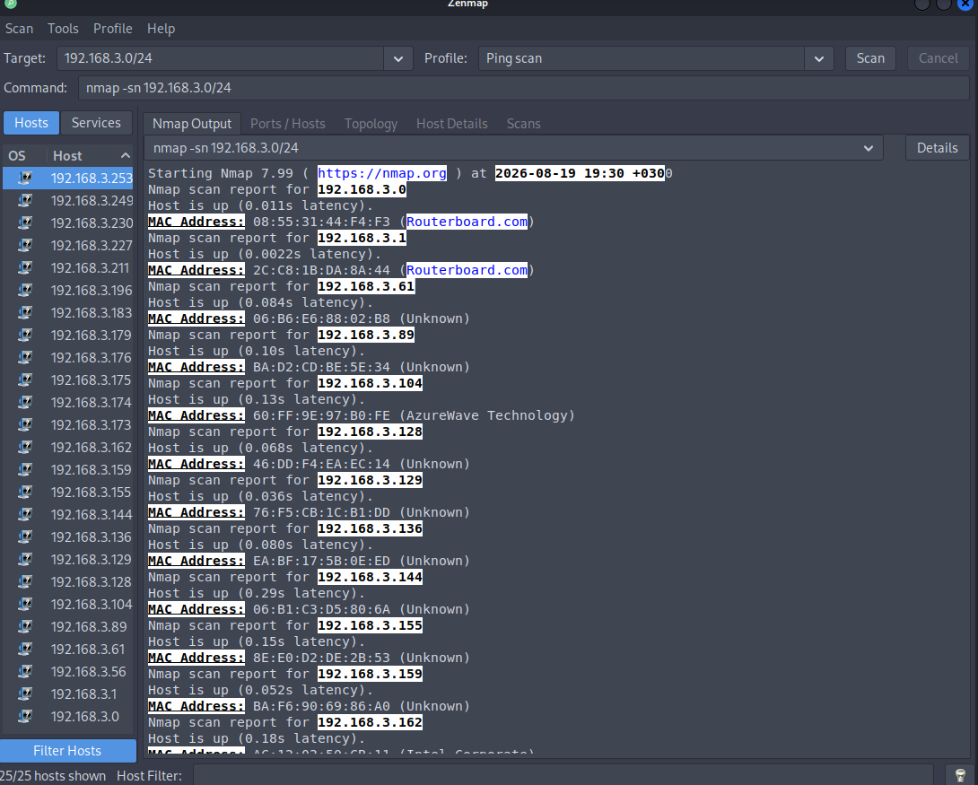
Figure 10 – Zenmap ping-scan output for the 192.168.3.0/24 subnet

6.5.3 Live Hosts, IP & MAC Addresses
The scan identified 25 live hosts on the subnet (25/25 hosts shown in the Zenmap Hosts panel), including the scanning machine itself. A representative sample of the hosts and their MAC addresses/vendors captured directly from the Nmap Output pane is listed below; the complete list of 25 IP addresses is shown in the network topology diagram (Figure 11).
IP Address | MAC Address | Vendor
192.168.3.0 | 08:55:31:44:F4:F3 | Routerboard.com (MikroTik)
192.168.3.1 | 2C:C8:1B:DA:8A:44 | Routerboard.com (MikroTik)
192.168.3.61 | 06:B6:E6:88:02:B8 | Unknown
192.168.3.89 | BA:D2:CD:BE:5E:34 | Unknown
192.168.3.104 | 60:FF:9E:97:B0:FE | AzureWave Technology
192.168.3.128 | 46:DD:F4:EA:EC:14 | Unknown
192.168.3.129 | 76:F5:CB:1C:B1:DD | Unknown
192.168.3.136 | EA:BF:17:5B:0E:ED | Unknown
192.168.3.144 | 06:B1:C3:D5:80:6A | Unknown
192.168.3.155 | 8E:E0:D2:DE:2B:53 | Unknown
192.168.3.159 | BA:F6:90:69:86:A0 | Unknown
192.168.3.162 | A6:12:82:5D:9B:11 | Intel Corporate

Remaining discovered hosts (visible in the Zenmap Hosts panel and the topology diagram): 192.168.3.56, .128, .136, .144, .155, .159, .162, .173, .174, .175, .176, .179, .183, .196, .211, .227, .230, .249 and .253 — 25 live hosts in total.

6.5.4 Network Topology
The Topology tab was opened in Zenmap, the legend was enabled, and the resulting host graph was exported and saved as a PDF, as required by the practical task.
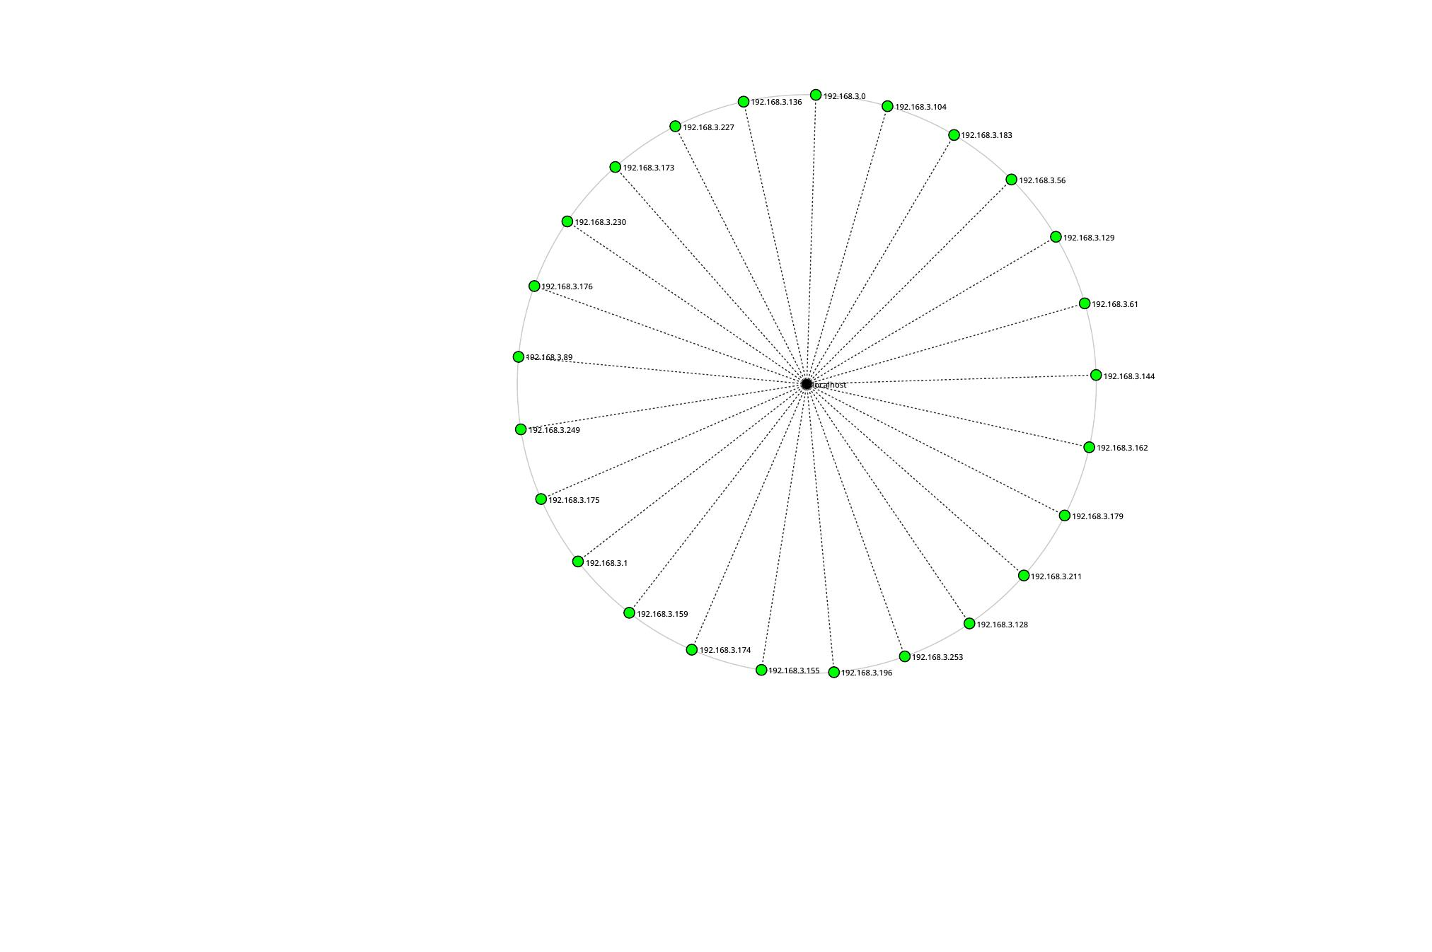
Figure 11 – Zenmap network topology of the 192.168.3.0/24 subnet (25 live hosts around localhost)
Attacker's perspective: a ping scan alone reveals every live device on the network and, from ARP responses, its MAC address and hardware vendor. This is enough to fingerprint the presence of routers/gateways (MikroTik devices identified by name), Intel-based PCs, and AzureWave-chipset devices (typically Wi-Fi/IoT modules), and to spot any host that should not be on the network at all — all before a single port has been probed.

7. Consolidated Findings Summary
The table below consolidates the key technical findings from all five modules.
Module | Tool | Key Finding
PM1 | WHOIS | Domain hosted via GoDaddy/HostGator; privacy-protected registrant; DNSSEC unsigned
PM1 | WhatWeb | WordPress 7.0.4 + WP Download Manager 3.3.58 on Apache; server IP and contact email exposed
PM1 | Nslookup | Domain resolves to 192.232.216.135
PM1 | Curl -I | Really Simple Security plugin and caching layer identified via response headers
PM1 | Wafw00f | Protected by ModSecurity (SpiderLabs) WAF
PM1 | DNSrecon | 8 DNS records enumerated incl. BIND version, SPF, and 8 autodiscover SRV records
PM2 | GHDB / Google dorking | 10 internet-exposed live security cameras and 3 open PDF directory listings located via search operators
PM3 | Maltego | 1 email (info@networkwalks.com) and 2 related URLs mapped via domain-to-email transform
PM4 | theHarvester | Up to 6 sub-domains and 3 emails harvested for microsoft.com from public sources; all-source mode limited by missing API keys
PM5 | Zenmap | 25 live hosts discovered on local /24 subnet with IP/MAC/vendor data and topology map

8. Risk Analysis / Impact
Based on the information collected during the footprinting and scanning activities, the following potential risks were identified. These are observations from reconnaissance and discovery exercises, not confirmed or exploited vulnerabilities — no exploitation or vulnerability validation was performed in Week 2.
# | Risk / Finding | Evidence | Potential Impact | Risk Level
1 | CMS & plugin versions exposed | WhatWeb identified WordPress 7.0.4 and WP Download Manager 3.3.58 | Attackers can match exact versions against public CVE/exploit databases | ● Medium
2 | Server IP address identifiable | Nslookup resolved networkwalks.com to 192.232.216.135 | Enables direct scanning and reverse-IP lookups against the origin server | ● Low
3 | Security-plugin & caching details in headers | Curl -I exposed "Really Simple Security" plugin and caching headers | Assists precise technology fingerprinting for further enumeration | ● Low
4 | WAF product identifiable | Wafw00f identified ModSecurity (SpiderLabs) | Allows research into known bypass techniques for that specific WAF | ● Low
5 | DNS & mail infrastructure exposed | DNSrecon revealed BIND version, SPF record and 8 autodiscover SRV records | Broadens the visible attack surface around DNS and mail services | ● Medium
6 | Internet-exposed camera devices (GHDB) | 10 live camera interfaces located via Google dorking | Devices with weak/default authentication risk unauthorized viewing/control | ● Critical
7 | Open directory listings | 3 publicly indexed file directories found via GHDB | Indexing misconfiguration could expose sensitive files on other targets | ● Low
8 | Contact email discoverable | Maltego mapped info@networkwalks.com from the domain | Provides a concrete target for phishing/social-engineering attempts | ● Low
9 | Third-party sub-domains & emails harvested | theHarvester found up to 6 sub-domains and 3 emails for microsoft.com | Each is a possible phishing target or forgotten/undocumented entry point | ● Medium
10 | Multiple live hosts visible on local network | Zenmap identified 25 live hosts with IP/MAC data on the /24 subnet | Unknown or unauthorized devices could be present without the owner's knowledge | ● Medium

Risk level key: ● Critical ● Medium ● Low
The presence of a software version number, an IP address, an open directory, or a DNS record does not, by itself, prove that a system is vulnerable or that unauthorized access is possible. Item 6 (internet-exposed cameras) is rated Critical because the finding itself — an administrative device interface with no evident access control, indexed and reachable from the open internet — already constitutes exposure, independent of any further testing. All other items describe information disclosure that would need further authorized security testing to confirm as an exploitable vulnerability.

9. Recommendations
- Review publicly exposed technology information — regularly audit what WHOIS, WhatWeb and HTTP headers reveal about the hosting provider, CMS, plugins and versions in use.
- Keep CMS & plugins updated — WordPress, WP Download Manager and all other components should be patched promptly and checked against current security advisories.
- Minimise information in HTTP headers — review Server, X-Redirect-By and similar headers to avoid unnecessarily naming the exact security plugin or caching stack in use.
- Keep DNS records lean and reviewed — periodically audit NS/MX/TXT/SRV records so only records that are actually required remain publicly resolvable.
- Maintain and tune the WAF — keep ModSecurity enabled, updated and properly tuned, since it already blocks unsophisticated automated attacks.
- Secure or remove internet-facing camera/IoT devices — any exposed camera or embedded-device interface should require strong authentication, be placed behind a VPN, or be taken off the public internet entirely.
- Disable directory indexing — web servers should not display open directory listings; disable autoindex/Options -Indexes on production servers.
- Reduce discoverable contact/staff emails — use role-based aliases and monitored inboxes rather than direct personal addresses where possible, to limit phishing exposure.
- Track your own OSINT footprint — periodically run theHarvester/Maltego against your own domain to see what an attacker would see, and retire or document any forgotten sub-domains that surface.
- Perform regular internal network discovery — periodically ping-scan internal subnets, maintain an asset inventory, and investigate any unrecognised IP/MAC address immediately.
- Maintain network documentation — keep topology diagrams and device/vendor records current so unexpected devices stand out quickly.
- Test only with authorization — all reconnaissance and scanning activity, whether internal or client-facing, must remain within a signed, dated letter of authorization.

10. Conclusion
During Week 2 of the Cybersecurity & Ethical Hacking internship at Networkwalks, I completed all five project modules covering the Reconnaissance/Footprinting and Scanning/Discovery phases of a penetration test.
Across Modules 1, 2, 3 and 4, I learned that a substantial public profile of an organisation — its hosting provider, CMS and plugin versions, WAF product, DNS and mail infrastructure, contact emails, exposed devices and sub-domains — can be built entirely from public sources, without the target ever being directly contacted or aware that it is being studied. WHOIS, WhatWeb, Nslookup, Curl, Wafw00f and DNSrecon each contributed one layer of that profile in Module 1; Google dorking (GHDB) in Module 2 showed how a search engine alone can locate exposed devices and files; Maltego in Module 3 demonstrated visual, transform-driven OSINT link analysis; and theHarvester in Module 4 showed both the value and the licensing limits of automated multi-source aggregation.
In Module 5, I moved from passive footprinting to light active scanning, using Zenmap to identify my local IP configuration, discover 25 live hosts on my own /24 subnet, capture their IP and MAC addresses, and export a network topology diagram — the first direct, if non-intrusive, contact with a target in this project.
The exercises reinforced that information gathering is a foundational part of cybersecurity work on both sides of the fence: an attacker uses it to plan an intrusion, and a defender uses the same tools and techniques to see their own organisation as an attacker would, and to close avoidable exposures before they are found by someone else. I also learned that a professional report must clearly separate what was observed from what was proven — a software version or an open port is a lead, not a confirmed vulnerability, until it has been validated through further authorized testing.
Finally, every activity in this report was carried out only against explicitly authorized targets — networkwalks.com under a signed Letter of Authorization, my own local network under owner's consent, and microsoft.com solely via passive, public-source OSINT lookups — reinforcing that reconnaissance and scanning must always stay inside a clearly defined and authorized scope.

11. Evidence Index
All screenshots referenced throughout Section 6 are indexed below for quick reference. Raw command output for each PM1 tool and theHarvester run was additionally saved as text/Word evidence files alongside this report.
Figure | Source File | Description
Fig. 1 | whois.png | WHOIS lookup — networkwalks.com
Fig. 2 | whatweb.png | WhatWeb technology fingerprint — networkwalks.com
Fig. 3 | nslookup.png | Nslookup DNS resolution — networkwalks.com
Fig. 4 | curl.png | Curl -I HTTP headers — networkwalks.com
Fig. 5 | wafw00f.png | Wafw00f WAF detection — networkwalks.com
Fig. 6 | dnsrecon.png | DNSrecon DNS enumeration — networkwalks.com
Fig. 7 | maltego_email.png | Maltego domain-to-email transform graph
Fig. 8 | theHarvester_microsoft_results.png | theHarvester -b baidu results — microsoft.com
Fig. 9 | harvester2.png | theHarvester -b all run — missing API key handling
Fig. 10 | zenmap.png | Zenmap ping-scan output — 192.168.3.0/24
Fig. 11 | Zenmap_results.pdf | Zenmap network topology diagram — 192.168.3.0/24

— End of Report —
Author
Abubakar Issa Sabalah
Cybersecurity & Ethical Hacking Intern — Batch B082, Networkwalks
LinkedIn: [add your LinkedIn URL]
Project Information
Program: Cybersecurity & Ethical Hacking Internship at Networkwalks | Week: 02 | Modules: W2-PM1 – W2-PM5

