**DE-Fellowship – Week 10**

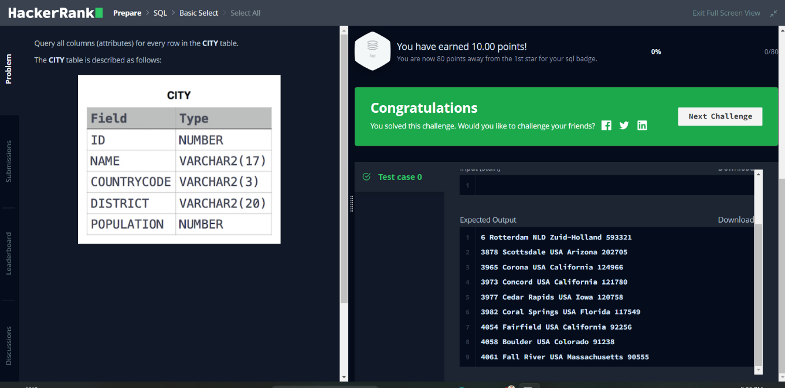Task#4 Date: 18-May-2023

