Professional Machine Learning Project Report
Heart Disease Prediction using Multiple Machine Learning Models

1. Introduction
Heart disease is one of the leading causes of death worldwide. This project applies Machine Learning algorithms to predict the presence of heart disease using medical datasets. The system trains on the Cleveland dataset and tests on multiple independent datasets including Hungarian, Switzerland, and VA datasets to evaluate generalization performance.

2. Project Objectives
- Predict heart disease using patient medical records
- Compare multiple machine learning classification models
- Perform preprocessing and feature engineering
- Handle imbalanced datasets using SMOTE
- Evaluate models using classification metrics

3. Workflow Diagram
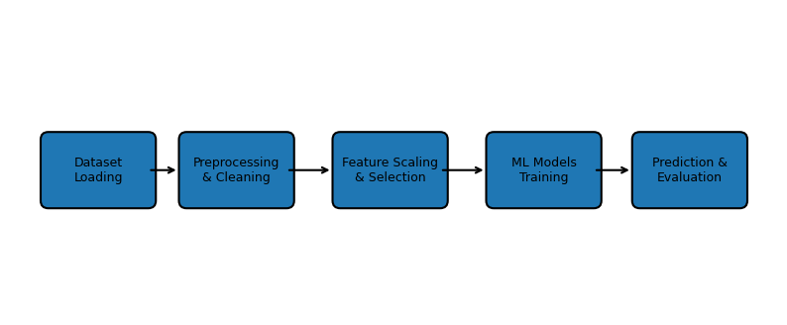

4. Dataset Description
The project uses publicly available UCI Heart Disease datasets. The Cleveland dataset was used for training while Hungarian, Switzerland, and VA datasets were used for testing. Features include age, chest pain type, cholesterol, blood pressure, heart rate, ECG results, and other medical indicators.

5. Data Preprocessing
Missing values represented by "?" were replaced with NaN and filled using mean and mode imputation. Invalid zero values in important medical columns were also handled. The data was cleaned and converted into numerical form for machine learning models.

6. Feature Scaling and Selection
Standardization and Min-Max Normalization techniques were applied to scale the features. Variance Threshold feature selection was used to remove low-variance and less important features.

7. Class Balancing
The dataset imbalance problem was solved using SMOTE (Synthetic Minority Oversampling Technique). This improved the learning capability of machine learning models by balancing target classes.

8. Machine Learning Models Used
- Logistic Regression
- K-Nearest Neighbors (KNN)
- Decision Tree
- Naive Bayes
- Support Vector Machine (SVM)
- Random Forest

9. Model Evaluation Metrics
The models were evaluated using Accuracy, Precision, Recall, F1-Score, Confusion Matrix, Mean Squared Error (MSE), and ROC-AUC score.

10. Expected Outputs
- Prediction of heart disease presence or absence
- Confusion matrices for each ML model
- Accuracy comparison between different models
- Graphs and visualizations of performance metrics
- Best performing model identification

11. Results and Findings
The project demonstrates that machine learning algorithms can effectively predict heart disease based on medical features. Ensemble and advanced classification models such as Random Forest and SVM generally provide better prediction performance compared to simpler algorithms.

12. Advantages of the Project
- Early detection of heart disease risk
- Automated healthcare prediction system
- Comparison of multiple ML algorithms
- Improved diagnostic support for medical analysis

13. Future Improvements
- Use larger real-world hospital datasets
- Deploy the model as a web application
- Apply Deep Learning techniques
- Integrate real-time healthcare monitoring

14. Conclusion
This project successfully demonstrates the use of Machine Learning in healthcare analytics. By combining preprocessing, feature engineering, class balancing, and multiple classification models, the system can predict heart disease with strong performance and practical healthcare applications.

